PRACTICAL MACHINE LEARNING · TRAINER MATERIAL
Regression Day — Trainer Handbook
Linear, Polynomial and Regularised Regression · Mathematics first
CDAC Kharghar, Mumbai · Session date 26 October 2026
7 instructional hours · Postgraduate AI cohort
File 03 of the PML Regression training package

Contents

How to use this handbook
This handbook lets a qualified trainer deliver the Regression day of the CDAC Practical Machine Learning course exactly as designed. It follows the trainer deck (01_PML_Regression_Trainer_Deck.pptx) topic by topic. For each topic you will find ten parts: A teaching objective, B prerequisites, C an explanation script, D the full derivation, E worked examples, F questions to ask, G expected answers, H common mistakes, I Python explanation and J timing.
The day follows one teaching contract, shown on slide 4 and repeated in every topic: Problem → Intuition → Visual → Mathematics → Manual calculation → Optimisation → Python → Interpretation → Challenge. The coloured tag in the top-right corner of each slide tells students which stage they are in.

Audience and assumptions
- Postgraduate AI students with beginner-to-intermediate Python; Pandas, NumPy, preprocessing, encoding, scaling and introductory EDA already covered — do not re-teach them.
- Students have not yet seen regression mathematics. Calculus is limited to the derivative as a slope and the chain rule for a square; both are recapped in Hour 2.
- All datasets are synthetic, generated with fixed random seeds, and labelled as such. Results quoted in this handbook come from executing 05_PML_Regression_Trainer_Solutions.ipynb.
- Assumed day timing: 09:00–17:15 with a 15-minute morning break, 45-minute lunch and 15-minute afternoon break (7 instructional hours). Adjust clock times if your centre differs; durations stay the same.

Notation used all day
Symbol | Meaning | Notes
xᵢ, yᵢ | feature and target of observation i | i = 1 … n
ŷᵢ | prediction for observation i | read 'y-hat'
x̄, ȳ | sample means | x̄ = Σxᵢ / n
b₀, b₁ | intercept and slope (statistics notation) | same as b and w in Hour 2
w, b | weight and bias (ML notation, Hour 2) | w ≡ b₁, b ≡ b₀
eᵢ = yᵢ − ŷᵢ | residual | actual minus predicted
SSE, SST | Σ(yᵢ − ŷᵢ)², Σ(yᵢ − ȳ)² | sum of squared errors / total
J | cost (objective) function | J = SSE/(2n) in Hour 2
α | learning rate (GD) or regularisation strength (Ridge/Lasso) | context makes clear which; say so aloud
p | number of features (excluding intercept) | X has p + 1 columns with the intercept column

Watch out: The symbol α is used for two different things today. Say explicitly in Hour 4: 'This α is a penalty strength, not a learning rate.'

Session plan (minute by minute)
Times assume the schedule above. Each row maps to deck slides; the Session_Plan.xlsx file contains the same plan in sortable form.
Time | Min | Activity | Slides / file
09:00 | 2 | Welcome; aim of the day | 1
09:02 | 2 | Seven-hour roadmap | 2
09:04 | 2 | Learning objectives; confidence self-rating | 3
09:06 | 2 | Teaching contract (9 stages) | 4
09:08 | 1 | Hour 1 divider | 5
09:09 | 3 | Delivery problem; students inspect scatter | 6
09:12 | 4 | Pause and predict: sketch a line | 7
09:16 | 3 | What a regression model is | 8
09:19 | 3 | Slope direction | 9
09:22 | 4 | Equation of a line, slope & intercept | 10
09:26 | 4 | Residuals | 11
09:30 | 5 | Candidate lines and SSE | 12
09:35 | 4 | Why square residuals | 13
09:39 | 6 | Worked example 1: deviations table | 14
09:45 | 4 | Slope and intercept | 15
09:49 | 4 | Predictions and residuals | 16
09:53 | 3 | Live code: LinearRegression | 17
09:56 | 4 | Knowledge check Hour 1 | 18
10:00 | 1 | Hour 2 divider | 19
10:01 | 4 | OLS objective | 20
10:05 | 5 | Derivative intuition | 21
10:10 | 6 | Derivation A (b₀) | 22
10:16 | 8 | Derivation B (b₁) | 23
10:24 | 5 | Matrix form, normal equations | 24
10:29 | 2 | Why gradient descent | 25
10:31 | 4 | Cost function | 26
10:35 | 4 | Gradients | 27
10:39 | 3 | Update rule | 28
10:42 | 5 | Worked example 2: step 1 | 29
10:47 | 5 | Worked example 2: step 2 | 30
10:52 | 2 | Contour path | 31
10:54 | 2 | Learning rates | 32
10:56 | 2 | Live code: NumPy GD | 33
10:58 | 2 | Knowledge check Hour 2 (finish after break if needed) | 34
11:00 | 15 | Break | —
11:15 | 1 | Hour 3 divider | 35
11:16 | 6 | MAE and MSE by hand | 36
11:22 | 6 | RMSE and outlier experiment | 37
11:28 | 6 | R² and SST/SSE | 38
11:34 | 3 | Adjusted R² | 39
11:37 | 3 | Metrics in scikit-learn | 40
11:40 | 4 | Pause and reason (MAE vs RMSE) | 41
11:44 | 3 | Why multiple features | 42
11:47 | 5 | MLR equation, 'holding others fixed' | 43
11:52 | 6 | Worked example 3: house by hand | 44
11:58 | 8 | Interpretation cautions | 45
12:06 | 9 | Live MLR results | 46
12:15 | 1 | Hour 4 divider | 47
12:16 | 4 | Curved relationships | 48
12:20 | 3 | Polynomial features table | 49
12:23 | 4 | Degree comparison | 50
12:27 | 4 | Training vs validation curve | 51
12:31 | 3 | Pause and reason | 52
12:34 | 4 | Bias and variance targets | 53
12:38 | 5 | Decomposition | 54
12:43 | 2 | Why regularise | 55
12:45 | 4 | Ridge objective | 56
12:49 | 5 | Worked example 4: penalties | 57
12:54 | 4 | Lasso objective | 58
12:58 | 3 | L1 vs L2 geometry | 59
13:01 | 3 | Coefficient paths | 60
13:04 | 5 | Linear vs Ridge vs Lasso | 61
13:09 | 6 | Knowledge check Hour 4 | 62
13:15 | 45 | Lunch | —
14:00 | 2 | Lab 1 brief | 63–64
14:02 | 15 | A1–A3 | notebook 04
14:17 | 10 | A4 manual OLS | notebook 04
14:27 | 15 | A5 gradient descent | notebook 04
14:42 | 15 | A6–A7 metrics, MLR | notebook 04
14:57 | 3 | Lab 1 debrief | —
15:00 | 2 | Lab 2 brief | 65
15:02 | 18 | A8 polynomial | notebook 04
15:20 | 20 | A9 bias–variance, CV | notebook 04
15:40 | 15 | A10 Ridge/Lasso | notebook 04
15:55 | 5 | Lab 2 debrief | —
16:00 | 15 | Break | —
16:15 | 5 | Challenge brief | 66; doc 08
16:20 | 50 | Final challenge (A11), individual | doc 08
17:10 | 2 | Misconceptions recap | 67
17:12 | 2 | Formula sheet; next session | 68–69
17:14 | 1 | Confidence re-rating, close | —

Priority rule: If running late, protect in this order: OLS derivation (Hour 2), gradient-descent worked example, R². Compress the coefficient-path and geometry slides (Hour 4) to one minute each; Ridge and Lasso are explicitly introductory today.

Topic 1 · Simple Linear Regression (Hour 1)

A. Teaching objective
Students can describe regression as predicting a continuous target, read slope and intercept with units, define a residual, explain why squared residuals are summed, and compute the least-squares line for a five-point dataset by hand.

B. Prerequisite knowledge
- Coordinates and plotting points; equation of a line y = mx + c.
- Mean of a list of numbers; summation notation Σ.
- Python: NumPy arrays; calling a method on an object.

C. Explanation script
Open with the problem (slide 6). "A delivery app has five past orders. Distance in km on the horizontal axis, time in minutes on the vertical. Before we write a single symbol, look at the plot for twenty seconds. What do you see?" Let students say 'it goes up', 'roughly straight', 'not perfect'. Write those three phrases on the board — they become slope, linear model and residual.
Make them commit (slide 7). "Draw one straight line through the points by eye. Where does it cut the vertical axis? How steep is it? What does it predict for 7 km?" Collect three lines from different students and write their intercepts and slopes. "Everyone drew a different line. Which is best — and who decides?" This question drives the whole hour.
Name the parts (slides 8–10). Introduce y, x, ŷ and parameters. Then write ŷ = b₀ + b₁x. "b₁ is how many minutes we add for each extra kilometre. b₀ is where the line sits when x is zero." Insist on units: b₁ is in minutes per km.
Residuals (slide 11). Trace the orange segment at x = 4: actual 18, predicted 16.8, residual +1.2 — the point is above the line, so we under-predicted. Residuals are vertical because we predict y from a known x.
Compare lines (slides 12–13). "To compare lines we need one number per line." Sum of residuals fails because signs cancel; squares fix that, punish big misses more, and make a smooth function we can minimise with calculus. Name the cost: outliers pull the line.
Compute the best line (slides 14–16). Fill the deviation table together, then substitute into the formulas. Tell students the formulas will be derived in Hour 2. Close with the Python check (slide 17) — the numbers must match the board.

D. Mathematical derivation
Model and residual:
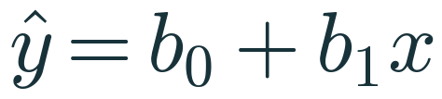
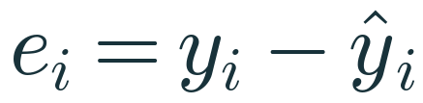
Objective (sum of squared errors):
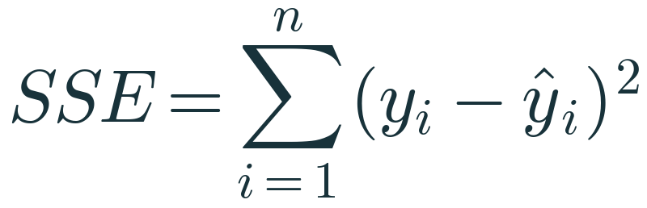
Hour 1 states the solution; Hour 2 derives it. The solution is:
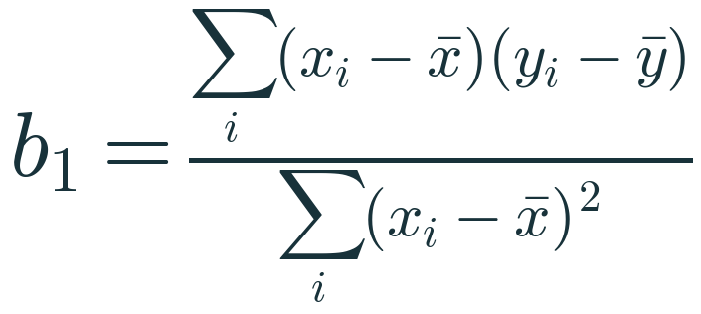
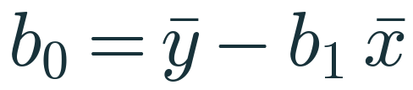
Why squaring is reasonable: a sum of residuals can be zero for a terrible line (e.g., residuals +5 and −5). Absolute values avoid cancellation but |e| has no derivative at e = 0, making a closed-form solution impossible; squares give a smooth quadratic in b₀ and b₁ whose minimum can be found by setting derivatives to zero. The price is sensitivity to outliers: an error of 10 contributes 100 to SSE.

E. Worked examples
Worked example 1 — regression_manual_example.csv: (x, y) = (2, 12), (4, 18), (6, 20), (8, 26), (10, 29).
xᵢ | yᵢ | xᵢ − x̄ | yᵢ − ȳ | (xᵢ − x̄)(yᵢ − ȳ) | (xᵢ − x̄)² | ŷᵢ | eᵢ | eᵢ²
2 | 12 | −4 | −9 | 36 | 16 | 12.6 | −0.6 | 0.36
4 | 18 | −2 | −3 | 6 | 4 | 16.8 | +1.2 | 1.44
6 | 20 | 0 | −1 | 0 | 0 | 21.0 | −1.0 | 1.00
8 | 26 | 2 | 5 | 10 | 4 | 25.2 | +0.8 | 0.64
10 | 29 | 4 | 8 | 32 | 16 | 29.4 | −0.4 | 0.16
x̄ = 6 | ȳ = 21 | 0 | 0 | 84 | 40 |  | 0 | 3.6

- x̄ = 30/5 = 6; ȳ = 105/5 = 21.
- b₁ = 84 / 40 = 2.1 minutes per km.
- b₀ = 21 − 2.1 × 6 = 21 − 12.6 = 8.4 minutes.
- Line: ŷ = 8.4 + 2.1x. Prediction at 7 km: 8.4 + 14.7 = 23.1 minutes.
- Residuals sum to 0; SSE = 3.6.
Candidate lines (slide 12) — verify one on the board. Line A: ŷ = 10 + 1.5x predicts 13, 16, 19, 22, 25; residuals −1, 2, 1, 4, 4; SSE = 1 + 4 + 1 + 16 + 16 = 38. Line B: ŷ = 4 + 3x predicts 10, 16, 22, 28, 34; residuals 2, 2, −2, −2, −5; SSE = 41. Least-squares line C: SSE = 3.6. If a student proposes ŷ = 8 + 2.2x: predictions 12.4, 16.8, 21.2, 25.6, 30.0; residuals −0.4, 1.2, −1.2, 0.4, −1.0; SSE = 0.16 + 1.44 + 1.44 + 0.16 + 1.0 = 4.2 > 3.6.
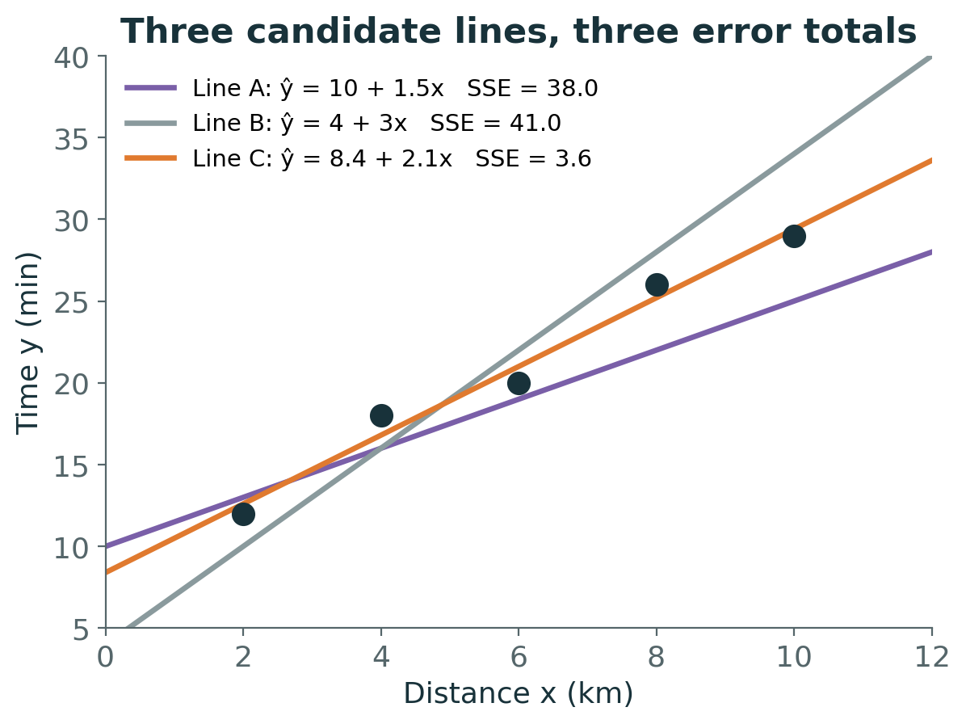

F. Trainer questions
- If a new order is 7 km away, how long should we promise?
- Interpret b₁ = 2.1 in one sentence with units.
- Is b₀ = 8.4 the time to deliver a 0 km order?
- Why measure residuals vertically?
- Knowledge check: Σ(x−x̄)(y−ȳ) = −30, Σ(x−x̄)² = 15, x̄ = 4, ȳ = 50. Find b₁, b₀ and ŷ at x = 6.

G. Expected answers
- About 23 minutes (exact: 23.1 from the fitted line).
- Each additional kilometre adds about 2.1 minutes to the predicted delivery time.
- Not literally — x = 0 is outside the data range. It anchors the line; it may be read loosely as fixed overhead (pickup, handover).
- We predict y from a known x; the error is in the y-direction.
- b₁ = −2, b₀ = 50 − (−2)(4) = 58, ŷ(6) = 58 − 12 = 46. Negative slope: y falls 2 units per unit x.

H. Common mistakes
- Using Σxᵢyᵢ instead of the centred cross-products in the numerator.
- Computing b₀ before b₁, or sign errors in ȳ − b₁x̄ when b₁ < 0.
- Dropping units, which makes interpretation impossible.
- Believing the best line must pass through some data points.
- Reading residual sign backwards (it is actual − predicted).

I. Python explanation
import numpy as np
from sklearn.linear_model import LinearRegression

x = np.array([[2], [4], [6], [8], [10]]) # shape (5, 1): 5 samples, 1 feature
y = np.array([12, 18, 20, 26, 29]) # shape (5,)
model = LinearRegression() # fit_intercept=True by default
model.fit(x, y) # computes OLS b0, b1
print(model.coef_, model.intercept_) # [2.1] 8.4
print(model.predict([[7]])) # [23.1]

- LinearRegression() creates an estimator; fit_intercept=True means b₀ is estimated (not penalised, not forced to 0).
- fit(X, y) expects X with shape (n_samples, n_features). Passing a 1-D array raises 'Expected 2D array'.
- coef_ returns an array with one slope per feature; intercept_ is a scalar.
- predict(X_new) returns b₀ + X_new·coef_. Its input must also be 2-D.
- Internally, fit solves the least-squares problem with a linear-algebra routine (SciPy's lstsq). It does not use gradient descent.

J. Timing
Segment | Minutes
Problem, prediction, definitions (slides 6–9) | 13
Line, residuals, candidates, squaring (10–13) | 17
Worked example 1 (14–16) | 14
Code + knowledge check (17–18) | 7
Divider/transitions | 1

Topic 2 · Ordinary Least Squares (Hour 2, first half)

A. Teaching objective
Students can explain OLS as minimising SSE over (b₀, b₁), derive b₀ = ȳ − b₁x̄ and the slope formula by setting partial derivatives to zero, state when the slope is undefined, and read the matrix form ŷ = Xβ and the normal equations with correct dimensions.

B. Prerequisite knowledge
- Derivative as slope of a tangent; derivative of u² is 2u·u′ (chain rule).
- Summation manipulation: Σ(a + b) = Σa + Σb; Σc·aᵢ = cΣaᵢ.
- Matrices: transpose, product, dimensions (introductory).

C. Explanation script
"In Hour 1 I gave you two formulas. Now we earn them." Shift the viewpoint: once data are collected, xᵢ and yᵢ are numbers. The unknowns are b₀ and b₁. SSE is a function of these two unknowns — a bowl. Show slide 21: fix b₀ at ȳ − b₁x̄ and vary b₁; SSE traces a U. Tangent slopes go from negative to zero to positive. "At the bottom, the slope is zero. So we find the bottom by setting the derivative to zero."
Explain partial derivatives as "differentiate with respect to one unknown, treat the other as a constant". Derive step A slowly, then step B. In step B the key move is replacing xᵢ by (xᵢ − x̄); show numerically that Σxᵢ(yᵢ − ȳ) = 2(−9)+4(−3)+6(−1)+8(5)+10(8) = −18−12−6+40+80 = 84, the same as Σ(xᵢ − x̄)(yᵢ − ȳ) = 84, because x̄·Σ(yᵢ − ȳ) = 0.
Finally present the matrix form only as "the same thing written compactly for many features".

D. Mathematical derivation
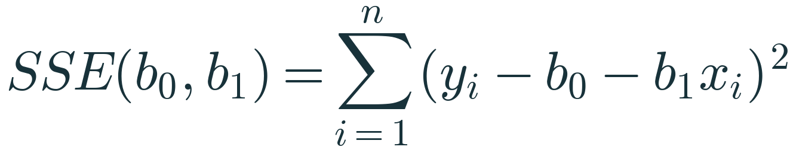
Step A — intercept. Differentiate with respect to b₀ (b₁ constant). For one term, d/db₀ (yᵢ − b₀ − b₁xᵢ)² = 2(yᵢ − b₀ − b₁xᵢ)·(−1). Summing and setting to zero:
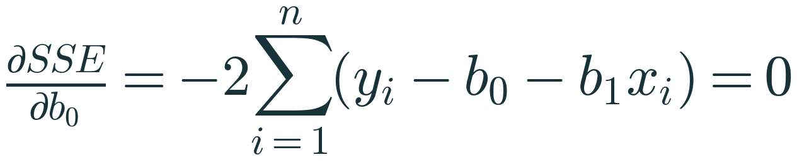
Divide by −2: Σyᵢ − n·b₀ − b₁Σxᵢ = 0. Divide by n:
Consequences: the line passes through (x̄, ȳ), and since the bracket is the residual, Σeᵢ = 0.
Step B — slope. Differentiate with respect to b₁: d/db₁ (yᵢ − b₀ − b₁xᵢ)² = 2(yᵢ − b₀ − b₁xᵢ)·(−xᵢ). Set the sum to zero:
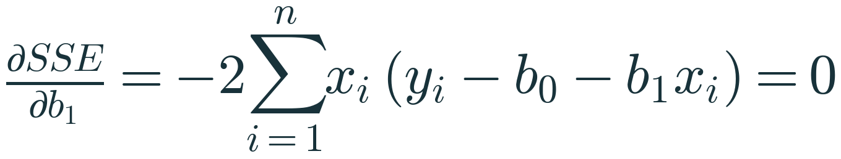
- Substitute b₀ = ȳ − b₁x̄: yᵢ − b₀ − b₁xᵢ = (yᵢ − ȳ) − b₁(xᵢ − x̄).
- So Σxᵢ(yᵢ − ȳ) − b₁Σxᵢ(xᵢ − x̄) = 0.
- Because Σ(yᵢ − ȳ) = 0 and Σ(xᵢ − x̄) = 0, subtracting x̄ times each sum changes nothing: Σ(xᵢ − x̄)(yᵢ − ȳ) − b₁Σ(xᵢ − x̄)² = 0.
- Hence b₁ = Σ(xᵢ − x̄)(yᵢ − ȳ) / Σ(xᵢ − x̄)², provided Σ(xᵢ − x̄)² > 0 (the x values are not all equal).
Is it a minimum? SSE is a sum of squares of linear functions of (b₀, b₁), hence convex. Its second-derivative (Hessian) matrix is 2[[n, Σxᵢ],[Σxᵢ, Σxᵢ²]], whose determinant 4[nΣxᵢ² − (Σxᵢ)²] = 4nΣ(xᵢ − x̄)² is positive when the x values vary. So the stationary point is the unique global minimum.
Matrix form. Stack observations: X is n × (p + 1) with a first column of ones; β is (p + 1) × 1; y is n × 1.
SSE = (y − Xβ)ᵀ(y − Xβ). Its gradient is −2Xᵀ(y − Xβ). Setting it to zero gives the normal equations XᵀXβ = Xᵀy and, if XᵀX is invertible,
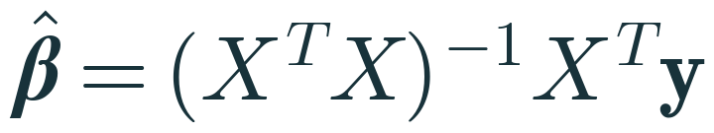
XᵀX is invertible exactly when X has full column rank: no column is an exact linear combination of others, which also requires n ≥ p + 1. In practice, software avoids forming the inverse: QR or SVD decompositions are more numerically stable and handle rank deficiency (SVD returns the minimum-norm solution).

E. Worked examples
Normal equations for worked example 1. X has rows [1, 2], [1, 4], [1, 6], [1, 8], [1, 10].
- XᵀX = [[5, 30], [30, 220]] (n = 5, Σx = 30, Σx² = 4 + 16 + 36 + 64 + 100 = 220)
- Xᵀy = [105, 714] (Σy = 105, Σxy = 24 + 72 + 120 + 208 + 290 = 714)
- Solve: 5b₀ + 30b₁ = 105 and 30b₀ + 220b₁ = 714. From the first, b₀ = 21 − 6b₁. Substitute: 630 − 180b₁ + 220b₁ = 714 ⇒ 40b₁ = 84 ⇒ b₁ = 2.1, b₀ = 8.4 ✓.

F. Trainer questions
- Which quantities are variables when we minimise SSE?
- What does b₀ = ȳ − b₁x̄ say geometrically?
- If every x were 5 km, what happens?
- Dimensions of XᵀX with 6 features plus intercept?
- Why do libraries not compute (XᵀX)⁻¹ directly?

G. Expected answers
- b₀ and b₁ only; the data are constants.
- The OLS line always passes through the point of means (x̄, ȳ) = (6, 21).
- Σ(xᵢ − x̄)² = 0; the slope is undefined — there is no variation in x to learn from.
- 7 × 7.
- Forming XᵀX squares the condition number, amplifying rounding error; QR/SVD are more stable and handle rank deficiency.

H. Common mistakes
- Differentiating with respect to x instead of the parameters.
- Losing the minus sign from the inner derivative (−1 or −xᵢ).
- Forgetting that Σ(yᵢ − ȳ) = 0 justifies step B's substitution.
- Claiming XᵀX is always invertible.

I. Python explanation
X_design = np.column_stack([np.ones_like(x), x]) # n x 2 design matrix
beta, *_ = np.linalg.lstsq(X_design, y, rcond=None) # stable least-squares solve
# beta -> [8.4, 2.1]

- np.column_stack builds the design matrix with the column of ones that represents the intercept.
- np.linalg.lstsq solves min‖y − Xβ‖² using SVD; rcond=None uses the machine-precision default cut-off for tiny singular values.
- Avoid np.linalg.inv(X.T @ X) @ X.T @ y in real code: it is less stable.

J. Timing
Segment | Minutes
Objective + derivative intuition | 9
Step A | 6
Step B | 8
Matrix form | 5

Topic 3 · Gradient Descent (Hour 2, second half)

A. Teaching objective
Students can define a cost function, derive its gradients, apply the update rule by hand for two iterations, explain the role and failure modes of the learning rate, and implement batch gradient descent in NumPy — knowing that LinearRegression does not use it.

B. Prerequisite knowledge
- Topic 2 (derivatives, SSE as a function of parameters).
- Python loops and NumPy vector operations.

C. Explanation script
"If OLS has a formula, why another method?" Many models (Lasso, logistic regression, neural networks) have no closed form; with huge data, iterative updates can be cheaper; and the same update rule trains deep networks. We learn it on linear regression because we can check its answer exactly.
Rename parameters: w (weight) = b₁ and b (bias) = b₀. Introduce J = SSE/(2n). "1/n makes it an average; 1/2 cancels the 2 from differentiating. Neither moves the minimum." Derive the gradients with the chain rule. Then the foggy-hill picture: feel the slope, step downhill, repeat; α is stride length.
Run iteration 0 on the board with students computing. Then let pairs compute iteration 1 before revealing. Show the contour map: each step is perpendicular to the contour line through its starting point; the path curves because the valley is elongated. Show α = 0.01, 0.1, 0.37. Finish with code mapped line by line to the equations.

D. Mathematical derivation
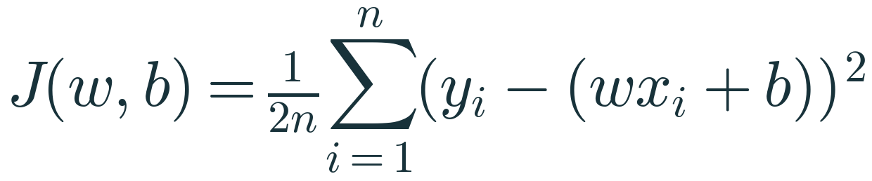
For one observation, with u = yᵢ − wxᵢ − b: d/dw (½u²) = u·du/dw = u·(−xᵢ) and d/db (½u²) = u·(−1).
Averaging over n observations:
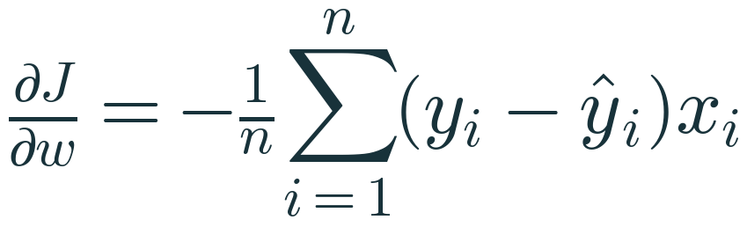
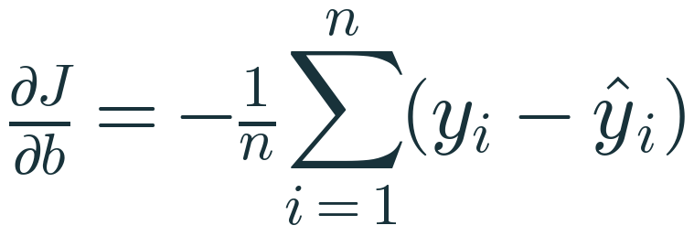
Update rule (simultaneous):


Learning-rate stability (trainer depth). J is quadratic with Hessian H = (1/n)[[Σxᵢ², Σxᵢ],[Σxᵢ, n]]. For x = [1, 2, 3], H = [[14/3, 2],[2, 1]], eigenvalues ≈ 5.546 and 0.120. Batch GD on a quadratic converges iff 0 < α < 2/λmax ≈ 0.361. That is why α = 0.3 converges (with oscillation) and α = 0.37 diverges. The small eigenvalue explains the slow final approach along the valley floor. Feature scaling makes eigenvalues more similar, allowing larger α and faster convergence.

E. Worked examples
Worked example 2 — x = [1, 2, 3], y = [2, 4, 5], w = b = 0, α = 0.1. Exact OLS: w = 1.5, b = 0.6667, minimum J = 0.0278.
It. | w | b | ŷ | residuals | J | ∂J/∂w | ∂J/∂b
0 | 0 | 0 | 0, 0, 0 | 2, 4, 5 | 45/6 = 7.5000 | −25/3 = −8.3333 | −11/3 = −3.6667
1 | 0.8333 | 0.3667 | 1.2, 2.0333, 2.8667 | 0.8, 1.9667, 2.1333 | 1.5098 | −3.7111 | −1.6333
2 | 1.2044 | 0.5300 | 1.7344, 2.9389, 4.1433 | 0.2656, 1.0611, 0.8567 | 0.3217 | −1.6526 | −0.7278
3 | 1.3697 | 0.6028 |  |  | 0.0861 | −0.7358 | −0.3245

Iteration 1 detail: ŷ = 0.8333x + 0.3667 gives 1.2, 2.0333, 2.8667. Squared residuals 0.64, 3.8678, 4.5511 sum to 9.0589; J = 9.0589/6 = 1.5098. ∂J/∂w = −(0.8·1 + 1.9667·2 + 2.1333·3)/3 = −(0.8 + 3.9333 + 6.4)/3 = −3.7111. ∂J/∂b = −(0.8 + 1.9667 + 2.1333)/3 = −1.6333. Updates: w = 0.8333 + 0.3711 = 1.2044; b = 0.3667 + 0.1633 = 0.5300.
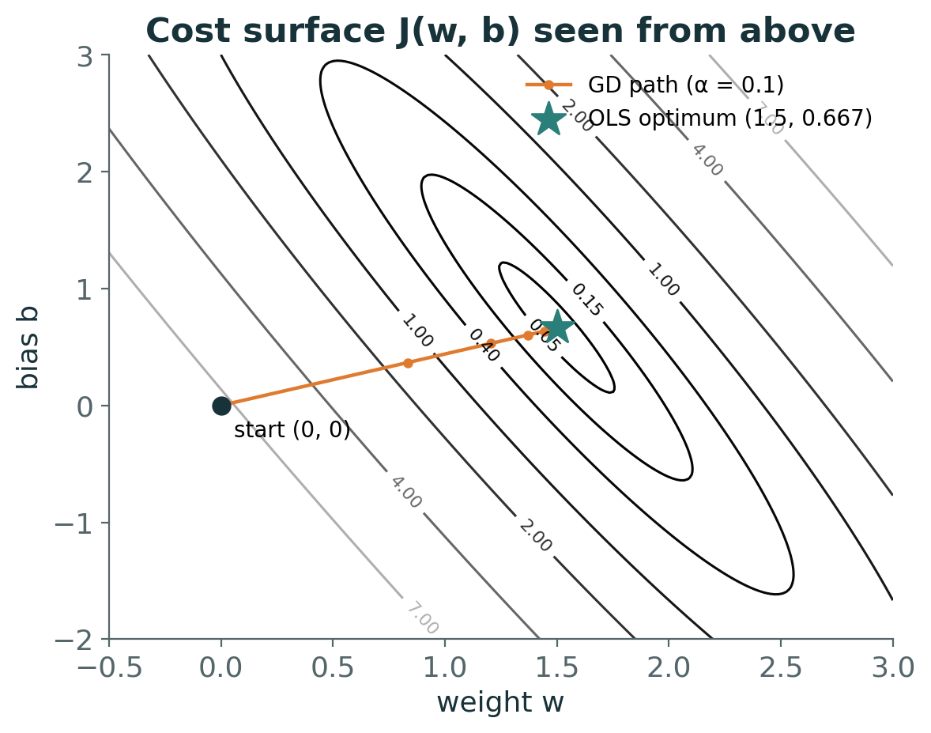

F. Trainer questions
- At iteration 0 both gradients are negative. Why do w and b increase?
- Why does the cost never reach 0 here?
- Your cost increases every iteration. First two things to check?
- Does LinearRegression use gradient descent?
- Knowledge check: w = 1, b = 0, α = 0.05, ∂J/∂w = −4, ∂J/∂b = 2.

G. Expected answers
- w − α·(negative) = w + something: a negative gradient means the cost falls as the parameter rises.
- The three points are not collinear; the best line still has J = 0.0278.
- The sign in the update rule; then reduce α.
- No. It solves least squares directly. SGDRegressor is scikit-learn's gradient-based linear regressor.
- w = 1.2, b = −0.1. With α = 2.5 (50×) the step Δw = +10 would overshoot and likely diverge.

H. Common mistakes
- w + alpha * grad (wrong sign).
- Updating w, then computing b's gradient with the new w (non-simultaneous update).
- Forgetting to divide by n, which effectively multiplies α by n.
- Assuming a larger α is always faster.
- Running GD on unscaled features with very different ranges and blaming the algorithm.

I. Python explanation
def compute_gradients(w, b, x, y):
n = len(x)
residuals = y - (w * x + b) # vector of y_i - y_hat_i
dJ_dw = -np.sum(residuals * x) / n # -(1/n) * sum(residual * x)
dJ_db = -np.sum(residuals) / n # -(1/n) * sum(residual)
return dJ_dw, dJ_db

- Vectorised NumPy: residuals * x multiplies element-wise; np.sum adds them.
- The gradient_descent function in the notebook records w, b, cost and both gradients each iteration in a DataFrame, so the table on slide 30 can be reproduced exactly.
- After 200 iterations: w = 1.5002, b = 0.6662 vs OLS 1.5, 0.6667 — compare within a tolerance, not with ==.

J. Timing
Segment | Minutes
Why GD, cost function | 6
Gradients and update rule | 7
Worked example (2 iterations) | 10
Contour, learning rate, code | 6
Knowledge check | 2 (+3 after break if needed)

Topic 4 · Regression evaluation metrics (Hour 3, first half)

A. Teaching objective
Students can compute MAE, MSE, RMSE, R² and adjusted R² by hand, state their units, explain why squared metrics punish large errors, relate R² to SSE and SST, and evaluate properly on held-out data.

B. Prerequisite knowledge
- Residuals and SSE (Topic 1).
- Train/test split (preprocessing module).

C. Explanation script
Start from the residuals students already have: −0.6, 1.2, −1.0, 0.8, −0.4. "We need to summarise five errors in one number. Two natural ways: average size, or average squared size." Compute MAE and MSE. Point out MSE's unit (minutes²) and fix it with RMSE.
Run the outlier experiment before showing results: ask which metric will move most. Then R²: "Is 0.72 min² good? Compared with what?" Introduce the laziest model, predicting ȳ for everyone; its error is SST. R² measures improvement over that baseline.
State clearly, twice: the five-point calculations are arithmetic practice on training data. Real evaluation uses held-out data, and every compared model uses the same split.

D. Mathematical derivation
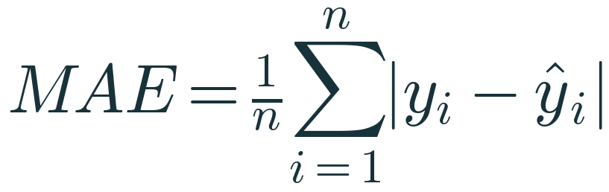
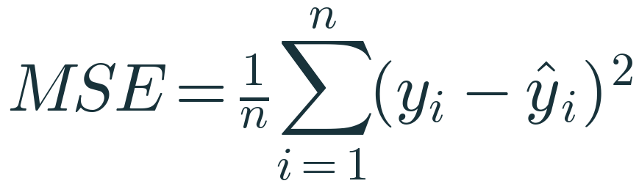

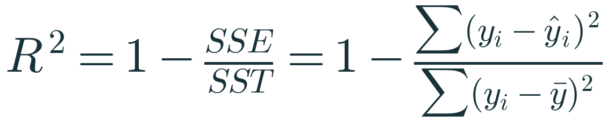
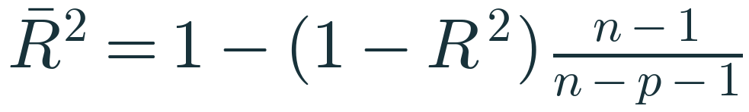
- MSE = SSE/n, so the OLS line also minimises training MSE among straight lines.
- Decomposition: for OLS with an intercept on training data, SST = SSR + SSE, where SSR = Σ(ŷᵢ − ȳ)². Hence R² = SSR/SST ∈ [0, 1] on training data. (The cross term 2Σ(ŷᵢ − ȳ)eᵢ vanishes because Σeᵢ = 0 and Σxᵢeᵢ = 0.)
- On held-out data the decomposition does not hold; R² = 1 − SSE/SST can be negative when the model's squared error exceeds that of predicting the evaluated targets' mean. (scikit-learn's r2_score uses the mean of the y_true it is given.)
- RMSE ≥ MAE always (quadratic mean ≥ arithmetic mean of |eᵢ|); equality only when all |eᵢ| are equal.
- Adjusted R² requires n − p − 1 > 0. Training R² never decreases when a feature is added, because least squares can set the new coefficient to zero; adjusted R² penalises the extra degree of freedom.

E. Worked examples
Metric | Calculation | Result | Units
MAE | (0.6 + 1.2 + 1.0 + 0.8 + 0.4)/5 | 0.80 | min
MSE | (0.36 + 1.44 + 1.00 + 0.64 + 0.16)/5 = 3.6/5 | 0.72 | min²
RMSE | √0.72 | 0.849 | min
SST | 81 + 9 + 1 + 25 + 64 | 180 | min²
R² | 1 − 3.6/180 | 0.98 | —
Adjusted R² | 1 − (0.02)(5 − 1)/(5 − 1 − 1) | 0.9733 | —

Outlier experiment. Actual [10, 12, 15, 20, 25]; Model P predicts [11, 11, 16, 19, 26] (all |errors| = 1); Model Q equals P except the last prediction is 35 (error 10).
 | MAE | MSE | RMSE | R²
P | 1.0 | 1.0 | 1.0 | 0.966
Q | 2.8 | 20.8 | 4.561 | 0.303

SST for these actuals = (−6.4)² + (−4.4)² + (−1.4)² + 3.6² + 8.6² = 40.96 + 19.36 + 1.96 + 12.96 + 73.96 = 149.2 (mean 16.4). P: R² = 1 − 5/149.2 = 0.966. Q: 1 − 104/149.2 = 0.303.
Held-out results (notebook A6–A7, same split). Area-only model: MAE 13.39, RMSE 16.08 ₹ lakh, R² 0.739. Six-feature model: MAE 4.38, RMSE 5.75, R² 0.967, adjusted R² 0.963 (n = 60, p = 6).

F. Trainer questions
- Which metric would you show a delivery manager?
- Model B: MAE 3.5, RMSE 9; Model A: MAE 4, RMSE 5. Interpret.
- What does test R² = −0.3 mean?
- Why can't training R² go down when we add a feature?

G. Expected answers
- MAE or RMSE in minutes; MAE is easiest to explain ('typical miss'), RMSE if big misses matter most.
- B is usually close but has a few very large errors. A bank penalised by large misses should prefer A.
- The model's squared error is 30% larger than predicting the test mean for every case.
- Least squares could always set the new coefficient to zero and recover the old fit.

H. Common mistakes
- Reporting training metrics as model performance.
- r2_score(y_pred, y_true) — argument order matters for R².
- Saying 'RMSE is the average error'.
- Comparing models on different splits.
- Using adjusted R² as if it were a test-set estimate.

I. Python explanation
from sklearn.metrics import mean_absolute_error, mean_squared_error, r2_score
mae = mean_absolute_error(y_test, y_pred)
mse = mean_squared_error(y_test, y_pred)
rmse = np.sqrt(mse) # portable across sklearn versions
r2 = r2_score(y_test, y_pred)

- All functions take (y_true, y_pred) arrays of equal length and return a float.
- np.sqrt(mean_squared_error(...)) is used rather than version-specific RMSE helpers so the code runs on any recent scikit-learn.
- In cross_val_score, scorers are 'greater is better', so error metrics appear negated: scoring='neg_root_mean_squared_error'.

J. Timing
Segment | Minutes
MAE/MSE by hand | 6
RMSE + outlier experiment | 6
R² | 6
Adjusted R² | 3
Code + reasoning question | 7

Topic 5 · Multiple Linear Regression (Hour 3, second half)

A. Teaching objective
Students can write and use the multiple-regression equation, interpret a coefficient 'holding other features fixed' with units, explain why raw coefficient sizes are not comparable, recognise multicollinearity, and distinguish association from causation.

B. Prerequisite knowledge
- Topics 1–4; correlation coefficient; DataFrame column selection.

C. Explanation script
Show the two scatterplots: area helps, but at the same area, distance still matters. "How would you combine them?" Write ŷ = b₀ + b₁x₁ + … + bₚxₚ. With two features, draw a plane over the (area, distance) floor. The new phrase is 'holding the other features fixed' — practise it aloud with the distance coefficient.
Do the manual house prediction with the illustrative coefficients. Then the three cautions: units, multicollinearity, causation. Close with the live results: RMSE drops from 16.1 to 5.8 ₹ lakh on the same 60 test houses.

D. Mathematical derivation
Matrix form ŷ = Xβ with X: n × (p + 1). OLS minimises ‖y − Xβ‖², giving the normal equations XᵀXβ = Xᵀy (Topic 2). Interpretation: ∂ŷ/∂xⱼ = bⱼ — the model's change in prediction for a one-unit change in xⱼ with all other inputs unchanged.
Why multicollinearity inflates coefficient variance (intuition). Under standard assumptions Var(β̂) = σ²(XᵀX)⁻¹. When two columns are highly correlated, XᵀX is nearly singular and its inverse has large entries, so the coefficient estimates vary a lot between samples. For one feature the inflation factor is VIFⱼ = 1/(1 − Rⱼ²), where Rⱼ² comes from regressing xⱼ on the other features. With area–bedrooms correlation 0.82 in a two-feature view, 1/(1 − 0.82²) ≈ 3.1.

E. Worked examples
Term | Coefficient | Value | Contribution
b₀ | 20 | — | 20.0
area | 0.045 per sq ft | 1,200 | 54.0
bedrooms | 3 per bedroom | 2 | 6.0
age | −0.6 per year | 10 | −6.0
distance | −1.8 per km | 8 | −14.4
ŷ |  |  | 59.6 ₹ lakh

Fitted model (notebook A7). Coefficients: area 0.0497 ₹ lakh/sq ft, bedrooms 1.927, age −0.383, distance −1.461, floor 0.228, parking 4.072; intercept 17.13. A 1,200 sq ft, 2-bed, 10-year-old house 8 km out on floor 5 with parking: 70.29 ₹ lakh by hand and by model. The data generator used 0.05, 2.5, −0.4, −1.5, 0.3, 4 (σ = 6) — a synthetic-data sanity check; bedrooms is the least precisely recovered, consistent with its correlation with area.

F. Trainer questions
- Interpret the distance coefficient.
- Is area 'less important' than bedrooms because 0.05 < 1.93?
- Area–bedrooms correlation is 0.82. What problem can this cause?
- Does the parking coefficient prove that adding parking raises value by ₹4 lakh?

G. Expected answers
- Holding the other five features fixed, each extra km from the centre is associated with about ₹1.46 lakh lower predicted price.
- No — different units. Compare after standardising (Topic 9 shows area dominates).
- Unstable, hard-to-interpret individual coefficients (multicollinearity); predictions can still be good.
- No. It is an association in this data; causal claims need design (experiments, careful causal analysis).

H. Common mistakes
- Interpreting a coefficient without 'holding others fixed'.
- Ranking features by raw coefficient size.
- Including target-derived features (price per sq ft) — leakage.
- Believing multicollinearity ruins predictions.

I. Python explanation
mlr = LinearRegression().fit(X_train, y_train) # all six features
coef_table = pd.DataFrame({'feature': FEATURES, 'coefficient': mlr.coef_})
by_hand = mlr.intercept_ + np.sum(mlr.coef_ * new_house.iloc[0].to_numpy())
house[FEATURES].corr() # check correlated predictors

- coef_ is ordered like the columns of X_train — always pair it with feature names.
- The manual prediction reproduces predict exactly: ŷ is just a weighted sum.
- DataFrame.corr() gives pairwise Pearson correlations; it does not detect multicollinearity involving three or more features (VIF does).

J. Timing
Segment | Minutes
Problem + equation | 8
Manual prediction | 6
Interpretation cautions | 8
Live results | 9

Topic 6 · Polynomial Regression (Hour 4)

A. Teaching objective
Students can construct polynomial features by hand, explain why polynomial regression is still linear in its coefficients, connect degree to flexibility, and choose a degree using validation error rather than training error.

B. Prerequisite knowledge
- Topics 1–5; Pipelines and StandardScaler (preprocessing module).

C. Explanation script
Show speed vs fuel efficiency: rises, peaks, falls. "A straight line cannot bend. Can we keep everything we know and still fit a curve?" Yes: invent a new column x². The model b₀ + b₁x + b₂x² is curved in x but each coefficient appears linearly, so OLS applies unchanged. Build the feature table by hand, then show PolynomialFeatures reproduces it.
Show four fits on only 25 training trips. Ask which has the lowest training error before revealing. Then the training-vs-validation curve on 105 trips with 5-fold CV: choose degree 2 and test once.

D. Mathematical derivation
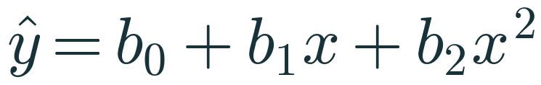
Define z₁ = x, z₂ = x², …, z_d = xᵈ. Then ŷ = b₀ + Σbⱼzⱼ is a multiple linear regression in the zⱼ, solved by the normal equations. 'Linear model' means linear in parameters, not in inputs.
Why scale after expansion: for speeds 20–110, x¹⁵ ranges over ~10¹⁹–10³⁰ and the power columns are nearly collinear, making XᵀX extremely ill-conditioned. Standardising the generated columns (inside the pipeline) keeps the solver accurate. With several input features, degree-d expansion also creates interactions; the number of columns is C(p + d, d) − 1 (6 features, degree 2 → 27).

E. Worked examples
x | x | x² | x³
1 | 1 | 1 | 1
2 | 2 | 4 | 8
3 | 3 | 9 | 27
4 | 4 | 16 | 64

Results (notebook A8–A9, 105 train / 45 test trips).
Degree | Train MSE | Test MSE
1 | 4.112 | 6.360
2 | 0.761 | 0.947
3 | 0.761 | 0.949
15 | 0.686 | 1.153

5-fold CV MSE on the training set: degree 1 = 4.19, degree 2 = 0.795 (minimum), then slowly rising to ≈ 0.93 at degree 15. On the 25-trip demo: degree 15 has training MSE 0.30 but unseen MSE ≈ 3,770.
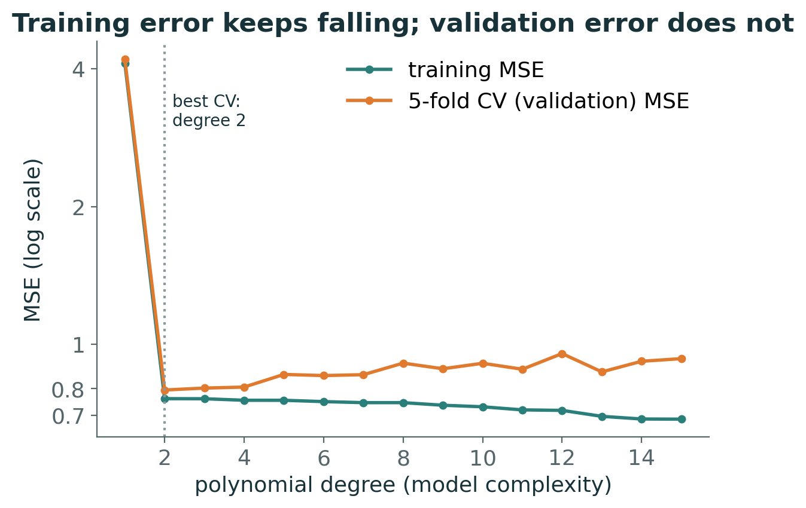

F. Trainer questions
- Is ŷ = b₀ + b₁x + b₂x² a linear model?
- Why can training MSE only fall as degree rises?
- Which degree would you choose, and how?
- Degree 10 has lower training error but higher test error than degree 2. Explain.

G. Expected answers
- Yes — linear in b₀, b₁, b₂.
- A degree-(d + 1) model contains the degree-d model (set the extra coefficient to 0).
- Degree 2: lowest 5-fold CV MSE on training data; then report test MSE once (0.947).
- Extra flexibility fits sample noise that does not recur; higher variance.

H. Common mistakes
- Scaling before splitting, or fitting PolynomialFeatures/StandardScaler on all data (leakage) — keep them in a Pipeline.
- Choosing degree by test score.
- Forgetting include_bias=False duplicates the intercept (harmless for OLS but confusing in coefficient tables).
- Extrapolating a high-degree polynomial beyond the data range.

I. Python explanation
def poly_model(degree):
return make_pipeline(PolynomialFeatures(degree, include_bias=False),
StandardScaler(),
LinearRegression())
cv = KFold(n_splits=5, shuffle=True, random_state=42)
cv_mse = -cross_val_score(poly_model(d), Xp_train, yp_train, cv=cv,
scoring='neg_mean_squared_error').mean()

- make_pipeline chains steps; fit fits each transformer on the training fold only, then the regressor.
- KFold(shuffle=True, random_state=42) makes folds random but reproducible; the same object is reused so every degree sees identical folds.
- cross_val_score returns one score per fold; negate the mean for MSE.

J. Timing
Segment | Minutes
Problem + features | 7
Degree plots | 4
Train/validation curve | 4
Reasoning question | 3

Topic 7 · Bias–Variance Trade-off (Hour 4)

A. Teaching objective
Students can define bias, variance and irreducible error, link underfitting to bias and overfitting to variance, read a complexity curve, and explain why these quantities are defined over repeated sampling rather than computed from one split.

B. Prerequisite knowledge
- Expectation as a long-run average; Topic 6.

C. Explanation script
Thought experiment: "Imagine collecting a fresh training set a hundred times and training the same kind of model each time. Each trained model is one dart." Bias: does the cloud centre on the target? Variance: how spread is the cloud? Place degree 1 (tight cloud, off-centre) and degree 15 (wide cloud) on the four targets.
Write the decomposition; emphasise σ² cannot be removed by any model, and that the curves on slide 54 are schematic. In the lab (A9) students make variance visible by refitting on 30 resamples and recording predictions at 100 km/h.

D. Mathematical derivation
Setting: y = f(x) + ε, E[ε] = 0, Var(ε) = σ², ε independent of the training set D that produced f̂. Fix x and write f̄ = E_D[f̂(x)].
- y − f̂ = (f − f̄) + (f̄ − f̂) + ε.
- Square and take expectation over D and ε. Cross terms vanish: E[ε] = 0 and ε is independent of f̂; E_D[f̄ − f̂] = 0 by definition of f̄.
- Remaining terms: (f − f̄)² = Bias², E_D[(f̂ − f̄)²] = Variance, E[ε²] = σ².
Hence expected squared error at x = Bias² + Variance + σ². These are expectations over hypothetical datasets — a single train/test split gives one realised error, not its decomposition. Synthetic data let us approximate them by resampling because we know f.

E. Worked examples
Resampling demo (notebook A9). 30 random samples of 25 trips; prediction at 100 km/h. True noise-free value: f(100) = 4 + 0.42·100 − 0.0035·100² = 11.0 km/l.
Model | Mean prediction | Std of predictions | Reading
Degree 1 | 13.49 | 0.93 | bias ≈ +2.5, low variance
Degree 2 | 10.95 | 0.36 | bias ≈ 0, low variance
Degree 9 | 8.67 | 13.37 | high variance

F. Trainer questions
- Overfitting is high ___; underfitting is high ___.
- Can more data reduce σ²?
- Why can't we compute bias and variance from one test score?
- What tools reduce variance?

G. Expected answers
- variance; bias.
- No. More data mainly reduces variance.
- They are defined over repeated training samples; one split yields a single error value.
- More data, simpler models, regularisation, averaging (ensembles).

H. Common mistakes
- Calling overfitting 'high bias'.
- Presenting the illustrative curves as measured data.
- Claiming the optimal model has zero bias.

I. Python explanation
for d in [1, 2, 9]:
preds = [poly_model(d).fit(s[['speed_kmph']], s['fuel_efficiency_kmpl'])
.predict(query)[0]
for s in (poly_df.sample(25, random_state=100 + r) for r in range(30))]
print(d, np.mean(preds), np.std(preds))

- poly_df.sample(25, random_state=…) draws a different, reproducible subsample each repetition.
- Mean prediction vs the known truth illustrates bias; the standard deviation illustrates variance.

J. Timing
Segment | Minutes
Targets thought experiment | 4
Decomposition | 5

Topic 8 · Ridge Regression — introduction (Hour 4)

A. Teaching objective
Students can write the Ridge objective, explain each term, describe the effect of α, explain why the intercept is not penalised and why features must be scaled, and work a numerical comparison of candidate coefficient vectors.

B. Prerequisite knowledge
- SSE objective; bias–variance; StandardScaler in a Pipeline.

C. Explanation script
Recall the degree-15 curve: wild bends need huge, opposite-signed coefficients. "What if large coefficients cost something?" Add α·Σβⱼ². α = 0 is OLS; α → ∞ forces slopes to 0 and predicts the mean. Do worked example 4 with the class; find the α at which A and B tie (≈ 0.18).
Say clearly: this is an introduction. The closed form and full derivation come next session.

D. Mathematical derivation
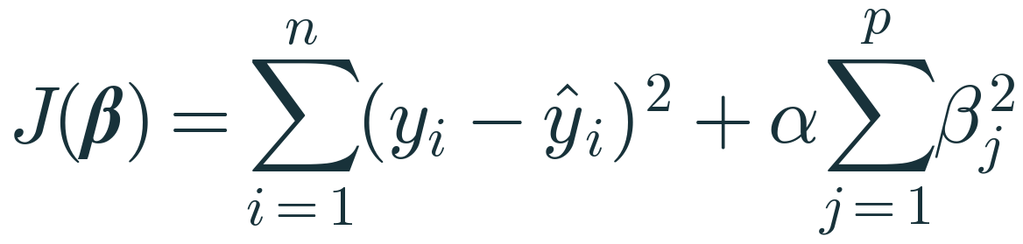
- Classroom convention: penalty over j = 1…p, intercept excluded. scikit-learn's Ridge minimises ‖y − Xβ‖² + α‖β‖² with the intercept unpenalised — the same scaling as our classroom form.
- Why not penalise the intercept: shifting all y by a constant should shift predictions by that constant; penalising b₀ would make the fit depend on the arbitrary origin of y.
- Why scale: the penalty acts on coefficient magnitudes, which depend on units (₹ lakh per sq ft vs per bedroom). Standardise inside a Pipeline so α treats features comparably and no test statistics leak.
- Preview (next session): with centred data, β̂_ridge = (XᵀX + αI)⁻¹Xᵀy; αI makes the matrix invertible even under perfect multicollinearity.

E. Worked examples
Candidate | β | SSE | Σβ² | J (α = 0) | J (α = 1)
A | (4, −3) | 10 | 25 | 10 | 35
B | (1.5, 1) | 14 | 3.25 | 14 | 17.25
C | (2, 0) | 15 | 4 | 15 | 19

Tie between A and B: 10 + 25α = 14 + 3.25α ⇒ α = 4/21.75 ≈ 0.184.
Notebook A10 (standardised house data, train split). Linear: area 28.14, bedrooms 2.01, age −4.04, distance −12.42, floor 1.39, parking 2.04. Ridge α = 10: area 25.23, bedrooms 4.10, … — Ridge shifts weight between the correlated area/bedrooms pair. CV RMSE by α: 0.1 → 6.355, 1 → 6.357, 10 → 6.681, 100 → 11.79: little regularisation is needed for this low-dimensional dataset. Degree-15 polynomial on 25 trips: unseen MSE 3,770 (OLS) vs 1.20 (Ridge α = 1).

F. Trainer questions
- What does Ridge become at α = 0? As α → ∞?
- Why do Ridge coefficients shrink as α grows?
- Why scale before Ridge?
- Does Ridge perform feature selection?

G. Expected answers
- OLS; all slopes → 0, predicting the mean.
- The penalty grows with Σβ²; trading a little SSE for smaller β lowers the total objective.
- Otherwise the penalty depends on arbitrary feature units.
- Rarely produces exact zeros; it shrinks.

H. Common mistakes
- Fitting StandardScaler on the full dataset before splitting.
- Tuning α on the test set.
- Assuming regularisation always improves test error.

I. Python explanation
ridge = make_pipeline(StandardScaler(), Ridge(alpha=10)).fit(X_train, y_train)
ridge[-1].coef_ # coefficients on standardised features

- ridge[-1] indexes the last pipeline step (the Ridge estimator).
- Coefficients are per standard deviation of each feature — comparable across features, but no longer in raw units.

J. Timing
Segment | Minutes
Why regularise | 2
Objective | 4
Worked example | 5

Topic 9 · Lasso Regression — introduction (Hour 4)

A. Teaching objective
Students can write the Lasso objective, explain why the L1 penalty can produce exact zeros (feature selection), contrast L1 with L2, note the instability with correlated predictors, and avoid comparing α values across differently scaled objectives.

B. Prerequisite knowledge
- Topic 8.

C. Explanation script
Replace squares with absolute values. Recompute the candidate table: L1 is relatively kinder to C, which has a zero. Explain the marginal argument: the L1 penalty pushes with constant force α however small the coefficient; the L2 push 2αβ fades near zero. Then the geometry slide: ellipses touching a diamond often meet at a corner on an axis. Show coefficient paths: floor_number reaches zero first.

D. Mathematical derivation
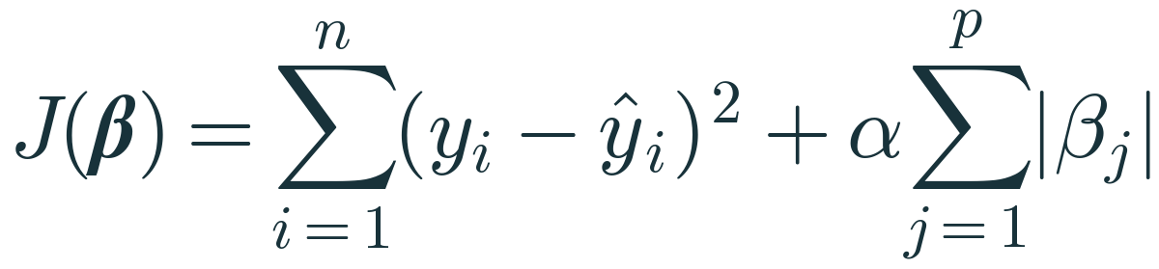
- Subgradient intuition (one standardised feature, others fixed): the Lasso solution is the OLS coefficient soft-thresholded: β = sign(z)·max(|z| − λ, 0) for a threshold λ proportional to α. Any coefficient whose OLS-like value is smaller than the threshold becomes exactly 0. Full coordinate-descent derivation next session.
- scikit-learn's Lasso minimises (1/(2n))‖y − Xβ‖² + α‖β‖₁. Compared with our classroom form (SSE + α‖β‖₁), the data term is divided by 2n, so sklearn's α corresponds to α_classroom/(2n). The same number in Ridge(alpha) and Lasso(alpha) is not the same strength.
- Correlated predictors: Lasso tends to keep one of a correlated group and drop others somewhat arbitrarily; Elastic Net (next sessions) addresses this.

E. Worked examples
Candidate | Σ|β| | J (α = 1) = SSE + Σ|β|
A | 7 | 17
B | 2.5 | 16.5
C | 2 | 17

Notebook A10. Lasso α = 1.5 (sklearn scale, standardised features): area 27.58, bedrooms 0.83, age −2.23, distance −10.60, floor 0.00, parking 0.63. Test RMSE 7.34 vs 5.75 for OLS — on this dataset the sparsity costs accuracy; the point here is to see the mechanism.
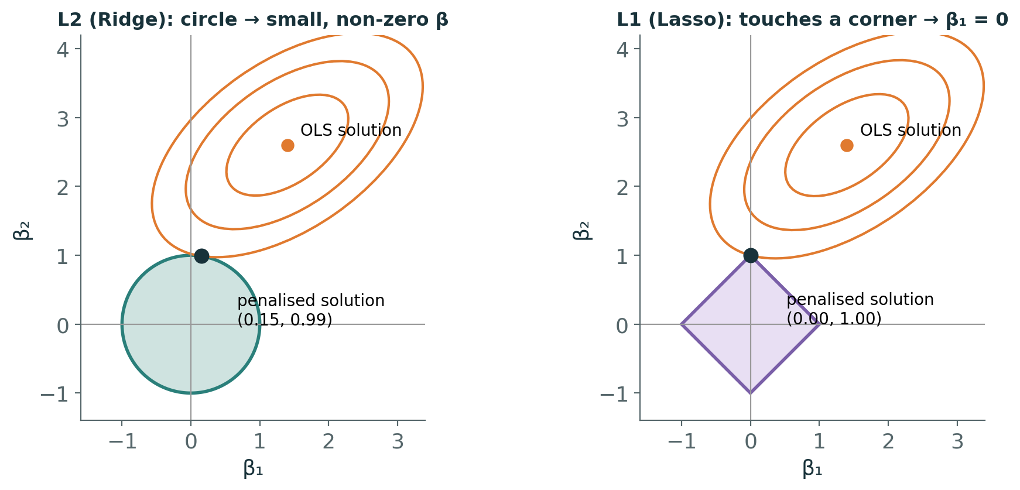

F. Trainer questions
- Why can Lasso produce exact zeros but Ridge rarely does?
- Lasso zeroes 'parking'. Does that prove parking is irrelevant?
- Why not compare Ridge(alpha=1) and Lasso(alpha=1)?
- When would you prefer Lasso?

G. Expected answers
- L1's constant marginal penalty keeps pushing small coefficients to 0; L2's push vanishes near 0. Geometrically, the L1 region has corners on the axes.
- No — at this α and with these data its contribution did not justify its penalty; correlated features can swap.
- Their objectives are scaled differently in scikit-learn.
- Many candidate features, expectation that few matter, interpretability needed.

H. Common mistakes
- Treating Lasso's selected set as the 'true' features.
- Not scaling features.
- Equating α across libraries or across Ridge/Lasso.

I. Python explanation
lasso = make_pipeline(StandardScaler(), Lasso(alpha=1.5)).fit(X_train, y_train)
lasso[-1].coef_ # floor_number -> 0.0

- Lasso is fitted by coordinate descent; max_iter (default 1000) may need raising for small α (ConvergenceWarning).
- Exact zeros appear in coef_; count them with (coef_ == 0).sum().

J. Timing
Segment | Minutes
Objective + candidate table | 4
Geometry + paths | 6
Comparison + knowledge check | 11

Facilitating the labs and challenge (Hours 5–7)

Before the session
- Install from requirements.txt; open 04_PML_Regression_Student_Exercises.ipynb from the 03_Jupyter_Notebooks folder (the setup cell finds ../04_Datasets automatically).
- Run 05_PML_Regression_Trainer_Solutions.ipynb once on the training-room machine to confirm versions.
- Print or share 07_PML_Regression_Student_Lab_Guide.docx and 08_Final_Regression_Challenge.docx.

Lab 1 (A1–A7) — what to watch for
Exercise | Checkpoint value | Typical blocker
A2 | shapes (240, 6) and (60, 6) | 1-D X ('Expected 2D array')
A3 | b₁ ≈ 0.0502, b₀ ≈ −3.57; 1,200 sq ft → 56.6 | reading coef_ as scalar
A4 | b₁ = 2.1, b₀ = 8.4, SSE = 3.6 | Σxy instead of centred products
A5 | J: 7.5 → 1.5098 → 0.3217 | sign error in update
A6 | toy: MAE 0.8, R² 0.98; test RMSE 16.08 | argument order in r2_score
A7 | test RMSE 5.75, R² 0.967; by-hand 70.285 | forgetting intercept in manual sum

Lab 2 (A8–A10)
Exercise | Checkpoint value | Typical blocker
A8 | degree 2 test MSE 0.947; degree 15 1.153 | scaling outside pipeline
A9 | best CV degree = 2 | using test set for selection
A10 | Lasso α = 1.5 zeroes floor_number; Ridge rescues degree 15 (1.20) | forgetting StandardScaler

Challenge (A11)
Brief 5 min, independent work 50 min, wrap-up 5 min. Use 09_Final_Challenge_Trainer_Key.docx for marking. Do not hint at the curved traffic effect; credit students who justify their alternative using residual plots or feature–target plots before seeing CV results.

Appendix · References and originality note
Topic coverage was checked against the folder index of the public CampusX '100 Days of Machine Learning' GitHub repository (accessed 25 October 2026: day48 simple linear regression, day49 regression metrics, day50 multiple linear regression, day51–52 gradient descent, day53 polynomial regression, day55 regularised linear models, day56 lasso, day57 elastic net). The videos and notebook contents were not reviewed; the repository was used only as a coverage checklist. All explanations, examples, datasets, figures and code in this package are original. Technical conventions (objective scaling for Ridge/Lasso, solver behaviour) follow the scikit-learn documentation. See References.md for the full list.

