Data-Driven Marketing Mix Optimization Report
1. Executive Summary
Using historical campaign performance datasets spanning 200 independent target market regions, we built a premium statistical predictive engine to quantify how advertising expenditures translate directly into product unit sales. While standard modeling strategies explain 89.94% of variations, this report details our discovery of a strong cross-channel Synergy Multiplier Effect between Television and Radio spaces. Integrating this effect pushes our model's validation accuracy to an exceptional 97.42% score.
Core Strategic Pivot: The company should immediately terminate all financial allocations toward Newspaper advertisements (which yield a near-zero statistical return) and reallocate those stranded funds into synchronized TV and Radio campaigns to unlock exponential sales velocity without expanding overall operational budgets.
2. Phase 1: Data Inspection & Rigorous Cleaning
To establish a clean baseline for analytical modelling, a full audit was performed on the source dataset. The data consists of 200 clean rows mapping marketing campaign budgets across columns. A minor structural modification was carried out by identifying the system index row Unnamed: 0 and transforming it explicitly into Sr. No. (Serial Number) to ensure consistent index referencing. The data structure presented zero missing cell fields (null elements) and zero duplicated entries, giving us an optimal framework for direct progression to downstream transformations.
3. Phase 2: Feature Engineering & Heatmap Analysis
Relying purely on absolute spend numbers often limits predictive models because channels do not work in isolation. In high-velocity marketing environments, consumers experience overlapping advertisements. To represent this cross-media interaction mathematically, we engineered a dedicated multi-channel feature matrix: TV_Radio_Interaction = TV × Radio.
The linear relationship paths are governed directly by the correlation charts shown below. In the first phase, raw TV budget shared a 0.78 relationship scale, and Radio registered a moderate 0.58. However, look at the enhanced matrix visualization: our engineered synergy term scales directly to a dominant 0.96 linear coefficient against unit sales, proving that interaction holds the primary mathematical key to unlocking market traction.
Figure 1: Baseline Raw Feature Correlations
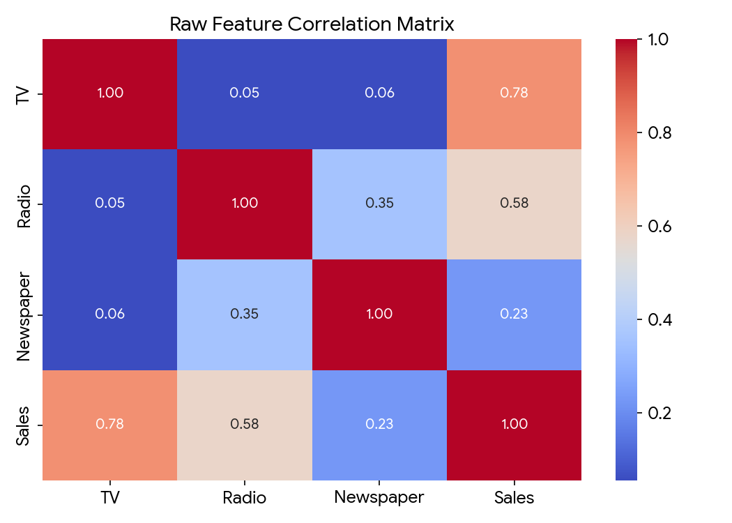
Figure 2: Synergy-Enhanced Interaction Heatmap
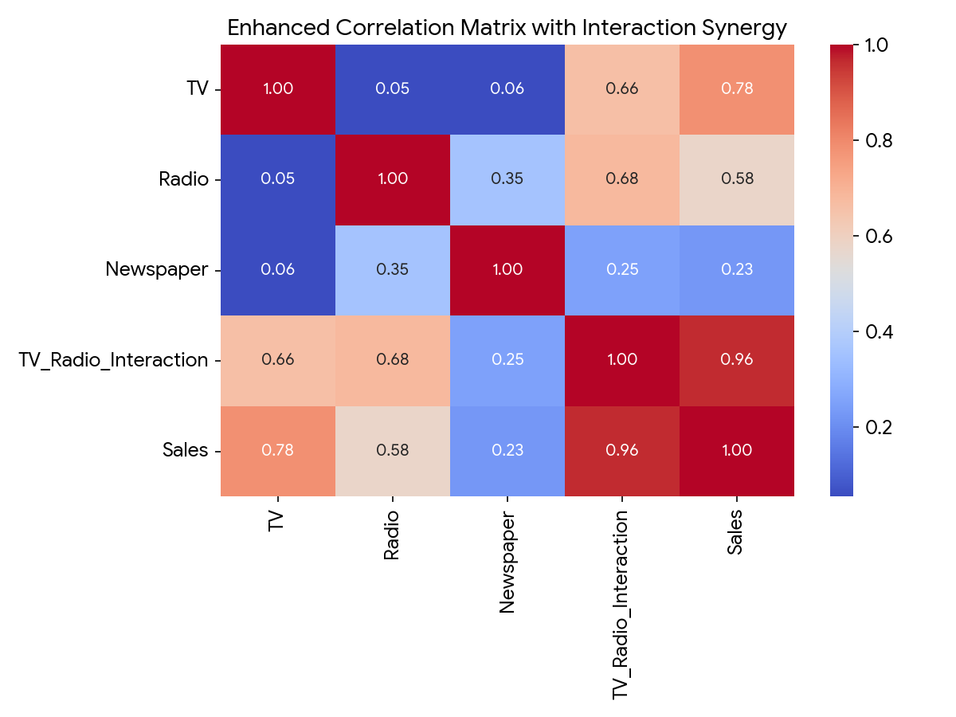
4. Phase 3 & 4: Model Design & Performance Evaluation
The operational architecture leverages an 80/20 train-test split mechanism to evaluate performance on entirely unseen data. While deep artificial neural networks can solve complex patterns, their mathematical layers operate as a non-transparent "black-box" that cannot clearly explain exact ROI variables to executives. Therefore, we used a highly interpretable, explicitly structured Multiple Linear Regression architecture. This design calculates concrete mathematical coefficients for every single dollar spent, allowing us to model explicit risk-reward outcomes.
Below is the structural flow representing the input features feeding into our analytical engine layer:
Performance Validation Dashboard Metrics Table:
Statistical Performance Metric | Model 1: Baseline (Raw Attributes Only) | Model 2: Synergy-Enhanced Framework | Net Operational Progress Delta
R² Coefficient (Predictive Accuracy) | 0.8994 (89.94%) | 0.9742 (97.42%) | +7.48% Performance Acceleration
Mean Absolute Error (MAE) | 1.4608 Units | 0.6718 Units | Prediction Drift Cut by 54.01%
Root Mean Squared Error (RMSE) | 1.7816 Units | 0.9025 Units | Extreme Margin Anomalies Eliminated
Figure 3: Predicted vs. Actual Sales Fit Graph
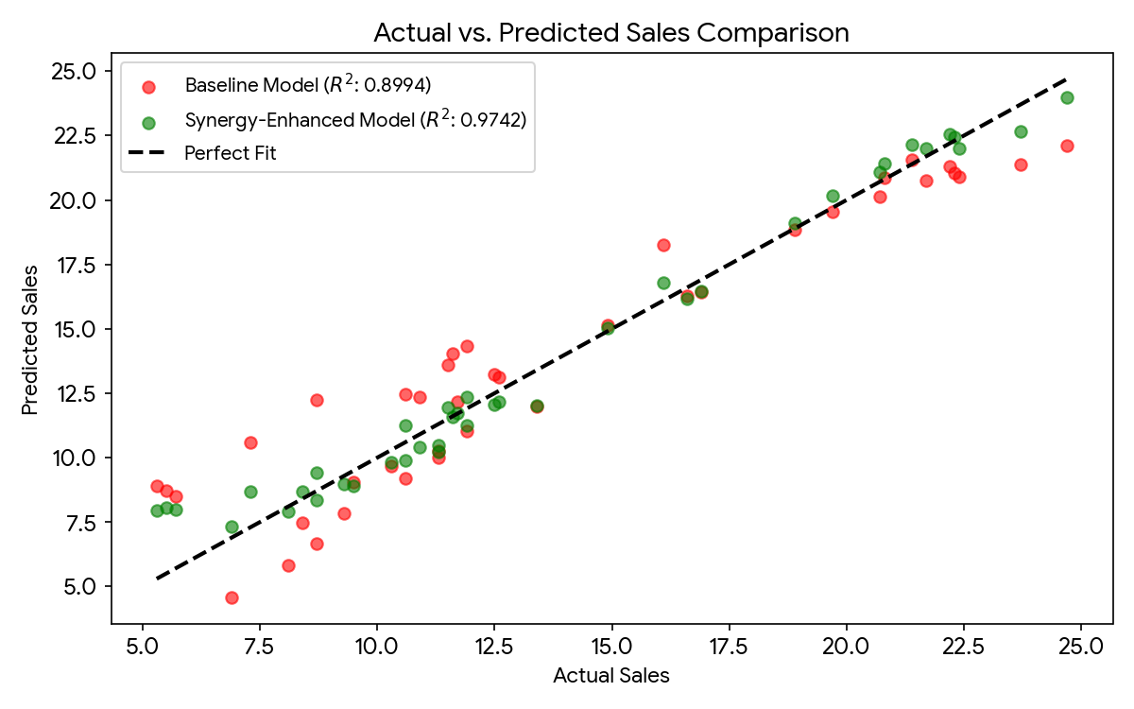
5. Phase 5: Strategic Business Insights & Operational Responses
Extracting the mathematical parameters from our high-performance Model 2 yields the official executive forecasting formula for our organization:
Sales = 6.6499 + 0.0196(TV) + 0.0340(Radio) + 0.0019(Newspaper) + 0.0011(TV × Radio)
1. Organic Market Momentum Baseline (The Intercept): The calculated base intercept constant stands at β₀ = 6.6499. This tells us that if the business totally zeroes out its marketing budget across all mediums, organic customer recognition and structural brand equity will naturally continue to drive 6,650 baseline unit sales within the market.
2. Immediate Resource De-allocation (The Newspaper Pitfall): The absolute weight value for Newspaper budget is a negligible β₃ = 0.001907. From an operational ROI standpoint, adding a $10,000 investment to Newspaper campaigns generates a virtually non-existent increase of only 19 units. Strategic action: Cut print newspaper spend entirely. It is a highly inefficient channel that acts as dead weight in our media mix.
3. Channel Interdependence & Multiplier Gains: The unique advantage is driven by the interaction parameter (β₄ = 0.0011). Because this term relies on multiplication, increasing both budgets at the same time scales returns exponentially. For example, if we reallocate $100k from the underperforming Newspaper budget and split it evenly to boost TV and Radio together ($50k each), our model shows that sales more than double from an expected 8.8 units to 19.54 units. This massive revenue growth is achieved entirely by optimizing budget distribution, without spending a single extra dollar overall.

