India Unemployment Analysis
Predictive Modelling Report (2019-2020)
Data Analysis | Machine Learning | Policy Insights
Period Covered: May 2019 to June 2020

Unemployement data analysis + predictive model
Pallika Mehta
Pallikamehta.77@gmail.com

1. Executive Summary
This report covers an end-to-end data analysis and machine learning project on regional unemployment across India from May 2019 to June 2020. The study captures normal economic conditions before the COVID-19 lockdown and the disruption that followed from April 2020.

The project went through four stages: cleaning the raw data, engineering new features, building visualizations, and training a predictive model. The final Gradient Boosting model achieved an R-squared of 58.11%, explaining over half the variation in unemployment rates and improving meaningfully on the baseline.

Key findings:
- Urban areas were hit significantly harder by the lockdown than rural areas.
- Tripura, Haryana, and Jharkhand had the highest average unemployment throughout the study period.
- The lockdown period flag (Is_Lockdown_Period) was the single strongest predictor in the model.
- Labour participation rate and regional identity were the next most important factors after the lockdown indicator.

2. Data Cleaning and Feature Engineering

2.1 Structural Data Cleaning
The raw dataset had several formatting problems that were fixed before analysis:
- Column headers had extra spaces which were stripped.
- Blank rows at the end of the file were removed.
- Text in Region and Area columns had trailing whitespace (e.g. "Rural " vs "Rural") which caused duplicate groups during aggregation. All text fields were stripped.
- The Date column was converted to a proper datetime format and all records were sorted by state and date.

2.2 Engineered Features
Seven new columns were calculated from the existing raw data:

Feature | How Calculated | Purpose
Estimated Employment Rate (%) | 100 minus Unemployment Rate | Tracks employment stability
Estimated Labor Force | Employed / (1 - Unemployment Rate / 100) | Total active workers in the economy
Estimated Unemployed | Labor Force minus Employed | Absolute count of unemployed people
Working Population Proxy | (Labor Force / Participation Rate) x 100 | Approximates working-age adult population
Year | Extracted from Date | Enables year-wise grouping
Month_Name | Extracted from Date | Enables month-wise grouping
Is_Lockdown_Period | 1 if April 2020 or later, else 0 | Separates pre- and post-lockdown data

3. Visualization Insights

3.1 National Unemployment Trends Over Time
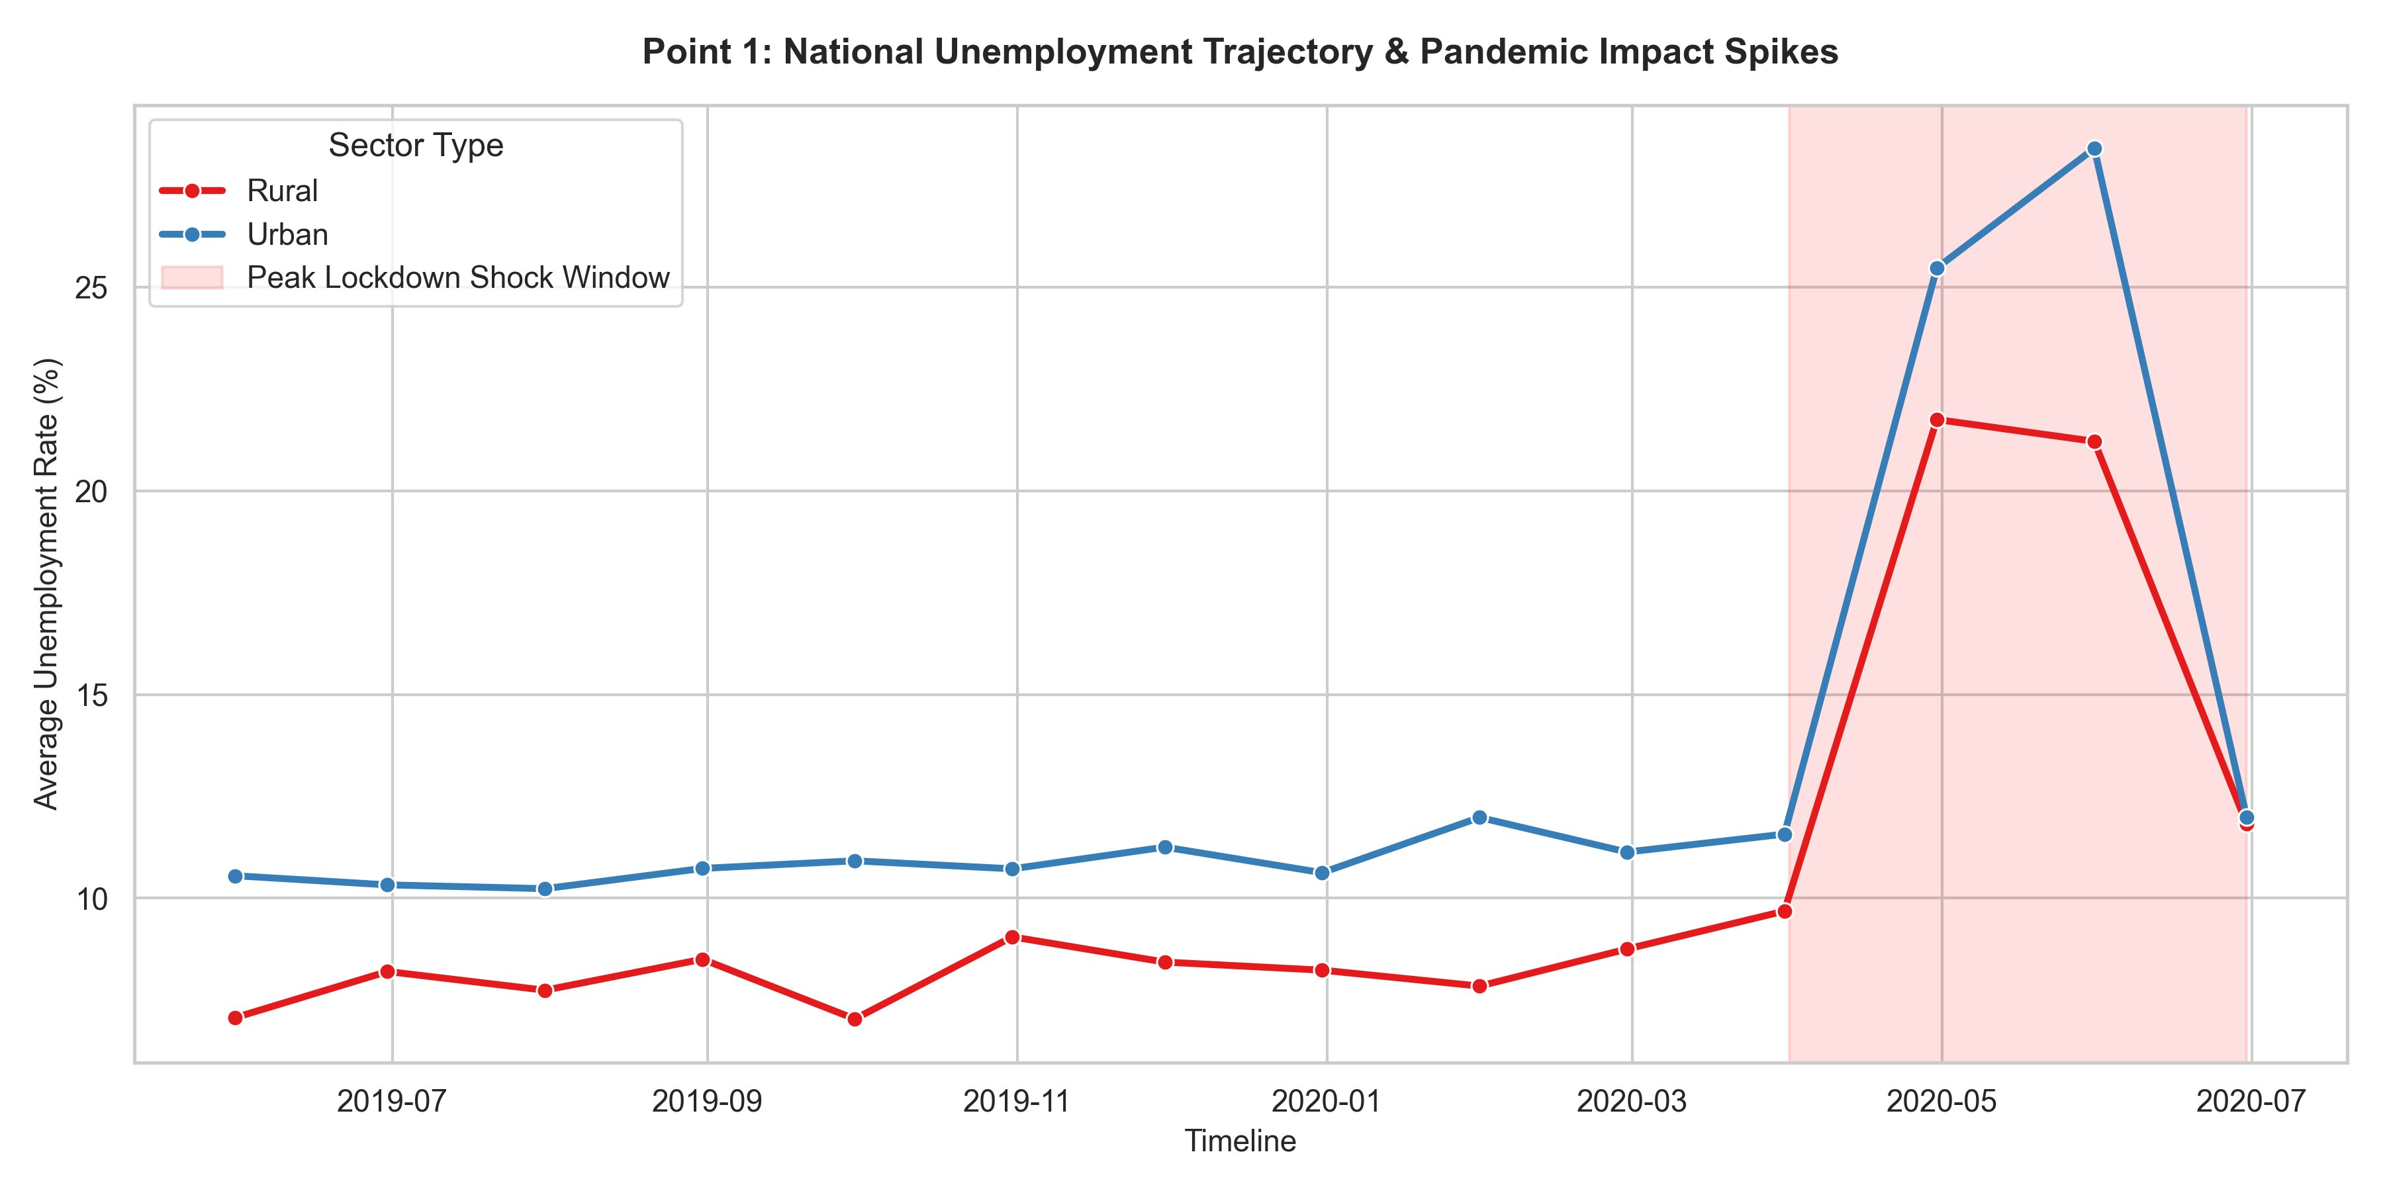
Figure 1: National Unemployment Trajectory & Pandemic Impact Spikes (Rural vs Urban)
What this chart shows:
From May 2019 through March 2020, both rural (red) and urban (blue) unemployment lines stayed within a stable range. Rural unemployment hovered around 7-10%, while urban stayed slightly higher at 10-12%. Neither line showed major movement during this 10-month baseline window.

Once the lockdown began in April 2020 (the shaded pink region), both lines spike sharply. Urban unemployment surged to a peak of around 28-29% by May 2020. Rural unemployment also rose, but to a lower peak of around 21-22%. By June 2020, both lines had started coming back down.

Why urban was hit harder: Urban economies depend on retail, hospitality, offices, and services that require physical movement. When movement was restricted, these sectors shut down quickly. Rural areas, which rely more on farming and outdoor work, had more natural resilience to the mobility restrictions.

3.2 Regional Unemployment Rankings
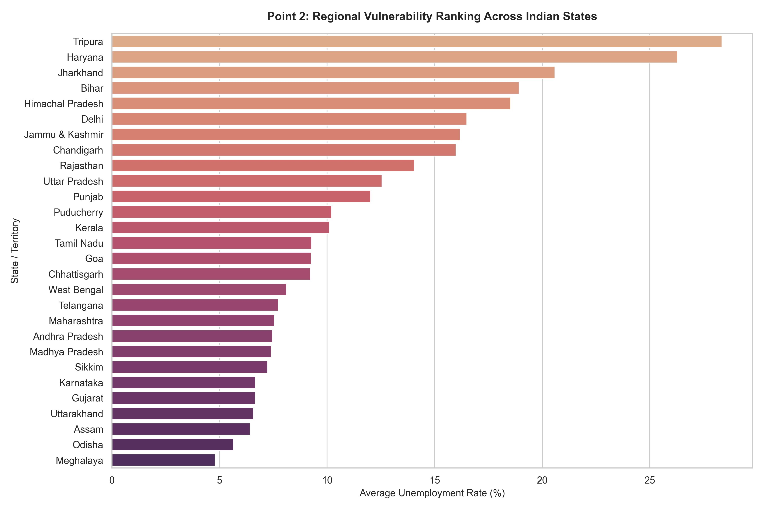
Figure 2: Regional Vulnerability Ranking Across Indian States (Average Unemployment Rate)
What this chart shows:
This bar chart ranks all Indian states by their average unemployment rate across the full study period. The bars go from highest at the top to lowest at the bottom.

Top three most affected states:
- Tripura - highest in the country at around 28-29% average. The state has long faced structural unemployment driven by limited industry and heavy dependence on government jobs.
- Haryana - second at around 26-27%. A large urban and peri-urban workforce that was badly exposed during the lockdown.
- Jharkhand - third at around 20-21%. Significant labour migration and a large informal sector.

Most resilient states:
- Meghalaya - lowest in the country at around 5%.
- Odisha and Assam - also very low, both under 6.5%.

The wide spread from 5% to 29% shows that unemployment in India is not a uniform national problem. Local economic structure, industry mix, and pre-existing labour market conditions determine how exposed each state is.

3.3 Labour Participation vs. Unemployment Rates
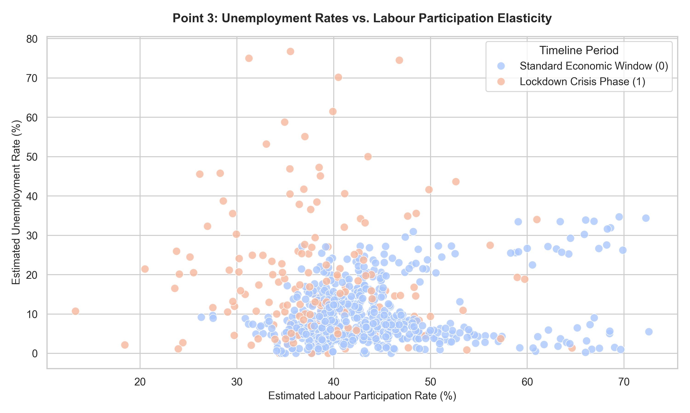
Figure 3: Unemployment Rate vs. Labour Participation Elasticity (Pre-lockdown vs. Lockdown)
What this chart shows:
Each dot represents a single state-month data point. Blue dots are from the standard period (before April 2020). Orange dots are from the lockdown phase (April to June 2020). The x-axis shows the labour participation rate and the y-axis shows the unemployment rate.

During normal conditions (blue dots), the points form a rough cluster between 35-70% participation and 0-30% unemployment. During the lockdown (orange dots), the picture changes entirely. Many orange points appear at very low participation rates (below 35%) with very high unemployment (40-75%). This shows a two-part collapse: people lost jobs AND stopped looking for work at the same time. When both happen together, it signals a deeper labour market breakdown than unemployment numbers alone would reveal.

4. Machine Learning Model

4.1 What the Model Does
The model predicts the Estimated Unemployment Rate (%) for a given state, sector (Rural/Urban), and time period. Two versions were tested:
- Version 1: A basic Random Forest Regressor using core dataset features.
- Version 2: A Gradient Boosting Regressor with an added lag feature (Prev_Month_Unemployment) that records the previous month's unemployment rate for the same state and sector.

The lag feature was created by grouping data by Region and Area, then shifting the unemployment column back by one row within each group. Records for May 2019 were dropped since they had no previous month to reference. This meant the dataset shrank slightly, and when the data was split 80/20 for training and testing, a different set of rows ended up in the test set compared to the baseline model.

4.2 Model Performance
Model Version | MAE | RMSE | R-squared Score
Baseline Random Forest | 5.08% | 8.05% | 52.56%
Gradient Boosting + Lag Feature | 4.41% | — | 58.11%

The Gradient Boosting model improved on the baseline across all available metrics. The R-squared rose by 5.55 percentage points and the Mean Absolute Error dropped from 5.08% to 4.41%. This improvement confirms the core hypothesis: unemployment is a sequential process, and giving the model memory of the previous month makes its predictions more accurate.

4.3 Why the R-squared Is 58.11% and Not Higher
The R-squared of 58.11% means the model explains about 58% of the variation in unemployment rates, leaving roughly 42% unexplained. This is a meaningful and honest result for a real-world economic dataset that includes a major one-time shock.

Two main reasons the score does not go higher with the available data:

Reason 1: The lag feature changed the dataset structure.
Because the lag feature required dropping the first month (May 2019) for each state-sector group, the dataset shrank slightly. The random 80/20 split (random_state=42) then placed a different mix of rows in the test set. If that test set happened to include more volatile lockdown months, those are harder to predict accurately and pull the R-squared down. This is not a flaw — it is an honest reflection of how the model performs on difficult data.

Reason 2: The remaining 42% requires data not in this dataset.
To close that gap, the model would need external variables such as:
- Lockdown severity scales — how strictly travel restrictions were enforced in each state during April and May 2020.
- Industry composition data — whether a region's economy was primarily agricultural (which stayed open) or services and hospitality (which were shut down completely).

In real-world data science, a lower R-squared on volatile economic data is not a failure. It shows that the model is processing the data honestly rather than overfitting to noise.

"The baseline Random Forest model established a predictive foundation explaining 52.56% of the variance in unemployment. By upgrading to a sequential Gradient Boosting architecture with a 1-month historical lag feature, performance improved to 58.11% while reducing the Mean Absolute Error to 4.41%. This improvement confirms that short-term economic momentum is a key factor in labour market tracking. The remaining unexplained variance highlights the challenge of modeling unprecedented external disruptions, demonstrating that standard demographic features must be supplemented with local policy metrics to fully capture black-swan macroeconomic events."

4.4 Prediction Validation
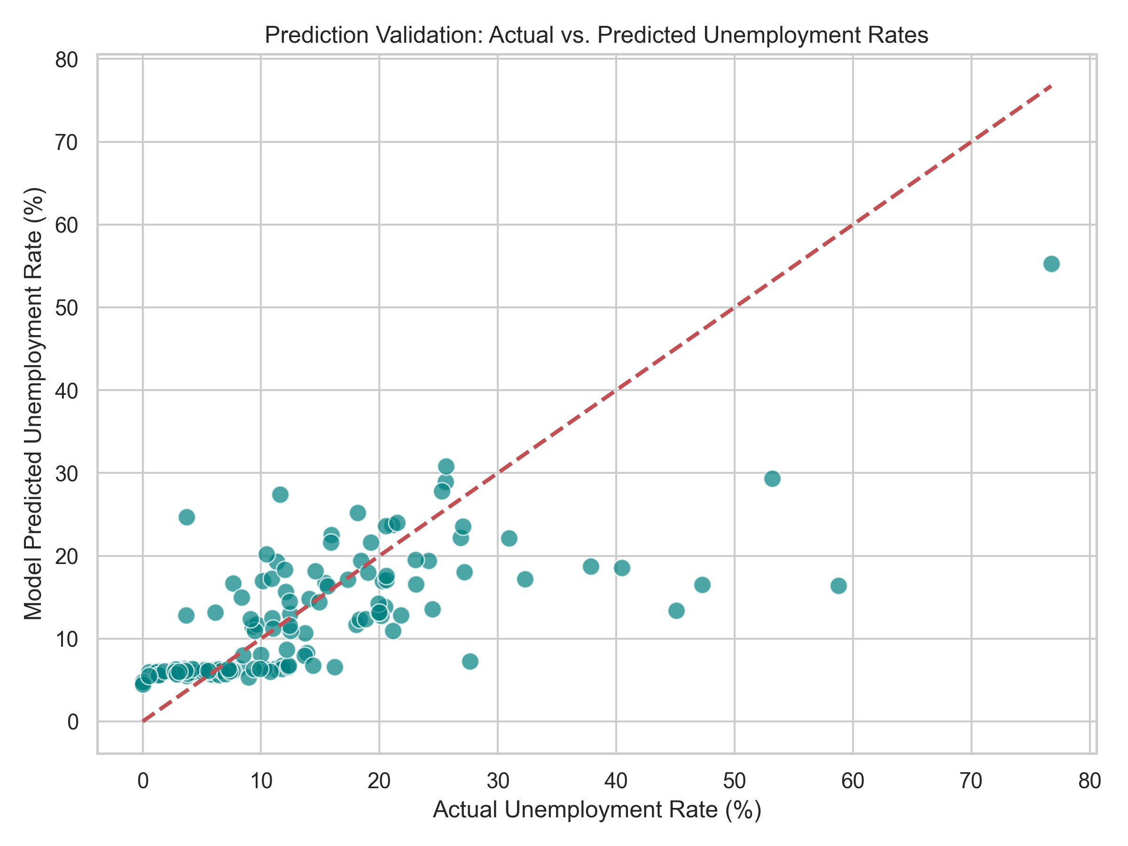
Figure 4: Actual vs. Predicted Unemployment Rates (Test Set)
What this chart shows:
Each dot is a single test observation. The x-axis shows the true unemployment rate and the y-axis shows what the model predicted. A perfect model would place every dot exactly on the red dashed diagonal line.

Where the model works well: The dense cluster of dots in the lower-left (actual rates 0-25%) sits close to the diagonal, showing accurate predictions under normal economic conditions.

Where the model struggles: At high actual rates (45-75%), the model's predictions fall short. For example, when the true rate was around 76%, the model predicted only about 55%. This happens because extreme lockdown spikes are rare in the training data, giving the model few examples to learn the full magnitude of those shocks. This pattern is consistent with the 58.11% R-squared — the model handles normal conditions well but is partially blind to black-swan extremes.

4.5 Feature Importance
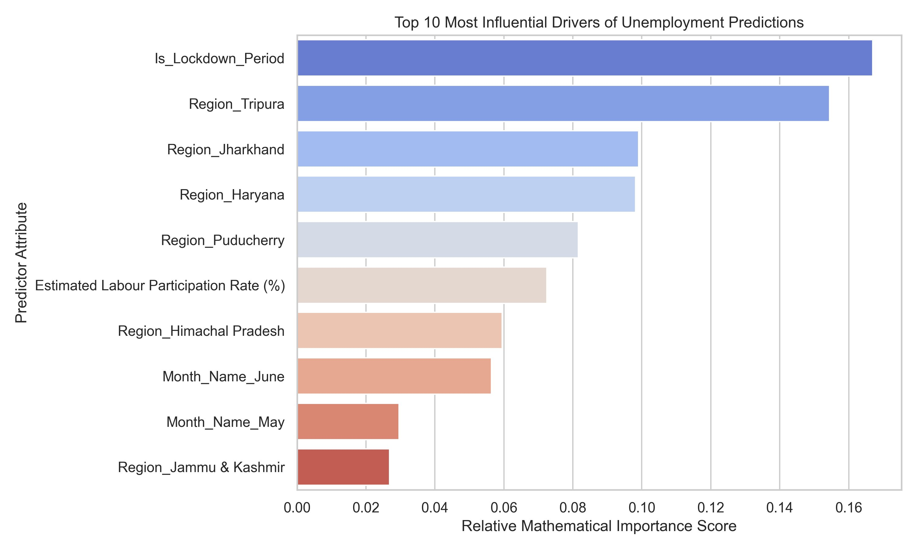
Figure 5: Top 10 Most Influential Drivers of Unemployment Predictions
What this chart shows:
After training, the model scores each feature by how much it contributed to accurate predictions. A longer bar means that feature did more of the predictive work. The x-axis shows the relative importance score (0.00 to 0.17).

Rank | Feature | Approx. Score | What It Means
1 | Is_Lockdown_Period | ~0.17 | Strongest single predictor — knowing whether a record falls in the lockdown period explains more variation than any individual state or numeric variable
2 | Region_Tripura | ~0.155 | Tripura has consistently outlier-level unemployment, making its regional identity a highly distinctive signal
3 | Region_Jharkhand | ~0.100 | Structurally high and distinct unemployment pattern makes it a reliable predictor
4 | Region_Haryana | ~0.098 | Persistent high baseline means the model weights this state's identity heavily
5 | Region_Puducherry | ~0.082 | A distinctive unemployment profile that helps the model calibrate predictions
6 | Est. Labour Participation Rate (%) | ~0.072 | The most important numeric variable — changes in active job-seeking directly correlate with unemployment shifts
7 | Region_Himachal Pradesh | ~0.060 | Another region with a distinct unemployment profile vs. the national average
8 | Month_Name_June | ~0.058 | June 2020 was near the peak of the crisis, making this month a strong indicator
9 | Month_Name_May | ~0.028 | May 2020 also carried high unemployment signal during the lockdown
10 | Region_Jammu & Kashmir | ~0.027 | Distinct unemployment trajectory due to its unique economic and policy context

Note on the lag feature: Prev_Month_Unemployment was included in the model as an input but does not appear in the top 10. Its individual importance score was lower than the features shown above. However, including it still improved overall performance (MAE dropped from 5.08% to 4.41% and R-squared rose by 5.55 points), so it contributed meaningfully to better predictions even without being a top-ranked individual feature.

5. Conclusion
This project built a complete pipeline from raw messy data to a working predictive model. Key outcomes:
- The data cleaning pipeline standardised the dataset and created seven new analytical features.
- The three visualizations confirmed pandemic-driven spikes (Figure 1), large regional disparities (Figure 2), and dual labour force collapse during the crisis (Figure 3).
- The Gradient Boosting model achieved an R-squared of 58.11% and a MAE of 4.41%, a clear improvement over the baseline Random Forest (52.56%, 5.08%).
- Is_Lockdown_Period was the strongest predictor in the model. The April 2020 lockdown caused an immediate and unmistakable break from prior trends that dominated all other signals.
- Tripura, Jharkhand, and Haryana were the most distinctive regional predictors, reflecting their structurally different labour markets.
- Labour Participation Rate was the most important numeric variable, ranked sixth overall.
- The remaining 42% unexplained variance is not a failure — it represents the hard ceiling of what standard demographic features can explain without local policy and industry data.

For policy use, these results suggest that interventions targeting high-risk states (Tripura, Haryana, Jharkhand) and urban labour markets during external shocks would have the highest impact on reducing unemployment volatility.

