**Palm Beach Code School “Apply Now”**

**@Post** User is redirected to *“application page”*

**1.) User Clicks Apply Now**

**Cases:**

-User has Account

- Is logged in

- Is not logged in

-User does not have Account

**@Pre** User is logged in, and on *“application page”*

**@Post** User has submitted their application and **cannot submit another one for this particular program**.

**2.) User Clicks Begin Application**

**Possible Questions:**

* First Name
* Last Name
* Phone Number
* Birth Date
* Gender
* T-Shirt Size

**DO WE WANT MAILING ADDRESS INFORMATION?**

* Give some reasons as to why you want to partake in this program.
* How did you hear about this program?
* Current Availability
* Current employer
* Would your employer be interested in sponsoring your course tuition?
* Are you interested in getting a new job?

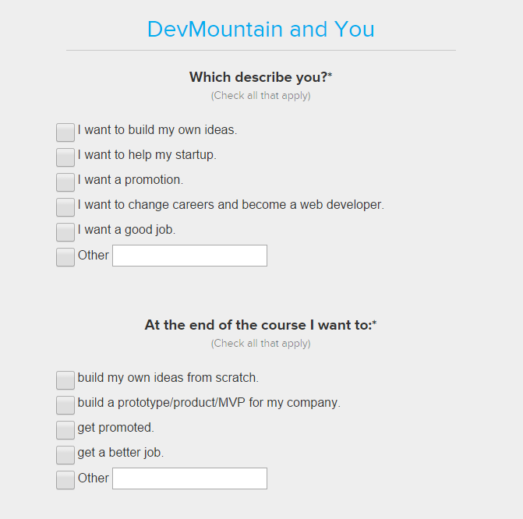 Maybe some questions like this

**3.) User Clicks Submit**

The user is informed that they have indeed successfully submitted their application. An email is sent, also indicating that their application was successfully submitted. Their next steps are to wait for a phone call to setup an interview.