MethodSCRIPT Example - Python





Last revision: March 22 2019

© 2019 PalmSens BV

www.palmsens.com

## Contents:

* PSEsPicoLib.py
* MSConsoleExample.py
* MSPlotCV.py
* MSPlotEIS.py
* \MethodSCRIPT files\ MSExampleCV.mscr
* \MethodSCRIPT files\ MSExampleEIS.mscr

The examples are based on Python under Windows using the Spyder IDE as part of the Anaconda distribution.

The example “MSConsoleExample.py” found in the “/MethodSCRIPTExample-Python” folder demonstrates basic communication with the EmStat Pico using Python.

The “MSPlotCV .py” example demonstrates the common electrochemical technique: Cyclic Voltammetry and plots the resulting voltammogram.

The “MSPlotEIS.py” example demonstrates the Electrochemical Impedance Spectroscopy technique and plot the resulting Nyquist and Bode plots.

### Example 1: Console Example (MSConsoleExample.py)

This example opens a communication port, sends a MethodSCRIPT file, reads and parses the data and prints the parsed data (variable type, value, unit) to the console. The metadata (status, currentrange) are not parsed in this example.

The name of the com port connected to the device can be found in the Device Manager in Control Panel in Windows as shown below.

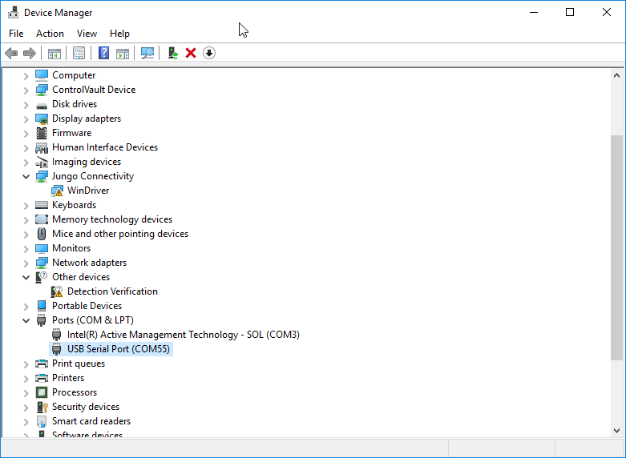

Figure 1: Available com ports in device manager

We use COM55 as our Emstat Pico comport and set the myport variable accordingly.

myport = "COM55" #set the comport

### Parsing the response

Each measurement data package returned by the function *ReadBuf()* in *MSComm* library, can be parsed further to obitain the actual data values. Here’s a set of data packages received from a Linear Sweep Voltammetry (LSV) measurement on a dummy cell with 10 kohm resistance.

eM0000\n

Pda7F85F3Fu;ba48D503Dp,10,288\n

Pda7F9234Bu;ba4E2C324p,10,288\n

Pda806EC24u;baAE16C6Dp,10,288\n

Pda807B031u;baB360495p,10,288\n

*\n

\n

While parsing a measurement package, various identifiers are used to identify the type of package. For example, In the above sample,

1. ‘e’ is the confirmation of the “execute MethodSCRIPT” command.
2. ‘M’ marks the beginning of a measurement loop.
3. ‘P’ marks the beginning of a measurement data package.
4. “*\n” marks the end of a measurement loop.
5. “\n” marks the end of the MethodSCRIPT.

The data values to be received from a measurement can be sent through ‘pck*’* commands in the MethodSCRIPT. Most techniques return the data values Potential (set cell potential in V) and Current (measured current in A). These can be sent with the MethodSCRIPT.

In case of Electrochemical Impedance Spectroscopy (EIS) measurements, the following *variable types*  can be sent with the MethodSCRIPT and received as measurement data values.

* Frequency (set frequency in Hz)
* Real part of complex Impedance (measured impedance Ohm)
* Imaginary part of complex Impedance (measured impedance in Ohm)

The following metadata values if present can also be obtained from the data packages.

* CurrentStatus (OK, underload, overload, overload warning)
* CurrentRange (the current range in use at the moment)
* Noise (Noise)

### Example 2: Cyclic Voltammetry Plot Example (MSPlotCV.py)

This example performs a CV and plots the I vs E.

The shown plot is the result when the Palmsens Dummy Cell WE A (RedOx circuit) is used.

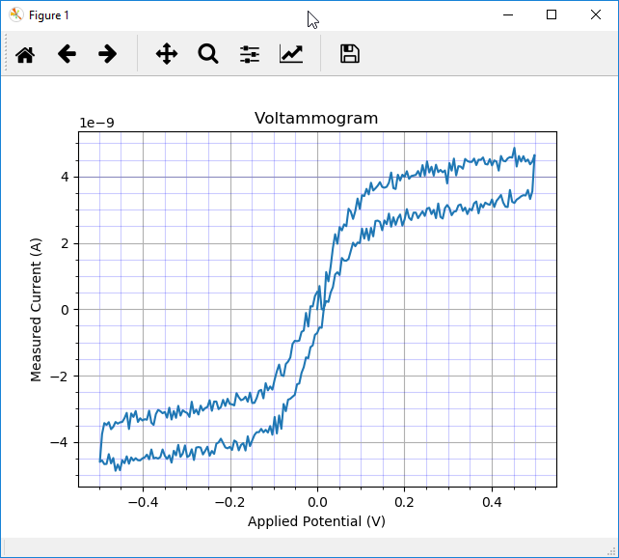

Figure 2: CV on Palmsens Dummy Cell WE A (RedOx circuit)

### Example 3: EIS Plot Example (MSPlotEIS.py)

This example performs an EIS (Electrochemical Impedance Spectroscopy) scan and generates a Nyquist plot and a Bode plot. The plots shown below are the results when the Palmsens Dummy Cell WE C (Randles circuit) is used.

Part-1 of the code connects to Emstat Pico and sends the MethodSCRIPT file and saves the results to the filename given by ResultFile using the functions from PSEsPicoLib.py.

Part-2 parses the data stored in ResultFile to a matrix given by value_matrix where the first column (0) holds the applied frequencies, the second (1) the real part of the complex impedance and the third (2) the imaginary part of the complex impedance. The complex impedance is composed from the real and imaginary parts and the absolute impedance (Z) and phase are calculated from the complex impedance: Zcomplex . Nyquist plot and the Bode plot are generated accordingly. At last the results are saved to a Comma Separated File enabling the results to be imported in other applications like Excel.

#### Part-1

import serial

import os.path

import PSEsPicoLib

import matplotlib.pyplot as plt

import numpy as np

#script specific settings

MSfilepath = ".\\MethodSCRIPT files"

MScriptFile = "MSExampleEIS.mscr"

#combine the path and filename

MScriptPathandFile = os.path.join(MSfilepath, MScriptFile)

#initialization and open the port

ser = serial.Serial() #Create an instance of the serial object

myport = "COM55" #set the comport

if PSEsPicoLib.OpenComport(ser,myport,1): #open myport with 1 sec timeout

print("Succesfuly opened: " + ser.port )

try:

if PSEsPicoLib.IsConnected(ser): #Check if EmstatPico is connected

print("Connected!")

# Send the MethodSCRIPT file

PSEsPicoLib.SendScriptFile(ser,MScriptPathandFile)

#Get the results and store it in datafile

datafile=PSEsPicoLib.GetResults(ser) # fetch the results

#Create "data" subfolder

(prefix, sep, suffix) = MScriptFile.rpartition('.') #split the file-extension and the filename

ResultFile = prefix + '.dat' #change the extension to .dat

ResultPath = MSfilepath+"\\data" #use subfolder for the data

try:

os.mkdir(ResultPath)

except OSError:

print ("Creation of the directory %s failed" % ResultPath)

else:

print ("Successfully created the directory %s " % ResultPath)

ResultFile = os.path.join(ResultPath, ResultFile) #combine the path and the filename

ResultFile = PSEsPicoLib.CheckFileExistAndRename(ResultFile) #Rename the file if it exists to a unique name by add the date+time

#print(ResultFile)

f = open(ResultFile,"w+") #Open file for writing

f.write(datafile) #write data to file

f.close() #close file

else:

print("Unable to connected!")

ser.close() #close the comport

except Exception as e1: #catch exception

print("error communicating...: " + str(e1)) #print the exception

else:

print("cannot open serial port ")

#### Part-2

value_matrix = PSEsPicoLib.ParseResultFile(ResultFile) #Parse result file to Value matrix

applied_frequency=PSEsPicoLib.GetColumnFromMatrix(value_matrix,0) #Get the applied frequencies

measured_zreal=PSEsPicoLib.GetColumnFromMatrix(value_matrix,1) #Get the measured real part of the complex impedance

measured_zimag=PSEsPicoLib.GetColumnFromMatrix(value_matrix,2) #Get the measured imaginary part of the complex impedance

#Calculate Z and Phase

measured_zimag = -measured_zimag #invert the imaginary part for the electrochemist convention

Zcomplex= measured_zreal + 1j*measured_zimag #compose the complex impedance

Zphase=np.angle(Zcomplex, deg=True) #Get the phase from the complex impedance in degrees

Z=np.abs(Zcomplex) #Get the impedance value

#show the Nyquist plot as figure 1

plt.figure(1)

plt.plot(measured_zreal,measured_zimag)

plt.title('Nyquist plot')

plt.axis('equal')

plt.grid()

plt.xlabel("Z\'")

plt.ylabel("-Z\'\'")

#show the Bode plot as dual y-axis

fig, ax1 = plt.subplots()

color = 'tab:red' #plot the impedance in Red

ax1.set_xlabel('Frequency (Hz)') #X-axes is Frequency

ax1.set_ylabel('Z', color=color) #axes-1 is Z (impedance)

ax1.semilogx(applied_frequency, Z, color=color) #X-axis is logarithmic

ax1.tick_params(axis='y', labelcolor=color) #show ticks

## Turn on the minor TICKS, which are required for the minor GRID

ax1.minorticks_on()

# Customize the major grid

ax1.grid(which='major', linestyle='-', linewidth='0.1', color='black')

ax2 = ax1.twinx() # instantiate a second axes that shares the same x-axis

color = 'tab:blue'

ax2.set_ylabel("-Phase (degrees)", color=color) # we already handled the x-label with ax1

ax2.semilogx(applied_frequency, Zphase, color=color)

ax2.tick_params(axis='y', labelcolor=color)

fig.tight_layout() # otherwise the right y-label is slightly clipped

plt.grid(True,which="both")

plt.title('Bode plot')

plt.show()

#Save results as comma seperated values (.csv) file

(prefix, sep, suffix) = ResultFile.rpartition('.')

CSVFile = prefix + '.csv'

print(CSVFile)

np.savetxt(CSVFile,np.transpose([applied_frequency,measured_zreal,measured_zimag,Z,Zphase]) , delimiter=',')

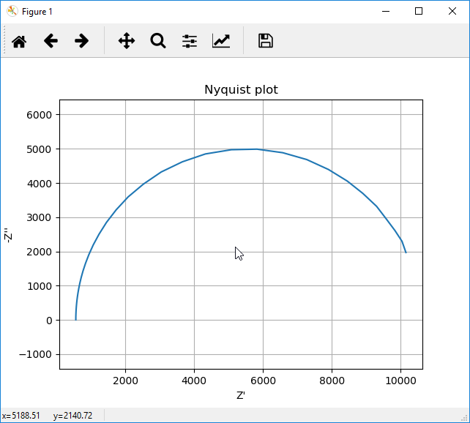

Figure 3; Nyquist plot of Palmsens Dummy Cel WE C (Randles circuit)

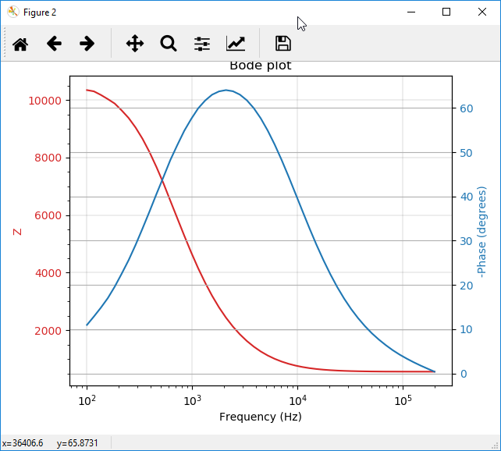

Figure 4;Bode plot of Palmsens Dummy Cel WE C (Randles circuit)