**Enhancing Functional-Structural Plant Models through Comprehensive Data Collection and Climate Scenario Analysis: A Case Study on Oil Palm Plants**

Raphael Perez1,2, Valentin Torrelli1,2,3,4, Sandrine Roques1,2, Sébastien DEVIDAL5, Clément PIEL5, Damien LANDAIS5, Merlin Ramel3,4, Thomas Arsouze3,4, Jean-Pierre Caliman6, Rémi Vézy3,4

*1CIRAD, UMR AGAP Institut, F-34398 Montpellier, France*

*2UMR AGAP Institut, Univ Montpellier, CIRAD, INRAE, Institut Agro, F-34398 Montpellier, France*

*3CIRAD, UMR AMAP, F-34398 Montpellier, France 4*

*4AMAP, Univ. Montpellier, CIRAD, CNRS, INRAE, IRD, F-34398 Montpellier, France*

*5Ecotron Européen de Montpellier, Unité Propre de Service 3248, Centre National de la Recherche Scientifique (CNRS), Campus Baillarguet, F-34980 Montferrier-sur-Lez, France;*

*6SMART Research Institute, Pekanbaru 28112, Indonesia*

# Abstract

Functional-structural plant models (FSPM) aim to replicate the intricate ecophysiological and developmental responses of plants to their surroundings environment. These models can be valuable for studying plant behavior in a changing climate but rely heavily on detailed structural and ecophysiological data. Limited databases hinder FSPM assessment due to the high cost and time required for data collection, including plant geometry, topology, and ecophysiological measurements. This scarcity often results in the omission of comprehensive FSPM evaluations.

A new dataset is proposed for FSPM evaluation at leaf to plant scale. Oil palm plants (*Elaeis guinnensis*) were sequentially placed in a growth chamber, where continuous measurements of H2O fluxes, CO2 fluxes, and leaf temperature were taken, alongside controlled air temperature, vapor pressure deficit, photosynthetically active radiation, and air CO2 concentration. This setup allowed for the investigation of the impact of climate variables on plant assimilation and transpiration through eight daily climate scenarios replicated on four plants. The dataset also includes data for model parameterization, such as detailed reconstructions of the 3D plant structure from terrestrial LiDAR point clouds and measurements of photosynthesis and stomatal conductance using leaf-scale response curves from a gas analyzer (including A/Ci, A/PPFD, and Gs/VPD response curves). The three-dimensional reconstructions of the plants and the growth chamber were utilized to create a digital twin of the experiment.

This database stands out for its comprehensive and complementary observations, enabling the testing of hypotheses on the spatial integration of physiological processes and the accuracy required in representing plants to capture the relationship between structure and function in FSPM.

Keywords: response curve; FSPM; temperature; radiation; VPD; CO2

# Introduction

Functional-structural plant models (FSPM) aim at reproducing the complexity of the ecophysiological and developmental responses of plants to their environment. Such models can be particularly useful to understand and explore plant behaviour in a changing climate, but depend on intensive collection of structural and ecophysiological data. Since errors can rise from different sources such as model implementation, calibration, and coupling, model evaluation can be a major difficulty. Furthermore, some sub-models simulate processes at fine scale (e.g. leaf scale) but the output of interest is an integration at a larger scale (i.e. plant or plot scale), which can also add errors that are difficult to assess when evaluation is only made at the finer scale. Lastly, very few databases are available for the assessment of FSPM because they require expensive and time-consuming measurements, including plant geometry and sometimes topology, ecophysiological data such as response curves (e.g. A-Ci), and whole-plant measurements to control for the error coming from the upscaling. Consequently, the assessment of an FSPM as a whole is usually omitted because of the lack of such data. However, it's crucial to thoroughly evaluate a model's ability to accurately replicate observed processes before applying it to avoid drawing incorrect conclusions.

Biophysical models like ARCHIMED (Dauzat & Eroy, 1997) simulate processes such as light interception, photosynthesis, transpiration and temperature at the leaf level under various environmental conditions. These models utilize leaf-scale measurements to parameterize different sub-models, enabling the upscaling of processes to the plant or plot level. Applications of these models range from simulating hard-to-measure variables (e.g., water and energy balance) to predicting system behavior under unfamiliar conditions (e.g., assessing climate change impacts) or even guiding trait selection for plant ideotyping. Evaluating a model becomes more challenging when numerous interconnected processes are simulated, as is often the case with biophysical processes in natural systems.

One approach to address this challenge is to compare model outputs with observations. However, observations are typically not conducted under highly controlled conditions with precise measurements, leading to additional unexplained sources of error. Schymanski and Or (2017)attempted to tackle the need for precise measurements in model evaluation, but their data is only relevant at the scale of an individual artificial leaf.

The proposed experiment aims to establish a database for evaluating a 3D biophysical model, by comparing measured CO2 fluxes, H2O fluxes, and leaf temperature with their simulated counterparts. This database provides all the elements needed to construct a digital twin o the experiment, such as growth chamber conditions, the 3D architecture of plants over time, and leaf-scale response curves obtained from a gas analyzer to calibrate photosynthesis and stomatal conductance models. All the raw data and the scripts to generate the final database are described and available on the following github repository: <https://github.com/PalmStudio/Biophysics_database_palm/tree/main>.

# Plant material and growing conditions

Four oil palm plants (*Elaeis guineensis Jacq.*) were studied, which included two genetic origin: Deli x Lame crossing (P1, P2 & P4) and a Deli x Yamgambi crossing (P3). The plants were sown on May 11th, 2020, and were cultivated in a glasshouse (Abiophen platform, CIRAD, Montpellier, France) under the following conditions: a temperature of approximately 26°C the day, 21°C the night, a relative humidity of 70%, a photosynthetically active radiation (PAR) of 600 µmol m-2 s-1, and an air CO2 concentration ([CO2]) of around 400ppm. To prevent water stress, the plants were irrigated every two to three days. On February 25th, 2021, the plants were transferred to the Ecotron (CNRS, Montpellier, France) and placed in a growth chambers wiht higly controlled climate, called microcosms. Two microcosms where used during 2 months to measure each of four plants with each condition. The two microcosms are 114cm (Width) x 113cm (Depth) x 152cm (Height) chambers with a radiation and climate control system that can precisely control the temperature, humidity, and CO2 concentration. The first microcosm was used to store three plants (storage microcosm), and the second one was used to measure the fluxes of a single plant in response to various climate conditions (see section Climate scenarios). Each plant took turns in the flux microcosm for three to five days (Figure 1).



Figure 1: Plant succession and climate scenarios in the flux microcosm. Grey cells indicate dates on which the plant ist he storage microcosm.

The scenarios with potential negative impacts on plant functionning du to extreme high temperature were performed the last days of measurements for each plant. Some repetitions of a scenario were performed to estimate changes in plant functionning over time. In the storage microcosm, the climate conditions were fixed to the reference scenario (400ppm), and each plant was irrigated every 6 hours using an irrigation system. The amount of water added during irrigation was adjusted over time to maintain non-limiting soil water availability throughout the experiment. In the flux microcosm, an irrigation system was also implemented to provide water every 6 hours, and the top of the pot was sealed with a non-emitting CO2 plastic bag to isolate the soil and roots, allowing only water and carbon fluxes from the aerial part of the plant to be measured (Figure 2).

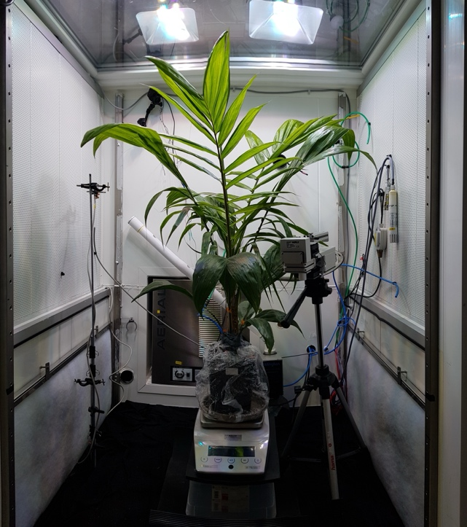

Figure 2: Oil palm plant in the flux microcosm. The pot was sealed to prevent measuring soil fluxes. The head of the leaf gas exchange analyzer was positioned in the chamber to conduct light and CO2 response curves. A scale was positioned under the pot to measure plant transpiration using gravimetry. Sensors for photosynthetically active radiation, temperature, and relative humidity were installed in the chamber to regulate the environmental conditions.

# Climate scenarios

The chambers allowed for precise control of radiation in the visible spectrum with four LED lamps, as well as the climatic conditions, including temperature (5-50±0.5°C), relative humidity (20-90±3%), and CO2 concentration (10-2000ppm). The climate conditions in the microcosm were defined based on the average daily variation observed at a weather station in Pekanbaru, Indonesia, where the conditions are known to be optimal for oil palm cultivation. This base condition was then modified by adjusting the CO2 concentration, radiation, temperature, and relative humidity. The resulting climate scenarios were as follows: (Figure 3):

* 400ppm: the base condition
* 600ppm: +50% [CO2]
* 800ppm: + 100% [CO2]
* Cloudy: the same as base condition but with the PAR values based on the most cloudy day of our database from the weather station. The dynamic of the PAR is kept as in the base condition though. The maximum PPFD was 130 µmol m² s⁻¹ at 51cm from the lamps, compared to 300 in the reference scenario.
* Cold: -30% °C
* Hot: +30% °C
* DryCold: -30% relative humidity and -30% °C
* DryHot: -30% relative humidity and +30% °C



Figure 3: Monitoring of radiation, temperature, and relative humidity over time for the eight climate scenarios. Each transparent line represents a day of measurement, while the bold line signifies the median value across all days. Measurement of photosynthetically active radiation was conducted at the center height of the chamber. The reference scenario is the ‘400ppm’ scenario.

# CO2 and H2O fluxes at the plant level

CO2 fluxes were measured using a flow-through open system (Picarro G2101-I CO2 analyzer) connected to the chamber. This system recorded the input [CO2] in the chamber for 5 minutes, followed by measuring the output [CO2] for another 5 minutes. The difference between these two [CO2] values allowed for the calculation of CO2 fluxes resulting from plant photosynthesis or respiration within the chamber's air volume.

Transpiration was calculated through gravimetry using a precision scale connected to a datalogger, enabling the monitoring of plant weight over time. Any variations in the weight of the potted plant were considered to be a result of water loss through transpiration, as the pot was sealed with plastic film.

# Leaf gas exchange: calibrating photosynthesis and stomatal conductance

The leaf-level response to changing conditions was assessed using a Walz GFS-3000 portable chamber. Initially, half of the plant leaves were measured in the laboratory during a pre-experiment, alongside SPAD measurements. These measurements aimed to determine the impact of leaf nitrogen content (as indicated by the SPAD value) on the photosynthetic parameters of the leaf. The hypothesis suggested that leaf nitrogen content is associated with leaf age and/or position (where leaf position, or rank, corresponds to its age).

Typically, very young leaves are believed to have a lower photosynthetic capacity, while more mature leaves exhibit higher photosynthetic capacity, which then decreases with age due to nutrient remobilization. This dataset was utilized to establish a relationship between SPAD values and their effects on photosynthetic parameters.

Before subjecting the plants to various climatic sequences in the flux microcosm (see Figure 1), one leaf per plant was measured in the storage microcosm. The aim was to assess the plant's photosynthetic capacity immediately before implementing the sequences, aiming to calibrate models as realistically as possible while considering factors such as plant age. This measurement also served to explore the necessity of systematic measurements for simulating a plant and to determine if different scenarios impacted the plant's photosynthetic capacity over time. For instance, it helped evaluate whether challenging conditions like a hot and dry scenario imposed significant stress on the plant. The measurements involved conducting a response curve of carbon assimilation in relation to the increasing internal concentration of CO2 (A-Ci curves), followed by another response curve of carbon assimilation to decreasing photosyntetic photon flux density (A-PPFD curves) and a last response curve of carbon assimilation and stomatal conductance to increasing vapor pressure deficit (VPD). To elevate the VPD, the relative humidity within the chamber was decreased while maintaining a constant temperature. These curves were consistently carried out on the same leaf rank, specifically selected as the penultimate fully expanded leaf. Additionally, during each day of measuring response curves, SPAD values were recorded for all leaves of the plant.

In the database, A-Ci curves were used to fit the Farquahr-van Caemmerer-Berry (FvCB) model for C3 photosynthesis (Farquhar et al., 1980) and estimate the parameters *VCmax*, *Jmax*, *Rd* and *TPU*. Response curves to VPD were used to estimate the parameters of the stomatal conductance model of Medlyn (Medlyn et al., 2011), i.e *g0* and *g1.*

# Leaf temperature

# Plants architecture

**Reference**

Dauzat, J., & Eroy, M. N. (1997). Simulating light regime and intercrop yields in coconut based farming systems. In *Developments in Crop Science* (Vol. 25, Issue C, pp. 87–98). https://doi.org/10.1016/S0378-519X(97)80011-6

Farquhar, G. D., Caemmerer, S., & Berry, J. A. (1980). A biochemical model of photosynthetic CO2 assimilation in leaves of C3 species. *Planta*, *149*(1), 78-90–90. http://dx.doi.org/10.1007/BF00386231

Medlyn, B. E., Duursma, R. A., Eamus, D., Ellsworth, D. S., Prentice, I. C., Barton, C. V. M., Crous, K. Y., De Angelis, P., Freeman, M., & Wingate, L. (2011). Reconciling the optimal and empirical approaches to modelling stomatal conductance. *Global Change Biology*, *17*(6), 2134–2144. https://doi.org/10.1111/j.1365-2486.2010.02375.x

Schymanski, S. J., & Or, D. (2017). Leaf-scale experiments reveal an important omission in the Penman-Monteith equation. *Hydrology and Earth System Sciences*, *21*(2), 685–706. https://doi.org/10.5194/hess-21-685-2017

# 