重点标记
FrameworkServlet中configureAndRefreshWebApplicationContext(cwac);
这个方法中调用了refresh方法，这个才是真正启动IOC容器的入口

AbstractApplicationContext的refresh()启动整个容器对bean的载入过程

Application
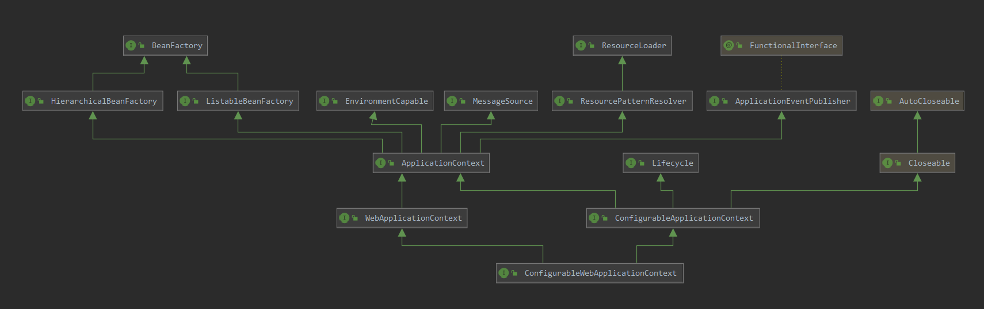
Dispatcher寻找init()
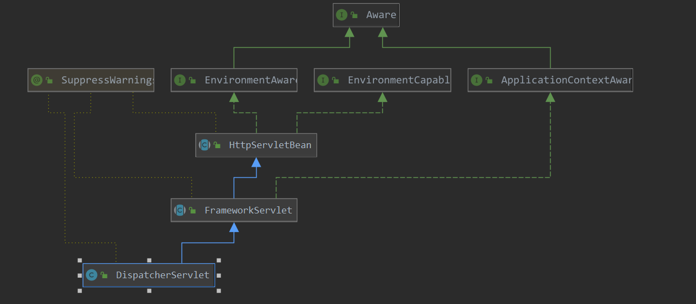

Refresh
@Override
public void refresh() throws BeansException, IllegalStateException {
synchronized (this.startupShutdownMonitor) {
// Prepare this context for refreshing.
//1、调用容器准备刷新的方法，获取容器的当时时间，同时给容器设置同步标识
prepareRefresh();
// Tell the subclass to refresh the internal bean factory.
//2、告诉子类启动refreshBeanFactory()方法，Bean定义资源文件的载入从
//子类的refreshBeanFactory()方法启动
ConfigurableListableBeanFactory beanFactory = obtainFreshBeanFactory();
// Prepare the bean factory for use in this context.
//3、为BeanFactory配置容器特性，例如类加载器、事件处理器等
prepareBeanFactory(beanFactory);
try {
// Allows post-processing of the bean factory in context subclasses.
//4、为容器的某些子类指定特殊的BeanPost事件处理器
postProcessBeanFactory(beanFactory);
// Invoke factory processors registered as beans in the context.
//5、调用所有注册的BeanFactoryPostProcessor的Bean
invokeBeanFactoryPostProcessors(beanFactory);
// Register bean processors that intercept bean creation.
//6、为BeanFactory注册BeanPost事件处理器.
//BeanPostProcessor是Bean后置处理器，用于监听容器触发的事件
registerBeanPostProcessors(beanFactory);
// Initialize message source for this context.
//7、初始化信息源，和国际化相关.
initMessageSource();
// Initialize event multicaster for this context.
//8、初始化容器事件传播器.
initApplicationEventMulticaster();
// Initialize other special beans in specific context subclasses.
//9、调用子类的某些特殊Bean初始化方法
onRefresh();
// Check for listener beans and register them.
//10、为事件传播器注册事件监听器.
registerListeners();
// Instantiate all remaining (non-lazy-init) singletons.
//11、初始化所有剩余的单例Bean
finishBeanFactoryInitialization(beanFactory);
// Last step: publish corresponding event.
//12、初始化容器的生命周期事件处理器，并发布容器的生命周期事件
finishRefresh();
}
catch (BeansException ex) {
if (logger.isWarnEnabled()) {
logger.warn("Exception encountered during context initialization - " +
"cancelling refresh attempt: " + ex);
}
// Destroy already created singletons to avoid dangling resources.
//13、销毁已创建的Bean
destroyBeans();
// Reset 'active' flag.
//14、取消refresh操作，重置容器的同步标识。
cancelRefresh(ex);
// Propagate exception to caller.
throw ex;
}
finally {
// Reset common introspection caches in Spring's core, since we
// might not ever need metadata for singleton beans anymore...
//15、重设公共缓存
resetCommonCaches();
}
}
}

