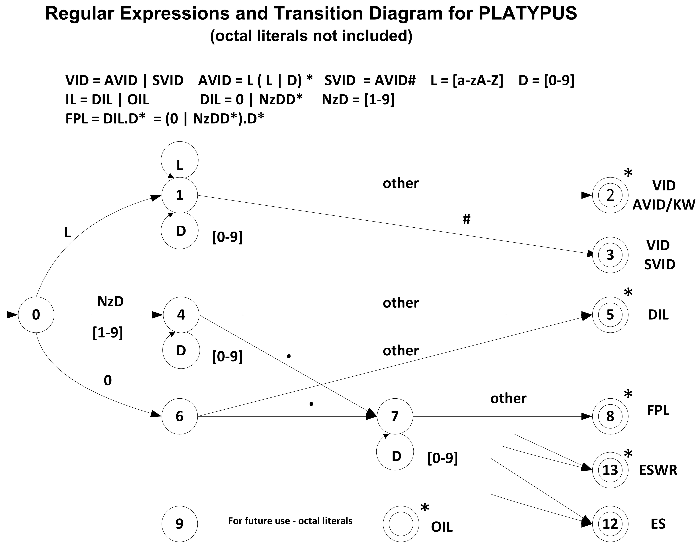

Transition Table
Current  State |  | INPUT SYMBOL |  |  |  |  |  |  | State Type  (Not Accepting or Accepting State)
Current  State | [a-zA-z] |  | 0 | [1-7] | [8-9] | . | # | other | State Type  (Not Accepting or Accepting State)
0 | 1 |  | 6 | 4 | 4 | IS/ES | IS/ES | IS/ES | NOAS
1 | 1 |  | 1 | 1 | 4 | E/A(2) | 3 | 2 | NOAS
2 | IS |  | IS | IS | IS | IS | IS | IS | VID AVID/KW - ASWR
3 | IS |  | IS | IS | IS | IS | IS | IS | VID SVID - ASNR
4 | E/A(5) |  | 4 | 4 | 4 | 7 | 5 | 5 | NOAS
5 | IS |  | IS | IS | IS | IS | IS | IS | DIL - ASWR
6 | ES |  |  |  | ES | 7 | ES | 5 | NOAS
7 | E/A |  | 7 | 7 | 7 | E/A | 8 | 8 | NOAS
8 | IS |  | IS | IS | IS | IS | IS | IS | FPL - ASWR
9 | ES |  | 9 | 9 | 11 | ES | ES | 11 | NOAS
10 | ES |  | ES | ES | ES | ES | ES | 11 | NOAS
11 | IS |  | IS | IS | IS | IS | IS | IS | OIL-ASWR
12 | IS |  | IS | IS | IS | IS | IS | IS | ES - ASNR
13 | IS |  | IS | IS | IS | IS | IS | IS | ESWR - ASWR

IS – Illegal State ES – Error State E/A – Error State or Accepting State
NOAS – Not Accepting State
ASWR - Accepting State With Retract ASNR - Accepting State No Retract

