REPORT

IoT-Based Smart Water Monitoring, Scheduling, and Leakage Detection System for Municipal Applications

Course Name: IOT FUNDAMENTALS Course Code: ECE-3501

Submitted By:
Dogiparthi Harini 22MIS1174
Daneshwaran 22MIS1124
Pamala Thanmai 22MIS1030

Abstract:
This project presents the design and implementation of an IoT-based Smart Water Management System intended to assist municipalities in efficiently monitoring and managing water distribution. The system integrates multiple IoT modules to track water usage, detect leakage, measure soil moisture, and provide real-time data visualization. Unlike fully automated systems, this project employs manual scheduling for water distribution, while leveraging IoT-based data collection to support data-driven decisions. The system utilizes Arduino and NodeMCU microcontrollers to collect, process, and transmit sensor data to a cloud dashboard. Various sensors, including soil moisture and rain detection modules, enable precise environmental monitoring. The Real-Time Clock (RTC) module maintains time-based data logging, while the relay module controls water pumps under operator supervision. By combining IoT sensing, manual control, and cloud visualization, the project demonstrates a cost-effective, reliable, and scalable approach to achieving efficient and sustainable water management for municipal applications.

PROJECT INTRODUCTION
Water scarcity and inefficient distribution remain pressing global challenges, particularly in urban municipalities that struggle to balance supply and demand. Traditional water management methods often rely on static scheduling without real-time insights, leading to either water wastage or shortages in different zones. This project addresses these issues by developing an IoT-based Smart Water Management System that enables municipalities to make informed manual scheduling decisions using sensor data and IoT connectivity.

The proposed system continuously monitors key parameters such as soil moisture, rainfall detection, and pump status. Data collected by Arduino and NodeMCU modules are transmitted to a cloud or dashboard interface for real-time visualization. Municipal operators can manually control water pumps and schedule supply times based on live feedback and sensor data, thereby achieving improved efficiency without the complexity or cost of full automation. By employing low-cost components and open-source software (Arduino IDE, Embedded C), this project offers an affordable and practical solution for municipalities to adopt smart water management practices that promote sustainability and reduce wastage.

GOAL
The primary goal of this project is to design and implement an IoT-based Smart Water Management System that supports municipalities in managing water distribution manually based on real-time data insights. The system aims to minimize water wastage, detect leaks, and optimize resource usage for agricultural areas, gardens, and public infrastructure.

OBJECTIVES
Specific objectives include:
  - To develop an IoT-based water monitoring system that provides real-time data on water levels, soil moisture, and rainfall conditions.
  - To design a manual scheduling interface that allows municipal staff to operate water pumps based on live data insights.
  - To implement a leakage detection mechanism using sensor data analysis for flow irregularities.
  - To measure and record soil moisture levels in public parks and agricultural zones for sustainable irrigation.
  - To use the RTC module for accurate time-stamped data logging and manual scheduling reference.
  - To integrate an LCD display and buzzer for local notifications and alerts.
  - To establish IoT connectivity through NodeMCU for cloud data visualization and remote monitoring.
  - To ensure system scalability, affordability, and reliability using readily available components and open-source software tools.

SYSTEM DESIGN AND IMPLEMENTATION

System Architecture
The system employs modular three-layer architecture:
  - Sensing Layer: Includes sensors such as the soil moisture sensor, raindrop sensor, and water level indicators that continuously monitor environmental and operational parameters.
  - Processing Layer: The Arduino microcontroller acts as the central processing unit, gathering input data from sensors, controlling relays, and interfacing with the RTC and LCD modules. NodeMCU is used to transmit processed data to the cloud for IoT monitoring.
  - Visualization Layer: A web-based or cloud dashboard provides data visualization for operators. It displays real-time sensor data, alerts, and manual control options for pump scheduling and system supervision.

Figure 1: Block Diagram
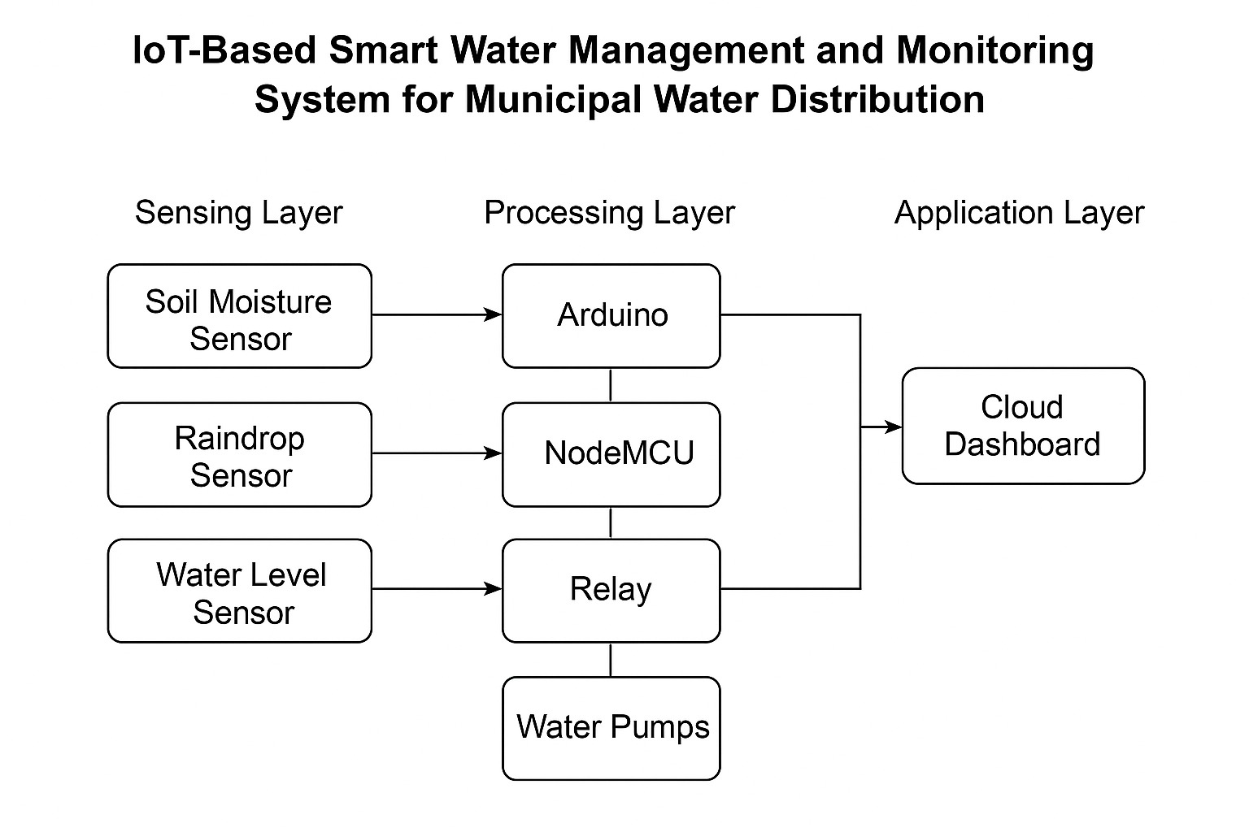

Hardware Components
Table 1: List of Components and Specifications

Component | Specification / Function
Arduino UNO | Main controller for sensor interfacing and control logic
NodeMCU (ESP8266) | IoT module for cloud connectivity and data transmission
RTC Module | Maintains real-time clock for time-stamped monitoring
LCD Display (16×2) | Displays real-time sensor readings and system status
Buzzer | Provides audio alerts for leakage or abnormal conditions
Relay Module | Controls water pumps manually through Arduino
Water Pumps | Represents municipal water distribution to various zones
Soil Moisture Sensor | Measures moisture level in soil to assist irrigation
Raindrop Sensor | Detects rainfall to adjust or delay water supply manually
Power Supply | Provides regulated DC voltage for system operation

Software Architecture
The software implementation on ESP32 includes:
- Sensor Data Acquisition: Collects data from the soil moisture and raindrop sensors.
- Data Processing: Converts analog sensor signals into digital readings using Arduino’s ADC.
- Control Logic: Controls the relay module and buzzer based on threshold conditions.
- Time Management: Uses the RTC module to log readings and assist manual scheduling.
- IoT Communication: NodeMCU uploads data to the cloud, enabling remote access and visualization.
- Display and Alerts: LCD shows real-time readings; buzzer indicates leaks or low water conditions.

Implementation Details
Sensor Configuration and Placement
- Soil moisture sensors are placed in representative areas (parks or fields).
- Raindrop sensors detect precipitation to inform manual scheduling.
- Flow or pump status is monitored through relay and power feedback.
Manual Scheduling Process
- Operators observe live data on the IoT dashboard.
- The RTC module records the operation time for future reference.
- Based on soil moisture, rainfall, and water level data, pumps are manually activated or deactivated via relay control.
Data Transmission and Visualization
- NodeMCU transmits real-time data to the IoT cloud platform.
- The dashboard displays graphical data trends for municipal staff to analyze.
- Alerts are generated when thresholds (e.g., low moisture or water overflow) are detected.
Local Indication System
- LCD shows current sensor readings and pump status.
- The buzzer gives an audible warning if irregular conditions occur (e.g., low moisture, leak detection).

NOVELTY / CONTRIBUTION
This project introduces several innovative aspects in IoT-based municipal water management:
  - Manual Scheduling with IoT Insight: Unlike fully automated systems, this project empowers human operators to make smarter manual decisions using live IoT data.
  - Integration of Environmental Parameters: Combines soil moisture and rainfall monitoring for more informed water supply management.
  - Low-Cost and Scalable Design: Built with affordable components, ensuring easy replication for small and large municipalities.
  - Local and Cloud Monitoring: Provides both on-site (LCD, buzzer) and remote (cloud dashboard) status updates.
  - Energy Efficiency: Relays and pumps operate only when required, reducing unnecessary power and water usage.
  - Time-Aware Operation: RTC-based timestamping allows historical data analysis and scheduling optimization.

IOT LEVELS AND JUSTIFICATION
This project corresponds to IoT Level 3: Cloud Data Monitoring with Local Control.
Justification:
- Data Acquisition and Local Control: Arduino handles sensor data collection and local relay control.
- Cloud Connectivity: NodeMCU transmits data to an IoT dashboard for remote monitoring.
- Manual Human Interaction: Operators analyze IoT data and decide pump operation manually, distinguishing it from fully autonomous systems (Level 4).
- Real-Time Feedback: Continuous sensor updates and alerts allow responsive management.
- Hybrid Operation: Combines edge processing (Arduino) and cloud storage (NodeMCU) for optimized performance.

REAL WORLD APPLICATION
This system has numerous municipal and environmental applications:
  - Urban Water Supply Management: Helps city authorities plan and manage daily water distribution efficiently.
  - Public Parks and Gardens: Provides soil moisture-based irrigation support, ensuring healthy plant growth with minimal water waste.
  - Agricultural Areas: Farmers and rural water departments can monitor and manually control irrigation schedules.
  - Leakage Detection and Maintenance: Identifies abnormal conditions in pipelines, allowing early maintenance actions.
  - Smart City Integration: Can serve as a component of broader smart city infrastructure for sustainable resource management.
  - Educational and Research Use: Demonstrates IoT integration in environmental monitoring and control systems.

FUTURE WORK
Future Improvements to this project may include:
  - Automatic Water Scheduling: Integrate machine learning algorithms to predict water demand and automate scheduling.
  - Flow and Pressure Sensors: Add sensors for detailed leakage and distribution monitoring.
  - Mobile App Development: Create a dedicated Android/iOS app for enhanced user interaction.
  - Solar Power Integration: Implement renewable energy for pump operation and system power supply.
  - Data Analytics and Reporting: Enable cloud-based analytics for long-term consumption trends and anomaly detection.
  - Integration with Municipal SCADA Systems: Connect to supervisory control systems for citywide automation.
  - AI-Based Demand Prediction: Use predictive modeling for smarter water allocation planning.

REFERENCES
Here are recent academic papers relevant to this project's domain:
- Rao, K.R., Srinija, S., Bindu, K.H. and Kumar, D.S., 2018. IOT based water level and quality monitoring system in overhead tanks. International Journal of Engineering & Technology, 7(2), pp.379-383.
- Wang, D., Chen, H., Ma, Z. and Yi, B., 2025. Optimization scheduling for multi-source water distribution systems in mountainous region based on seagull optimization algorithm. Modern Physics Letters B, 39(13), p.2450497.
- Khan, R., Zakarya, M., Balasubramanian, V., Jan, M.A. and Menon, V.G., 2020. Smart sensing-enabled decision support system for water scheduling in orange orchard. IEEE Sensors Journal, 21(16), pp.17492-17499.
- Romano, M. and Kapelan, Z., 2014. Adaptive water demand forecasting for near real-time management of smart water distribution systems. Environmental Modelling & Software, 60, pp.265-276.
- Hajgató, G., Paál, G. and Gyires-Tóth, B., 2020. Deep reinforcement learning for real-time optimization of pumps in water distribution systems. Journal of Water Resources Planning and Management, 146(11), p.04020079.
- Li, F., Ma, L., Sun, Y. and Mathew, J., 2016. Optimized group replacement scheduling for water pipeline network. Journal of Water Resources Planning and Management, 142(1), p.04015035

