Configuration and run Venafi simulator
- Open folder and run file “AdaptableCASimulator.exe” as Administrator
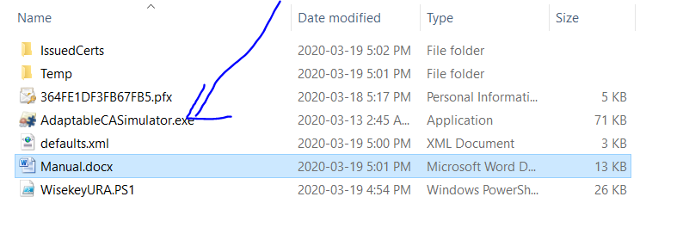
- Configure app to run
- At Username, enter “34614391-AF70-44A8-92CD-F5C825698094”
- At Password, enter …
- At Client Certificate File, browse to select to file “364FE1DF3FB67FB5.pfx” in working folder
- At File Password, enter …
- At PowerShell Script choose “WisekeyURA” (List all file PS1 in folder)

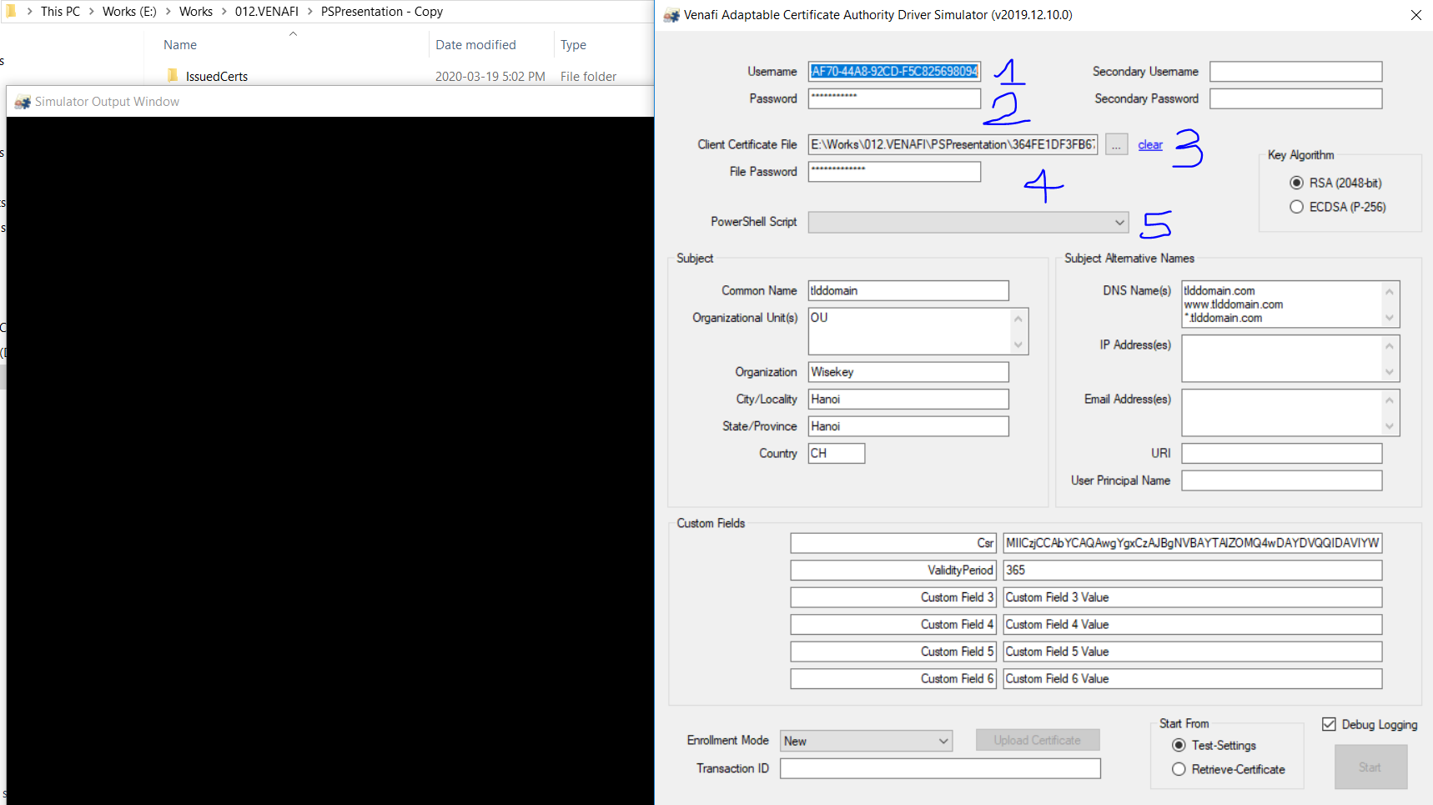

- Fill parameters to create request, get certificate from URA
- Fill data to Common Name, Organization, Country , DNS Name(s).
- In Customer Fields add 2 fields (optional) and value for certificate:
- Csr = [Csr of certificate] or [Path to file Csr] or [empty]
- Validity Period = [day number] or [empty]
- Select mode to run simulator:
At Enrollment Mode, select “New”
At Start Form, Select “Test-Settings”
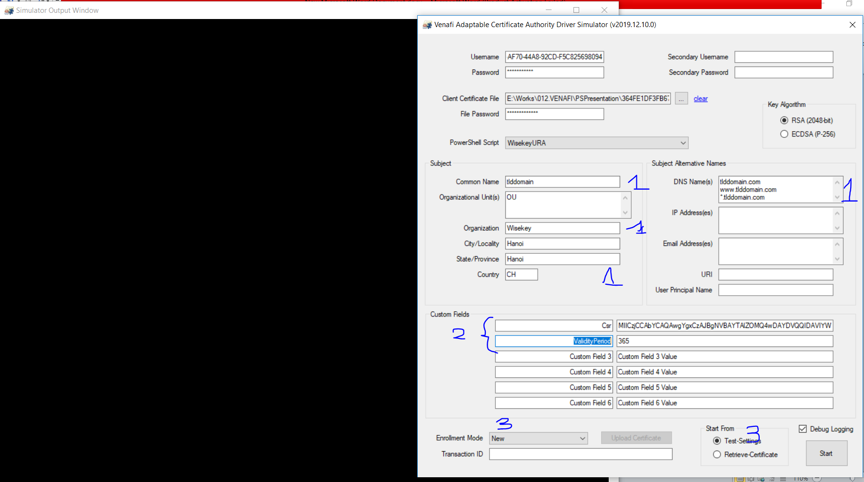

- Run and view console
Press “Start” button to run simulator an view result
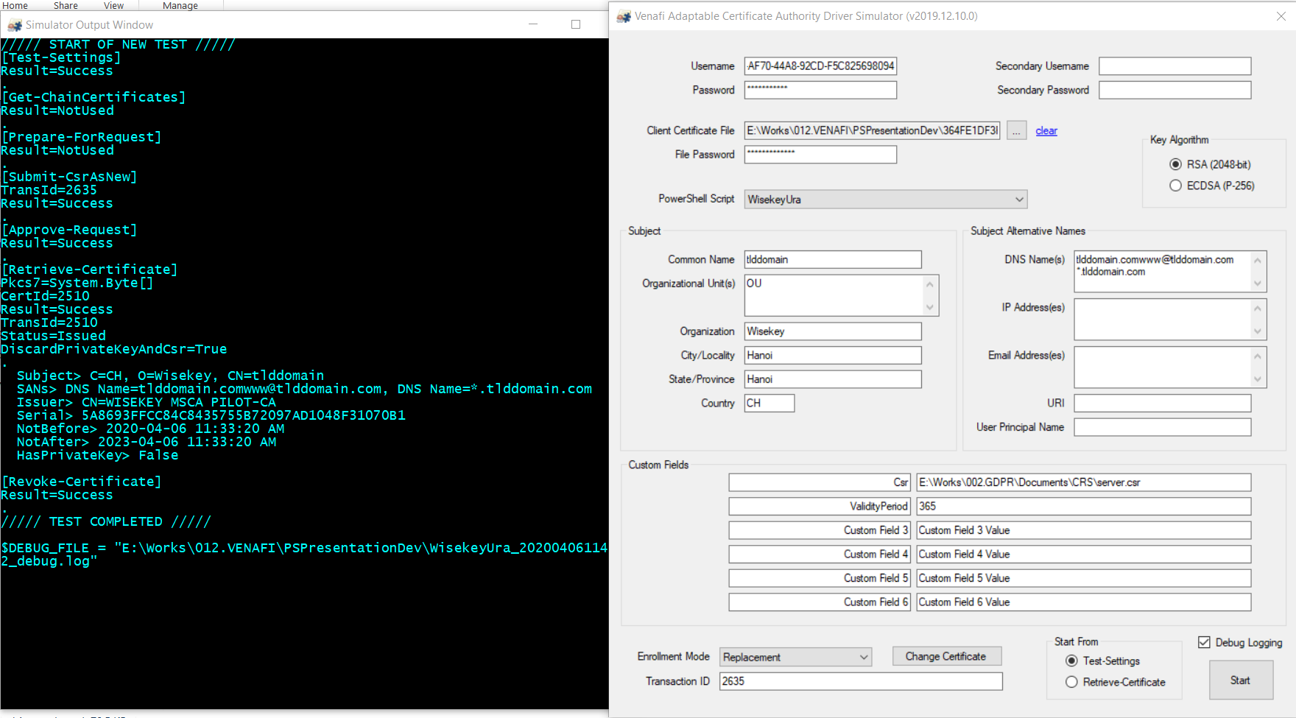

- Note:
- Current support case create “New”, not support case “Renewal” and “Replacement”
- Log files store in working folder.
- The CSR store at file [Working Folder]/ CertsData /csr_<ID>.txt
- The request id store at file [Working Folder]/ CertsData/ request_id_<ID >.txt
- The certificates store at file [Working Folder]/ CertsData/ cert_id_<ID >.cer

The main function of script
- Test-Settings
Verifies the ability to connect to and authenticate with the URA using the supplied credentials.
- Details:
<##################################################################################################
.NAME
Test-Settings
.DESCRIPTION
Verifies the ability to connect to and authenticate with the URA using the supplied credentials
.PARAMETER General
A hashtable containing the general set of variables needed by all or most functions
UserName : the username for authenticating with the URA
UserPass : the password for authenticating with the URA
PfxData : a PKCS#12 containing client certificate and private key for authenticating with the URA
PfxPass : the password for access to the private key in the PKCS#12
AuxUser : a username paired with AuxPass for secondary authentication purposes
AuxPass : the password for the AuxUser (username credential), AuxPfxData (certificate credential), or independent (password credential)
AuxPfxData : a PKCS#12 containing client certificate and private key for secondary authentication purposes
CertObjDN : the Venafi distinguished name of the certificate object in the policy tree
CustomFields : hashtable of Custom Fields; keys are field labels and values are strings (single valued) or string arrays (multi-valued)
.NOTES
Returns a hashtable that includes the following variables
Result : 'Success' or 'NotUsed' to indicate the non-error completion state
##################################################################################################>

- Submit-CsrAsNew
Submits a CSR to URA for enrollment as a new, first time certificate.
- Details:
<##################################################################################################
.NAME
Submit-CsrAsNew
.DESCRIPTION
Submits a CSR to URA for enrollment as a new, first time certificate
.PARAMETER General
A hashtable containing the general set of variables needed by all or most functions (see Test-Settings)
.PARAMETER Specific
A hashtable containing the specific set of variables needed by this function
Pkcs10 : the Base64-encoded PKCS#10 formatted certificate signing request to be enrolled
SubjectDN : the requested subject distiguished name as a hashtable; OU is a string array; all others are strings
SubjAltNames : hashtable keyed by SAN type; values are string arrays
.NOTES
Returns a hashtable that includes the following variables
Result : 'Success' to indicate the non-error completion state; this function is required
TransId : the identifier used to subsequently approve and/or retrieve the certificate request from the URA
Pkcs7 : a collection that includes the issued certificate and optionally includes all of the URA certificates in the chain
Pkcs12 : a collection that includes the issued certificate, its private key, and optionally all of the URA certificates in the chain
PrivKeyPem : an OpenSSL or PKCS#8 private key in PEM format
EncryptPass : the password used to encrypt the private key or PKCS#12
##################################################################################################>

- Submit-CsrAsRenewal
Submits a CSR to a URA for enrollment as a renewal of an existing certificate
- Details:
<##################################################################################################
.NAME
Submit-CsrAsRenewal
.DESCRIPTION
Submits a CSR to a URA for enrollment as a renewal of an existing certificate
.PARAMETER General
A hashtable containing the general set of variables needed by all or most functions (see Test-Settings)
.PARAMETER Specific
A hashtable containing the specific set of variables needed by this function (see Submit-CsrAsNew plus the following)
CertId : a integer that the URA can use to uniquely identify the certificate request being renewed
CertPem : the raw, Base64-encoded X509 certificate to be renewed
.NOTES
Returns a hashtable that includes the same variables detailed in Submit-CsrAsNew
##################################################################################################>

- Submit-CsrAsReplacement
Submits a CSR to a URA for enrollment as a replacement for an existing certificate
- Details:
<##################################################################################################
.NAME
Submit-CsrAsReplacement
.DESCRIPTION
Submits a CSR to a URA for enrollment as a replacement for an existing certificate
.PARAMETER General
A hashtable containing the general set of variables needed by all or most functions (see Test-Settings)
.PARAMETER Specific
A hashtable containing the specific set of variables needed by this function (see Submit-CsrAsNew plus the following)
CertId : a integer that the URA can use to uniquely identify the certificate request being replaced
CertPem : the raw, Base64-encoded X509 certificate to be replaced
.NOTES
Returns a hashtable that includes the same variables detailed in Submit-CsrAsNew
##################################################################################################>

- Approve-Request
Approves a previously submitted CSR
- Details:
<##################################################################################################
.NAME
Approve-Request
.DESCRIPTION
Approves a previously submitted CSR
.PARAMETER General
A hashtable containing the general set of variables needed by all or most functions (see Test-Settings)
.PARAMETER Specific
A hashtable containing the specific set of variables needed by this function
TransId : a integer that uniquely identifies the certificate request submitted to the URA
.NOTES
Returns a hashtable that includes the following variables
Result : 'Success' or 'NotUsed' to indicate the non-error completion state
##################################################################################################>

- Retrieve-Certificate
Retrieves a signed certificate from the URA
- Details:
<##################################################################################################
.NAME
Retrieve-Certificate
.DESCRIPTION
Retrieves a signed certificate from the URA
.PARAMETER General
A hash table containing the general set of variables needed by most (or all) functions (see Test-Settings)
.PARAMETER Specific
A hash table containing the specific set of variables needed by this function
CertId : a integer that uniquely identifies the certificate request issued by the URA
.NOTES
Returns a hash table that includes the following variables:
Result: 'Success' or 'NotUsed' to indicate the non-error completion state
Status: 'Pending' or 'Issued' to indicate whether the certificate has been issued by the URA
Pkcs7: a collection that includes the issued certificate and (optionally) all of the URA certificates in the chain
DiscardPrivateKeyAndCsr : boolean that when $true tells the driver to discard stored assets that will not match the certificate being returned
##################################################################################################>

- Revoke-Certificate
Revokes a certificate issued by the URA
- Details:
<##################################################################################################
.NAME
Revoke-Certificate
.DESCRIPTION
Revokes a certificate issued by the URA
.PARAMETER General
A hash table containing the general set of variables needed by most (or all) functions (see Test-Settings)
.PARAMETER Specific
A hash table containing the specific set of variables needed by this function
CertId: a integer that uniquely identifies the certificate request issued by the URA
CertPem: the raw, Base64-encoded X509 certificate to be revoked
ReasonCode : 1 (User Key Compromised), 2 (CA Key Compromised), 3 (User Changed Affiliation), 4 (Certificate Superseded), 5 (Original Use No Longer Valid)
Comment: a comment provided by the revocation requester
.NOTES
Returns a hashtable that includes the following variables:
Result: 'Success' or 'NotUsed' to indicate the non-error completion state
##################################################################################################>

