

ztPKI Import Setup

Table of Contents
Table of Contents 2
// Scope & Objectives 2
// Audience and assumptions 2
//Configuration Procedure Section 6
Capture Policy ID from ztPKI 6
Create Credentials 8
Venafi Username and Password Credential 10
Adaptable Job Creation 11
//Execution Section 12
//Troubleshooting 14

Document control

Version History
Version | Date | Description
1.0 | 4/4/2023 | Initial Usage guide
1.01 | 4/24/2024 | Updates for configuration values related to new filter features on import script

// Scope & Objectives
The purpose of this document is to provide a usage guide for a ztPKI Adaptable CA Import only script to pull in certificate inventory into Venafi Trust Protection Platform instance from a ztPKI Certificate Authority that has been setup for a customer.

// Audience and assumptions
This document is intended for administrators of the Venafi Trust Protection Platform servers. It is assumed that Venafi Trust Protection Platform has been deployed and the administrators are familiar with general concepts in TPP including certificate imports and also familiarity and access to a ztPKI account as well as administrative access to a ztPKI console.
The assumption is also that ztPKI onboarding has been completed, that the series of certificate authorities have been created, policy templates have been created and certificates have been successfully issued from ztPKI. The primary use case for this ztPKI Import only Adaptable solution is to pull in existing ztPKI certificate inventory for visibility and review within Venafi Trust Protection Platform. If it is desired to create or issue certificates from within Venafi Trust Protection Platform, the ztPKI Driver install should be performed.

The version of Venafi Trust Protection Platform server is assumed to be at least in the 21.x Release branch. The sample script provided for this has no assumptions of support from Venafi without going through the Venafi Software Extension (VSE) process. The helper script includes a license that indemnifies Venafi from any support or issues that may arise.

Copyright (c) 2023 Venafi, Inc. All rights reserved.
//
// Venafi, Inc. hereby grants you limited permission to use and modify this software during only the period in which you
// hold a valid license from Venafi, Inc. to use the Venafi Trust Protection Platform, on condition that (a) such use or
// modification is for your sole internal business use, and (b) you hereby assign to Venafi, Inc. all rights in any
// modifications of this software that you may create (and agree to take all such actions as may be necessary and desirable
// to perfect such assignment), except that you (i) shall retain any Background Intellectual Property that you may
// incorporate into any such modifications and (ii) hereby agree to grant Venafi, Inc., a perpetual, worldwide, royalty
// free license to use, copy, modify, reproduce, distribute such modifications, including, without limitation, any
// Background Intellectual Property incorporated into such modifications. For the purposes of this paragraph, â€œBackground
// Intellectual Propertyâ€ means any intellectual property developed by you independently of this software (or any
// modifications thereof). You may not copy, reproduce or distribute this software (or any modifications thereof) without
// the prior written consent of Venafi, Inc. (which may be by email). Without limiting the foregoing, the above copyright
// notice, this paragraph and the following paragraph must appear in all copies, modifications, reproductions, and
// distributions of this software.
// IN NO EVENT SHALL VENAFI, INC., ITS DIRECTORS, OFFICERS, EMPLOYEES, AGENTS, OR AFFILIATES BE LIABLE TO ANY PARTY FOR
// DIRECT, INDIRECT, SPECIAL, INCIDENTAL, OR CONSEQUENTIAL DAMAGES, INCLUDING LOST PROFITS, ARISING OUT OF THE USE OF THIS
// SOFTWARE OR ITS DOCUMENTATION, IF ANY, EVEN IF VENAFI, INC. HAS BEEN ADVISED OF THE POSSIBILITY OF SUCH DAMAGES.
// VENAFI, INC. SPECIFICALLY DISCLAIMS ANY WARRANTIES, INCLUDING, BUT NOT LIMITED TO, ANY IMPLIED WARRANTIES OF
// MERCHANTABILITY OR FITNESS FOR A PARTICULAR PURPOSE. THIS SOFTWARE, ALONG WITH ITS DOCUMENTATION, IF ANY, IS PROVIDED
// "AS IS". VENAFI, INC. HAS NO OBLIGATION TO PROVIDE MAINTENANCE, SUPPORT, OR UPDATES FOR THE SOFTWARE OR ITS
// DOCUMENTATION, IF ANY.

// Introduction
Zero Touch PKI (ZTPKI) is a simple and secure private CA managed by Venafi.
Venafi Zero Touch PKI is a fully SaaS-based alternative to creating and running your own internal PKI. It can be configured and managed in any way you need, in conjunction with multiple CAs and with the options you need for security and traceability.
Venafi Zero Touch PKI gives you:
- Complete policy control and delegated administration
- Automation for mixed IT environments using Venafi TLS Protect
- Active Directory and Autoenrollment integration
- Multiple options
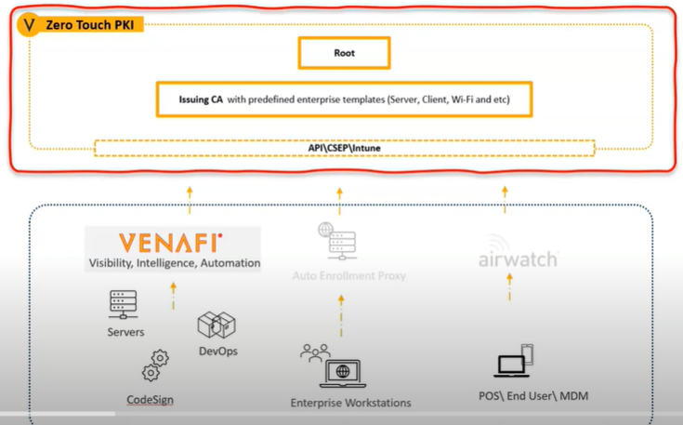
This guide will walk you through the integration process of running a certificate import from ZTPKI within your existing TPP environment. Venafi Trust Protection Platform allows for certificate imports from certificate authorities as a way of gaining visibility and governance on your machine identities. Venafi Trust Protection Platform also has an ‘Adaptable’ framework that uses powershell scripts to provide maximum flexibility with any Certificate Authority that may be leveraged by a customer.

// ztPKI Adaptable CA Import Only Script

Overview of ztPKI Adaptable CA import Script
- The script can be downloaded and will need to be installed on every Venafi Trust Protection Platform server. The script will need to be placed in the Venafi install directory under Scripts\Adaptable CA folder.
- ztPKI Dependencies
The script requires the following from ztPKI
- A user with access to a customer account or organization
- an API Key issued for the user on the ztPKI Console

Use of the script requires adding an API Integration in Venafi TPP for a named application (details below in the configuration screen).
- Venafi Trust Protection Platform dependencies
The windows servers running Venafi Trust Protection Platform will need access to the ztPKI system locations on the internet in order to reach the API endpoints.
- ZTPKI Production URL: https://ztpki.venafi.com
- ZTPKI Staging URL: https://ztpki-staging.venafi.com
To run the Adaptable CA script, a Certificate import adaptable job will need to be setup to leverage the script and the various settings for these types of jobs.
The Certificate import adaptable job will need the following:
- The script name from step 1
- A credential created for the user API Key from step 2
- The ztPKI url in use for either production or staging
- Options for profile string to isolate a particular policy template if desired
- Setting options for include revoked or expired certificates
- A policy folder to place results into

For more information regarding an Adaptable CA Certificate import job refer to this link
https://docs.venafi.com/Docs/current/TopNav/Content/CA/t-CA-Import-ConfiguringCertImport-AdaptableCA-Aperture.php

- Script Logic
  - The script will run under the context of a certificate import job only.
  - The script will pull down the credentials from the certificate import job, the selections for profile string and filters on expired or revoked certificates.
  - In default mode, the script will , on first run, connect to the ztPKI API and pull in all certificates up to 30K records at a time with a max limit of 100K and a max timer of an hour.
  - If the script does not complete the work within an hour or goes past the default 30K cert import limit, it will return incomplete and will pick back up at the last order an hour later. On first run, this will return complete once it has reached the last order.
  - If the script has been previously run, in its default mode it will refer to the last processed ID and only start backup at the last order to make the import job more efficient.
  - On subsequent runs, if the script does not complete the work within an hour or goes past the default 30K new cert import limit , it will return incomplete and will pick back up at the last order an hour later.
  - Adaptable CA job certificate inventory that has been found by the script will be processed by TPP in the following manner:
On first run:

- Once the job has completed, the adaptable CA import job will display results on the inventory placement.
- Certificates not already in inventory will be placed in the default folder.
- Certificates already in inventory will not be placed and will be classified as “Already Managed”.
- Certificates matching exact details on subject/SAN but are unique will be updated to the History tab on the existing certificate object and will be classified as “Updated”.
- The script will return the latest processed certificate ID.

On subsequent runs:

- The script will read the last processed ID and will ignore certificates until it finds the latest processed certificate ID and will start collecting certificate inventory from that point in and will return results back to TPP.
- Once the job has completed, the adaptable CA import job will display results on the inventory placement.
- Certificates not already in inventory will be placed in the default folder.
- Certificates already in inventory will not be placed and will be classified as “Already Managed”. By default, there will be always at least one certificate ‘already managed’ metric due to the way the script will pick up the last processed id.
- Existing Certificates matching exact details on subject/SAN but are unique will be updated to the History tab on the existing certificate object and will be classified as “Updated”.
- Certificates that have been previously deleted from this CA import job will be classified as ignored.

Note on the ignored metrics:
- Venafi Trust Protection Platform will not import certificates that are Certificate Authority certificates.
- Deleted certificates from the existing import job will never be re-imported if an admin has made a request to remove certificates. This is a component of certificate reconciliation logic. To pull in previously deleted certificates for evaluation will require either an edit key from Venafi Support to disable reconciliation or to delete and recreate the certificate import job.

//Configuration Procedure Section

Capture Policy ID from ztPKI
ZTPKI Instance Table

Zero Touch PKI Instance | US | EU
ZTPKI Production URL | https://ztpki.venafi.com | https://ztpki.eu.venafi.com

Note: You should log into the production instance of Zero Touch PKI using your Account Administration account via your configured SSO.
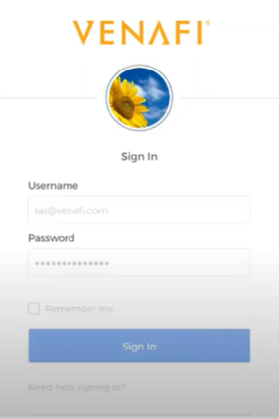
- Logon to ZTPKI. Go to Accounts and download the Policy IDs as a CSV.
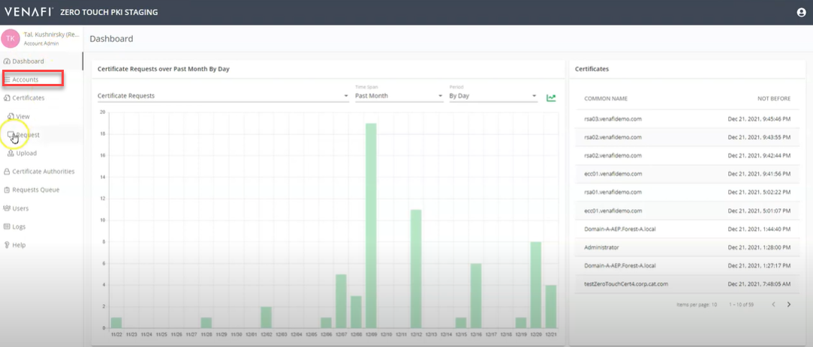
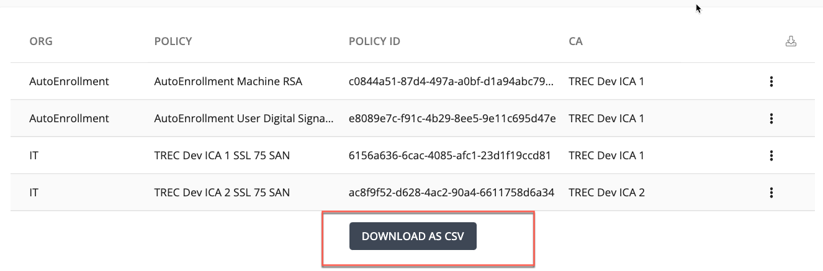
Note: A policy ID is the equivalent to a certificate template.
- Review the desired Policy and record the policy ID for the CA template that you wish to import which will be used in a later step.

Create Credentials

Zero Touch PKI
It is assumed that a service user account has been created that will has been used for other ztPKI certificate issuance. This service account needs to be part of the SSO so that the service account can login to create an API key to be used as credentials within TPP. If an existing API key has been created that has access to the organization for the policy templates, this can be used and you can skip to the adaptable Job creation section. Review Notes below.

Note:
- e-Mail address should be tied to team distribution list/role.
- Account should not be a person.
- The role should be an Organizational Requestor, which is the least privileged role that can also submit, renew, and revoke certificate requests.
- The role should have access to the organizations that are desired to import into Venafi TPP.
- API Requesters do not normally logon to the console, except to generate the API key or Roll the API key when API key rollover is required.
- If an API Key is created under a regular user, then that ZTPKI integration may break when the user leaves and their account is Blocked in ZTPKI.

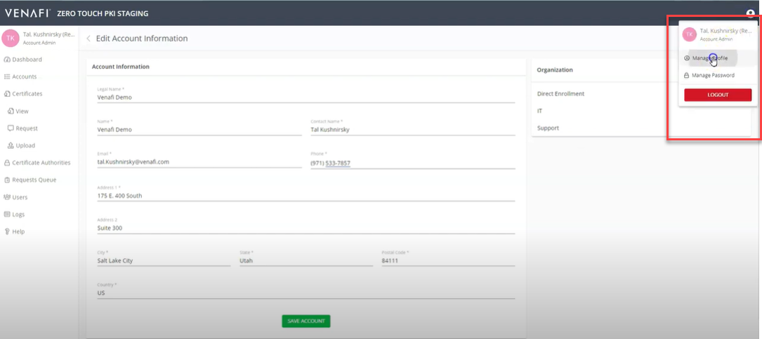
- Click on the service account user that the API key will be creating in.
- Under API service account user account, scroll down and click ADD API KEY in ZTPKI console.

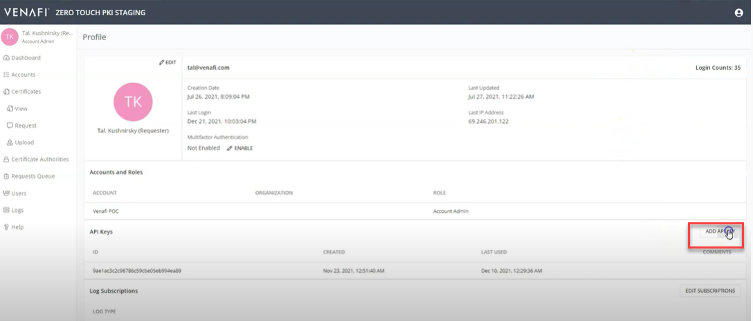

- In the API Key Details dialog box record the both the ID, also known as the HAWK ID and the Key

Note: Make sure to capture a copy of this API key as this is the only time it will be displayed. You will need it in the Trust Protection Platform credentials setup for the ZTPKI CA Driver configuration.

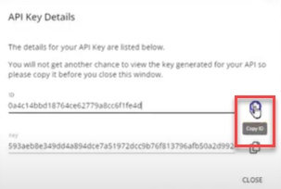

Venafi Username and Password Credential

- Create username credential in TPP from these values with username set to HAWK/key id and password set to API Key secret value.
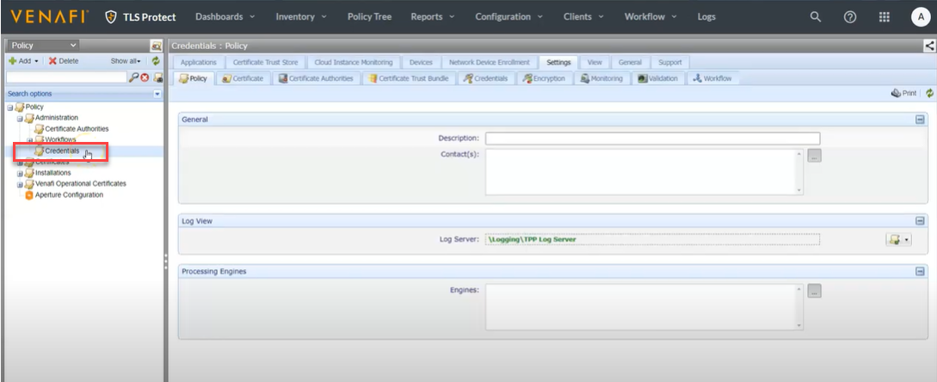

- The credentials will be the ID and associated Key you just created and copied down within the ZTPKI portal.

Adaptable Job Creation

- Logon to the Venafi Web Console and select the TLS Protect menu and then click on Configuration|Jobs

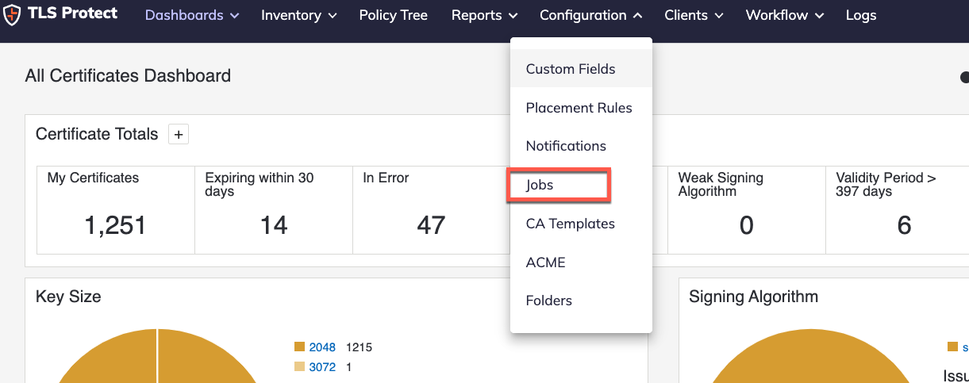

- Click On Create New Job

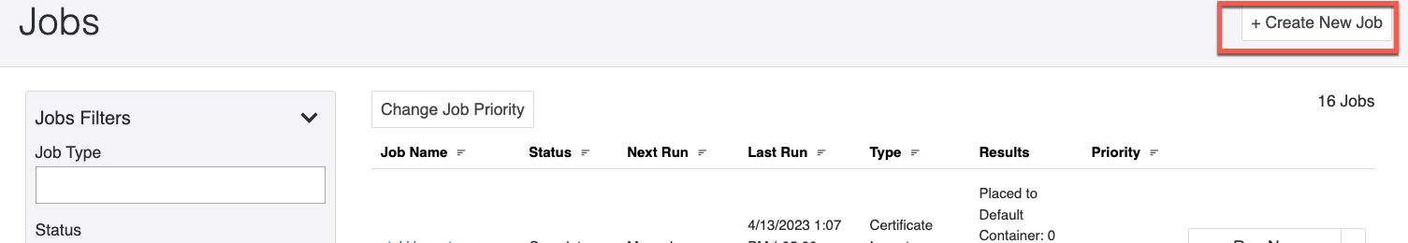

Choose Certificate Import and Start

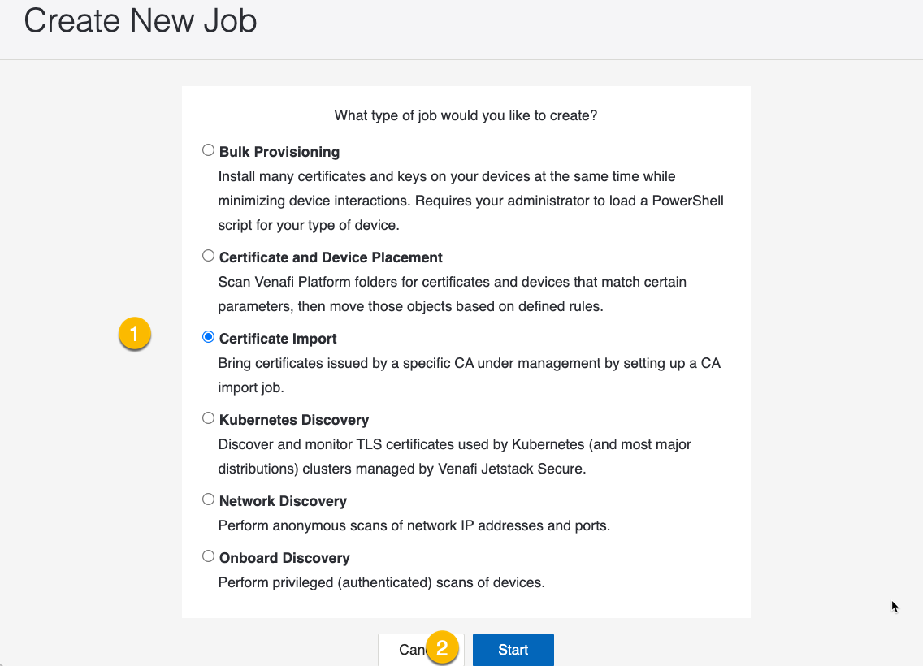

- Job Configuration settings

Provide a descriptive name for the Adaptable import and choose adaptable for import type

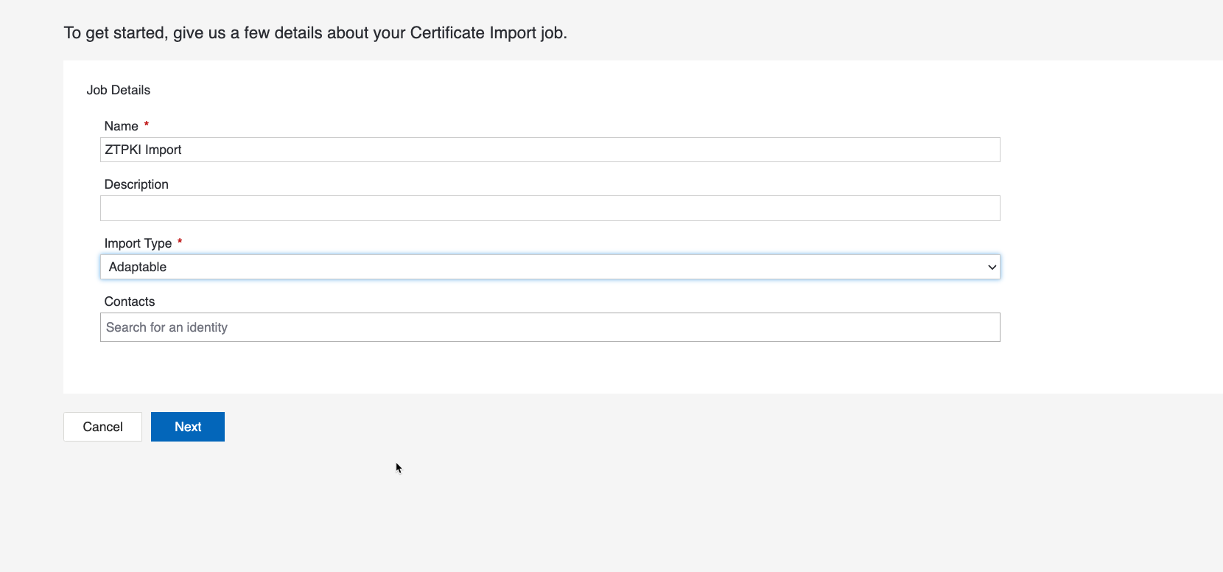

Job Settings

Powershell script: choose the script name for ZTPKI_Importonly
Enable Debug Logging: Enable to provide advanced troubleshooting.
It is recommended to enable debug logging on first runs and then to turn off once imports are successful.
Username Credential: Select the ZTPKI Credential created earlier.
Include Expired , Include Revoked: Select these options to bring in Expired and/or Revoked Certificates
Service Address: Refer to the ZTPKI instance address information referred to earlier in the document.Note-only enter in the Fully Qualified Domain name of the url and NO trailing slashes.
For example:
Correct https://ztpki.venafi.com
Incorrect https://ztpki.venafi.com/

If you do not enter in the address correctly, you may get random connection errors, such as 405-Method not allowed or address is not well formed.

Profile String: Include the desired Profile string from the ZTPKI Policy ID strings downloaded earlier. If this field is left blank, all certificates will be pulled into TPP with the import job.
Certificate Origin: Optional. Enter a desired value which will record certificate origin in TPP.
Placement Settings: Enter the desired Certificate policy/folder location in TPP to store certificates discovered.
Sample Screen:
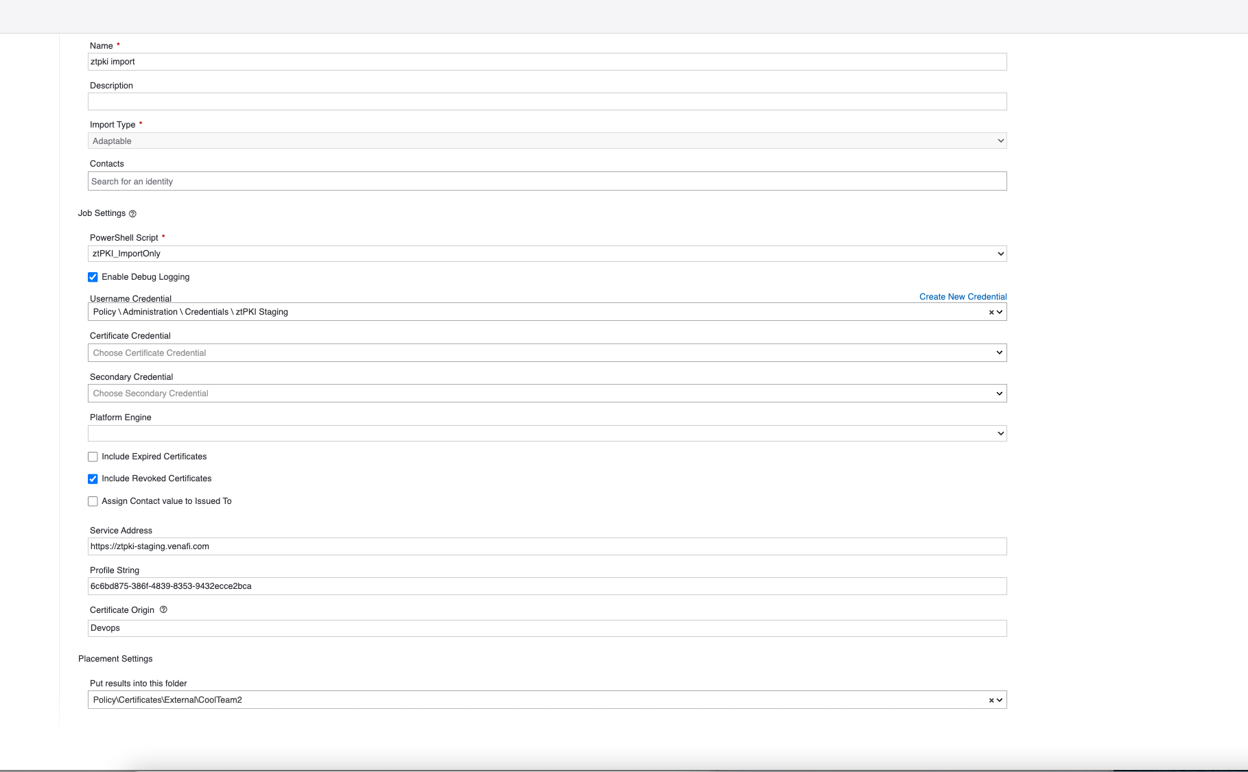

//Troubleshooting

Issues to review

  - Does the Venafi TPP system connecting to ZTPKI have network access to the ZTPKI service address ?
  - What errors show in Default SQL Channel ?
  - Does the API credential have correct access to the ZTPKI System or organizations matching the Policy ID ?
  - If debug logging is enabled, what errors are shown on the TPP servers in the <Venafi Home>\Logs directory for the ZTPKI import logs ?
Debug Logs will be named like so with the script value and hash value with a trailing date.
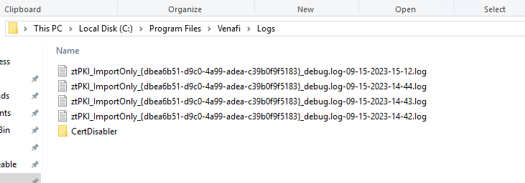

  - Is the HAWK ID and API Key entered in correctly in the Credential object in Venafi used for the import ?

Error | Indication
Debug log file mentions following error  [Error encountered: System.Net.WebException: The remote server returned an error: (403) Forbidden.  Error details: {"message":"Unknown credentials","status":"Failure"} | Was the HAWK ID and API Key entered in correctly ? This indicates that the credential is not correct.
Debug log file mentions following error  [ Error encountered: System.Net.WebException: The remote server returned an error: (403) Forbidden.  [09/19/2023 16:01:37] - Error details: {"message":"Bad mac","status":"Failure"} | This indicates that the API Key has been rolled over from an earlier version and the TPP credential has the previous version. Only the latest version of an API key should be used if it has been rolled over. Log back into the ZTPKI interface and obtain a new API key by either rolling over the current one or clickin on add Api Key.

  - If the debug logs show 405 method not allowed, make sure that your Service Address has no additional values on the URI. Refer to the earlier section on Service Address.
  - If the debug logs show “Url is not well formed. must contain https:// in service address”, ensure that the url is entered in the following format:
https://<ZTPKI instance>
This will be https://ztpki.venafi.com in most configurations.

//Advanced Configuration Section

The script has the following configuration directives at the beginning of the script which can be enabled to provide additional processing methods.
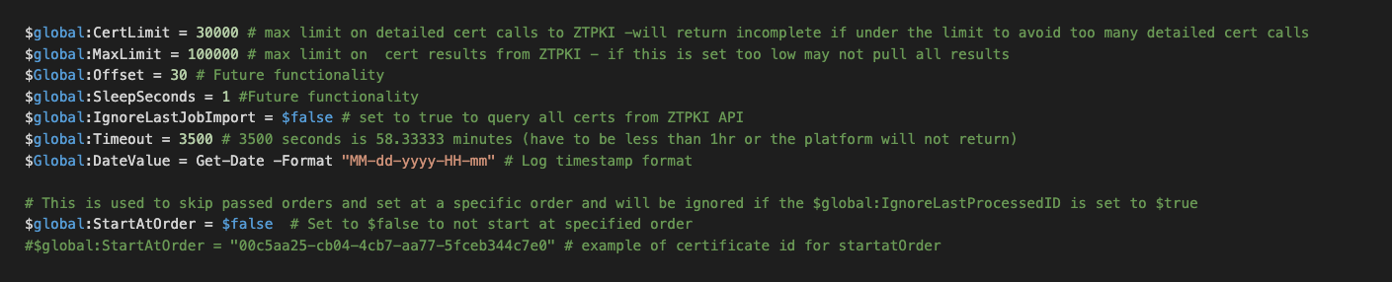

To change the settings, open the script in a script editor as administrator and change the values. Note you will have to re-save the import job each time you edit the script.

- IgnoreLastJobImport ID
Script can be set to $true to ignore last processed ID and always process all certificates
Default: $false (will always read in the last processed ID from TPP)
Why this may be needed: If the lastprocessedID was for some reason not set correctly or if you need to make sure it’s not skipping past results, this will tell the adaptable to pull in all cert details.
- StartAtOrder
Script can be set to start at a specific ID, Requires IgnoreLastJobImport to be set to $true
Default: not set
Why this may be needed: If there are a large number of certs to import and some certs were not found, this may be useful to tell the script where to start at.
- Timeout functionality
Script can be set to stop before a certain number of seconds to prevent TPP from calling it a runaway.
If the number of seconds the script has run has surpassed the global timeout, the script will return incomplete and will pass a parameter to TPP to run again in an hour.
If IgnoreLastProcessedID is set to $false, the job will start processing at the last order when it picks back up.
Default: 3500 which is 58 minutes
Why this may be needed: This ensures TPP won’t call it a runaway job or time it out if it doesn’t complete within an hour.
- MaxLimit
Script is set with global variable to limit how many certs to pull results on.
Note: this is an API requirement for ztPKI but can be set very high.
If this is set too low, the adaptable may never pull in the entire list of results.
Default: 100000
Why this may be needed: The Limit setting is a ZTPKI requirement and can be changed if there are other issues with cert results calls.
- CertLimit
Script is set with global variable to limit how many detailed certificate result calls can be made.
This can be paired with timeout values and/or set to a specific number to throttle how many cert details are requested per run as well as preventing timeouts on large imports. When the cert limit is reached, the script will return incomplete and will pass a parameter to TPP to run again in an hour.
If IgnoreLastJobImport is set to $false, the job will start processing at the last order when it picks back up.
Default: 30000
Why this may be needed: The CertLimit setting ensures that the number of detailed cert requests which include the X.509 data, are set to appropriate limits, if there are a number of certs to import. Also makes the calls to ZTPKI REST API more efficient.



Venafi is the cybersecurity market leader in machine identity management, securing the cryptographic keys
and digital certificates on which every business and government depends to deliver safe machine-to-machine communication. Organizations use Venafi key and certificate security to protect communications, commerce, critical systems and data, and mobile and user access. To learn more, visit venafi.com

