Plant I&C Software Environment

Software Overview
The 55.GA UWAVS2 control software is distributed over multiple hardware devices located in five locations. In order to propose a better readability, the 55.GA UWAVS2 software structure will be depicted for only one cubicle considering that this software structure will be replicated for all the other cubicles.
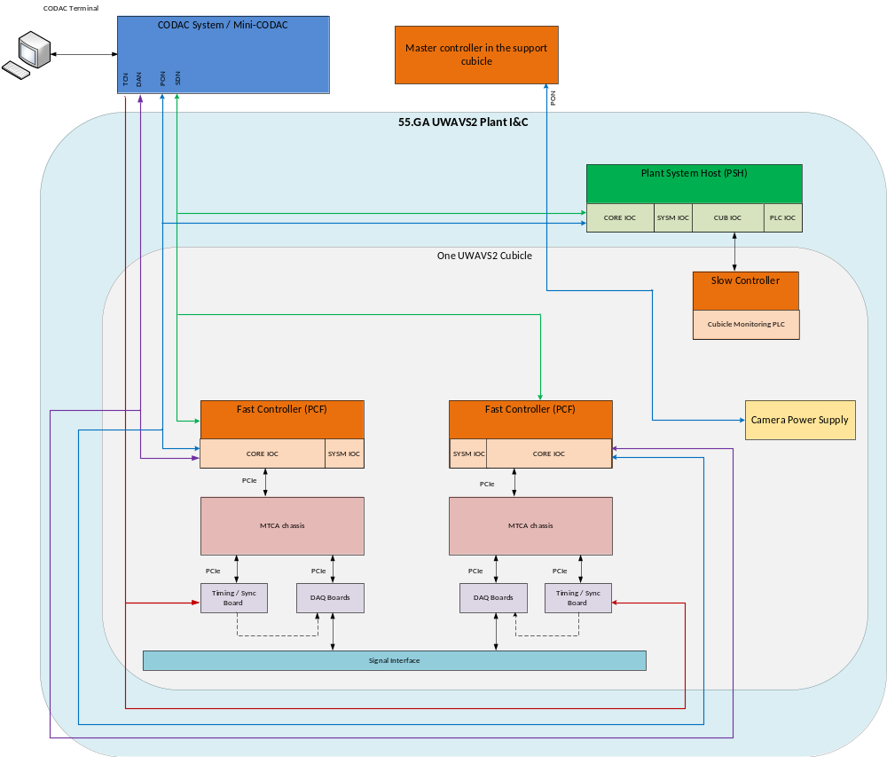
Figure 1 : 55.GA UWAVS2 software structure (for only one cubicle).
The CODAC System sends commands, configuration via PON interface using the channel access protocol to PSH, and PSH sends various data using this interface. This interface is fully defined and configured by self-description data. The PON interface is mostly used for providing the data for Human Machine Interface accessible in CODAC terminals in CODAC System network. It is also used for providing the data which need to be archived with CSS BEAUTY services. The PON network is additionally used to connect the Plant System Host with the Fast Controller IOCs.
For time critical data delivery Plant System I&C uses SDN high speed low latency network. The data
sent over SDN delivers the information which may be used in CODAC control system to make various operation decisions. The 55.GA UWAVS2 Plant I&C System will send over SDN the calculation result of the real-time Measurement Parameters.
When the system needs to handle high throughput data streams which need to be archived, a DAN network is used. The data are archived and available for further analysis.
The MTCA chassis is synchronized with central CODAC time using TCN network. Acquired and processed data are precisely timestamped to the time.
The Camera power supply (used for supplying the visible cameras, their media converters and the trigger signal amplifiers) is controlled through a dedicated PON link by the Master Controller located in the support cubicle.
The IR cameras and their media converters will be supplied by NEX0 power supplies.
The Plant System I&C operates with the following software:
- IOC services running in Plant System Host:
  - CORE IOC: dedicated to run PSOS state machine (implemented in SNL language), PSOS-COS mapping routines (generated from SDD); it also translates internal device support PVs into CODAC System PVs (implemented as direct PV mapping using DB files or software-based translation)
  - SYSM IOC: dedicated to monitor PSH system status and health (generated from SDD)
  - CUB IOC: dedicated to monitor Plant System I&C cubicle status and health (generated from SDD)
  - PLC IOC: not used by UWAVS2 Plant I&C system (dedicated to Slow Controller monitoring)
- IOC services running in Fast Controller:
  - CORE IOC: dedicated to data acquisition and control of system hardware (generated from SDD including standard CCS device support and custom device support for COTS devices)
  - SYSM IOC: dedicated to monitor PCF system status and health (generated from SDD)

UWAVS2 Software flux

The flux related to the UWAVS2 software are:
- The acquired images are transferred to the frame grabbers
- Some pre-processing is potentially applied in the frame grabbers’ FPGA.
- The raw or pre-processed images are transferred in the Fast Controller RAM (PCIe)
- The data processing is achieved in the GPU, when parallelization is relevant, and in CPU (PCIe).
- The main program configures the algorithms, gets the results and sends them through CODAC networks.

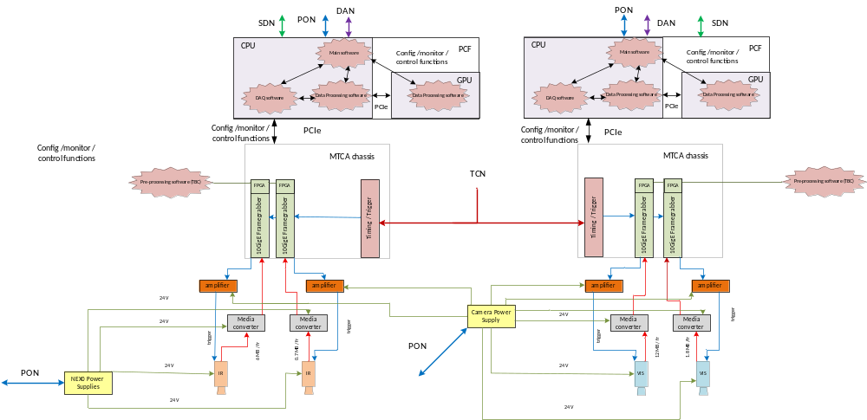
Figure 2 : Software flux.

The figure hereafter depicts the 55.GA UWAVS2 software architecture running in PCF and cubicle including all software layers.
Data Acquisition
The DAQ software part will be a DAQ service responsible for initializing the system, configuring it, acquiring data from all the configured cameras, and publishing image streams to the main C++ application. This application is in charge of image processing and data archiving.

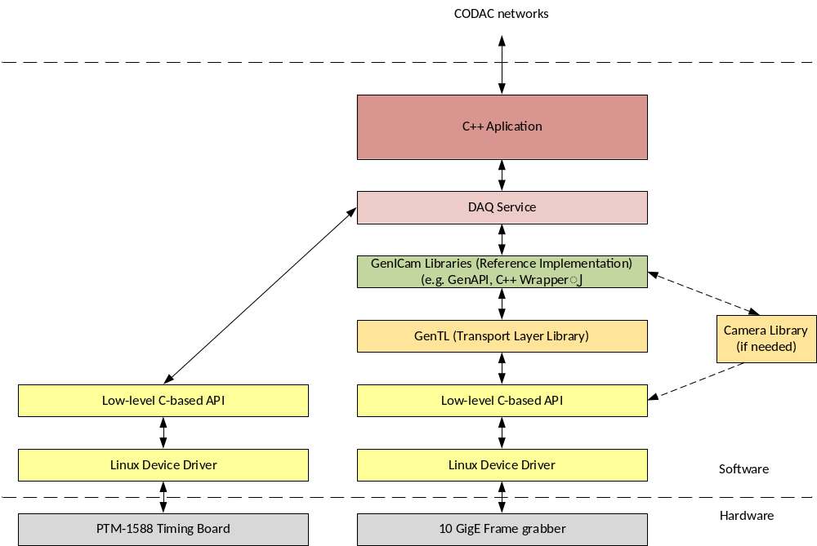
Figure 3: DAQ Software structure.

Data Processing
When an acquired image is available in the RAM, the potential pre-processing will be performed by the CPU (Central Processing Unit). Then, depending on the involved algorithm to be processed for measurement parameters calculation and for time processing reasons, the pre-processed image can be processed either by the CPU or by the GPU (Graphics Processing Unit).
Data transfers between the host memory and the device memory is a major concern regarding the overall performance of an application using the GPU. Indeed, these transfers are very often the bottleneck of such applications, representing more processing time than the kernel functions running on the GPU to compute operations.
Therefore, the Data Processing software will be designed to avoid, as far as possible, multiple back and forth image transfer between the CPU and the GPU.
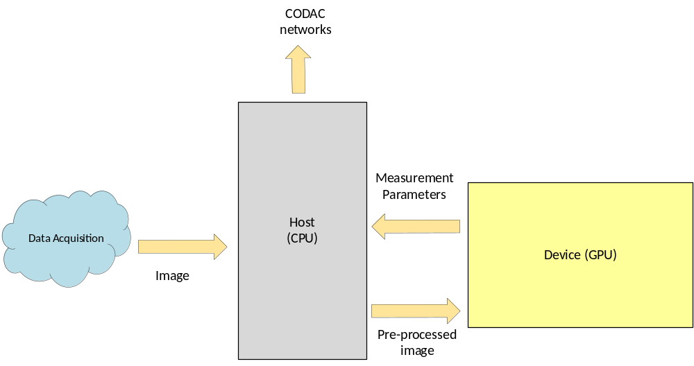
Figure 4: DAQ Processing software principles.

During prototyping activities, hotspot detection and Temperature map calculation have been implemented using the GPU to be more time processing efficient.

Fast Controller(s) Time synchronization

TCN daemon synchronize system clock with PTP clock through the PTM-DAMC-1588-10F board in the MTCA chassis.
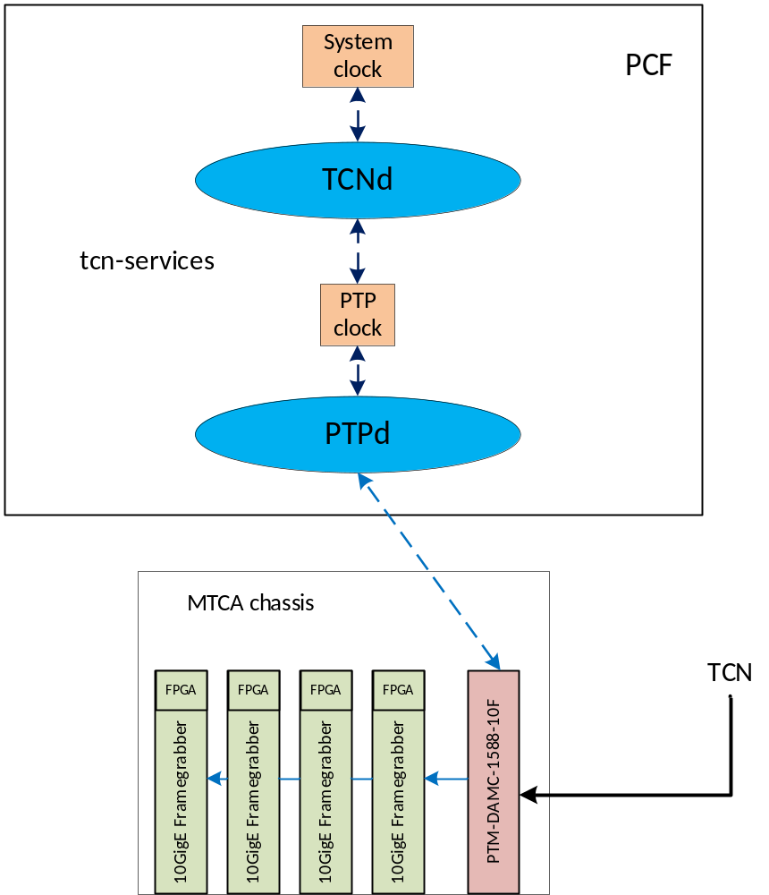
Figure 5 : Fast Controller Time Synchronization.

UWAVS2 Software Architecture

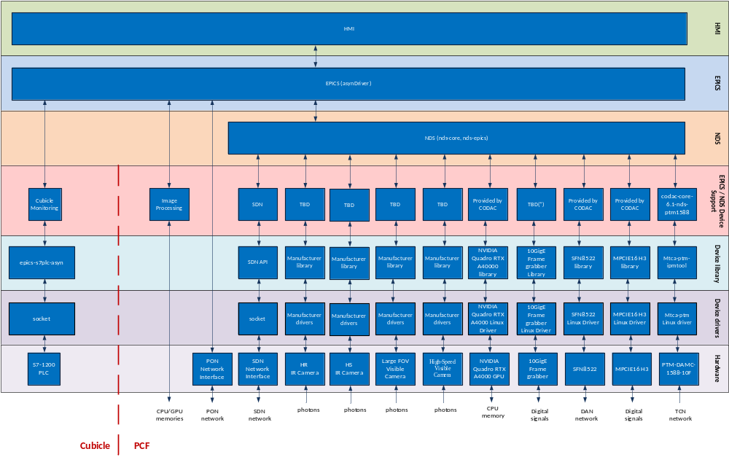
Figure 6 : PCF and cubicle 55.GA UWAVS2 software architecture. The EPICS / NDS layer for cameras and frame grabber have to be developed (TBD).
The top EPICS layer is common to all the devices of the system. It communicates with individual devices’ control and status variables using asynDriver API. It also exposed all the variables to PON CODAC network using channel access protocol.
NDS layer is required by all the devices. From one side it handles the details of EPICS layer usage (NDS-EPICS library) and from other side provides set of C++ classes to give the developer the possibility to organize a device support in a tree-like structure including state machines, data acquisition, data generation, data processing, digital acquisition, health monitoring, streaming, and firmware control objects.
The EPICS/NDS Device Support layer interfaces device specific functionality with upper layers. It is responsible for calling device API to configure it, retrieves readings and data streams. It also provides software-based data processing.
The device library layer provides sets or API calls for individual devices. They are either standard CCS software, or for COTS devices they need to be additionally installed. When the device support layer directly calls device handlers (e.g. network sockets in described system), no library is required.
The drivers layer allows interaction between the software running in Linux user space and Linux kernel where physical devices are accessed. As for the device library layer drivers comes as standard CCS software, custom drivers for COTS or native Linux drivers.
The 10GigE frame grabber, based on the Image Acquisition System (IAS) has been developed during a prototyping activity. Therefore, the low-level software has been developed, but the software related to this frame grabber will have to be completed and configured.

