CSCI230 Assignment #2

Requirements

- Please create a functional calculator similar to the one in the Figure 1. The NetBeans project name shall be Lastname_ Assignment2. (Please replace “Lastname” with your own last name).

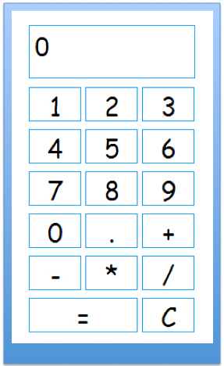
Figure 1.

Grade:
Total: 25

Submission
1) Run your code and take a Screen Capture of your program. Save the image file and name it Lastname_Assignment2.png in the project folder.

2) Compress the project folder and create zip file named Lastname_Assignment2.zip
3) Upload it to Assignment_2 dropbox.

