CSCI230 Assignment #10

map_and_data.txt file is given. It draws the US map using the data provided by state.txt. You can reuse the parts of the code to construct the following visualization with Java.

Requirements:
Create a program that provides the visualization of timeline of US Presidents by their home states.
You can decide however express the data (e.g., you can design your own file format ).
Please create two buttons:
- “Start” button: Clicking it shall trigger the timeline visualization from the 1st president to the last president in order. A single election period( 4 years ) shall be represented with 5 second delay. For each president, the window content (a. picture of the president; b. information about the president; and c. the affiliated state name) and years as the titles (e.g., 1984-1988 in figure 1) shall be updated. If time reaches the end, the animation shall start from the beginning automatically.

- “Stop” button: Stops the animation.

The Figure and data is available at:
http://en.wikipedia.org/wiki/List_of_Presidents_of_the_United_States_by_home_state

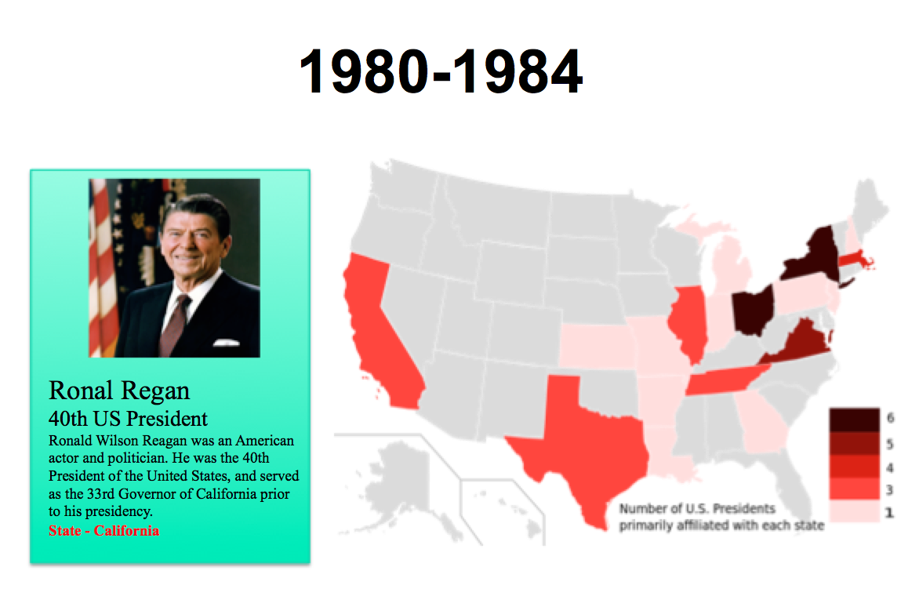

Figure 1.

Grade:
Total: 40

Submission:
- Execute your program and take a screen capture of the program. Name the figure as following:
Assignment_10.png.
2) Put all the files (source, executable, figures etc.) in one folder.
3) Name the folder Lastname_Assignment10
(Please try to run and make sure it runs)
4) Compress and create zip file named Lastname_Assignment10.zip
5) Upload it to Assignment_10 dropbox.

