CSCI230 Assignment #11

Requirements:

- By utilizing Java language and JavaFX, please create a functional and interactive “AVL Tree Editor” similar to the one in the Figure 1.
Using your AVL editor shall allow users:
- create an AVL tree;
- insert integer numbers by typing into the “Insert” text box and pressing enter. The tree shall accommodate at least 50 nodes;
- can remove an element by typing into the “Remove” text box and pressing enter;
Your program shall:
- check, warn (via message box) automatically adjust to make sure the tree is AVL. ( if “Cancel” button is pressed the last element entered, or removed shall be cancelled)
- display “Number of Nodes” and “Tree Height”;
- display current tree in the lower part of the editor;
- shall zoom in, zoom out, scroll (horizontally and vertically) the tree visualization window;

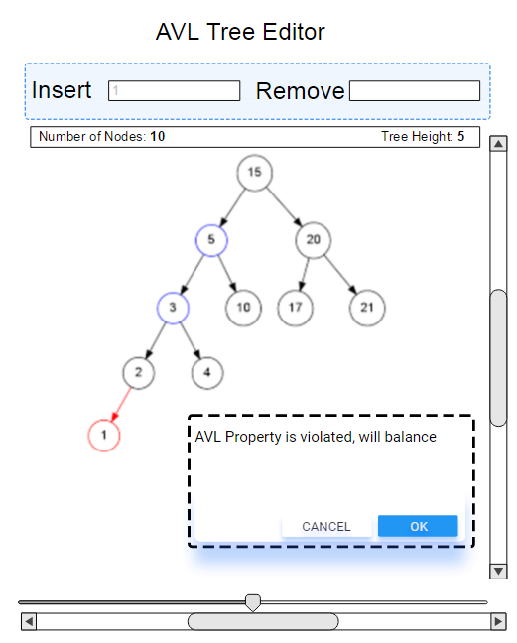
Figure 1.

Grade:
Total: 35

Submission:
1) Put all the files (source, jar files, figures, NetBeans project etc.) in one folder.
2) Name the folder Lastname_Assignment11
(Please try to run and make sure it runs)
3) Compress and create zip file named Lastname_Assignment11.zip
4) Upload it to Assignment_11 dropbox.

