CSCI230 Assignment #3

Requirements:

- Based on the Calculator you made on Assignment2, please create a “Settings” functionality of the calculator.
  - The main calculator shall have a “Settings” button.
  - The pressing of “Settings” button shall bring the Settings window.
  - Settings window shall allow users chose “Background color”, “Foreground color”, “Keypad Color”, “Font Type”, “Number of digits after decimal point”.
  - Settings window shall have “Ok” button. (You can use any proper SWING component to implement)
  - The pressing of “Ok” button in the Settings window shall bring the Main calculator window.
  - The current Settings shall affect the look and feel of the Main window.

The Figure 1 and Figure 2 shows one possible design of the Calculator Main Window and Settings Window (Please note: Your design not necessarily exactly similar to the ones in the Figures.)

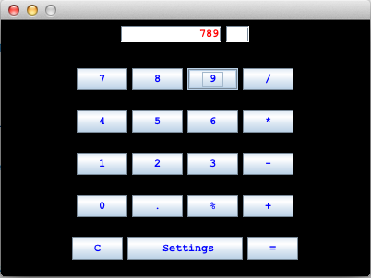

Figure 1.

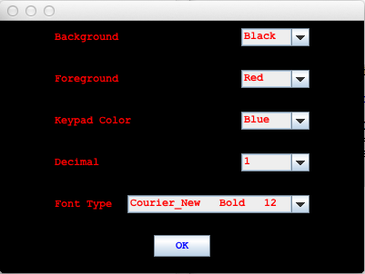

Figure 2.

Grade:
Total: 25

Submission:
1) Put all the files (source, executable, figures etc.) in one folder.
2) Name the folder Lastname_Assignment3
(Please try to run and make sure it runs)
3) Compress and create zip file named Lastname_Assignment3.zip
4) Upload it to Assignment_3 dropbox.

