CSCI230 Assignment #4

Requirements:

- Design and implement a “Picture Slider”.
  - The main window is shown in Figure 1
  - Main window shall have 3 areas. 1) Menu area 2) Picture area 3) Picture control area .
  - File menu shall have “Open” and “Exit” items. Clicking the “Open” shall bring a File Chooser and shall let the user choose a slider file. (The format of the slider file described in Figure 2) After reading the contents of the slider file, the first picture item and its title shall be displayed in the picture area. Clicking the “Exit” menu shall end the program.
  - The “Help” menu shall have “About” and “Help/UserManual” items. Clicking the “About” item shall show a dialog box about your software. (Name. Author, Version etc. ) Clicking the “Help/UserManual” item shall show simple user manual shown in Figure 3.
  - The picture change area shall have “Home”, “Previous”, “Next”, “Last” buttons. These buttons shall be functional in choosing which picture to be displayed.

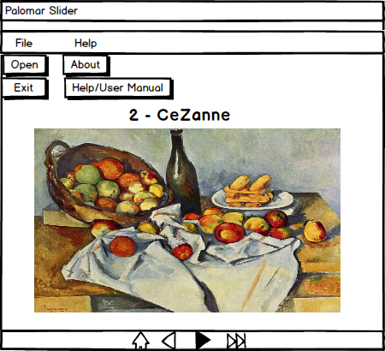

Figure 1.

Figure 2.

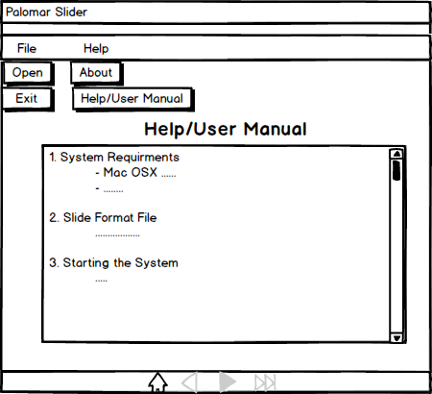

Figure 3.

Grade:
Total: 25

Submission:
1) Put all the files (source, executable, figures etc.) in one folder.
2) Name the folder Lastname_Assignment4
(Please try to run and make sure it runs)
3) Compress and create zip file named Lastname_Assignment4.zip
4) Upload it to Assignment_4 dropbox.

