CSCI230 Assignment #5

Requirements:
This assignment is based on Assignment #4, the Picture slider. Please add the following functionalities to the Picture slider:
- “Play”  button to the picture change area. This button shall trigger the Picture Slider automatically change and display every image starting from the current picture until the last picture ;and start again from the first picture…. (Each image shall be displayed for ~5 seconds). Clicking any Button other than “Play” button shall stop the automatic play.

- Add “Thumbnail List”  button to the picture change area.

Both the “Play” and “Thumbnail List” button are shown in the Figure 1.

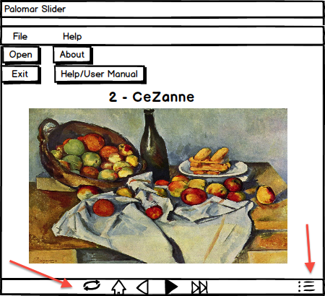

- Clicking this button shall bring the list of images as shown in Figure 2. The list shall display smaller size of images in multiple row and columns. The up and down buttons (, ) shall control the view when list does not fit the window.
- Clicking any image on the list shall bring the large size version of that image.

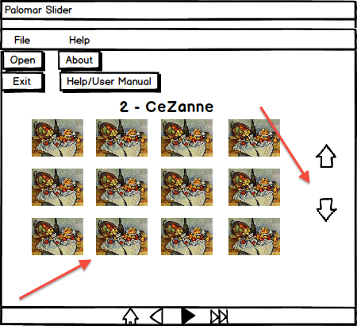

Figure 1.

Grade:
Total: 25

Submission:
1) Put all the files (source, executable jar, figures etc.) in one folder.
2) Name the folder Lastname_Assignment5
(Please try to run and make sure it runs)
3) Compress and create zip file named Lastname_Assignment5.zip
4) Upload it to Assignment_5 dropbox.

