CSCI230 Assignment #6

Requirements:
Design and implement a watch shown in the Figure 1.

- The watch shall be functional – correctly display current time.

- Pressing the “settings” , users shall be able to customize the look of the watch – switch between digital and analog display.

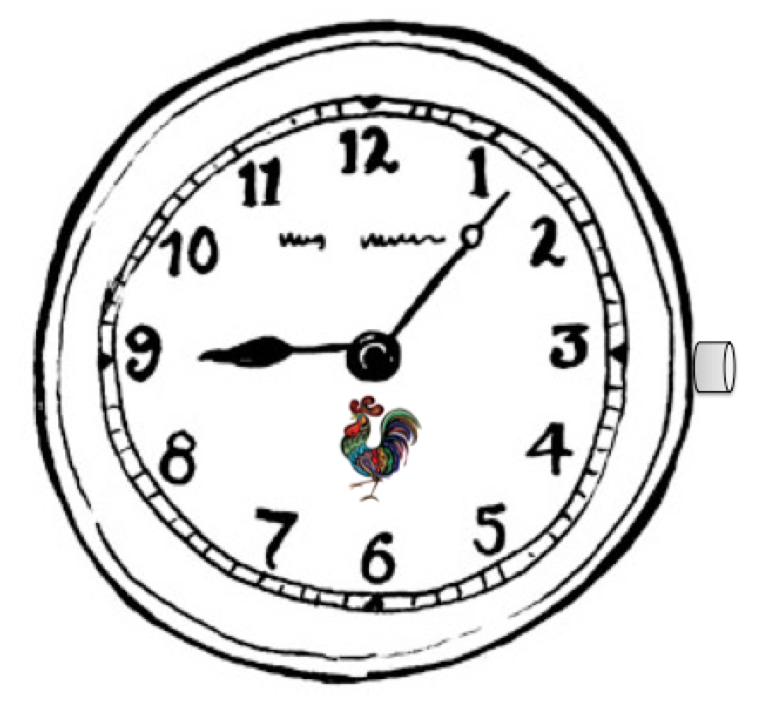

Figure 1.

Grade:
Total: 25
Extra: Animated icon for half minute (walking chicken in the figure): 5

Submission:
1) Capture a screen shot figure of the main window and settings window.
2)Put all the files (source, NetBeans project file, executable jar, figures etc.) in one folder.
3) Name the folder Lastname_Assignment6
(Please try to run and make sure it runs)
4) Compress and create zip file named Lastname_Assignment6.zip
5) Upload it to Assignment_6 dropbox.

