CSCI230 Assignment #9

map_and_data.txt file is given. It draws the US map using the data provided by state.txt. You can reuse the parts of the code and construct the following visualizations with Java.

Requirements:
Create a program that provides different visualization options via menu. You can decide however express the raw data (e.g., come up with your own file format etc.)

1. 2014 Senate Election
Visualize the 2014 Senate election results shown in the Figure 1.
The Figure and data is available at
http://www.politico.com/2014-election/results/map/senate/#.VHUoaod7TIY

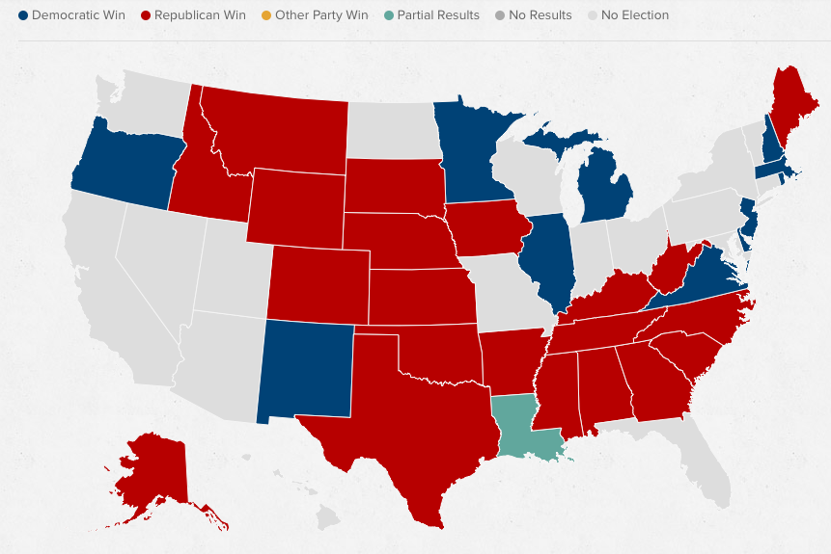

Figure 1.

2. 2013 State Population
Visualize the 2013 State Population shown in the Figure 2. The Figure and data is available at
http://en.wikipedia.org/wiki/List_of_U.S._states_and_territories_by_population

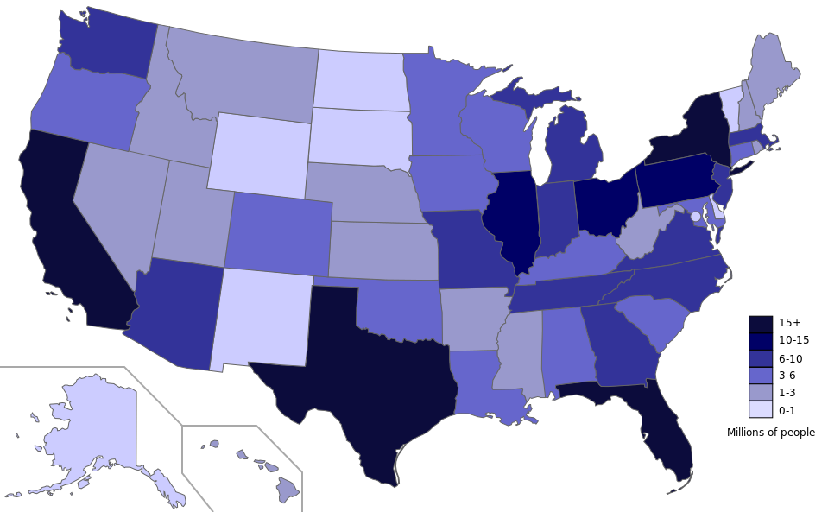

Figure 2.

3. US NFL Team Locations
Visualize the United States National Football League teams location as shown in the Figure 3. The clicking each team also shall bring up a dialog box to display general information about the specific team as shown in Figure 4. The Figure and data is available at
http://en.wikipedia.org/wiki/National_Football_League

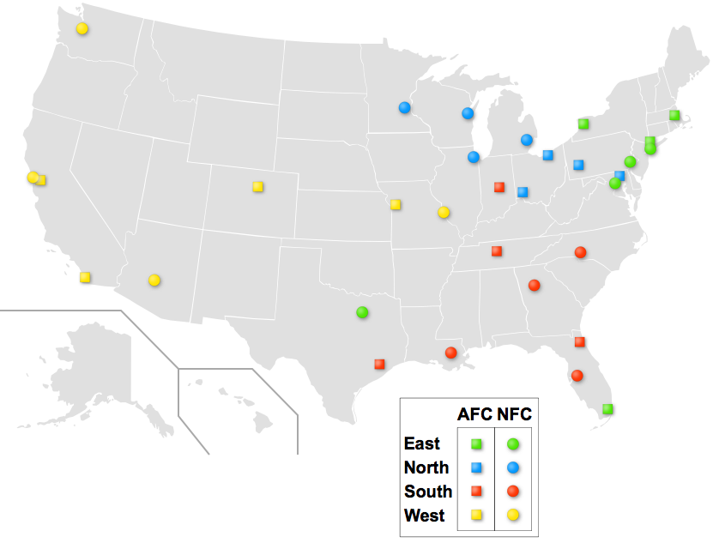
Figure 3.

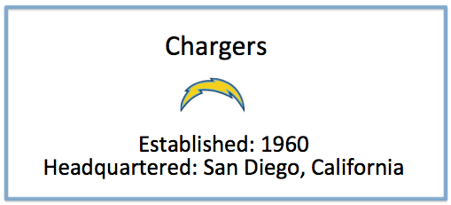
Figure 4.

Grade:
Total: 50 (Menus and overall:10, 1:10; 2:10, 3:20)

Submission:
- Execute your program and take screen capture of each functionality. Name the figures as folliwing:
Assignment_9_menu.png, Assignment_9_1.png, Assignment_9_2.png, Assignment_9_3.png, Assignment_9_3_dialog.png
2) Put all the files (source, executable, figures etc.) in one folder.
3) Name the folder Lastname_Assignment9
(Please try to run and make sure it runs)
4) Compress and create zip file named Lastname_Assignment9.zip
5) Upload it to Assignment_9 dropbox.

