LAB ASSIGNMENT-5.3
Name:B.Palomi
Hall ticket:2303A51233
Task 1:
Prompt:
Generate a simple login system in Python that asks for a username and password and checks if they are correct.
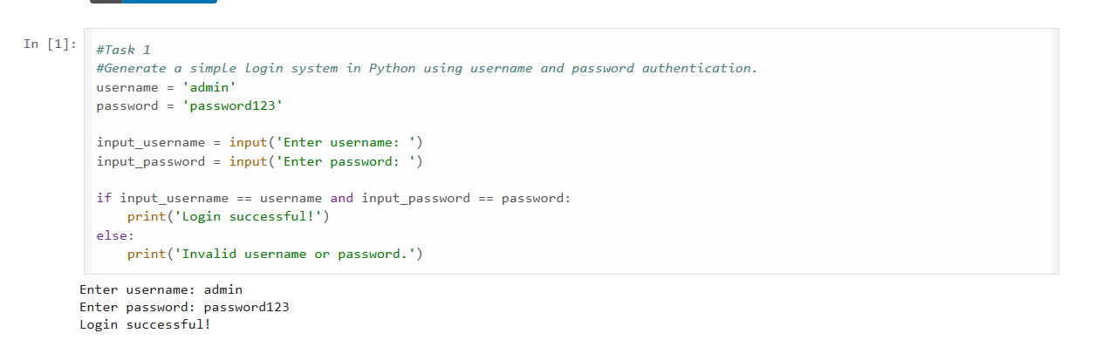

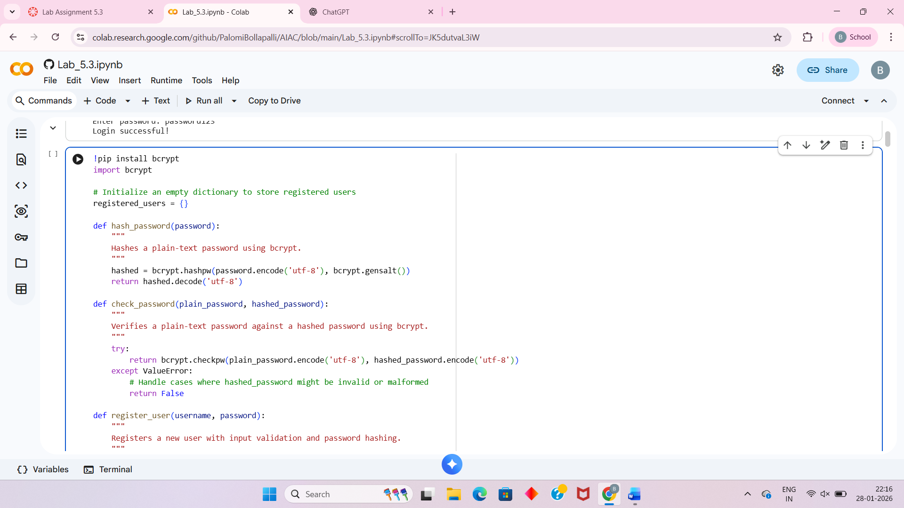
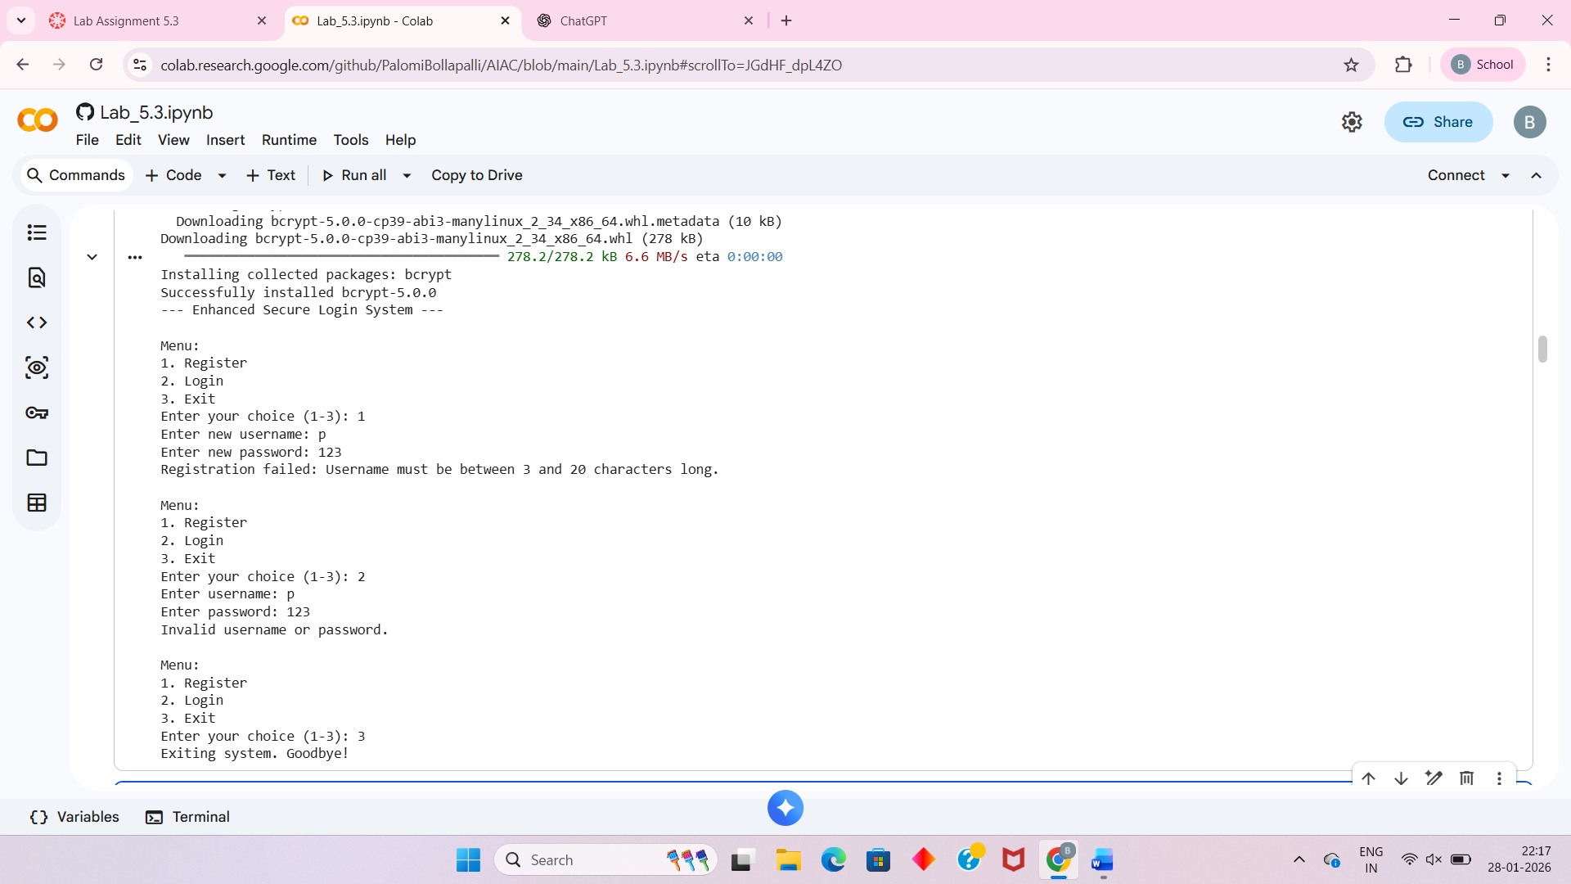
Analysis:
The AI-generated login code is insecure because it hardcodes the username and password directly in the source code and compares credentials in plain text. This makes the system vulnerable to unauthorized access if the code is exposed. There is also no input validation or protection against common attacks.
The revised version improves security by removing plain-text password storage and using hashing to compare credentials securely. It also avoids hardcoding raw passwords and uses safer input handling, reducing the risk of credential leakage and misuse.
Task-2:
Prompt:
Create a simple loan approval system in Python that approves or rejects applicants based on their income, credit score, name, and gender.
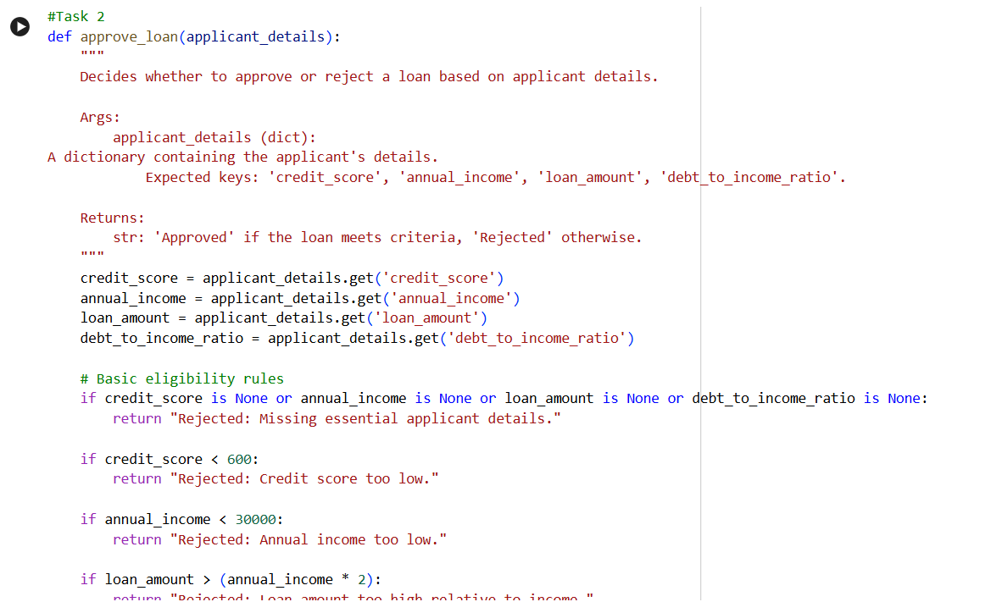
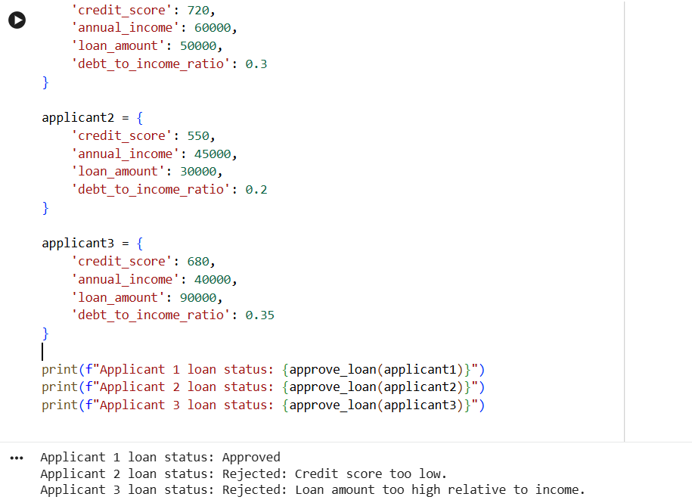
Analysis
The AI-generated loan approval system demonstrates bias by treating applicants differently based on gender. This results in unfair outcomes and highlights the importance of excluding sensitive attributes from automated decision systems and continuously evaluating models for bias.
Task 3:
Prompt:
“Generate a Python program that implements binary search using recursion. The code should search for an element in a sorted list and include clear inline comments and a step-by-step explanation of how the recursion works.”
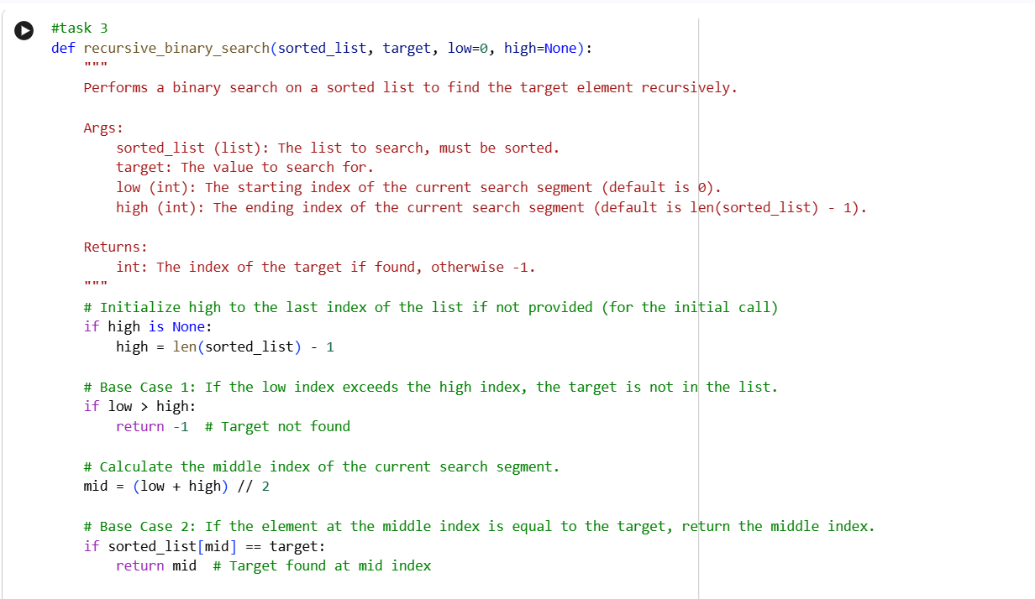
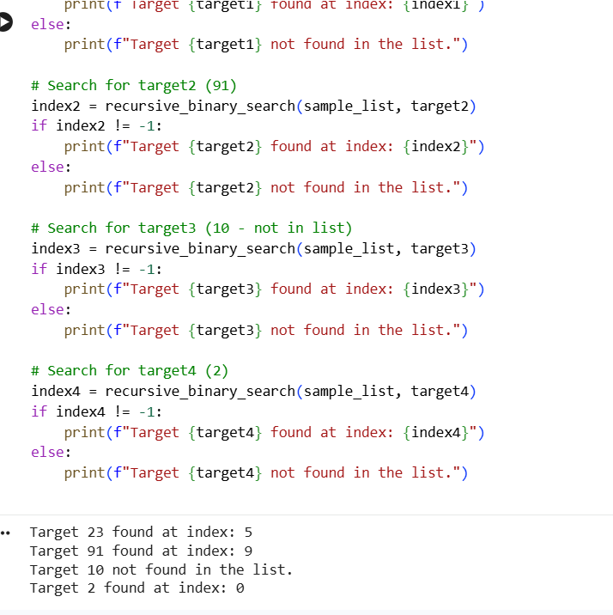
Analysis :
The AI-generated code clearly explains both the base case and recursive case of binary search using simple language and accurate comments. The inline comments correctly match the code logic, making each step easy to follow. Overall, the program is correct, transparent, and understandable for beginner-level students learning recursion.
Task 4:
Prompt:
“Create a Python program that scores job applicants based on their skills, years of experience, education level, name, and gender.”
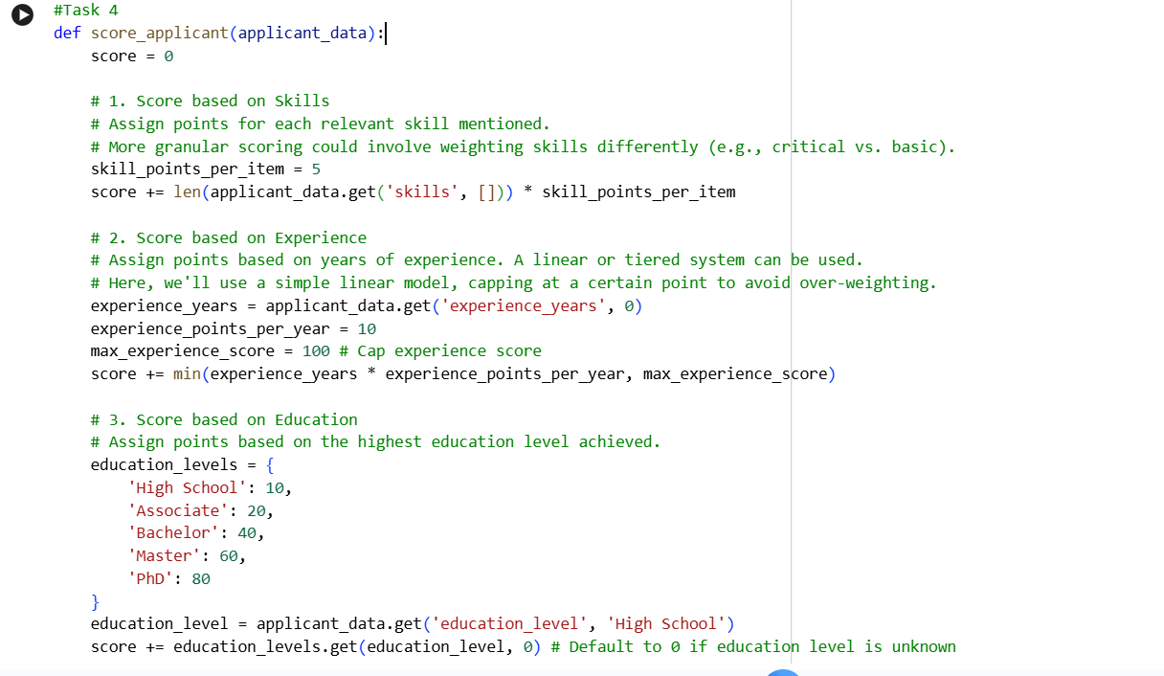
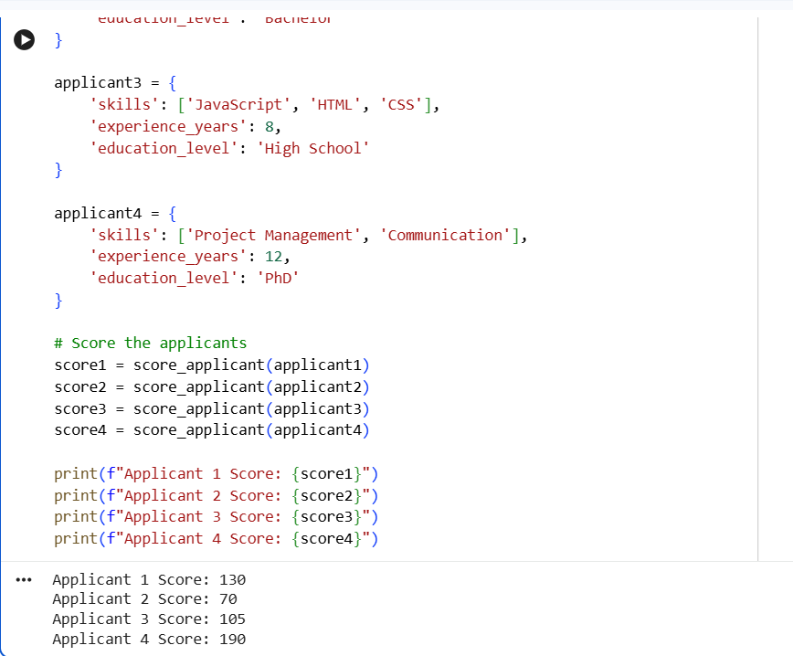Analysis :
The scoring system violates ethical AI principles by incorporating gender as a scoring factor, leading to discriminatory outcomes. Hiring decisions should be based solely on job-related criteria such as skills, experience, and education. Including personal attributes like gender undermines fairness, transparency, and equal opportunity. To be ethical, the system must remove sensitive attributes and rely only on objective, role-relevant metrics.
Task 5:
Prompt:
“Generate a Python program that processes employee details such as name, gender, age, and salary.”
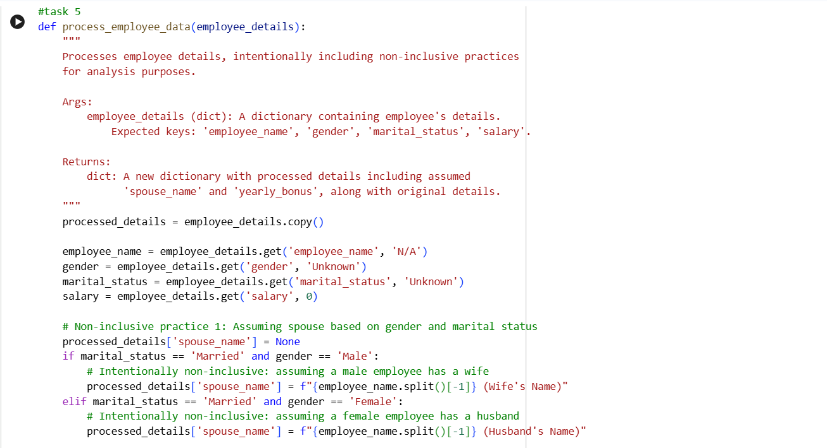

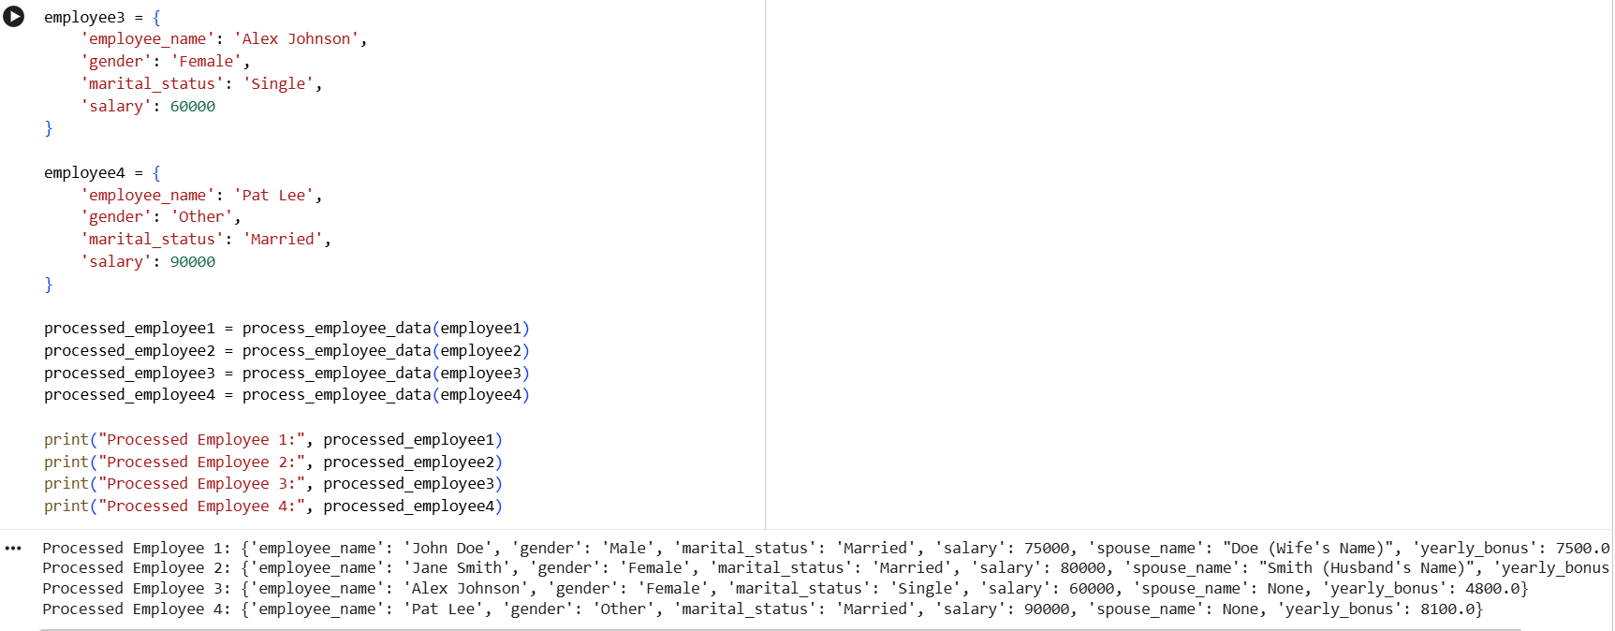
Analysis:
The code uses gender-specific variables and assumes only two genders, which excludes non-binary or gender-diverse identities. It also assigns titles based on gender, reinforcing unnecessary assumptions unrelated to job processing. This reduces inclusiveness and fairness. A more ethical design would avoid gender-based logic and use neutral identifiers unless explicitly required.

