Linear Regression Mini-Project

Missy Lee

September 27, 2016

knitr::opts_chunk$set(echo = TRUE)

## This is my work for the Linear Regression Mini-Project.

## Instructions will be interwoven with code and results and the data used here can be found in the dataSets folder.

## The only original code is in the Exercise section at the end.

# 

### Set working directory

## ─────────────────────────

# set the working directory

getwd()

## [1] "C:/Users/mlee/Documents/GitHub/DataWranglingExercise1"

### Load the states data

## ────────────────────────

# read the states data

states.data <- readRDS("dataSets/states.rds")   
#get labels  
states.info <- data.frame(attributes(states.data)[c("names", "var.labels")])  
#look at last few labels  
tail(states.info, 8)

## names var.labels  
## 14 csat Mean composite SAT score  
## 15 vsat Mean verbal SAT score  
## 16 msat Mean math SAT score  
## 17 percent % HS graduates taking SAT  
## 18 expense Per pupil expenditures prim&sec  
## 19 income Median household income, $1,000  
## 20 high % adults HS diploma  
## 21 college % adults college degree

## Linear regression

## ═══════════════════

# Examine the data before fitting models

## ──────────────────────────────────────────

# Start by examining the data to check for problems.

# summary of expense and csat columns, all rows

sts.ex.sat <- subset(states.data, select = c("expense", "csat"))  
summary(sts.ex.sat)

## expense csat   
## Min. :2960 Min. : 832.0   
## 1st Qu.:4352 1st Qu.: 888.0   
## Median :5000 Median : 926.0   
## Mean :5236 Mean : 944.1   
## 3rd Qu.:5794 3rd Qu.: 997.0   
## Max. :9259 Max. :1093.0

# correlation between expense and csat  
cor(sts.ex.sat)

## expense csat  
## expense 1.0000000 -0.4662978  
## csat -0.4662978 1.0000000

## Plot the data before fitting models

## ───────────────────────────────────────

# Plot the data to look for multivariate outliers, non-linear

# relationships etc.

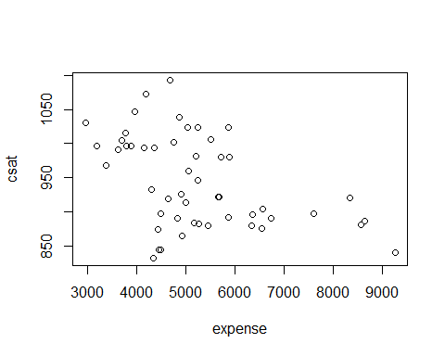

## Linear regression example

## ─────────────────────────────

# • Linear regression models can be fit with the lm()' function # • For example, we can uselm' to predict SAT scores based on

# per-pupal expenditures:

# Fit our regression model

sat.mod <- lm(csat ~ expense,data=states.data)

# Summarize and print the results

summary(sat.mod)

##   
## Call:  
## lm(formula = csat ~ expense, data = states.data)  
##   
## Residuals:  
## Min 1Q Median 3Q Max   
## -131.811 -38.085 5.607 37.852 136.495   
##   
## Coefficients:  
## Estimate Std. Error t value Pr(>|t|)   
## (Intercept) 1.061e+03 3.270e+01 32.44 < 2e-16 ***  
## expense -2.228e-02 6.037e-03 -3.69 0.000563 ***  
## ---  
## Signif. codes: 0 '***' 0.001 '**' 0.01 '*' 0.05 '.' 0.1 ' ' 1  
##   
## Residual standard error: 59.81 on 49 degrees of freedom  
## Multiple R-squared: 0.2174, Adjusted R-squared: 0.2015   
## F-statistic: 13.61 on 1 and 49 DF, p-value: 0.0005631

## Why is the association between expense and SAT scores /negative/?

## ──────────────────────────────────────────────────────────

# Many people find it surprising that the per-capita expenditure on

# students is negatively related to SAT scores. The beauty of multiple

# regression is that we can try to pull these apart. What would the

# association between expense and SAT scores be if there were no

# difference among the states in the percentage of students taking the

# SAT?

summary(lm(csat ~ expense + percent, data = states.data))

##   
## Call:  
## lm(formula = csat ~ expense + percent, data = states.data)  
##   
## Residuals:  
## Min 1Q Median 3Q Max   
## -62.921 -24.318 1.741 15.502 75.623   
##   
## Coefficients:  
## Estimate Std. Error t value Pr(>|t|)   
## (Intercept) 989.807403 18.395770 53.806 < 2e-16 ***  
## expense 0.008604 0.004204 2.046 0.0462 *   
## percent -2.537700 0.224912 -11.283 4.21e-15 ***  
## ---  
## Signif. codes: 0 '***' 0.001 '**' 0.01 '*' 0.05 '.' 0.1 ' ' 1  
##   
## Residual standard error: 31.62 on 48 degrees of freedom  
## Multiple R-squared: 0.7857, Adjusted R-squared: 0.7768   
## F-statistic: 88.01 on 2 and 48 DF, p-value: < 2.2e-16

## The lm class and methods

## ────────────────────────────

## OK, we fit our model. Now what?

# • Examine the model object:

class(sat.mod)

## [1] "lm"

names(sat.mod)

## [1] "coefficients" "residuals" "effects" "rank"   
## [5] "fitted.values" "assign" "qr" "df.residual"   
## [9] "xlevels" "call" "terms" "model"

methods(class = class(sat.mod))[1:9]

## [1] "add1.lm" "alias.lm"   
## [3] "anova.lm" "case.names.lm"   
## [5] "coerce,oldClass,S3-method" "confint.lm"   
## [7] "cooks.distance.lm" "deviance.lm"   
## [9] "dfbeta.lm"

# • Use function methods to get more information about the fit

confint(sat.mod)

## 2.5 % 97.5 %  
## (Intercept) 995.01753164 1126.44735626  
## expense -0.03440768 -0.01014361

## Linear Regression Assumptions

## ─────────────────────────────────

# • Ordinary least squares regression relies on several assumptions,

# including that the residuals are normally distributed and

# homoscedastic, the errors are independent and the relationships are

# linear.

# • Investigate these assumptions visually by plotting your model:

par(mar = c(4, 4, 2, 2), mfrow = c(1, 2))

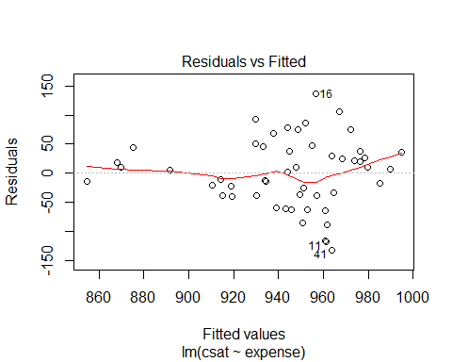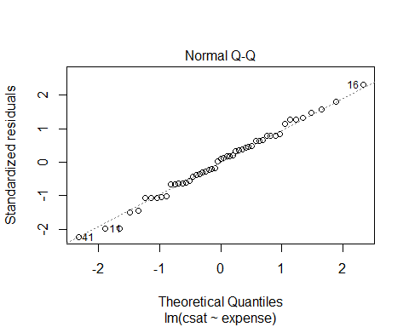

## Linear Regression Assumptions

## ─────────────────────────────────

# • Ordinary least squares regression relies on several assumptions,

# including that the residuals are normally distributed and

# homoscedastic, the errors are independent and the relationships are

# linear.

# • Investigate these assumptions visually by plotting your model:

par(mar = c(4, 4, 2, 2), mfrow = c(1, 2), plot(sat.mod, which = c(1, 2)))





## Comparing Models

## ─────────────────────────────────

# Do congressional voting patterns predict SAT scores over and above

# expense? Fit two models and compare them:

# Fit first model, adding house and senate as predictors

sat.voting.mod <- lm(csat ~ expense + house + senate, data = na.omit(states.data))

# Fit another model, adding house and senate as predictors

sat.voting.mod <- lm(csat ~ expense + house + senate, data = na.omit(states.data))  
sat.mod <- update(sat.mod, data=na.omit(states.data))

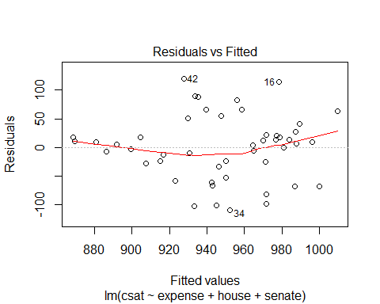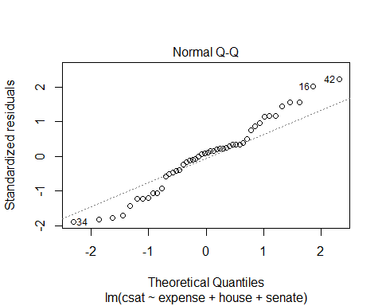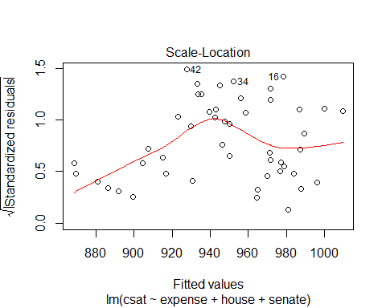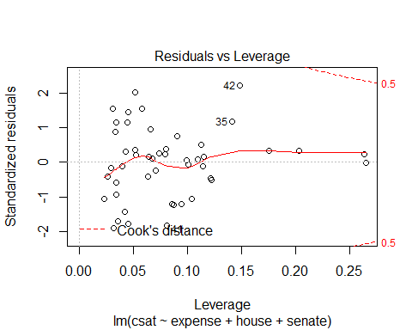

# compare using the anova() function

anova(sat.mod, sat.voting.mod)

## Analysis of Variance Table  
##   
## Model 1: csat ~ expense  
## Model 2: csat ~ expense + house + senate  
## Res.Df RSS Df Sum of Sq F Pr(>F)   
## 1 46 169050   
## 2 44 149284 2 19766 2.9128 0.06486 .  
## ---  
## Signif. codes: 0 '***' 0.001 '**' 0.01 '*' 0.05 '.' 0.1 ' ' 1

coef(summary(sat.voting.mod))

## Estimate Std. Error t value Pr(>|t|)  
## (Intercept) 1082.93438041 38.633812740 28.0307405 1.067795e-29  
## expense -0.01870832 0.009691494 -1.9303852 6.001998e-02  
## house -1.44243754 0.600478382 -2.4021473 2.058666e-02  
## senate 0.49817861 0.513561356 0.9700469 3.373256e-01

## Exercise: least squares regression

## ────────────────────────────────────────

# Use the /states.rds/ data set. Fit a model predicting energy consumed

# per capita (energy) from the percentage of residents living in

# metropolitan areas (metro). Be sure to

# 1. Examine/plot the data before fitting the model

str(states.data)

## 'data.frame': 51 obs. of 21 variables:  
## $ state : chr "Alabama" "Alaska" "Arizona" "Arkansas" ...  
## $ region : Factor w/ 4 levels "West","N. East",..: 3 1 1 3 1 1 2 3 NA 3 ...  
## $ pop : num 4041000 550000 3665000 2351000 29760000 ...  
## $ area : num 52423 570374 113642 52075 155973 ...  
## $ density: num 77.08 0.96 32.25 45.15 190.8 ...  
## $ metro : num 67.4 41.1 79 40.1 95.7 ...  
## $ waste : num 1.11 0.91 0.79 0.85 1.51 ...  
## $ energy : int 393 991 258 330 246 273 234 349 NA 237 ...  
## $ miles : num 10.5 7.2 9.7 8.9 8.7 ...  
## $ toxic : num 27.86 37.41 19.65 24.6 3.26 ...  
## $ green : num 29.2 NA 18.4 26 15.6 ...  
## $ house : int 30 0 13 25 50 36 64 69 NA 45 ...  
## $ senate : int 10 20 33 37 47 58 87 83 NA 47 ...  
## $ csat : int 991 920 932 1005 897 959 897 892 840 882 ...  
## $ vsat : int 476 439 442 482 415 453 429 428 405 416 ...  
## $ msat : int 515 481 490 523 482 506 468 464 435 466 ...  
## $ percent: int 8 41 26 6 47 29 81 61 71 48 ...  
## $ expense: int 3627 8330 4309 3700 4491 5064 7602 5865 9259 5276 ...  
## $ income : num 27.5 48.3 32.1 24.6 41.7 ...  
## $ high : num 66.9 86.6 78.7 66.3 76.2 ...  
## $ college: num 15.7 23 20.3 13.3 23.4 ...  
## - attr(*, "datalabel")= chr "U.S. states data 1990-91"  
## - attr(*, "time.stamp")= chr " 6 Apr 2012 08:40"  
## - attr(*, "formats")= chr "%20s" "%9.0g" "%9.0g" "%9.0g" ...  
## - attr(*, "types")= int 20 251 254 254 254 254 254 252 254 254 ...  
## - attr(*, "val.labels")= chr "" "region" "" "" ...  
## - attr(*, "var.labels")= chr "State" "Geographical region" "1990 population" "Land area, square miles" ...  
## - attr(*, "expansion.fields")=List of 4  
## ..$ : chr "_dta" "_lang_c" "default"  
## ..$ : chr "_dta" "_lang_list" "default"  
## ..$ : chr "_dta" "__xi__Vars__To__Drop__" "_Iregion_2 _Iregion_3 _Iregion_4 _IregXperce_2 _IregXperce_3 _IregXperce_4"  
## ..$ : chr "_dta" "__xi__Vars__Prefix__" "_I _I _I _I _I _I"  
## - attr(*, "version")= int 12  
## - attr(*, "label.table")=List of 1  
## ..$ region: Named int 1 2 3 4  
## .. ..- attr(*, "names")= chr "West" "N. East" "South" "Midwest"

Plot the data: Energy and popuation

Energy and miles

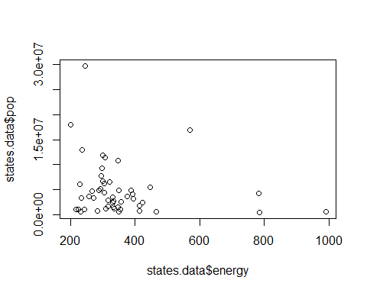

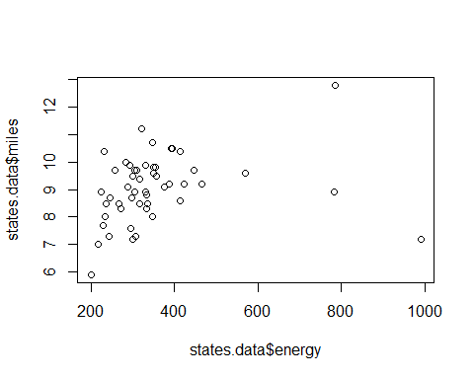

Energy and waste

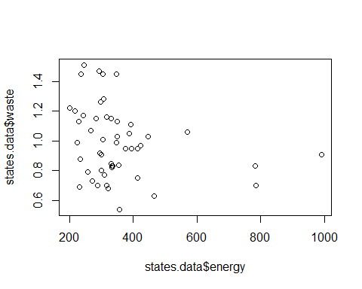

Energy and toxic waste

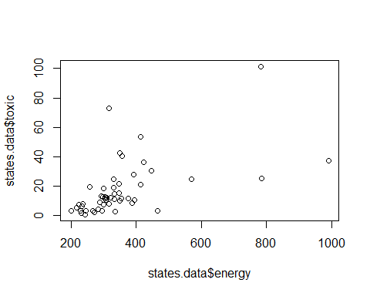

Fit the model

energy.mod <- lm(states.data$energy ~ states.data$metro + states.data$density + states.data$miles)  
summary(energy.mod)

## Call:  
## lm(formula = states.data$energy ~ states.data$metro + states.data$density + states.data$miles)  
##   
## Residuals:  
## Min 1Q Median 3Q Max   
## -197.33 -69.60 -33.74 15.00 588.64   
##   
## Coefficients:  
## Estimate Std. Error t value Pr(>|t|)   
## (Intercept) 442.9017 228.9018 1.935 0.0592 .  
## states.data$metro -1.4462 1.2271 -1.179 0.2446   
## states.data$density -0.1183 0.1113 -1.062 0.2937   
## states.data$miles 2.6409 20.6078 0.128 0.8986   
## ---  
## Signif. codes: 0 '***' 0.001 '**' 0.01 '*' 0.05 '.' 0.1 ' ' 1  
##   
## Residual standard error: 141.2 on 46 degrees of freedom  
## (1 observation deleted due to missingness)  
## Multiple R-squared: 0.14, Adjusted R-squared: 0.08388   
## F-statistic: 2.495 on 3 and 46 DF, p-value: 0.07158

A revised model

lm(formula = states.data$energy ~ states.data$metro + states.data$density +   
 states.data$miles)

##   
## Call:  
## lm(formula = states.data$energy ~ states.data$metro + states.data$density +   
## states.data$miles)  
##   
## Coefficients:  
## (Intercept) states.data$metro states.data$density   
## 442.9017 -1.4462 -0.1183   
## states.data$miles   
## 2.6409

Comment:

Enery.mod with extra predictors has a lower adjusted R-squared than energy.mod2 with only one predictor.

## Interactions and factors

## ══════════════════════════

# Modeling interactions

## ─────────────────────────

# Interactions allow us assess the extent to which the association

# between one predictor and the outcome depends on a second predictor.

# For example: Does the association between expense and SAT scores

# depend on the median income in the state?

Add the interaction to the model

sat.expense.by.percent <- lm(csat ~ expense*income, data=states.data)

Show the results

coef(summary(sat.expense.by.percent))

## Estimate Std. Error t value Pr(>|t|)  
## (Intercept) 1.380364e+03 1.720863e+02 8.021351 2.367069e-10  
## expense -6.384067e-02 3.270087e-02 -1.952262 5.687837e-02  
## income -1.049785e+01 4.991463e+00 -2.103161 4.083253e-02  
## expense:income 1.384647e-03 8.635529e-04 1.603431 1.155395e-01

## Regression with categorical predictors

## ──────────────────────────────────────────

# Let's try to predict SAT scores from region, a categorical variable.

# Note that you must make sure R does not think your categorical

# variable is numeric.

# Make sure R knows region is categorical

str(states.data$region)

## Factor w/ 4 levels "West","N. East",..: 3 1 1 3 1 1 2 3 NA 3 ...

# Add region to the model

sat.region <- lm(csat ~ region, data=states.data)

# Show the results

coef(summary(sat.region))

## Estimate Std. Error t value Pr(>|t|)  
## (Intercept) 946.30769 14.79582 63.9577807 1.352577e-46  
## regionN. East -56.75214 23.13285 -2.4533141 1.800383e-02  
## regionSouth -16.30769 19.91948 -0.8186806 4.171898e-01  
## regionMidwest 63.77564 21.35592 2.9863209 4.514152e-03

anova(sat.region)

## Analysis of Variance Table  
##   
## Response: csat  
## Df Sum Sq Mean Sq F value Pr(>F)   
## region 3 82049 27349.8 9.6102 4.859e-05 ***  
## Residuals 46 130912 2845.9   
## ---  
## Signif. codes: 0 '***' 0.001 '**' 0.01 '*' 0.05 '.' 0.1 ' ' 1

## Setting factor reference groups and contrasts

## ─────────────────────────────────────────────────

# In the previous example we use the default contrasts for region. The

# default in R is treatment contrasts, with the first level as the

# reference. We can change the reference group or use another coding

# scheme using the `C' function.

# Print default contrasts

contrasts(states.data$region)

## N. East South Midwest  
## West 0 0 0  
## N. East 1 0 0  
## South 0 1 0  
## Midwest 0 0 1

# Change the reference group

coef(summary(lm(csat ~ C(region, base=4), data=states.data)))

## Estimate Std. Error t value Pr(>|t|)  
## (Intercept) 1010.08333 15.39998 65.589930 4.296307e-47  
## C(region, base = 4)1 -63.77564 21.35592 -2.986321 4.514152e-03  
## C(region, base = 4)2 -120.52778 23.52385 -5.123641 5.798399e-06  
## C(region, base = 4)3 -80.08333 20.37225 -3.931000 2.826007e-04

# Change the coding scheme

coef(summary(lm(csat ~ C(region, contr.helmert), data=states.data)))

## Estimate Std. Error t value Pr(>|t|)  
## (Intercept) 943.986645 7.706155 122.4977451 1.689670e-59  
## C(region, contr.helmert)1 -28.376068 11.566423 -2.4533141 1.800383e-02  
## C(region, contr.helmert)2 4.022792 5.884552 0.6836191 4.976450e-01  
## C(region, contr.helmert)3 22.032229 4.446777 4.9546509 1.023364e-05

### Original coding begins here--

## Exercise: interactions and factors

## ────────────────────────────────────────

# Use the states data set.

# 1. Add on to the regression equation that you created in exercise 1 by

# generating an interaction term and testing the interaction.

energy.mod <- lm(states.data$energy ~ states.data$pop * states.data$area, data=states.data)

coef(summary(energy.mod))

## Estimate Std. Error t value  
## (Intercept) 3.029774e+02 2.838904e+01 10.67233658  
## states.data$pop -6.288445e-06 5.187475e-06 -1.21223613  
## states.data$area 1.176763e-03 2.079198e-04 5.65969696  
## states.data$pop:states.data$area -1.392399e-12 3.438859e-11 -0.04049015  
## Pr(>|t|)  
## (Intercept) 4.934838e-14  
## states.data$pop 2.316117e-01  
## states.data$area 9.343431e-07  
## states.data$pop:states.data$area 9.678776e-01

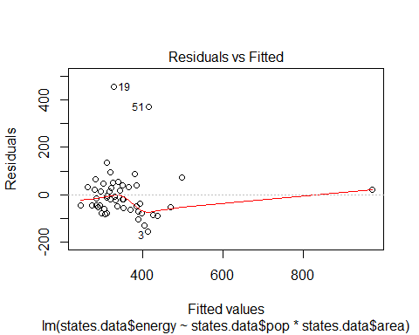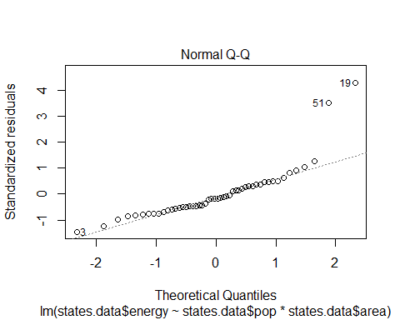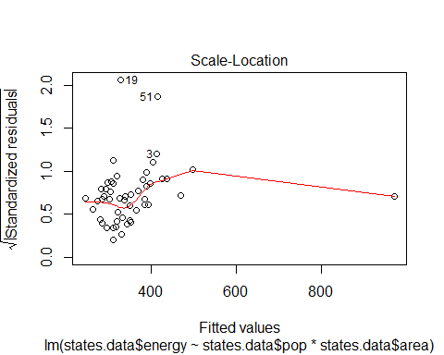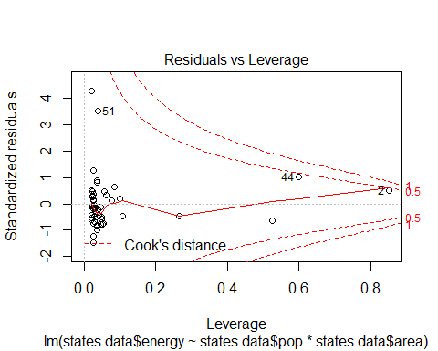

coef(summary(energy.mod))

## Estimate Std. Error t value  
## (Intercept) 3.029774e+02 2.838904e+01 10.67233658  
## states.data$pop -6.288445e-06 5.187475e-06 -1.21223613  
## states.data$area 1.176763e-03 2.079198e-04 5.65969696  
## states.data$pop:states.data$area -1.392399e-12 3.438859e-11 -0.04049015  
## Pr(>|t|)  
## (Intercept) 4.934838e-14  
## states.data$pop 2.316117e-01  
## states.data$area 9.343431e-07  
## states.data$pop:states.data$area 9.678776e-01

# 2. Try adding region to the model. Are there significant differences

# across the four regions?

energy.mod3 <- lm(states.data$energy ~ states.data$metro + states.data$density + states.data$miles + states.data$region)

coef(summary(energy.mod3))

## Estimate Std. Error t value Pr(>|t|)  
## (Intercept) 636.68378162 245.4176158 2.5942872 0.01290973  
## states.data$metro -2.36303503 1.2915234 -1.8296494 0.07424112  
## states.data$density 0.03849528 0.1430191 0.2691618 0.78909254  
## states.data$miles -9.31951252 21.5856905 -0.4317449 0.66808398  
## states.data$regionN. East -156.04967990 82.1351593 -1.8999133 0.06416398  
## states.data$regionSouth -25.09299582 54.0558457 -0.4642050 0.64484256  
## states.data$regionMidwest -69.82374799 56.7612911 -1.2301297 0.22533620

Interpretation of exercise results: I would interpret this coefficient table to mean there are no significant reationships in this model. The small t values are not high enough to indicate the null hypothesis can be rejected. The standard deviations for most variables are too high. Pr(>|t|) are high enough in most cases are high enough to say the observed results are due to chance. None of the p-values are indicated by asterisks to be significant.