Guide: Building a Literature-Recommendation Assistant with RAG + Local LLM
Step 1: Setting Up a GenAI Project in GitHub
Goal: Create a well-organized GitHub repository.
- Log in to your GitHub account and create a new repository.
  - Name: e.g. GenAI_assistant
  - Description: e.g. A GenAI-powered assistant for literature recommendation tasks
  - Select:
    - Add README file -> √
    - Add .gitignore -> choose Python
    - License -> MIT or Apache 2.0 (if open source)
- Clone the repository locally:
  - Open the terminal, go to your desired directory
  - “git clone https://github.com/your-username/genai-assistant.git”

Step 2: Framing Requirements
Problem statement:
Researchers often need recent, relevant papers on a topic. We want a system where a user asks in natural language (e.g., “recent papers on RAG for personalized learning”) and receives 5 recommended papers with short reasons.
Requirements:
- Accept a natural-language query.
- Generate a concise, cited recommendation list.

Step 3: Selecting and Installing a GenAI Framework
3.1 Basics and terms
When we start working with GenAI tools, three terms should be in our mind: model, runtime, and ecosystem.
First, we should distinguish between two very important kinds of models: embedding model and language model. Both of them are neural models with learned weights. Conceptually:
- A Language Model takes text and generates new text (next-token prediction).
- An Embedding Model takes text and maps it to a vector (a point in a high-dimensional space) that captures its meaning.
For understanding, we can see Language Model as “brain that writes and explains”, and Embedding Model as “brain that measures semantic similarity”.
Strictly speaking, an embedding model is not a generative model because it does not produce fluent text, images, etc. However, in practical GenAI systems, embedding models are often considered part of the GenAI stack as they enable semantic search and retrieval, and can determine which context is fed into the generative model.
For simplicity, in the rest of this guide the term “model” refers only to the language model. We will not discuss embedding models in detail; as a practical hint, a common choice for text embeddings is all-MiniLM-L6-v2.
- Model: which language model are we using
A model is the actual neural network, which contains:
- its architecture (how layers are connected)
- its parameters (billions of learned weights)
And thus has its capabilities, that is how well it follows instructions, reasons, writes, etc.
Examples: Mistral 7B, Llama 3 70B, Qwen 2.5 14B.
You can see that each model has suffix like “7B”, which indicates the number of parameters of the model. In practice, models with more parameters (known as large language models (LLMs)) generally achieve better reasoning and language quality, but they also require much more compute, memory, and power, while models with less parameters (so-called small language models (SLMs)) is the opposite. There’s no specific threshold for the distinction, but we can see 10B as a dividing line.
The model itself is just a set of files on disk (checkpoints). It does not “run” or answer questions on its own. That’s why we also need Runtime.
- Runtime: how we run the model
A runtime is the piece of software that actually loads the model and performs inference on your machine. We can understand it as the engine that runs the brain.
For example, Ollama (one of the runtimes):
- downloads and stores model weights
- loads them into CPU / GPU memory
- handles quantization and optimizations
- exposes a simple API that your Python code can call
From our Python code we never talk to models directly. We send HTTP requests to Ollama, and we simply tell Ollama which model to use and what is the prompt. If we want to change the model, we can simply instruct the runtime, but the runtime itself and our code can stay exactly the same.
- Ecosystem: where models and tools live
An ecosystem is the broader environment where models, datasets, and tools are shared and discovered. We can understand it as the library and marketplace where we get models and tools.
For example, Huggingface (one of the ecosystems) provides:
- a model hub (for both language models and embedding models)
- libraries such as Transformers and SentenceTransformers
- documentation, examples, evaluation leaderboards, etc.
- Mature frameworks
With models, runtimes and ecosystems, we can build our own GenAI frameworks. However, there are also several mature programming frameworks, such as LangChain and LlamaIndex, which are designed to help developers build more complex Generative AI applications. These frameworks act as an orchestration layer on top of models and runtimes: they provide abstractions for LLM calls, tools, memory, multi-step workflows, and integrations with external data sources. They can plug into many different back-ends, but they do not execute neural networks themselves and they are not model stores. Because these frameworks introduce additional abstraction and a steeper learning curve, we only mention them briefly here and do not use them in this beginner-oriented guide.
3.2 How to choose
- Runtime choices
First, we should consider runtime as it will affect our choice for models.
There are basically two types of runtimes:
- Model APIs
- You send a request to a server that hosts the model.
- You don’t manage or download the model.
- The model runs in the cloud and returns only the result.
- Local Model Runners
- You first download the model weights to your machine.
- All computation happens locally, using CPU or GPU.
- No internet is required after setup, and you have full control of the model.
Here is a short summary of different choices:
Framework Name | Category | Payment Needed | Requires GPU | Notes
Hugging Face Inference API | Cloud API (Remote) | ✅ | ❌ | Hosts many open-source models
OpenAI API | Cloud API (Remote) | ✅ | ❌ | Access to GPT-3.5, GPT-4
Claude API | Cloud API (Remote) | ✅ | ❌ | From Anthropic
Gemini API | Cloud API (Remote) | ✅ | ❌ | From Google
Ollama | Local Runner | ❌ | Optional | CLI to run open-source models locally
LM Studio | Local Runner (GUI) | ❌ | Optional | GUI alternative to Ollama
Text Generation WebUI | Local Runner (Web UI) | ❌ | Preferred | Powerful, flexible, community-driven

We can choose it according to our resource and requirements (such as locality for security concern). As a beginning, we choose Ollama, which is very widely used, as an example.
- Model choices
When choosing models, we should also consider our resource and requirements, and choose a model of a size that is both feasible and effective.
There are many models available. We can choose based on their reputation, by reading their documentation, or by comparing them on public evaluation sites such as the Open LLM Leaderboard [1].
If we want to use small open models for a beginning, Mistral-7B, Llama-3-8B, Qwen-2.5-7B would be good choices. Here, we use llama-3 as an example
- Ecosystem choices
We have
- Hugging Face Hub – the main open-source ecosystem for models and embeddings.
- OpenAI platform – models, docs, examples, evaluation tools, but mostly closed-source.
- NVIDIA AI / NIM, Cohere platform, Google Vertex AI – more enterprise-focused ecosystems.
The most popular one in today’s open-source LLM world is Hugging Face.
3.3 Our example
Components:
- Model: llama-3-8B, all-MiniLM-L6-v2
- Runtime: Ollama
  - Pros: private, free, reproducible; sufficient for keyword extraction + summarization.
- Ecosystem: Huggingface
Install: (codes are marked in grey)
Pips：
pip install arxiv requests sentence-transformers faiss-cpu numpy
Start local LLM (will download automatically for the first time):
ollama run llama3
As we choose HuggingFace embeddings, we need first-time download: (run in python)
from sentence_transformers import SentenceTransformer
print("Downloading all-MiniLM-L6-v2 from HuggingFace...")
model = SentenceTransformer("sentence-transformers/all-MiniLM-L6-v2")
print("Download finished and cached locally.")

Step 4: Getting Started with Design
  - Basics
As a short introduction, prompt engineering, fine-tuning, and Retrieval-augmented-generation (RAG) represent three complementary approaches for enhancing the performance of GenAI.
Among them, fine-tuning is the only approach that modifies the model itself by adjusting its parameters through additional training. As such, it has the highest potential ceiling in terms of performance improvement, but it also demands significant computational resources, careful data design, and extensive experimentation.
In contrast, prompt engineering and RAG do not alter the model’s internal parameters. Prompt engineering enhances model performance by improving communication, crafting clear, structured, and contextually precise instructions that maximize the model’s reasoning and expressive capabilities. RAG, on the other hand, extends the model’s effective knowledge base by providing relevant external information beyond its original training corpus, or more broadly, by integrating external tools and retrieval mechanisms that simplify the target task.
For ease of understanding, if we consider the language model as a student, and our task as an exam, fine-tuning would be the training and exercises for the student, which will enhance his/her performance in the exam by actually improving the ability of the student him/herself; prompt engineering would be improving the question stems and instruct the students of what knowledge should be used or else; RAG would be making the exam an open-book one, and provide the students with the knowledge needed for the exam. The later two could also enhance the student’s performance in the exam but won’t change the student’s ability itself.
Every task can benefit from well-designed prompting, as it directly optimizes how the model interprets and executes instructions. The effectiveness of RAG, however, depends more on the task type, particularly for knowledge-intensive or context-dependent problems. Fine-tuning, while universally applicable, is constrained by hardware limitations and requires sophisticated training strategies. Together, these three techniques form a continuum of model enhancement methods, ranging from lightweight prompt-level control to full parameter adaptation.
  - Our example
Requirements: (redefined after architecture choice)
- Accept a natural-language query.
- Extract searchable keywords.
- Retrieve recent candidate papers from arXiv.
- Build a vector store over candidate abstracts.
- Use RAG to select top-K most relevant items for the query.
- Ask an LLM to generate a concise, cited recommendation list.

High-level flow:
1. Keyword extraction (LLM → 3–6 keywords)
2. Candidate retrieval from arXiv (title, abstract, url)
3. Vector store build (embeddings → FAISS)
4. Top-K semantic retrieval (RAG)
5. Grounded generation (strict prompt → cited list)

Step 5: Start Coding Towards Delivering Results
Project layout:
genai_paper_recommender/
├── main.py
├── data/
├── search/arxiv_client.py
├── core/keyword_extractor.py, vector_store.py, rag_pipeline.py
└── llm/ollama_client.py, prompt_templates.py

main.py — Orchestrator / Entry point
Coordinates the whole pipeline:
- Accepts a user’s natural-language query.
- Extracts keywords.
- Retrieves candidate papers from arXiv.
- Builds a vector store and performs Top-K retrieval.
- Calls the LLM with evidence and generates final recommendations.
Outputs results to console (and optionally a Markdown file).
search/arxiv_client.py — Literature search
Implements the connection to arXiv API.
- Builds a query from extracted keywords.
- Fetches candidate papers (title, abstract, URL, updated date).
- Returns a structured list of papers for downstream processing.
core/keyword_extractor.py — Keyword extraction
Uses the LLM to transform a natural-language question into 3–6 precise arXiv keywords.
- Calls ollama_client.query_ollama() with a keyword prompt.
- Cleans and formats the result into a keyword list.
core/vectorstore.py — Vector store (RAG core)
Manages embeddings and semantic search.
- Converts paper abstracts (and titles) into vectors using either HuggingFace or Ollama embeddings.
- Builds and saves a FAISS index.
- Encodes the user query and retrieves the Top-K most similar papers.
core/rag_pipeline.py — Evidence-based generation
Constructs a strict prompt with the Top-K evidence and calls the LLM.
- Ensures recommendations are grounded in the retrieved papers.
- Returns a Markdown list of ~5 recommended papers with short explanations and citations.
llm/ollama_client.py — LLM API wrapper
Encapsulates HTTP calls to Ollama.
- query_ollama() → sends a prompt and returns generated text.
- (Optional) embedding requests if using Ollama’s embedding models.
llm/prompt_templates.py — Prompt definitions
Central place for all prompt text.
- keyword_prompt() → guides the LLM to output comma-separated keywords.
- rag_answer_prompt() → structures the evidence (papers) and instructs the LLM to generate a cited recommendation list.

Run sequence:
1. Start LLM: ollama run llama3
2. Run pipeline: python main.py
3. Enter queries like:
- Find recent papers on how RAG improves performance of LLM.
Here is an example:
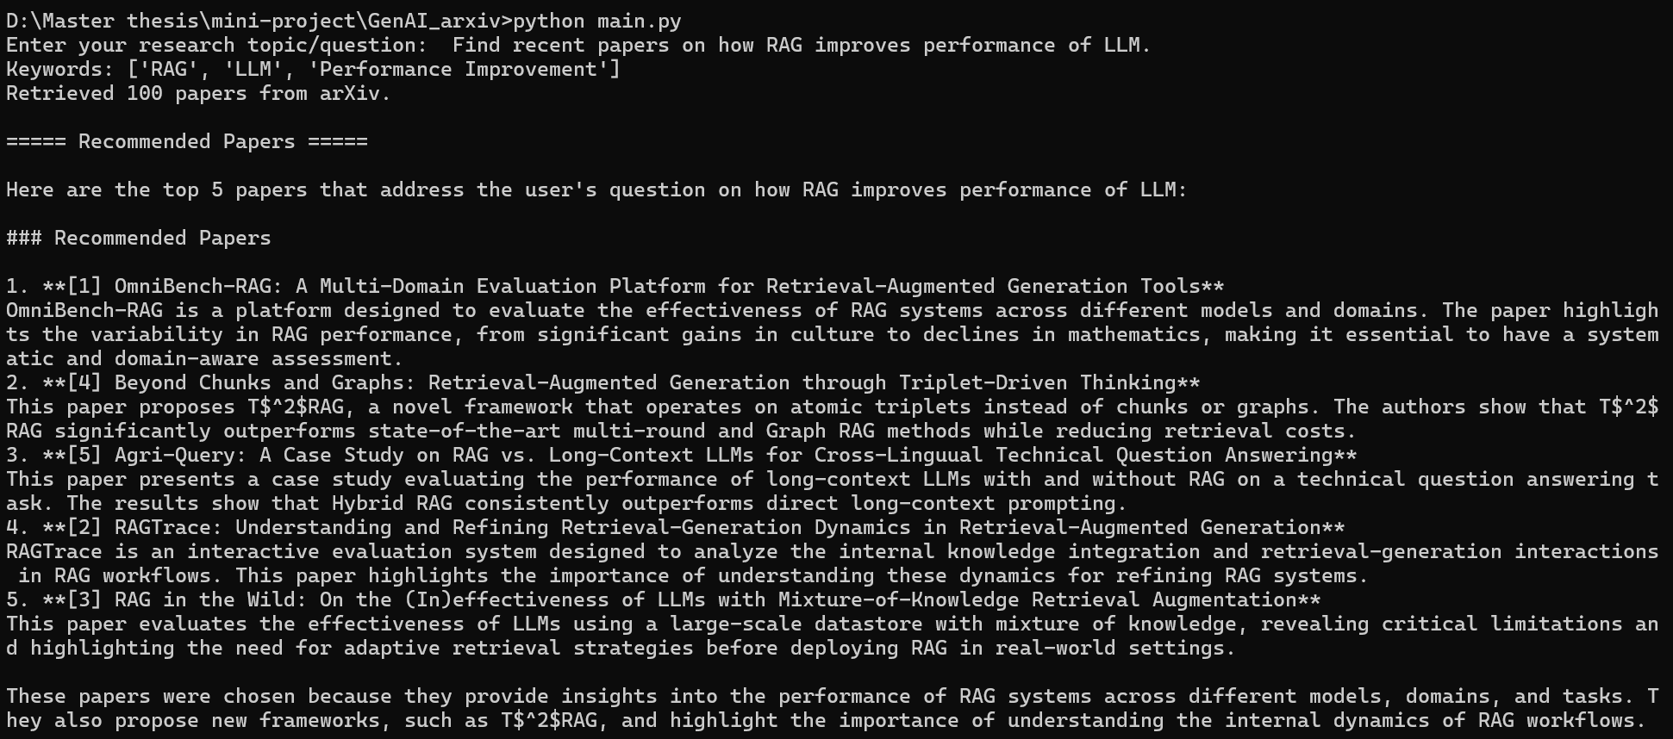
This project is just an example. For better performance, you can work on your prompts for better instruction to the LLM, known as Prompt Engineering; Or you can work on a better way of RAG or fine-tuning instead.
You can see the full example project on:
Palovine1412/GenAI-data-analytics-assistant: A GenAI-powered assistant for data analytics tasks

Step 6: Delivering the Project on GitHub
Lastly, we can modify the README.md, and then deliver the project on GitHub.
Go to your file’s directory
- git add .
It will temporarily store all changes of your file.
- git commit -m "Add project files for GenAI assistant"
It will save your changes to the local Git repository.
Sometimes you also need to run
- git config --global user.email “YourEmailAddress”
or
- git config --global user.name "Your Name"
to identify yourself.
- git push origin main
It will upload these changes to a remote repository on GitHub.
And by now, you’ve successfully created a simple project based on GenAI.

[1] “Open LLM Leaderboard - a Hugging Face Space by open-llm-leaderboard.” Accessed: Dec. 19, 2025. [Online]. Available: https://huggingface.co/spaces/open-llm-leaderboard/open_llm_leaderboard

