Contents
CS Subjects 2
DBMS 2
DS 2
FEWT 2
WEB TECHNOLOGIES 3
HTML 3
CSS 3
JavaScript 3
PARTS OF MACHINE LEARNING 4
Supervised Learning 4
Unsupervised Learning 4
Reinforcement Learning 4
Additional Perspectives 4
Frameworks 5
React 5
Angular 5
Vue 5

Engineering

CS Subjects

DBMS
A Database Management System (DBMS) is specialized software used to create, store, retrieve, and manipulate data within a database. It acts as a secure intermediary between the database and end-user applications, allowing users to efficiently manage structured and unstructured information while ensuring consistency and security.

DS
A Data Structure (DS) is a specialized format used to organize, store, manage, and manipulate data efficiently on a computer. Choosing the correct data structure allows programmers to minimize memory usage (space complexity) and reduce execution speed (time complexity) during tasks like searching, sorting, inserting, or deleting information.

FEWT
Front-end web technologies build the client-side user interface. They dictate everything users see, click, and interact with on a website. The ecosystem is built on three core pillars: HTML (structure), CSS (styling), and JavaScript (interactivity).

WEB DESIGNING

WEB TECHNOLOGIES

HTML
HTML, which stands for HyperText Markup Language, is the standard standard language used to create and structure web pages across the internet. It acts as the structural skeleton of a website, instructing web browsers on how to display text, images, hyperlinks, and multimedia. Web browsers receive HTML documents from a web server or from local storage and render the documents into multimedia web pages. HTML describes the structure of a web page semantically and originally included cues for its appearance.

CSS
CSS (Cascading Style Sheets) is the code that styles web content. This article walks you through a basic understanding of CSS — how it works and how to improve the look and feel of the content structure you created in the previous article. Like HTML, CSS is not a programming language. It's not a markup language either. CSS is a style sheet language. CSS is used to style HTML elements: you select the elements you want to style and set values for their style properties, which define how they will look.

JavaScript
JavaScript is a versatile, dynamically typed programming language that brings life to web pages by making them interactive. It is used for building interactive web applications and supports both client-side and server-side development. JavaScript runs on the user's browser, so it has a faster response time without needing to communicate with the server. Can be used for a wide range of tasks, from simple calculations to complex server-side applications.

MACHINE LEARNING(ML)

PARTS OF MACHINE LEARNING

Supervised Learning
Supervised learning involves training algorithms on labelled data, where the input-output relationship is known. The model learns to map inputs to outputs and can make predictions on new, unseen data. Common applications include classification (e.g., spam detection, medical diagnosis) and regression (e.g., predicting house prices or stock values). Popular algorithms include linear regression, logistic regression, decision trees, support vector machines (SVM), k-nearest neighbours (k-NN), Naive Bayes, and random forests

Unsupervised Learning
Unsupervised learning works with unlabelled data to identify patterns, groupings, or structures within the dataset. It is often used for clustering, dimensionality reduction, and association rule mining. Examples include customer segmentation, market basket analysis, and anomaly detection. Clustering methods can be centroid-based, distribution-based, connectivity-based, or density-based, while dimensionality reduction techniques help simplify data while retaining important information.

Reinforcement Learning
Reinforcement learning trains an agent to make decisions by interacting with an environment and receiving feedback in the form of rewards or penalties. The goal is to learn a strategy or policy that maximizes cumulative rewards over time. Methods include model-based and model-free approaches, with further distinctions such as value-based and policy-based methods. Applications include robotics, game playing, and autonomous systems

Additional Perspectives
Some sources also describe machine learning in terms of components of the learning process, including data storage, abstraction, generalization, and evaluation, which highlight the workflow and reasoning behind how models learn from data. While these components are not divisions of ML per se, they provide insight into the stages involved in building and refining machine learning models.
In summary, the three primary divisions—supervised, unsupervised, and reinforcement learning—cover the majority of machine learning approaches, each suited to different types of data and problem-solving scenarios.

JavaScript

Frameworks

React
- What it is: Technically a specialized UI library, but it operates as a full ecosystem framework in practice.
- Creator: Developed and maintained by Meta (Facebook).
- Core Feature: Uses a Virtual DOM to selectively update parts of a webpage without reloading the entire page, ensuring lightning-fast performance.
- Best For: Dynamic single-page applications (SPAs) and projects requiring highly reusable user interface components.

Angular
- What it is: A complete, heavyweight, and highly opinionated framework.
- Creator: Developed and maintained by Google.
- Core Feature: Built entirely on TypeScript, enforcing a rigid, modular structure with built-in tools for routing, data fetching, and form validation.
- Best For: Large-scale enterprise applications where consistency, strict code architecture, and scalability are critical.

Vue
- What it is: A progressive, lightweight framework designed to be easily adoptable.
- Creator: Created by Evan You by combining the best aspects of React and Angular.
- Core Feature: Utilizes a highly intuitive HTML-based template syntax and offers an official Command Line Interface (CLI) to accelerate rapid prototyping.
- Best For: Small to medium projects, startup environments, and developers looking for a gentle learning curve without sacrificing power.

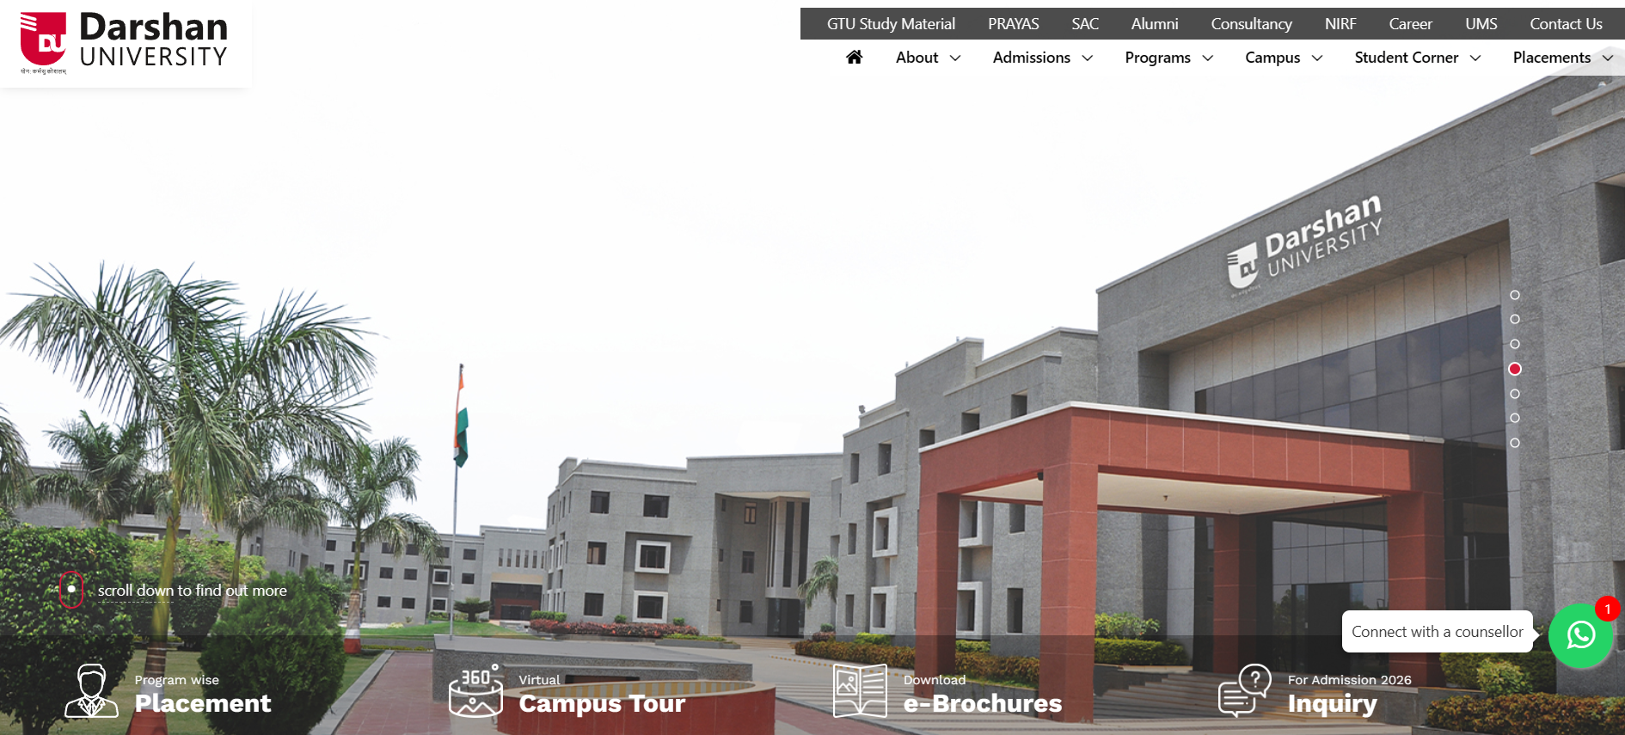

Video provides a powerful way to help you prove your point.
When you click Online Video, you can paste in the embed code for the video you want to add.
You can also type a keyword to search online for the video that best fits your document.
To make your document look professionally produced, Word provides header, footer, cover page, and text box designs that complement each other.
For example, you can add a matching cover page, header, and sidebar.
Click Insert and then choose the elements you want from the different galleries.
Themes and styles also help keep your document coordinated.
When you click Design and choose a new Theme, the pictures, charts, and SmartArt graphics change to match your new theme.
When you apply styles, your headings change to match the new theme.
Save time in Word with new buttons that show up where you need them.
Video provides a powerful way to help you prove your point.
- When you click Online Video, you can paste in the embed code for the video.
- You can also type a keyword to search online for the video that best fits your document.
- Chemical Formula
- H₂O , CO₂ .

Henish Palsana
Roll no: 108
Batch: 3A-1

