CTU
CBSE CLASS XII — BOARD EXAMINATION (THEORY)
Subject: Science
Time Allowed: 3 Hours | Maximum Marks: 80 | 25 May 2025
Name: _________________________ Roll No.: _________________________ Class/Section: _____________
GENERAL INSTRUCTIONS
1. All questions are compulsory.
2. Read each question carefully before answering.
3. Figures to the right indicate full marks.
4. Use of calculator is not permitted unless stated.
────────────────────────────────────────────────────
SECTION A — MULTIPLE CHOICE QUESTIONS
Each question carries 1 mark. Select the correct option.
Q1. (1 marks)
Read the following excerpt from the syllabus material:
"Printed on 80 GSM paper with NCERT watermark Published at the Publication Division by the Secretary, National Council of Educational Research and Training, Sri Aurobindo Marg New Delhi 110 016 and printed at Amit Printing Press, D-12 and 13, Industrial Area, Site-A, Mathura- 281 001 (U.P.) ISBN 81-7450-654-3 ALL RIGHTS RESERVED /boxshadowdwnNo part of this publication may..."
Which statement is most directly supported by the excerpt above?
(a) The main ideas and facts stated in the excerpt are accurately reflected in this choice.
(b) Part IV A (Article 51 A) 2018-19
(c) circuit breaker (MCB) CAUTION Always, use proper fuses which have been specified for...
(d) a screen. 2. Mark ‘T’ if the statement is true and ‘F’ if it is false: (a) We can...
Q2. (1 marks)
Read the following excerpt from the syllabus material:
"Printed on 80 GSM paper with NCERT watermark Published at the Publication Division by the Secretary, National Council of Educational Research and Training, Sri Aurobindo Marg New Delhi 110 016 and printed at Amit Printing Press, D-12 and 13, Industrial Area, Site-A, Mathura- 281 001 (U.P.) ISBN 81-7450-654-3 ALL RIGHTS RESERVED /boxshadowdwnNo part of this publication may..."
Which statement is most directly supported by the excerpt above?
(a) The main ideas and facts stated in the excerpt are accurately reflected in this choice.
(b) Part IV A (Article 51 A) 2018-19
(c) circuit breaker (MCB) CAUTION Always, use proper fuses which have been specified for...
(d) a screen. 2. Mark ‘T’ if the statement is true and ‘F’ if it is false: (a) We can...
Q3. (1 marks)
Read the following excerpt from the syllabus material:
"SCIENCE46 (d) No medium is required for transfer of heat by the process of __________. (e) A cold steel spoon is dipped in a cup of hot milk. Heat is transferred to its other end by the process of ______________. (f ) Clothes of ______________ colours absorb more heat better than clothes of light colours. 4. Match the following : (i) Land breeze blows during (a) summer (ii)..."
Which statement is most directly supported by the excerpt above?
(a) The main ideas and facts stated in the excerpt are accurately reflected in this choice.
(b) Part IV A (Article 51 A) 2018-19
(c) circuit breaker (MCB) CAUTION Always, use proper fuses which have been specified for...
(d) a screen. 2. Mark ‘T’ if the statement is true and ‘F’ if it is false: (a) We can...
Q4. (1 marks)
Read the following excerpt from the syllabus material:
"terminal. (b) The combination of two or more cells is called a . (c) When current is switched ‘on’ in a room heater, it . (d) The safety device based on the heating effect of electric current is called a . 9. Mark ‘T’ if the statement is true and ‘F’ if it is false: (a) To make a battery of two cells, the negative terminal of one cell is connected to the negative terminal..."
Which statement is most directly supported by the excerpt above?
(a) The main ideas and facts stated in the excerpt are accurately reflected in this choice.
(b) Part IV A (Article 51 A) 2018-19
(c) circuit breaker (MCB) CAUTION Always, use proper fuses which have been specified for...
(d) a screen. 2. Mark ‘T’ if the statement is true and ‘F’ if it is false: (a) We can...
Q5. (1 marks)
Read the following excerpt from the syllabus material:
"Printed on 80 GSM paper with NCERT watermark Published at the Publication Division by the Secretary, National Council of Educational Research and Training, Sri Aurobindo Marg New Delhi 110 016 and printed at Amit Printing Press, D-12 and 13, Industrial Area, Site-A, Mathura- 281 001 (U.P.) ISBN 81-7450-654-3 ALL RIGHTS RESERVED /boxshadowdwnNo part of this publication may..."
Which statement is most directly supported by the excerpt above?
(a) The main ideas and facts stated in the excerpt are accurately reflected in this choice.
(b) Part IV A (Article 51 A) 2018-19
(c) circuit breaker (MCB) CAUTION Always, use proper fuses which have been specified for...
(d) a screen. 2. Mark ‘T’ if the statement is true and ‘F’ if it is false: (a) We can...
Q6. (1 marks)
Read the following excerpt from the syllabus material:
"LIGHT 189 Exercises 1. Fill in the blanks: (a) An image that cannot be obtained on a screen is called ____________. (b) Image formed by a convex __________ is always virtual and smaller in size. (c) An image formed by a __________ mirror is always of the same size as that of the object. (d) An image which can be obtained on a screen is called a _________ image. (e) An image..."
Which statement is most directly supported by the excerpt above?
(a) The main ideas and facts stated in the excerpt are accurately reflected in this choice.
(b) Part IV A (Article 51 A) 2018-19
(c) circuit breaker (MCB) CAUTION Always, use proper fuses which have been specified for...
(d) a screen. 2. Mark ‘T’ if the statement is true and ‘F’ if it is false: (a) We can...
Q7. (1 marks)
Read the following excerpt from the syllabus material:
"5. Squirrel 19 6. Domestic mouse 11 7. Human 40 8. Giant tortoise 0.27 9. Snail 0.05 2018-19"
Which statement is most directly supported by the excerpt above?
(a) The main ideas and facts stated in the excerpt are accurately reflected in this choice.
(b) Part IV A (Article 51 A) 2018-19
(c) circuit breaker (MCB) CAUTION Always, use proper fuses which have been specified for...
(d) a screen. 2. Mark ‘T’ if the statement is true and ‘F’ if it is false: (a) We can...
Q8. (1 marks)
Read the following excerpt from the syllabus material:
"Fig. 14.26 A working model of a railway signal 4. Visit an electric shop. Request an electrician to show you the various types of fuses and MCB and to explain how they work. 2. Make four electromagnets with 20, 40, 60 and 80 turns. Connect them one by one to a battery of 2 cells. Bring the electromagnet near a box of pins. Count the number of pins attracted by it. Compare..."
Which statement is most directly supported by the excerpt above?
(a) The main ideas and facts stated in the excerpt are accurately reflected in this choice.
(b) Part IV A (Article 51 A) 2018-19
(c) circuit breaker (MCB) CAUTION Always, use proper fuses which have been specified for...
(d) a screen. 2. Mark ‘T’ if the statement is true and ‘F’ if it is false: (a) We can...
SECTION B — VERY SHORT ANSWER
Answer in 40-60 words. Each question carries 2 marks.
Q9. (2 marks)
In 40–60 words, define or explain the central idea of the following:
(v) formation of faeces ________________. 10. Write one similarity and one difference between the nutrition in amoeba and human beings. 11. Match the items of Column I with suitable items in Column II Column I Column II (a) Salivary gland (i) Bile juice secretion (b) Stomach (ii) Storage of undigested food (c) Liver (iii) Saliva secretion (d) Rectum (iv)...
Q10. (2 marks)
In 40–60 words, define or explain the central idea of the following:
SCIENCE32 Exercises 1. You must be familiar with the following nursery rhymes: (i) ‘Baa baa black sheep, have you any wool.’ (ii) ‘Mary had a little lamb, whose fleece was white as snow.’ Answer the following: (a) Which parts of the black sheep have wool? (b) What is meant by the white fleece of the lamb? 2. The silkworm is (a) a caterpillar, (b) a...
SECTION C — SHORT ANSWER
Answer in 60-80 words. Each question carries 3 marks.
Q11. (3 marks)
Answer in 60–100 words:
What are the important points a student should remember from the following?
SCIENCE144 move. The distance covered by you after 5 minutes would be much smaller than that covered by the bus. Would you say that the bus is moving faster than the bicycle? We often say that the faster vehicle has a higher speed. In a 100-metre race it is easy to decide whose speed is the highest. One who takes shortest time to cover the distance of 100 metres has the highest speed. 13.2...
Q12. (3 marks)
Answer in 60–100 words:
What are the important points a student should remember from the following?
represents the positive terminal and the thicker, shorter line represents the negative terminal. For a switch the ‘ON’ position and the ‘OFF’ position are represented by the symbols as shown. The wires used to connect the various components in a circuit are represented by lines. In Table 14.1, a battery and its symbol are also shown. Do you know what a battery is? Look at the symbol of a...
SECTION D — CASE BASED / SOURCE BASED
Read the passage and answer the sub-questions. Each question carries 4 marks.
Q13. (4 marks)
A student is revising from the following two related portions of the textbook.
Portion I:
(ii) under the ground remains constant. (iii) in the seas and oceans of the world remains constant. (iv) of the world remains constant. 9. Make a sketch showing groundwater and water table. Label it. Extended Learning — Activities and Projects 1. Role play You are a water detective in your school. You have a team of six members. Survey the campus and make a note of the...
Portion II:
PREFACE This book is the outcome of the efforts of the Textbook Development Committee appointed by the NCERT. The committee met a few times to interact with one another to improve the draft. Then there was a review meeting in which many experts and practicing school teachers were invited to review the draft and suggest improvements. By and large we have stuck to the format...
Use the diagram if relevant.
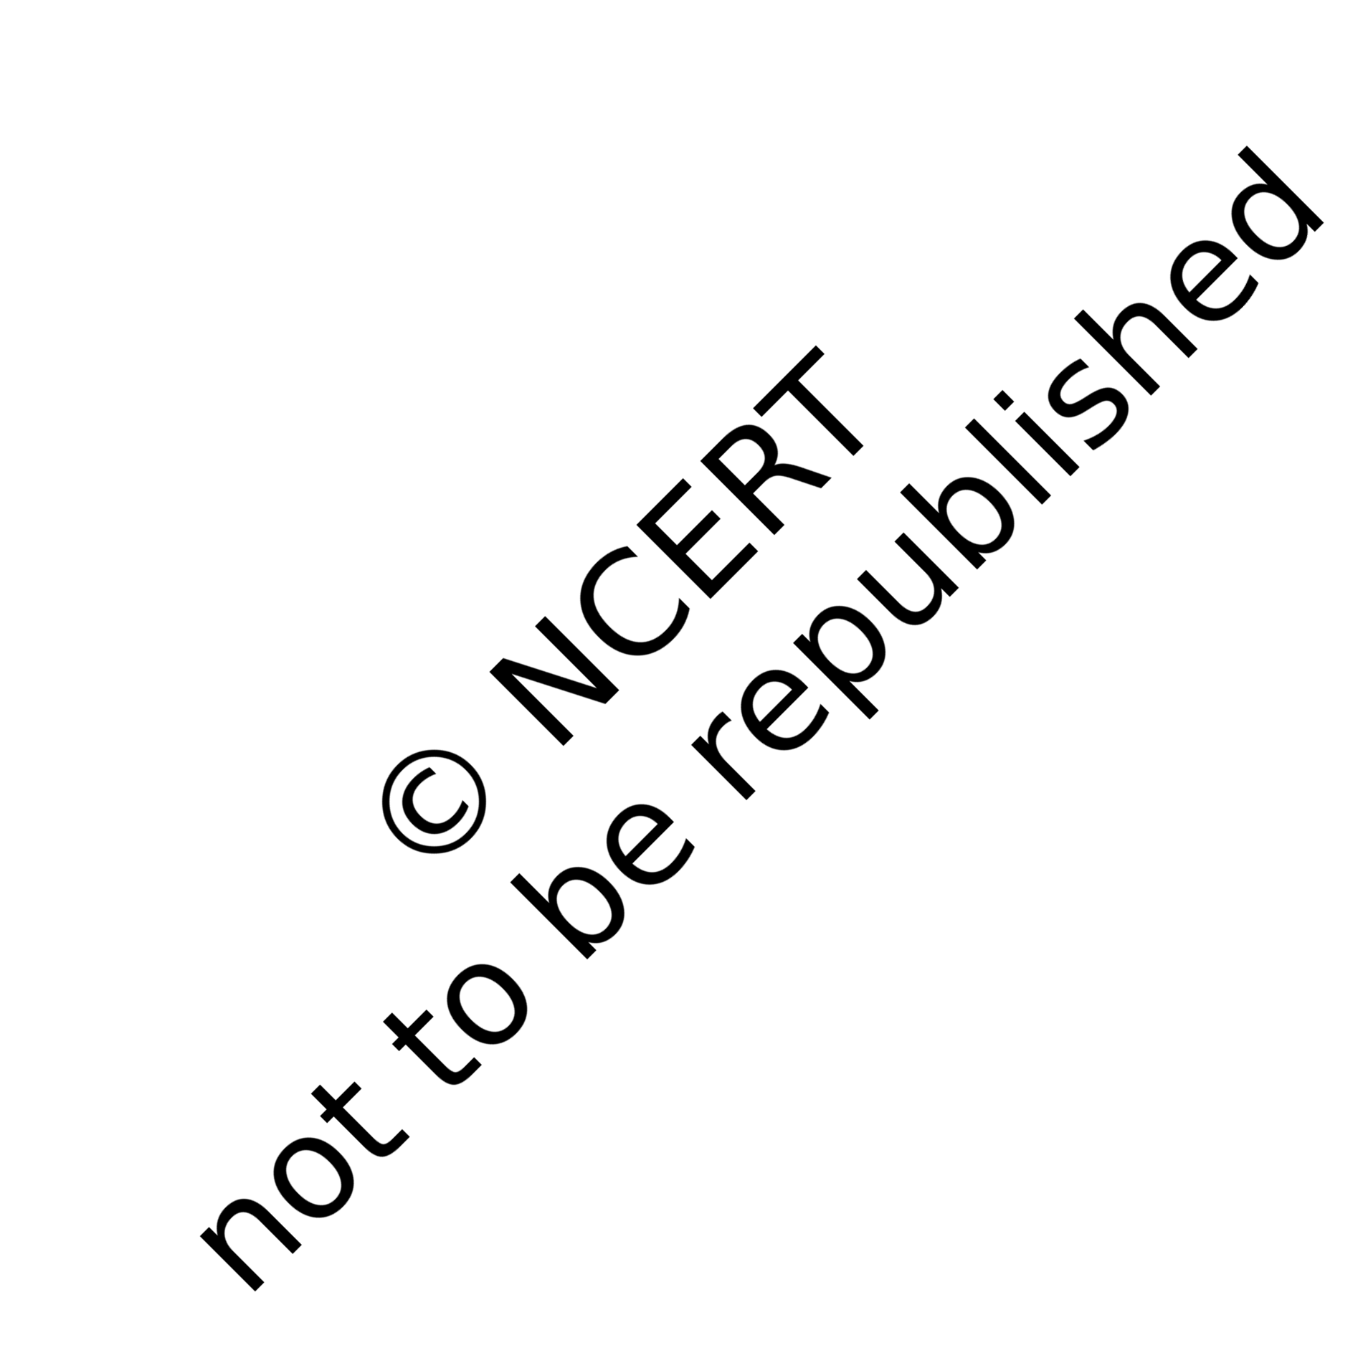
(a) Identify two key ideas from Portion I that a student must remember. (2 marks)
(b) How does Portion II connect to or extend the ideas in Portion I? Explain briefly. (2 marks)
SECTION E — LONG ANSWER
Answer in detail with diagrams where necessary.
Q14. (5 marks)
Discuss in detail (with examples where possible) the concepts implied by the following material. Organise your answer with clear sub-headings.
distance-time graphs. /square6 The distance-time graph for the motion of an object moving with a constant speed is a straight line. 2018-19
SECTION F — EXTENDED RESPONSE
Answer with proper derivation / explanation. (8 marks)
Q15. (8 marks)
Discuss in detail (with examples where possible) the concepts implied by the following material. Organise your answer with clear sub-headings.
F ORESTS : O UR L IFELINE 213 them may belong to different tribes. Tibu explained that these people depend mostly on the forests. The forest provides them with food, shelter, water and medicines. They have traditional knowledge about many medicinal plants in the forest. While Boojho was drinking water from a small stream, he saw some deer crossing the stream (Fig. 17.11). They disappeared into the bushes. The dense bushes and the tall grass provide animals with the food and shelter. They

