ABC SENIOR SECONDARY SCHOOL
CBSE CLASS XII — BOARD EXAMINATION (THEORY)
Subject: Science / Mathematics
Time Allowed: 3 Hours | Maximum Marks: 80 | Date: _______________
Name: _________________________ Roll No.: _________________________ Class/Section: _____________
GENERAL INSTRUCTIONS
1. All questions are compulsory.
2. Read each question carefully before answering.
3. Figures to the right indicate full marks.
4. Use of calculator is not permitted unless stated.
────────────────────────────────────────────────────
SECTION A — MULTIPLE CHOICE QUESTIONS
Each question carries 1 mark. Select the correct option.
Q1. (1 marks)
What happens when a fault occurs in the electrical system?
(a) The MCB will trip and interrupt the current flow
(b) A fuse will melt, breaking the circuit
(c) The system will automatically repair itself
(d) The voltage will increase to stabilize the system
Study the figure below.

Q2. (1 marks)
Which of the following statements correctly describe the behavior of a fuse and a MCB in an electrical circuit?
(a) Only the fuse will melt, breaking the circuit
(b) Only the MCB will trip and interrupt the current flow
(c) Both the fuse and MCB will behave the same way
(d) The correct options cannot be determined without specific figures
Study the figure below.
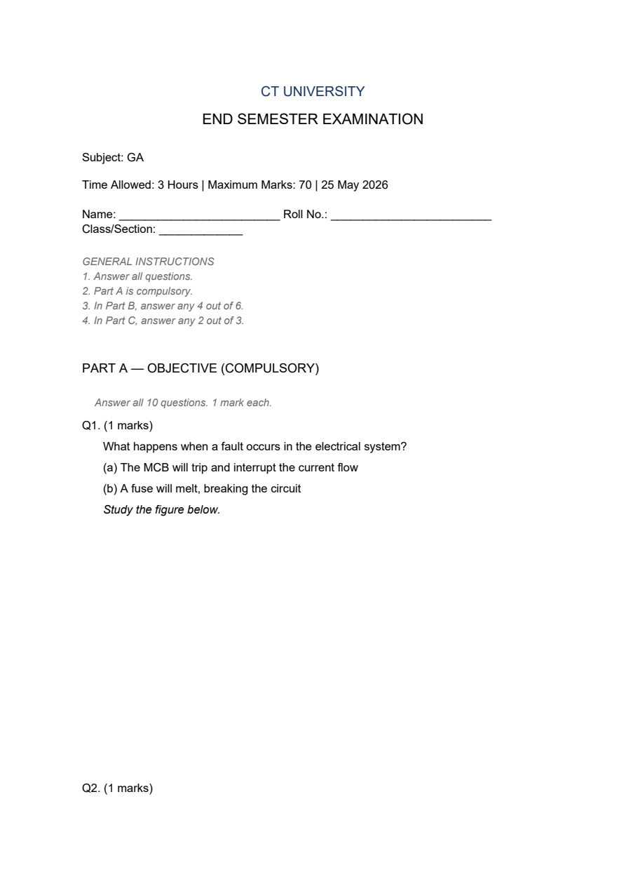
Q3. (1 marks)
Which of the following statements accurately describe the railway signal model depicted in the figure?
(a) All four statements are accurate descriptions
(b) Only two statements accurately describe aspects related to fuses and MCB
(c) None of the statements accurately describe the model
(d) The correct option cannot be determined without referring to specific figures
Study the figure below.
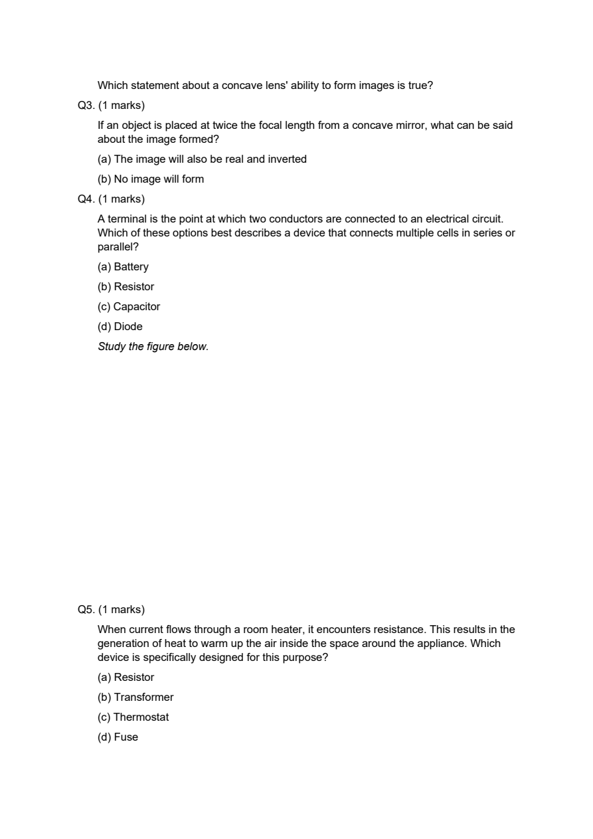
Q4. (1 marks)
Which of the following best describes the function of a capacitor in an electrical circuit?
(a) Stores electrical energy in an electric field
(b) Stores electrical energy in a magnetic field
(c) Serves as a switch to control current flow
(d) Is used to increase the voltage
Study the figure below.

Q5. (1 marks)
What is the primary purpose of a resistor in an electronic circuit?
(a) To amplify the signal
(b) To convert AC to DC
(c) To regulate the current flow
(d) To store electrical energy
Study the figure below.

Q6. (1 marks)
Which of the following statements is true regarding the relationship between voltage, current, and resistance in an electrical circuit?
(a) Voltage is the rate at which electrical energy is used
(b) Current is the resistance to the flow of electrons
(c) Resistance is the product of voltage and current
(d) Ohm's Law states that V = I × R
Study the figure below.

Q7. (1 marks)
If an object is placed at twice the focal length from a concave mirror, what can be said about the image formed?
(a) The image will also be real and inverted
(b) No image will form
(c) The image will be virtual and upright
(d) The image will be the same size as the object
Q8. (1 marks)
Which of these options best describes a device that connects multiple cells in series or parallel?
(a) Battery
(b) Resistor
(c) Capacitor
(d) Diode
SECTION B — VERY SHORT ANSWER
Answer in 40-60 words. Each question carries 2 marks.
Q9. (2 marks)
Based on the principles of motion and velocity, describe the difference between uniform and non-uniform motion. ?
Q10. (2 marks)
Arrange the following activities in order of increasing breathing rates: sleeping, walking, running, and sprinting. ?
SECTION C — SHORT ANSWER
Answer in 60-80 words. Each question carries 3 marks.
Q11. (3 marks)
Explain how resistance in a circuit leads to the generation of heat, using an example from everyday life.
Study the figure below.

Q12. (3 marks)
Identify and explain the function of a device that is specifically designed to generate heat from electrical current, and give an example of such a device.
SECTION D — CASE BASED / SOURCE BASED
Read the passage and answer the sub-questions. Each question carries 4 marks.
Q13. (4 marks)
Refer to the diagram below for the following questions. The diagram shows a simple electrical circuit with a battery, a fuse, and a heater connected in series.
A simple electrical circuit with a battery, a fuse, and a heater connected in series.

(a) What is the primary function of the fuse in the circuit?
(b) If the heater is turned on and the current flows through it, what phenomenon is primarily responsible for the heating effect?
SECTION E — LONG ANSWER
Answer in detail with diagrams where necessary.
Q14. (5 marks)
Given the distance-time graph for the motion of two vehicles A and B as shown in the diagram, vehicle A completes 20 full oscillations in 32 seconds, and the railway track between City X and City Y is 240 kilometers long, which the train travels in 4 hours without any stops. Calculate the time period 'T' of a single oscillation for the pendulum and the constant speed 'v' of the train. Additionally, identify which vehicle (A or B) shows a truck moving with a non-constant speed based on the graph. (5 marks)
Figure

SECTION F — EXTENDED RESPONSE
Answer with proper derivation / explanation. (8 marks)
Q15. (8 marks)
Refer to the distance-time graph provided in Fig_0001, which shows the motion of two vehicles A and B. Vehicle A starts from rest and accelerates uniformly, while vehicle B maintains a constant speed throughout its journey. Calculate the acceleration of vehicle A and its speed at the moment it overtakes vehicle B, and explain your reasoning. ?
Figure


