

Course Code : GO 142

Course Name : Art Appreciation

Lecturer : Mohd Shazmir Bin Shaharuddin

Academic Session : 2022/09

Art Experience and visual element in Colour

Assessment Title : Submission Due Date :

|  |  |
| --- | --- |
|  |  |
| Student ID | Student Name |
| EEE2209292 | Li Jiake |
|  |  |
|  |  |
|  |  |
|  |  |
|  |  |

Prepared by :

Date Received :

Feedback from Lecturer:

Mark:

**Own Work Declaration**

I/We hereby understand my/our work would be checked for plagiarism or other misconduct, and the softcopy would be saved for future comparison(s).

I/We hereby confirm that all the references or sources of citations have been correctly listed or presented and I/we clearly understand the serious consequence caused by any intentional or unintentional misconduct.

This work is not made on any work of other students (past or present), and it has not been submitted to any other courses or institutions before.

Signature: Li Jiake

Date:17/10/2022

# In this colourful world, everyone has their own interpretation of art and their own unique artistic experiences. For me, there are many vivid memories of my experiences. But my focus here is not on my passive experience of art, such as visiting art galleries or museums, but on my active exploration and discovery of art. Here I would like to talk about the following experiences.

# 1. I began to love the art of origami in primary school, and played an important role in my campaign for the Arts Council in junior high school.

# 2. I started to learn drawing in junior high school and won awards in the city. I was also responsible for the design of the blackboard of my class.

# 3. I designed two logos for my high school club

# 4. In high school, I designed my own personal website

# Firstly, I have been involved in origami and handicrafts since primary school. The reason I got into it was that I happened to browse through beautiful and three-dimensional "three-dimensional objects" on the internet - handmade origami works. I was excited to see the life-like origami of animals and plants. It gave me a sense of authenticity as opposed to painting, which is a flat art. My best work at the time was the "Kawasaki Rose" from a Japanese designer. Folding a rose not only requires step-by-step instructions, but also a lot of patience and handwork, and after folding it, it needs to be shaped as appropriate. With this rose origami, I was elected to the junior high school art committee.

This picture shows the Kawasaki rose I learned to fold in primary school

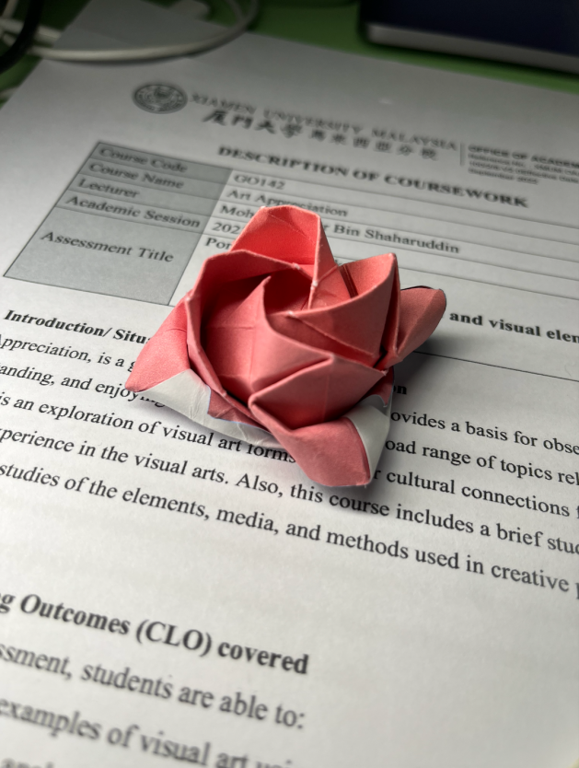

# Secondly, in junior high school I started to experiment with drawing and painting with markers, watercolours and gouache. In the case of markers, not every colour that you want to paint can be found directly in the colours available, and you need to mix two or even more colours in an overlapping way to get the desired colour. But not having a solid foundation in shading in relation to sketching led me to step in a number of holes during this experience. But I never gave up either and drew some pictures in my spare time. At that time, I was very fond of the anime form of drawing, and drawing anime characters on paper made me feel happy. In my junior year, I took part in the city drawing competition and won an award. I was in charge of the blackboard in my class because I was the art committee member. I designed a number of blackboards and it was my understanding of art that deepened.

Both of these images are from my junior high school painting days, and although they may not be good enough, they are my introductory work.The skeleton shown in the second one was drawn by me with a biro to practice shading.And the first picture is the painting I won at school, which is still hanging on the school wall.

# 扫描 12IMG_4815Thirdly, I started my own programming club in high school and designed two separate logos for the club, both of which were based on gorillas because in China, programmers are pronounced like "apes" and we call them "程序猿". One of the logos is made up of gears on the outside, meaning that our society is a society about technology, and the indigo colour scheme emphasises how up-to-date and young our society is. I used Adobe's AI software for the vector design, which gave the logo more flexibility. Designing the Logo has changed my artistic aesthetic and made me understand the difference that differences in composition can make.

# I designed the following three logos, the first of which has now been replaced by the second as my society's logo, and the third now serves as the website I developed.

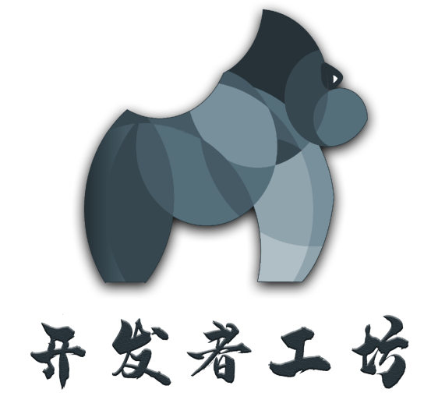

# Fourthly, in high school, I also designed my own personal website (https://www.pamalee.cn). I like a simple and atmospheric design, so I tried to be conservative in my choice of elements, keeping the essential elements and cutting out unnecessary views. I wanted the viewer to feel relaxed and happy rather than overwhelmed by a pile of information. I have reflected the focus of the site through the design of the layout. My personality is reflected through the choice of background images. Through this "invisible" art, my website reflects my own unique style and my personality. Therefore, the artistic concept plays a very important role in the design of my website.

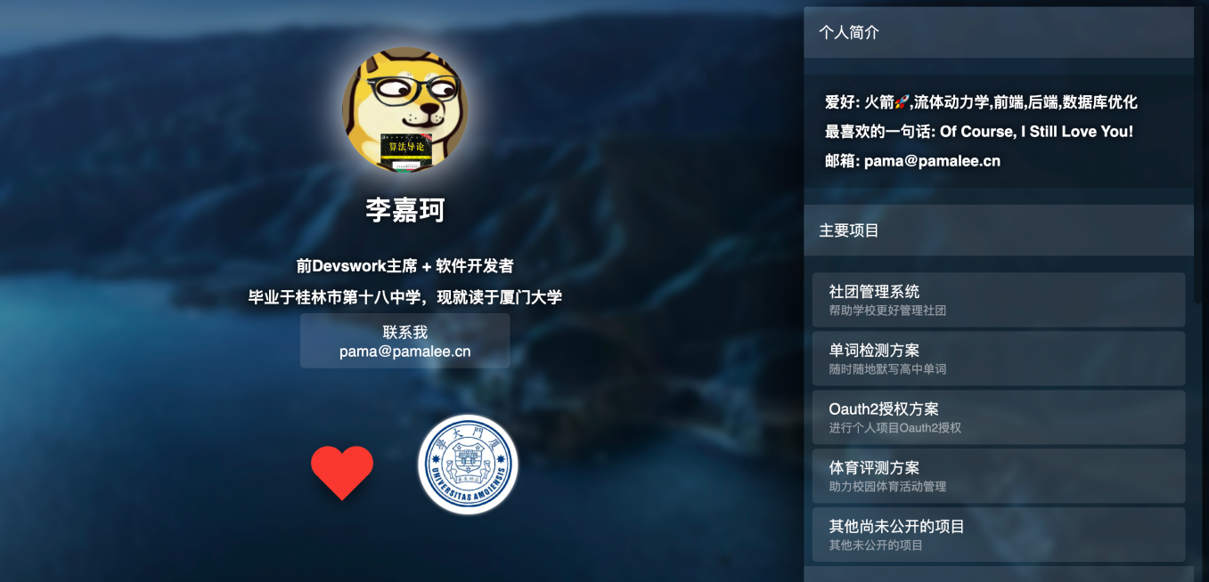

# Also, regarding my favourite colours and dislikes.

# Favourite colour: Indigo

# Dislike colour: chocolate brown

# I like indigo because it makes me feel young. Although it is a cool colour and blue usually represents depth and silence, when I see indigo I feel the quietness of the sky and the expanse of the meadow. Indigo also makes me feel stylish and techy, so it is often used in my personal website or logo design. I'm very much a techie person myself, so I have an unusual feeling for indigo.

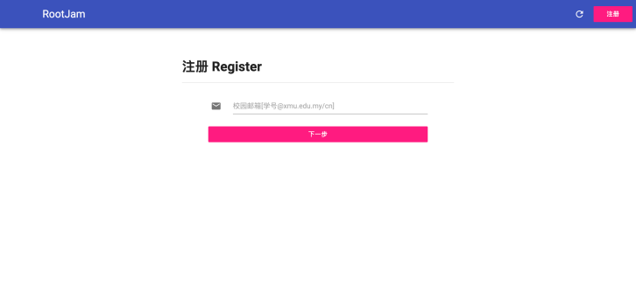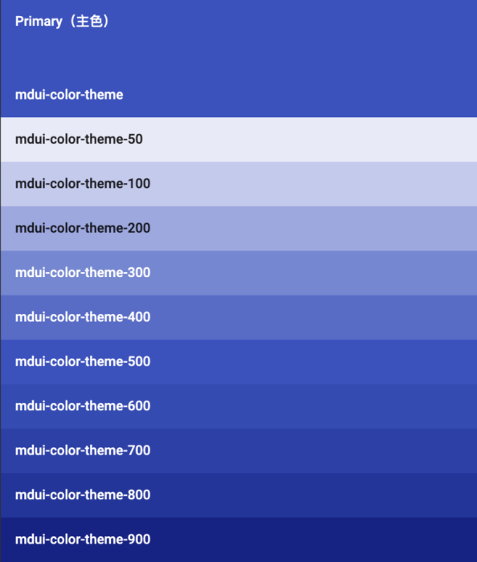

# I don't like the feeling of chocolate because I feel it's a dirty colour and I can't include it in my work because it makes my images dirty. But mainly because I'm not mature enough with colour to be able to do different colours. Also, chocolate colour makes me feel heavy and depressed, and encountering this colour in my daily life makes me feel a touch uneasy.

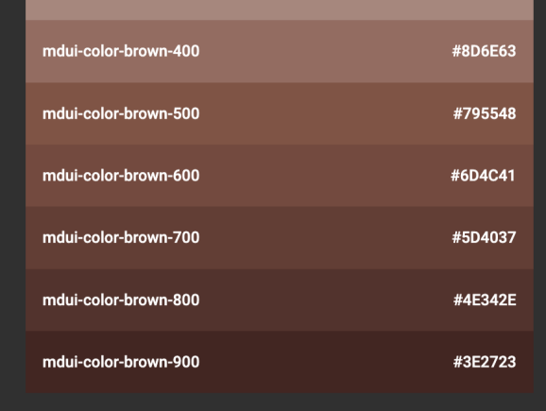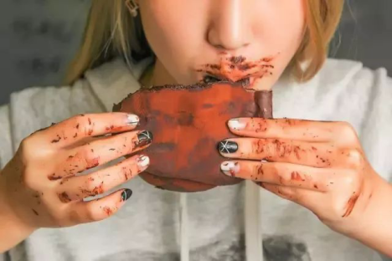



(910 words)

**References**

Sohu. (n.d.). https://www.sohu.com/a/209969037\_418658

MDUI. (n.d.). <https://www.mdui.org/docs/color>

PamaLee. (n.d.). <https://www.pamalee.cn>

RootJam. (n.d.). <https://p.pamalee.cn>

Devswork. (n.d.). <https://work.dev-space.cn>