FUNCTIONAL SPECIFICATION DOCUMENT
Visha IT Solutions – Corporate Website
Version 1.0 | Prepared for Website Development
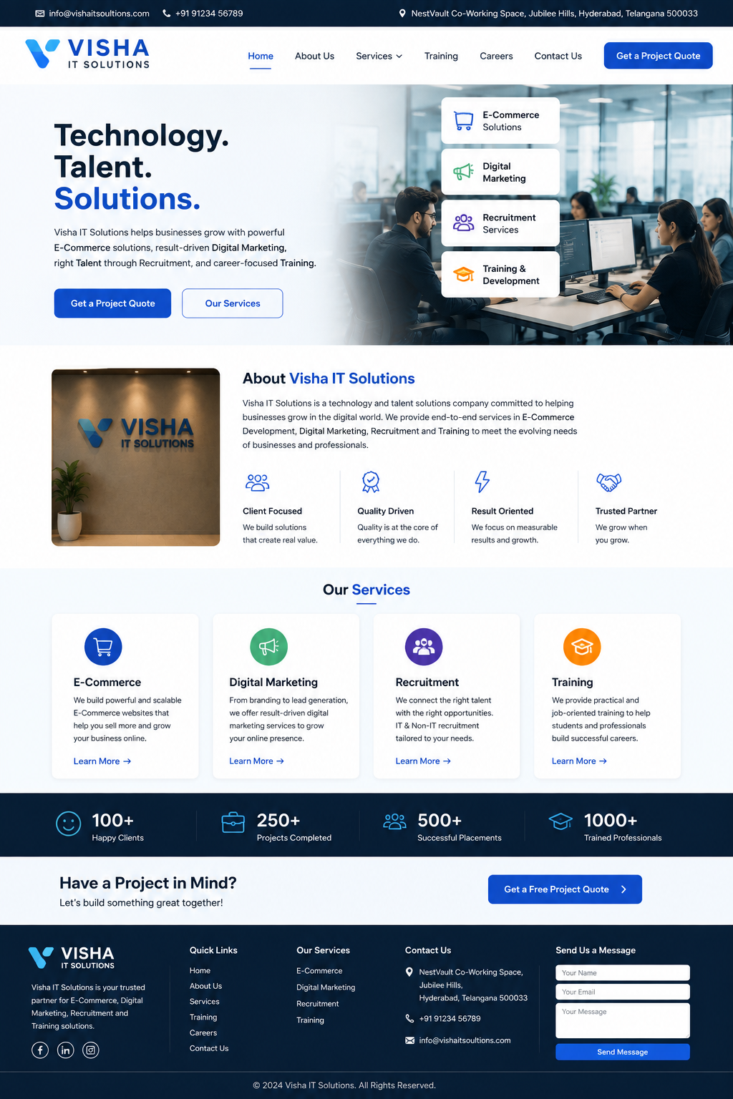
Reference homepage design generated for the developer. Use this as the visual direction, not as a source of factual business statistics.

1. Project Overview
Build a modern, responsive corporate website for Visha IT Solutions. The website must present the company as a professional technology and talent solutions business and generate enquiries for four core services: E-Commerce, Digital Marketing, Recruitment, and Training.

2. Primary Website Goals
- Build trust and a professional online presence.
- Generate project enquiries and quote requests.
- Generate recruitment/hiring enquiries.
- Promote training programs and collect candidate enquiries.
- Clearly explain the four core services.
- Provide easy contact through form, email, phone and WhatsApp if supplied.
- Be fast, mobile-friendly, SEO-ready and easy to maintain.

3. Target Users
- Business owners and companies looking for e-commerce or digital marketing services.
- Companies requiring recruitment or staffing support.
- Students and job seekers interested in training programs.
- Existing clients looking for support or additional services.

4. Sitemap
- Home
- About Us
- Services
- ├─ E-Commerce
- ├─ Digital Marketing
- ├─ Recruitment
- └─ Training
- Projects / Portfolio
- Training Programs
- Careers
- Contact Us
- Privacy Policy
- Terms & Conditions

5. Header / Navigation
Desktop header:
- Top information bar: official email, phone and permitted business/virtual-office address.
- Logo: Visha IT Solutions.
- Navigation: Home, About Us, Services, Training, Careers, Contact Us.
- Primary CTA button: Get a Project Quote.
- Sticky header on scroll.
Mobile:
- Hamburger menu.
- Logo visible.
- Get a Project Quote CTA accessible from menu.
- Tap-to-call and tap-to-email actions.

6. Home Page Functional Specification

6.1 Hero Section
- Headline: Technology. Talent. Solutions.
- Short company description focused on E-Commerce, Digital Marketing, Recruitment and Training.
- Primary CTA: Get a Project Quote.
- Secondary CTA: Our Services.
- Right-side visual/office image or approved brand visual.
- Service highlights may appear as floating cards: E-Commerce Solutions, Digital Marketing, Recruitment Services, Training & Development.

6.2 About Preview
- Short 3–5 line company introduction.
- 4 trust/value points: Client Focused, Quality Driven, Result Oriented, Trusted Partner.
- CTA: Learn More.

6.3 Services Section
Show four service cards:
- E-Commerce – website/store development, online store setup, payment integration and support.
- Digital Marketing – SEO, social media, Google/Meta advertising, content and lead generation.
- Recruitment – IT/non-IT recruitment, staffing and hiring support.
- Training – IT, digital marketing, job-oriented and real-time project training.
Each card must have: icon, title, 2–3 line description, Learn More CTA.

6.4 Trust / Statistics
A statistics strip may be included, but all numbers must be supplied and approved by Visha IT Solutions. Do NOT publish placeholder numbers such as 100+ clients, 250+ projects, etc. unless the company confirms them.

6.5 Project CTA
- Headline: Have a Project in Mind?
- Supporting text: Let's build something great together!
- CTA: Get a Free Project Quote.
- CTA opens the quote/enquiry form.

6.6 Footer
- Visha IT Solutions logo and short description.
- Quick Links.
- Services links.
- Contact details.
- Social media icons only for accounts actually owned by Visha IT Solutions.
- Copyright year should be dynamic/current, not hard-coded.

7. About Us Page
- Company introduction.
- Mission.
- Vision.
- Why choose Visha IT Solutions.
- Service overview.
- Optional founder/team section if approved.
- CTA to contact the company.

8. Services Pages
Each service must have its own SEO-friendly detail page.

8.1 E-Commerce
- E-commerce website development.
- Online store setup.
- Product/catalog management.
- Payment gateway integration.
- Order/customer management.
- Maintenance and support.
- CTA: Get a Project Quote.

8.2 Digital Marketing
- SEO.
- Social media marketing.
- Google Ads.
- Meta Ads.
- Content marketing.
- Lead generation.
- Analytics/reporting.
- CTA: Discuss Your Marketing Requirement.

8.3 Recruitment
- IT recruitment.
- Non-IT recruitment.
- Contract staffing.
- Bulk hiring.
- Candidate sourcing and screening.
- Employer enquiry form.
- CTA: Hire Talent.

8.4 Training
- List active training programs.
- Program duration.
- Eligibility.
- Mode: online/offline/hybrid as applicable.
- Curriculum overview.
- Project/practical training details.
- Enrolment/interest form.
- CTA: Join Training.

9. Get a Project Quote Form
The primary lead-generation form should contain:
- Full Name – required
- Company Name – optional/required as decided
- Business Email – required
- Phone Number – required
- Service Required – dropdown: E-Commerce, Digital Marketing, Recruitment, Training, Other
- Project/Requirement Description – required
- Budget Range – optional
- Preferred Contact Method – Email / Phone / WhatsApp
- Consent checkbox for privacy policy.
- Submit button: Get a Free Project Quote.
After submission:
- Validate required fields and email/phone format.
- Show success message: Thank you. Our team will contact you shortly.
- Send notification to the official company email.
- Store enquiry in admin/database if backend is implemented.
- Prevent spam using CAPTCHA or equivalent protection.
- Do not expose submitted data publicly.

10. Contact Us Page
- Company name: Visha IT Solutions.
- Official business email: use the confirmed company domain email.
- Phone: use the confirmed business number.
- Address: display the NestVault virtual-office address only as permitted by the virtual-office agreement.
- Google Maps link/embed only if the address is approved for public display.
- Contact form.
- Optional WhatsApp CTA.

11. Careers
- List current openings.
- Job title, location, experience, employment type and short description.
- Apply Now button.
- Resume upload form.
- Candidate acknowledgement email.
- Admin notification for each application.

12. Projects / Portfolio
- Show only genuine completed projects or clearly label demo/internal projects.
- Project cards: title, category, technologies, short description and outcome.
- Optional project detail page.
- Do not publish client logos, names, screenshots or results without permission.

13. Admin / Content Management
Preferred: CMS or simple admin panel so the business team can update:
- Services.
- Training programs.
- Career openings.
- Projects/portfolio.
- Contact information.
- Homepage text.
- Blog/news if added later.

14. Technical Requirements
- Responsive design for desktop, tablet and mobile.
- Modern semantic HTML5/CSS3/JavaScript.
- Developer may use React/Next.js or another agreed framework; choose based on maintainability and hosting requirements.
- Backend/API required for forms, resume uploads and admin functions.
- HTTPS/SSL mandatory.
- Secure server-side validation.
- Rate limiting/spam protection for public forms.
- Secure file upload restrictions for resumes.
- Database backups if a database is used.
- No hard-coded secrets or API keys in frontend code.

15. SEO Requirements
- Unique title and meta description for every page.
- Clean URLs.
- H1/H2 heading structure.
- Open Graph/social sharing metadata.
- XML sitemap.
- Robots.txt.
- Canonical URLs.
- Local SEO for Hyderabad where appropriate.
- Google Search Console and Analytics setup after ownership/access is provided.
- Fast-loading optimized images with alt text.

16. Design Requirements
- Overall style: modern, clean, corporate and trustworthy.
- Primary visual direction: blue/white with dark navy accents.
- Rounded cards, clean icons and generous spacing.
- Use the supplied reference screenshot as the visual direction.
- Use the official Visha IT Solutions logo and brand assets once supplied.
- Typography must be readable and consistent.
- Animations should be subtle and not reduce performance.
- Accessibility: keyboard navigation, visible focus states, sufficient contrast, alt text and accessible form labels.

17. Content & Business Rules
- Do not invent clients, projects, reviews, employee counts, placement counts or revenue figures.
- All claims such as '100+ clients' or '250+ projects' require written business approval before publishing.
- Use the final official domain/email after domain registration.
- Use the exact virtual-office address allowed by the NestVault agreement.
- Privacy Policy and Terms must be reviewed/approved before launch.

18. Suggested CTA Labels
- Get a Free Project Quote
- Our Services
- Hire Talent
- Join Training
- Discuss Your Requirement
- Contact Us

19. Acceptance Criteria
- All pages work on Chrome, Edge, Safari and current mobile browsers.
- Website is fully responsive.
- All navigation and CTAs work.
- Project quote form successfully validates and sends/stores enquiries.
- Career application form accepts permitted resume formats and notifies admin.
- No broken links or console errors in production.
- HTTPS enabled.
- Basic SEO checks pass.
- Page speed is optimized.
- Admin/content update process is documented.
- Final website content and contact details are approved by Visha IT Solutions before launch.

20. Developer Deliverables
- Responsive production website.
- Source code repository.
- Deployment to agreed hosting/server.
- Domain/DNS configuration support.
- SSL configuration.
- Database/backend setup if required.
- Admin/CMS access if included.
- Form email configuration.
- Basic SEO configuration.
- Testing report.
- Deployment/maintenance documentation.

21. Final Navigation
Home | About Us | Services | Training | Projects | Careers | Contact Us | Get a Project Quote

Note to Developer: The supplied screenshot is a visual reference. Build the website as a functional, responsive production site, not as a single image. All business facts, contact details, statistics, logos and legal content must be supplied or approved by Visha IT Solutions.

