**Industrial Internship Report on**

**”QUIZ GAME”**

**Prepared by**

**[Pamali Sahoo]**

|  |
| --- |
| *Executive Summary* |
| This report provides details of the Industrial Internship provided by upskill Campus and The IoT Academy in collaboration with Industrial Partner UniConverge Technologies Pvt Ltd (UCT).  This internship was focused on a project/problem statement provided by UCT. We had to finish the project including the report in 6 weeks’ time.  My project was The **QUIZ GAME** is a Python project that quizzes users on various topics. It reads questions and answers from a file or database, presents them to the user, and keeps track of their score.  This internship gave me a very good opportunity to get exposure to Industrial problems and design/implement solution for that. It was an overall great experience to have this internship. |

**TABLE OF CONTENTS**

1 Preface 3

2 Introduction 4

2.1 About UniConverge Technologies Pvt Ltd 4

2.2 About upskill Campus 8

2.3 Objective 9

2.4 Reference 9

3 Problem Statement 11

4 Existing and Proposed solution 12

5 Proposed Design/ Model 13

6 Performance Test 14

6.1 Test Plan/ Test Cases 14

6.2 Test Procedure 14

6.3 Performance Outcome 14

7 My learnings 15

8 Future work scope 16

# Preface

This whole 6 week have been very useful for me as I have learned a lot during this time period I have learnt about the Python programming knowledge and also solved the problems during the quiz test.I am very grateful towards UPSKILL for making me confident in the particular field

An internship is an official program offered by organisations to help train and provide work experience to students and recent graduates. The concept of working as an intern began a long time ago but has drastically evolved over the years. Internships first started as a labourer who would take on young individuals and teach them their art or trade. In exchange for being taught a skill, the trainee would agree to work for the labourer for a specific time. Even then, the purpose of an internship or rather an apprenticeship was to gain new skills to be able to obtain future work.

This project involves designing a user interface to display questions and collect user answers, implementing a database or file system to store quiz data, and developing a scoring algorithm to track the user's progress and calculate their final score.

This is a beautiful Opportunity given by USC/UCT for every learner.

How Program was planned

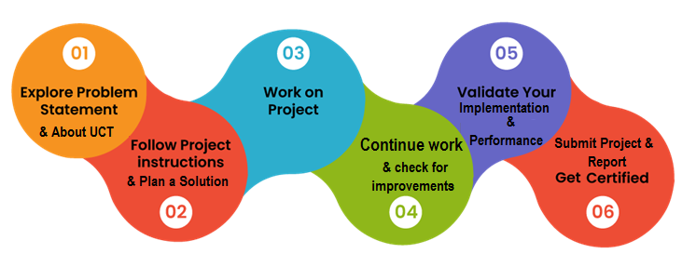

My overall experience is so good and unforgettable .Every I liked about this program as I have successfully completed for the corresponding domain that I have applied so that it reached at this beautiful ending.

Thank to all who have helped me directly or indirectly.

I would like to suggest everyone for joining this organization as I have been a part of this organization and it was trully so fruiful to me and also it’s a great opportunity to every learner.

# Introduction

## About UniConverge Technologies Pvt Ltd

A company established in 2013 and working in Digital Transformation domain and providing Industrial solutions with prime focus on sustainability and RoI.

For developing its products and solutions it is leveraging various**Cutting Edge Technologies e.g. Internet of Things (IoT), Cyber Security, Cloud computing (AWS, Azure), Machine Learning, Communication Technologies (4G/5G/LoRaWAN), Java Full Stack, Python, Front end**etc.



1. UCT IoT Platform **(****)**

**UCT Insight** is an IOT platform designed for quick deployment of IOT applications on the same time providing valuable “insight” for your process/business. It has been built in Java for backend and ReactJS for Front end. It has support for MySQL and various NoSql Databases.

* It enables device connectivity via industry standard IoT protocols - MQTT, CoAP, HTTP, Modbus TCP, OPC UA
* It supports both cloud and on-premises deployments.

It has features to  
• Build Your own dashboard  
• Analytics and Reporting  
• Alert and Notification  
• Integration with third party application(Power BI, SAP, ERP)  
• Rule Engine

 

1. **Smart Factory Platform (****)**

Factory watch is a platform for smart factory needs.

It provides Users/ Factory

* with a scalable solution for their Production and asset monitoring
* OEE and predictive maintenance solution scaling up to digital twin for your assets.
* to unleased the true potential of the data that their machines are generating and helps to identify the KPIs and also improve them.
* A modular architecture that allows users to choose the service that they what to start and then can scale to more complex solutions as per their demands.

Its unique SaaS model helps users to save time, cost and money.

 

1.  based Solution

UCT is one of the early adopters of LoRAWAN teschnology and providing solution in Agritech, Smart cities, Industrial Monitoring, Smart Street Light, Smart Water/ Gas/ Electricity metering solutions etc.

1. Predictive Maintenance

UCT is providing Industrial Machine health monitoring and Predictive maintenance solution leveraging Embedded system, Industrial IoT and Machine Learning Technologies by finding Remaining useful life time of various Machines used in production process.



## About upskill Campus (USC)

upskill Campus along with The IoT Academy and in association with Uniconverge technologies has facilitated the smooth execution of the complete internship process.

USC is a career development platform that delivers **personalized executive coaching** in a more affordable, scalable and measurable way.



Seeing need of upskilling in self paced manner along-with additional support services e.g. Internship, projects, interaction with Industry experts, Career growth Services

<https://www.upskillcampus.com/>

upSkill Campus aiming to upskill 1 million learners in next 5 year

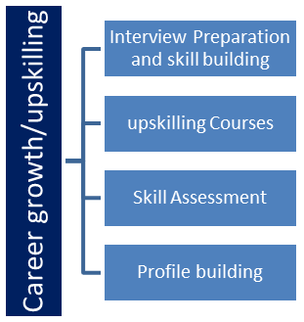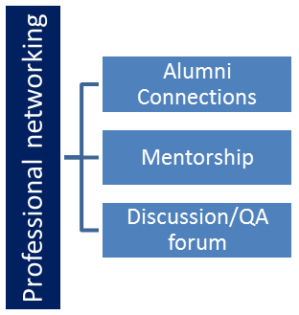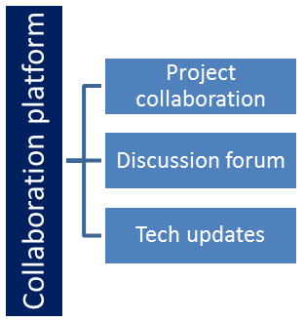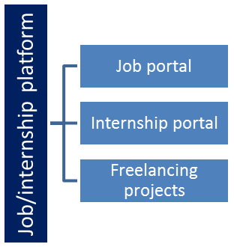

## The IoT Academy

The IoT academy is EdTech Division of UCT that is running long executive certification programs in collaboration with EICT Academy, IITK, IITR and IITG in multiple domains.

## Objectives of this Internship program

The objective for this internship program was to

 ☛ get practical experience of working in the industry.

 ☛ to solve real world problems.

 ☛ to have improved job prospects.

 ☛ to have Improved understanding of our field and its applications.

 ☛ to have Personal growth like better communication and problem solving.

## Reference

[1] ALLINPYTHON

# Problem Statement

Quiz Contest is an application developed to conduct a quiz based on time constraints. Quiz Contest system is accessed by entering the user name and password which is added to the database. Before start of the quiz, the rules and regulations are displayed that includes description of the time limit, number of questions to be answered and scoring methods. Quiz is started by displaying one question with four options each based on computer and general knowledge. if the answer is correct, 7 score is incremented by four and no negative marks for wrong answers . If the time exceeds 20secs next question will come automatically after giving few limited question's answer quiz application will finally direct you to the score page. Final score will be displayed and updated in the database with username.

Quiz Contest system is accessed by entering the user name and password which is added to the

database. Before start of the quiz, the rules and regulations are displayed that includes

description of the time limit, number of questions to be answered and scoring methods. Quiz is

started by displaying one question with four options each based on computer and general

knowledge. if the answer is correct, 7 score is incremented by four and no negative marks for

wrong answers . If the time exceeds 20secs next question will come automatically after giving

few limited question's answer quiz application will finally direct you to the score page. Final

score will be displayed and updated in the database with username

7

Chapter 3

Requirements and Analysis

3.1 Problem Definition:

Quiz Contest is an application developed to conduct a quiz based on time constraints.

Quiz Contest system is accessed by entering the user name and password which is added to the

database. Before start of the quiz, the rules and regulations are displayed that includes

description of the time limit, number of questions to be answered and scoring methods. Quiz is

started by displaying one question with four options each based on computer and general

knowledge. if the answer is correct, 7 score is incremented by four and no negative marks for

wrong answers . If the time exceeds 20secs next question will come automatically after giving

few limited question's answer quiz application will finally direct you to the score page. Final

score will be displayed and updated in the database with username

Quiz Contest is an application developed to conduct a quiz based on time constraints.

Quiz Contest system is accessed by entering the user name and password which is added to the

database. Before start of the quiz, the rules and regulations are displayed that includes

description of the time limit, number of questions to be answered and scoring methods. Quiz is

started by displaying one question with four options each based on computer and general

knowledge. if the answer is correct, 7 score is incremented by four and no negative marks for

wrong answers . If the time exceeds 20secs next question will come automatically after giving

few limited question's answer quiz application will finally direct you to the score page. Final

score will be displayed and updated in the database with username

Quiz Contest is an application developed to conduct a quiz based on time constraints.

Quiz Contest system is accessed by entering the user name and password which is added to the

database. Before start of the quiz, the rules and regulations are displayed that includes

description of the time limit, number of questions to be answered and scoring methods. Quiz is

started by displaying one question with four options each based on computer and general

knowledge. if the answer is correct, 7 score is incremented by four and no negative marks for

wrong answers . If the time exceeds 20secs next question will come automatically after giving

few limited question's answer quiz application will finally direct you to the score page. Final

score will be displayed and updated in the database with username

Quiz Contest is an application developed to conduct a quiz based on time constraints.

Quiz Contest system is accessed by entering the user name and password which is added to the

database. Before start of the quiz, the rules and regulations are displayed that includes

description of the time limit, number of questions to be answered and scoring methods. Quiz is

started by displaying one question with four options each based on computer and general

knowledge. if the answer is correct, 7 score is incremented by four and no negative marks for

wrong answers . If the time exceeds 20secs next question will come automatically after giving

few limited question's answer quiz application will finally direct you to the score page. Final

score will be displayed and updated in the database with username

Quiz Contest is an application developed to conduct a quiz based on time constraints.

Quiz Contest system is accessed by entering the user name and password which is added to the

database. Before start of the quiz, the rules and regulations are displayed that includes

description of the time limit, number of questions to be answered and scoring methods. Quiz is

started by displaying one question with four options each based on computer and general

knowledge. if the answer is correct, 7 score is incremented by four and no negative marks for

wrong answers . If the time exceeds 20secs next question will come automatically after giving

few limited question's answer quiz application will finally direct you to the score page. Final

score will be displayed and updated in the database with username.

Quiz Contest is an application developed to conduct a quiz based on time constraints.

Quiz Contest system is accessed by entering the user name and password which is added to the

database. Before start of the quiz, the rules and regulations are displayed that includes

description of the time limit, number of questions to be answered and scoring methods. Quiz is

started by displaying one question with four options each based on computer and general

knowledge. if the answer is correct, 7 score is incremented by four and no negative marks for

wrong answers . If the time exceeds 20secs next question will come automatically after giving

few limited question's answer quiz application will finally direct you to the score page. Final

score will be displayed and updated in the database with username.

Quiz Contest is an application developed to conduct a quiz based on time constraints.

Quiz Contest system is accessed by entering the user name and password which is added to the

database. Before start of the quiz, the rules and regulations are displayed that includes

description of the time limit, number of questions to be answered and scoring methods. Quiz is

started by displaying one question with four options each based on computer and general

knowledge. if the answer is correct, 7 score is incremented by four and no negative marks for

wrong answers . If the time exceeds 20secs next question will come automatically after giving

few limited question's answer quiz application will finally direct you to the score page. Final

score will be displayed and updated in the database with username.

Quiz Contest is an application developed to conduct a quiz based on time constraints.

Quiz Contest system is accessed by entering the user name and password which is added to the

database. Before start of the quiz, the rules and regulations are displayed that includes

description of the time limit, number of questions to be answered and scoring methods. Quiz is

started by displaying one question with four options each based on computer and general

knowledge. if the answer is correct, 7 score is incremented by four and no negative marks for

wrong answers . If the time exceeds 20secs next question will come automatically after giving

few limited question's answer quiz application will finally direct you to the score page. Final

score will be displayed and updated in the database with username

# Existing and Proposed solution

Provide summary of existing solutions provided by others, what are their limitations?

What is your proposed solution?

What value addition are you planning?

## Code submission (Github link):

## https://github.com/Pamalisahoo/Upskill_Campus.git

## Report submission (Github link) :

https://github.com/Pamalisahoo/Upskill_Campus.git

# Proposed Design/ Model

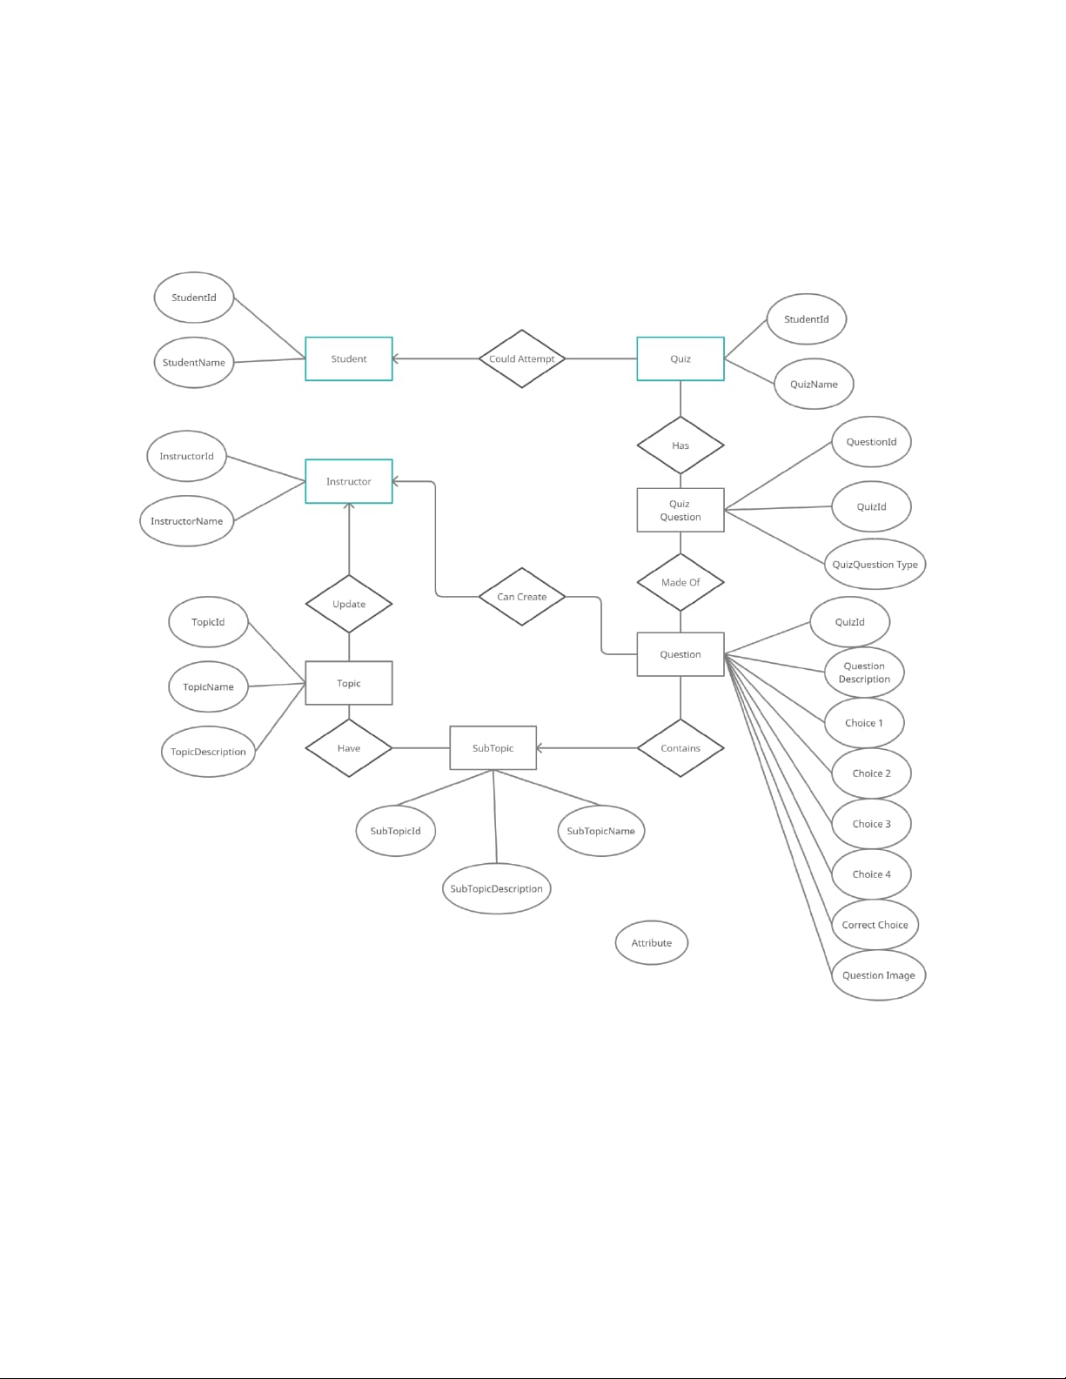

# Performance Test

This is very important part and defines why this work is meant of Real industries, instead of being just academic project.

Here we need to first find the constraints.

How those constraints were taken care in your design?

What were test results around those constraints?

Constraints can be e.g. memory, MIPS (speed, operations per second), accuracy, durability, power consumption etc.

In case you could not test them, but still you should mention how identified constraints can impact your design, and what are recommendations to handle them.

## Test Plan/ Test Cases

A test approach is the test strategy implementation of a project, defining how testing would be carried out.Implementation of test strategy for a particular project is known as "test approach".The test approach is usually defined in all test plans and test designs. Test approach refers to the commencement of various project activities such as planning the testing process, selecting the designs, defining the entry and exit criteria etc

## Test Procedure

Test approach has two techniques:

● Proactive An approach in which the test design process is initiated as early as possible in order to find and fix the defects before the build is created.

● Reactive An approach in which the testing is not started until after design and coding are completed

## Performance Outcome

Quiz application provides facility to attempt quiz anywhere and anytime. It save time since user does need to wait for result. So student/user cannot wait for the result. All Student/ user get extra knowledge and skills. Administrator has a privilege to put as much as question in given Quiz in application. User can register, log-in to atempt Quiz. If user forget thier password then he/ she can reset password with the help of Forgot Pasword option. There is instruction page for students o get imformation about quiz like number of question, given time etc. After that student get the result of quiz. so, student cannot wait for result. also admin is resposible to add, delete and update quetion in the system. also he can view result of all students

# My learnings

It has been a great pleasure for me to work on this exciting and challenging project. This project proved good for me as it provided practical knowledge of programming in PYTHON and also about all handling procedure related with Quiz System. It also provides knowledge about the latest technology used in developing application and server technology tha will be great demand in future. This will provide better opportunities and guidance in future in developing projects independently. This Quiz Game can be efficiently used by any students and Educational platforms. During the course of this assignment I have gone through many obstacle which made me to research and aalso increase mu knowledge. At last it can be concluded that the “Quiz Game” was the real learning experience. The project has been made as per as the given specification. The sytem has been made as userfriendly as possible

# Future work scope

The Scope of this project is very broad in terms of gaining knowledge and sharing knowledge among world.

* Can be used anywhere any time as it is a application.
* This application will be used in educational institutions as well as in corporate world