D802 – Deep Learning | Task 4 | Robert Parham | Student ID: 012420086

Exploring Deep Learning and Image Classification in the Real World
Evaluation isn’t the final step in building a model, it is an ongoing diagnostic tool. A robust evaluation strategy should consider how and why a model makes a decision. Instead of focusing solely on raw training accuracy you should track the validation loss and metrics like precision and recall to ensure that the model generalizes well to unseen data. This helps catch overfitting early and allows you to pinpoint exactly which edge cases or image classes are triggering issues with the model so you can adjust the hyperparameters accordingly (Req. A).
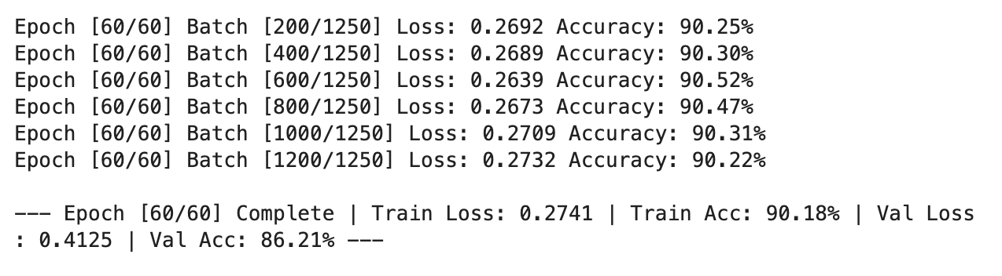
When you hardcode a set number of epochs like the 60 I used in the above screenshot, you’re essentially guessing how long the model will take to learn the data. A better option would have been to implement early stopping based on validation loss. This method takes the guesswork out of it. Early stopping uses the specified criteria, such as validation loss, to determine when to stop training. In the screenshot above you can see that, while training accuracy was approaching 90%, the validation accuracy lagged behind at 86%. Early stopping would have prevented the model from over learning the training set in those final cycles (Req. B).
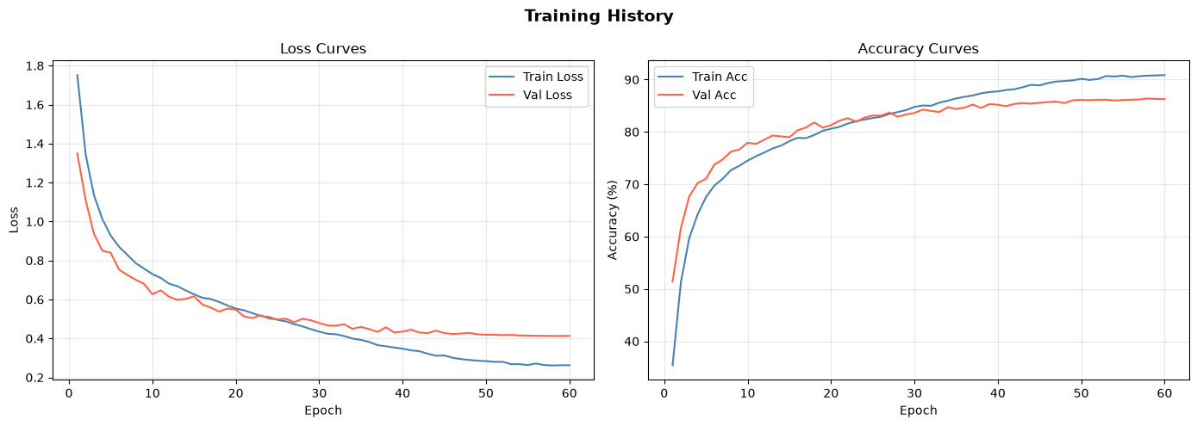
The charts above track our model’s performance over all 60 epochs, showing the loss steadily dropping and the accuracy climbing for both the training and validation splits.
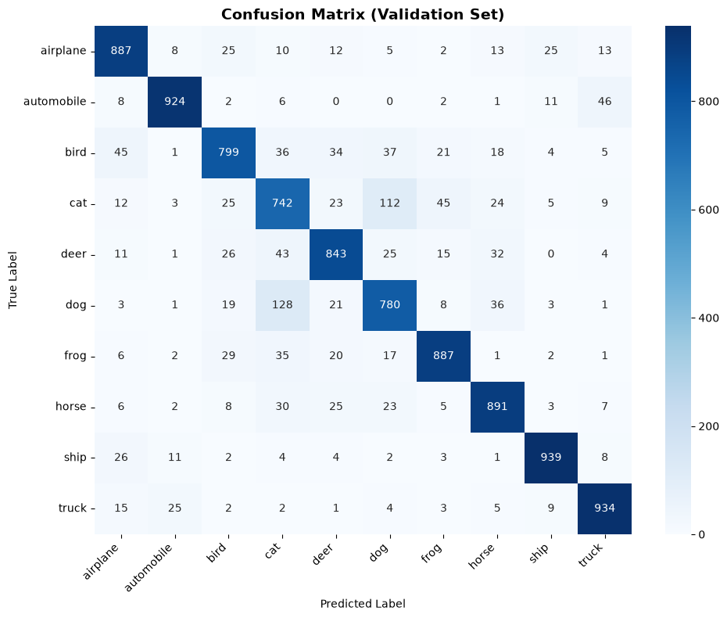
The confusion matrix above shows that the model struggled mostly with cats and dogs, but did pretty well with different types of vehicles (Req. C).

