**Pymaceuticals Trend Observations**

1. **Tumor Response to Treatment Table : From the plot below it shows , that the tumor value reduced for mice treated with Drugs “Capomulin” and “Ramicane” , whereas the tumor volume increased for the other drugs**

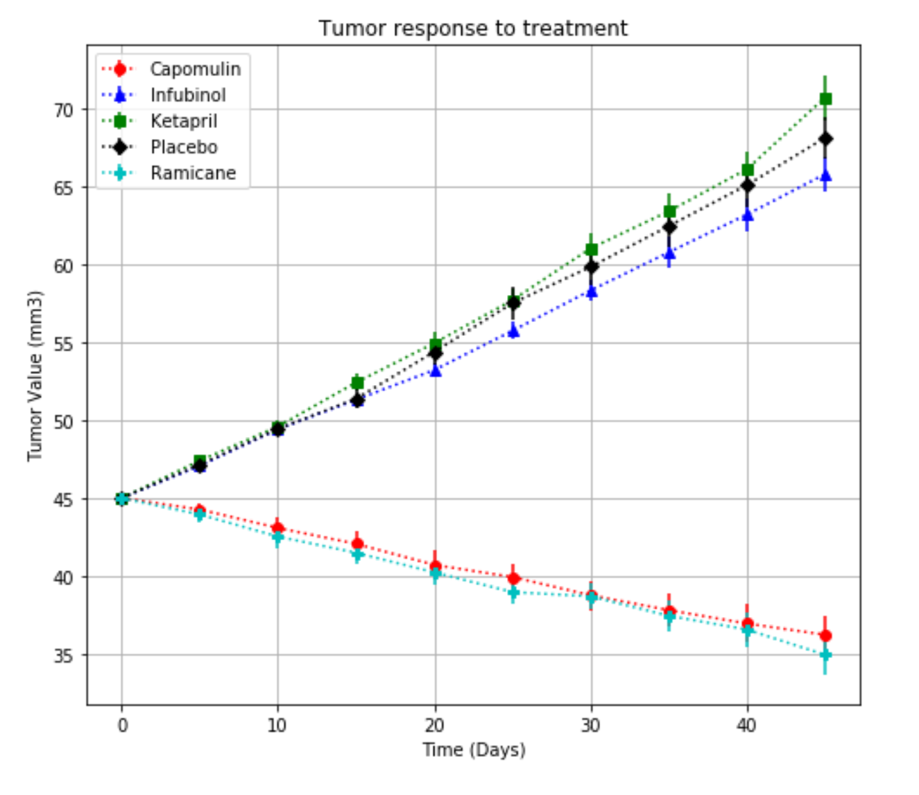

1. **Metastatic Response to Treatment Table :** Similarly , the metastatic sites are also minimal with the treatment of **“Capomulin” and “Ramicane” drugs as the number of treatment days increases , compared to the other drugs**

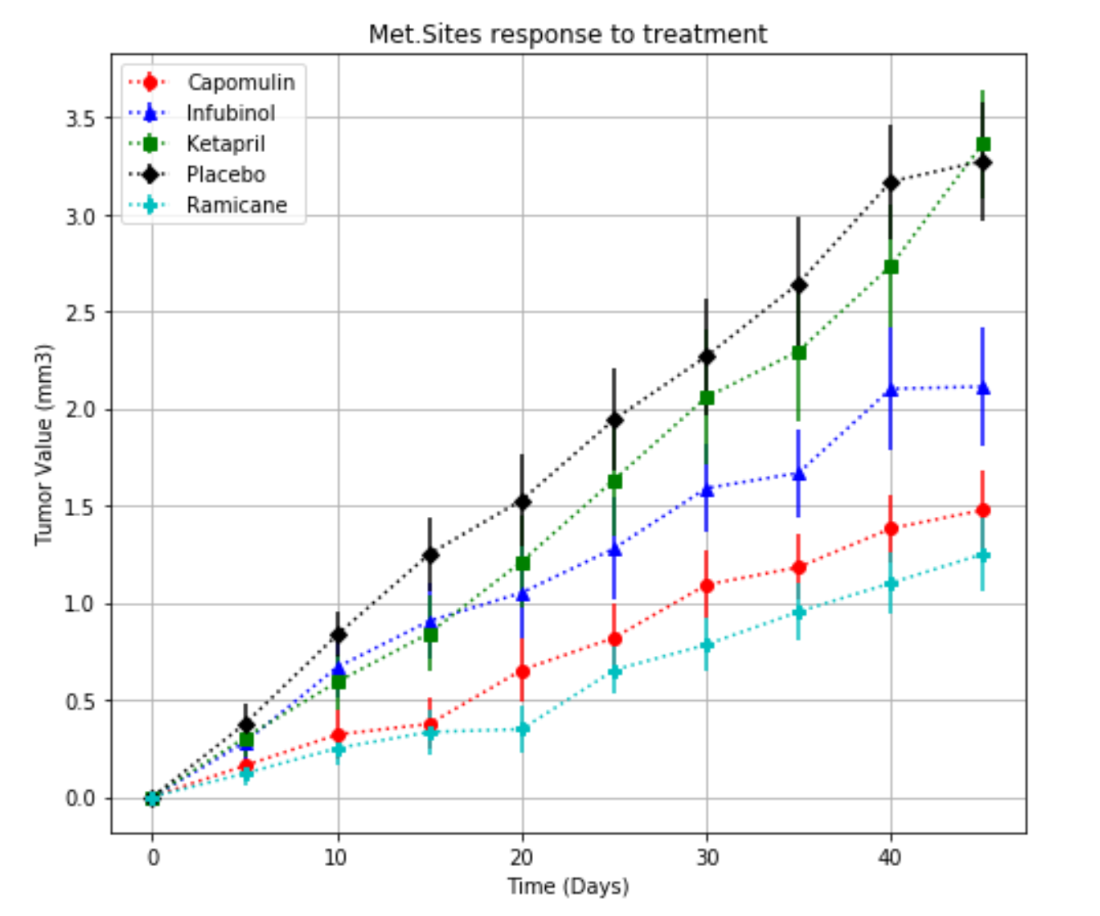

1. **Survival Rates Table:** The survival rate of mice treated with drugs “Capomulin” and “Ramicane” are at 84 % and 80 % respectively , compared to other drugs which are around 50 % or less ( graph is plotted for 5 drugs) other drugs are available in the dataframe table.

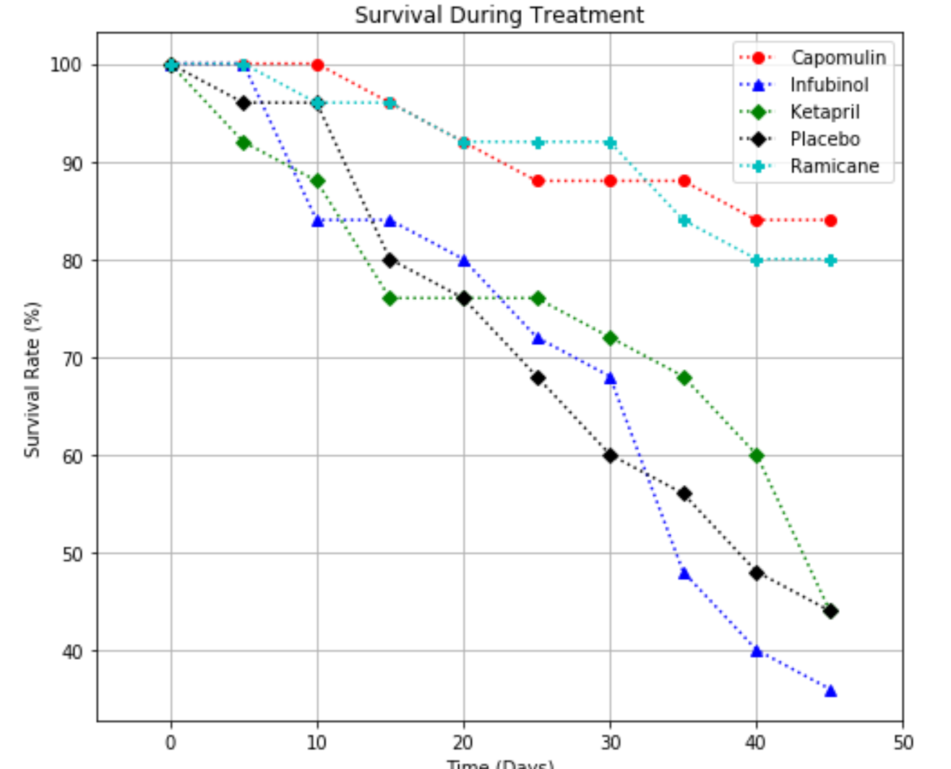

1. **Summary Bar Graph:**  The tumor size decreased with drugs “Capomulin” and “Ramicane” (percentage change in tumor volume) over a 45 day treatment , whereas the tumor size increased for all other drugs. Thus “Capomulin” and “Ramicane” are the passing drugs.

