_________________________________________________________________________

Instructions
(i) Present solutions on the specified date
ii). Compile and Submit pdf document with solutions of Task 1 and submit it through model by the specified date. The document should include screen shots of the created database, data lake, tables with data and the created primary/foreign keys, code and output generated

Requirements

Task1 [15 marks]
i. Identify and apply at least one data base schemas to design the schema of analytics database (Dataware house) of your organization or any other local organization you are familiar with [5 marks]
ii. Use PostgreSQL or any other DBMS to implement the designed schema [5 marks]
iii. Store 10 dummy data in the implemented analytics database [5 marks]

MOVIE SHOP DATABASE
SCHEMA DESIGNS
- Customers Table;
Customers _Id: (Primary Key)
first _name: First name of the customer.
last _name: Last name of the customer.
email: Email address of the customer).
phone _number: Phone number of the customer.
address: Address of the customer.
city: City of residence of the customer.
state: State or province of residence of the customer.
country: Country of residence of the customer.
date registered: Date when the customer registered with the movie shop.

2. Rental History Table:
rental_id: Unique identifier for each rental transaction (Primary Key).
customer_id: Foreign Key referencing the Customer Table, indicating the customer who made the rental.
movie_id: Foreign Key referencing the Movie Table, indicating the movie rented by the customer.
rental date: Date when the movie was rented by the customer.
return date: Date when the movie was returned by the customer.
rental fee: Fee charged for renting the movie.
- Payment Information Table:
payment_id: (Primary Key).
customer_id: Foreign Key referencing the Customer Table, indicating the customer who made the payment.
payment_date: Date when the payment was made.
payment_amount: Amount paid by the customer.
payment_method: Method used for payment (e.g., credit card, cash, etc.).
transaction_id: Unique identifier for the payment transaction (e.g., transaction ID for credit card payments)

SQL DESIGN

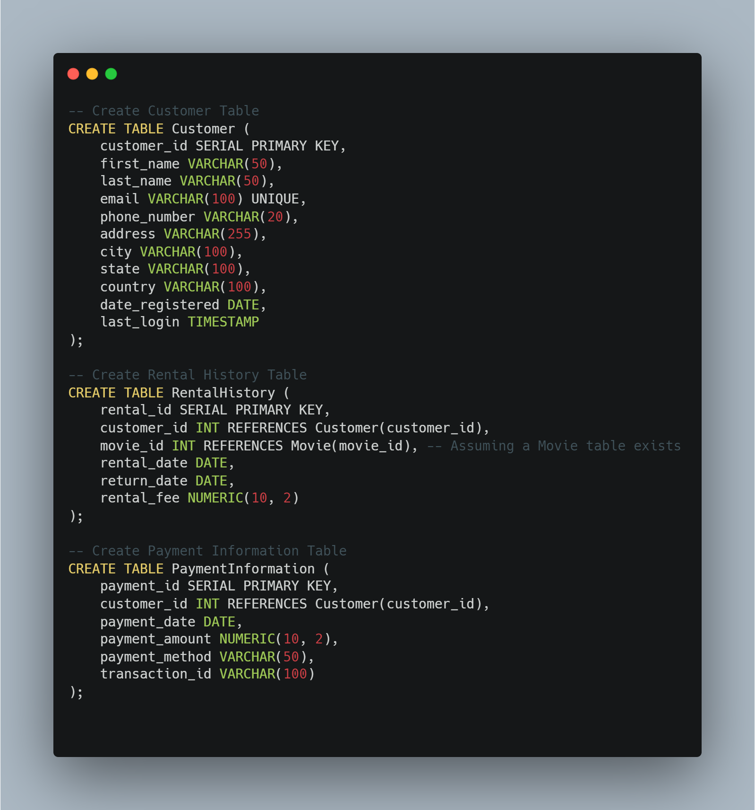

INSERTING DUMMY DATA

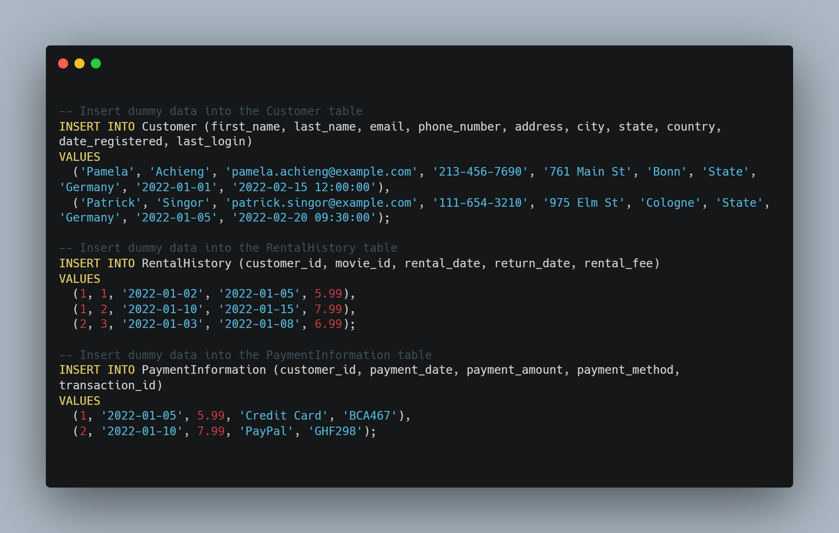

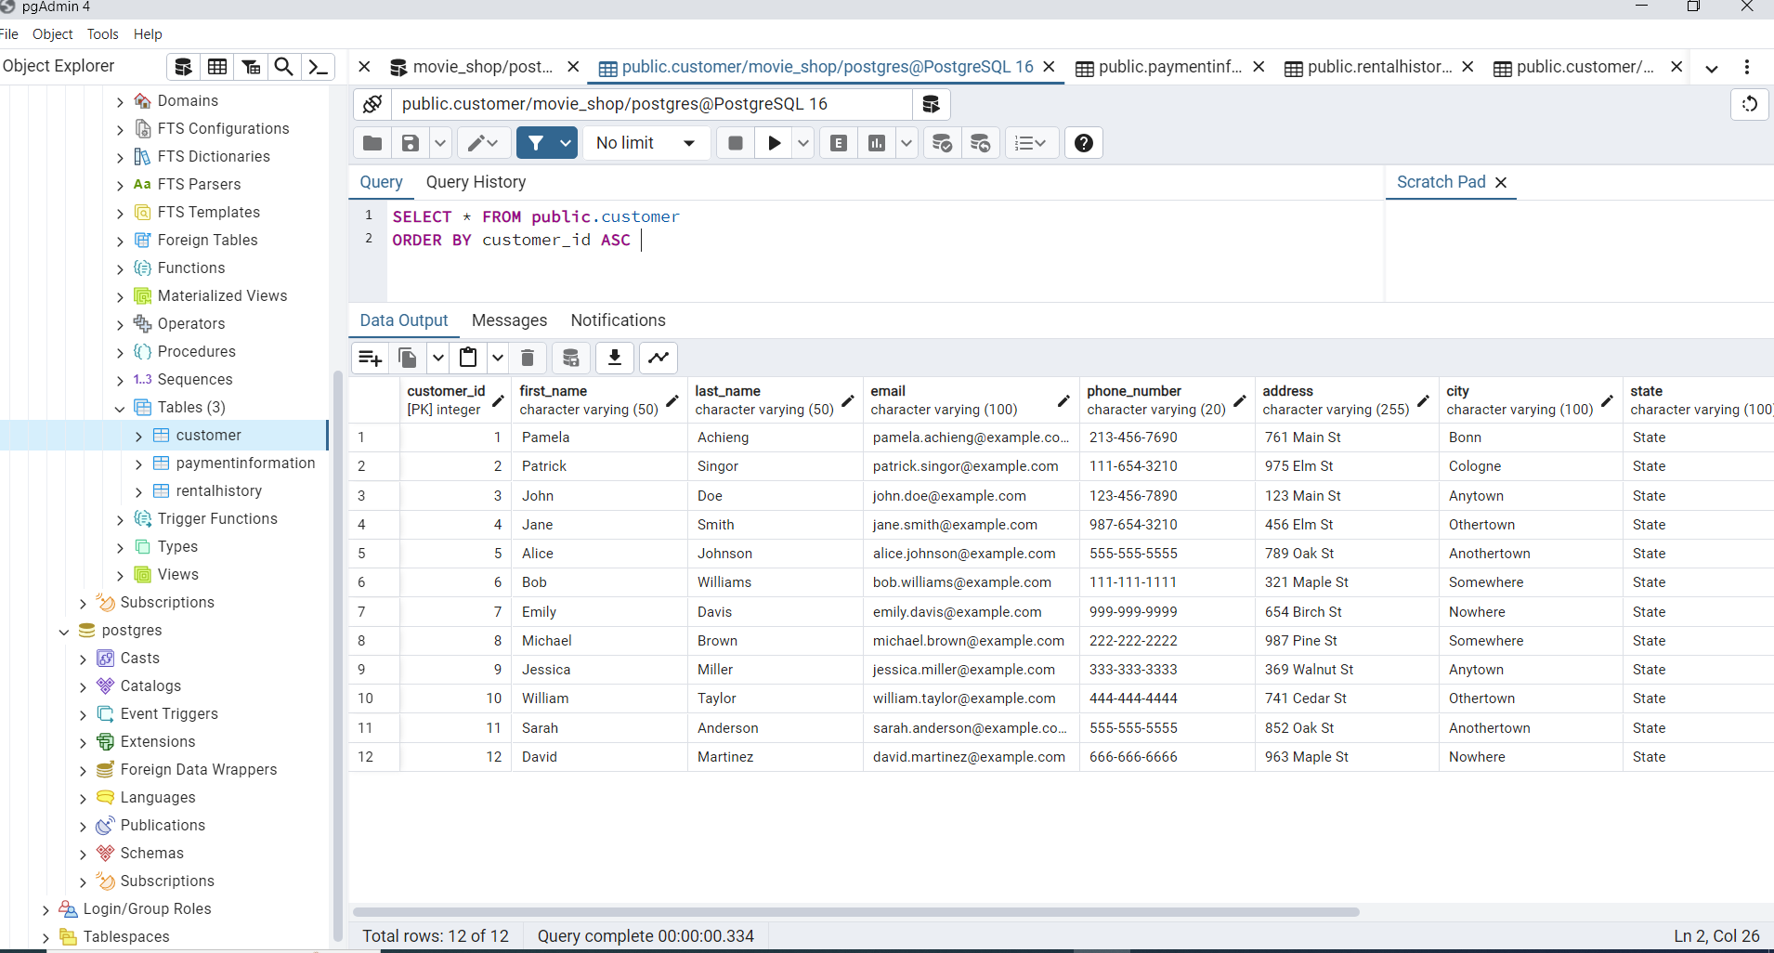

CUSTOMER TABLE

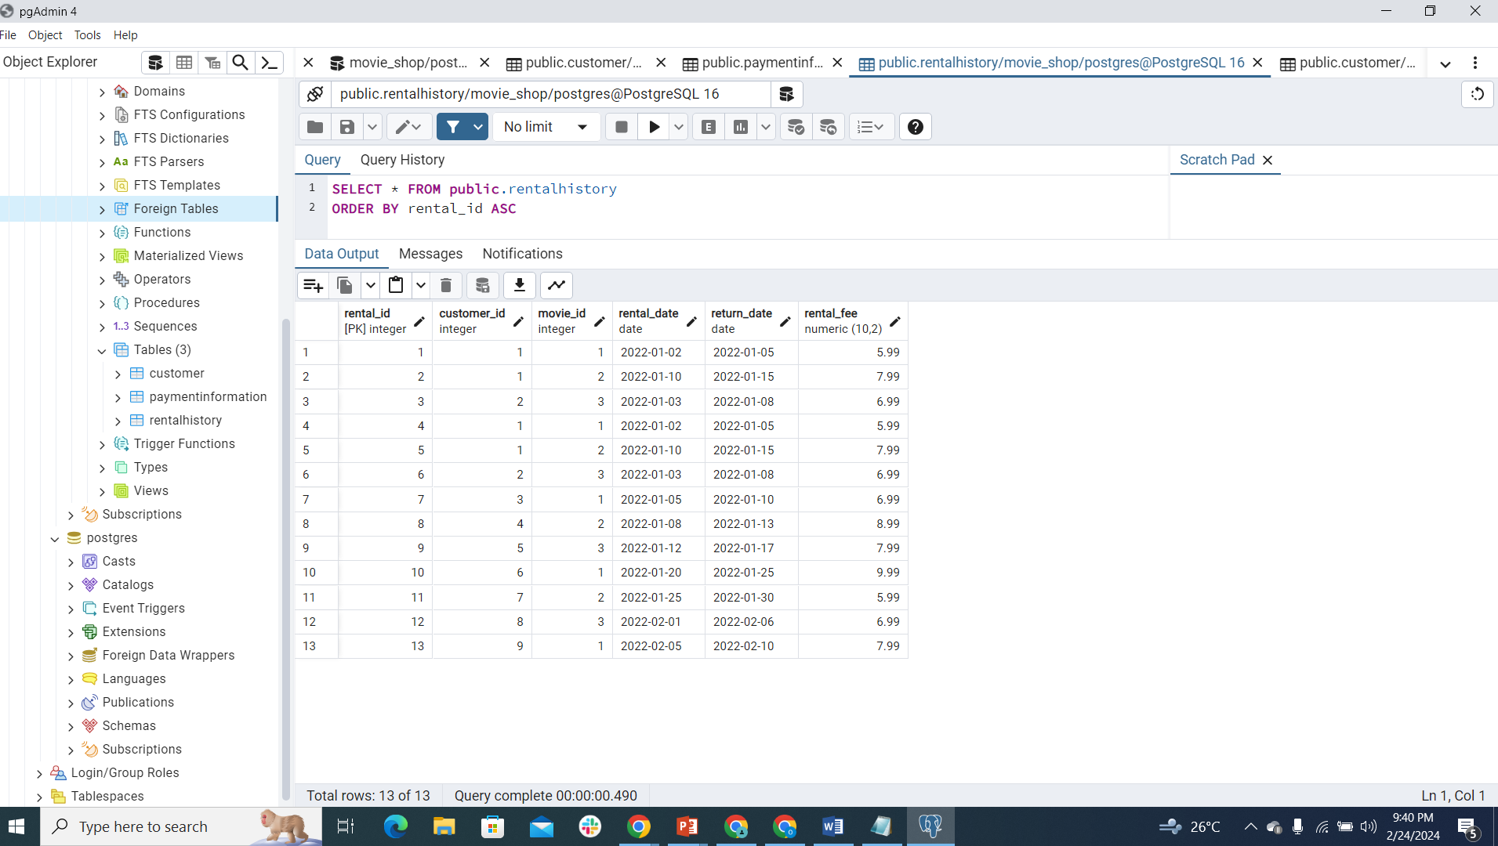

RENTAL HISTORY TABLE
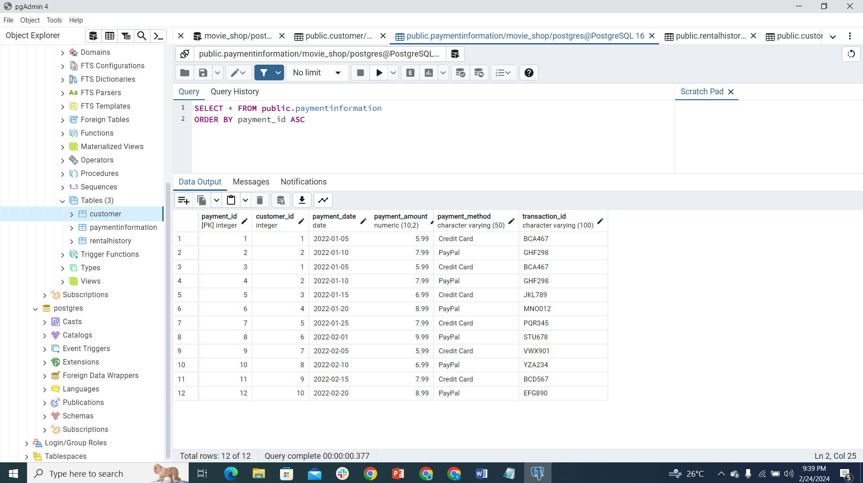

PAYMENT INFORMATION TABLE

