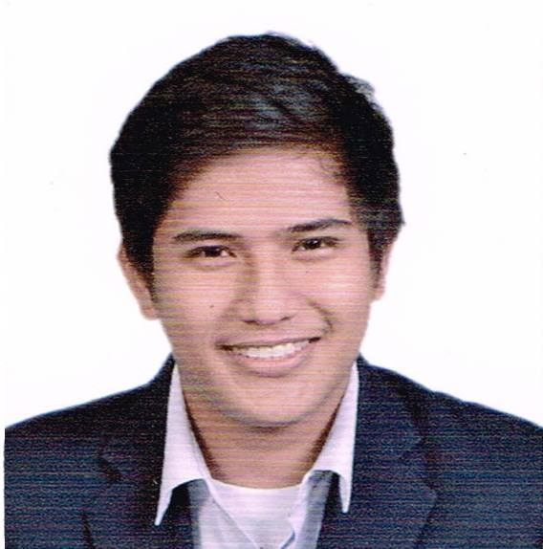**Almer S. Omandam**

Blk5 Lot22 Villamar Subd., Iponan

Cagayan de Oro City, 9000

+639057100568

**Professional Profile**

Hardworking, dedicated with a positive attitude

Proficient in Oral and Writing Communications

Willing to work under pressure

Flexible and Team Worker

**Work Experience**

March 2020- Present China Online Education Group (51talk)

Junior Teacher

May 2015- December 2019 Eperformax Contact Centers, Inc

Customer Service Representative- eBay

November 2014 – March 2015 Fuser’s Company (Feasibility Study)

Financial Manager

June 2014 – October 2014 Fuser’s Company (Feasibility Study)

Purchasing and Inventory Manager

**Trainings and Seminars Attended**

May 2015- August 2016 Global Communications Training

Eperformax Contact Centers, Inc

January 2014 Seminar on Business Outsourcing

Synnex Concentrix Corp, CDO.

August 13, 2014 Job Search Seminar

Xavier University- Ateneo de Cagayan

August 2014 Labor Education for Graduating Students

Xavier University- Ateneo de Cagayan

September 2013 Financial Literacy Caravan

Junior Confederation of Finance Associations - Philippines (JCFAP)

January 2011 Leadership Seminar- Youth Leadership Seminar

Yes-O (Youth for Environment in School Organization)

2007-2011 Journalism Seminars & Workshops

Department of Education

**Educational Background**

2011-2015 Bachelor of Science of Business Administration

Majoring Financial Management

Xavier University- Ateneo de Cagayan

2007-2011 Iponan National High School

2004-2007 Iponan Elementary School

2001-2003 Community Christian Academy

**Eligibility**

CSC CAREER SERVICE PROFESSIONAL ELIGIBLE

**Personal background**

Date of Birth: June 7.1995

Place of Birth: Cagayan de Oro City

Age: 20

Weight: 191 lbs

Height: 5’6ft

Civil status: Single

Citizenship: Filipino

Dialects spoken: English, Cebuano, Tagalog

Religion: Roman Catholic

**Character References**

Joselito Un  **+**639063106687Xavier University- Ateneo de Cagayan

Professor

Hurel Dave Ensencio +639266799155 Xavier University- Ateneo de Cagayan

Professor

Shyraldine Benlota +699998866311 Eperformax Contact Centers, Inc

Supervisor