Scrum 1: Planning Meeting – 10th March 2017

Attended by:

Customer: Devin Stacey

Team: Emma Byrne, Katherine Campbell, Pamela Kelly

Plan for Scrum 1:

Visual Overview:

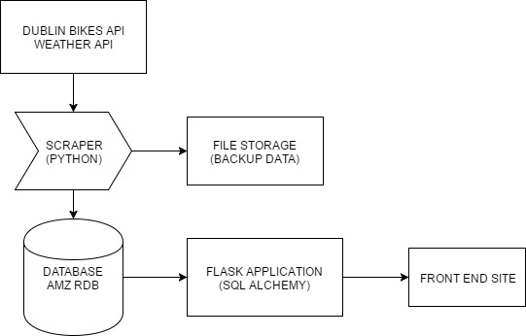

Tasks for Sprint 1:

* Familiarise ourselves with the Dublin Bikes API, and as a secondary priority the Weather API.
* Formalise a structure for how the data scraped from the API will be stored in the database.
* Familiarise ourselves with the other technologies pertinent to the project: Amazon RDB, Amazon Hosting, Flask, SQL Alchemy.
* Sign up for a Trello account and begin organising the project tasks through that. Look at how to convert to burndown charts.
* Plan standups (may vary over the break in terms of what days suit – the team will decide on regular days prior to when classes recommence).
* Set up scraper to scrape information from the APIs. (Priority: High 1)
* Set up database so that information can be stored immediately once scraper is ready. (Priority High 1)
* Create basic html/css front end site. (Priority: Medium 1)
* Set up Flask App to process queries to the database from the front end site. (Priority: Medium 2)

Standup Meeting: 14th March 2017:

Katherine:

* Looked at project organisation tools, i.e. Trello.
* Started researching Flask, looked at Flask tutorials.
* Looking at ways to develop the database from a user point of view.
* Next step: Work on database setup with Amazon RDS and MySQL.
* Not Blocked.

Pamela:

* Looked at Dublin bikes API.
* Defined a possible structure for the database based on data types given by API.
* Started a team Trello board and organised structure.
* Next step: Work on setting up the scraper in python.
* Not Blocked.

Emma:

* Looked at Dublin bikes API.
* Looked at scraping the API and using javascript to access information.
* Researched Amazon S3 and RDS.
* Next step: Work on the front end set up in HTML and CSS.
* Not Blocked.