**Important Note**

Before delving into the details of this group project, it is important to note that Katherine Campbell, although part of the git repository, was not detected and incorporated accurately into the graphs on github. This was discovered in the last few days of the project and the customer was notified. Please refer not to the contribution graphs on github, but to the commit history where you will be able to see all of Katherine’s commits to the repository over the course of the project. This depicts a more accurate representation of group member contribution.

# 1.Sprint 1

## 1.1 Sprint 1: Planning Meeting

### 1.1.1. Meeting Details

Name: Pamela Kelly (scrum master)

Team: 7

Date: 10th March 2017

Attended by:

Customer: Devin Stacey

Team: Emma Byrne, Katherine Campbell, Pamela Kelly

### 1.1.2. Plan for Sprint 1

Current weather data comes directly from the OpenWeatherAPI into the flask app

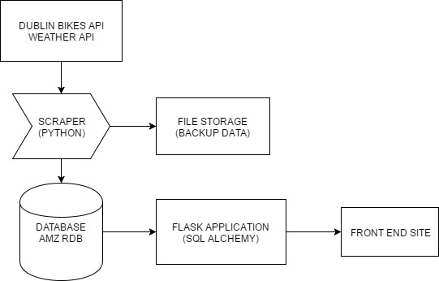

Figure 1: A visual technical overview of the overall project

During this meeting, we approached the given problem and task at hand and sketched out the overview of all components that would be used when building and running this app as well as their interactions when they are eventually integrated. We created a general list of necessary tasks and prioritized them, eventually putting them up on a group Trello board. A table for each sprint with its tasks and their respective owners, estimated times, due and actual completion dates, and any pertinent notes of interest has been created and may be viewed at the reader’s discretion in the appendices (Sprint 1 is Appendix A).

## 1.2. Stand-up Meeting/Scrum 1

### 1.2.1 Meeting Details

Name: Pamela Kelly (scrum master)

Team: 7

Date: 14th March 2017

Attended by: Emma Byrne, Katherine Campbell, Pamela Kelly

After our initial research, we confirmed that the highest priority tasks are the scraper, the database and the front end site. We divided these tasks up as reflected below (Table 1, section 1.2.3.). We decided that for the database we are going to use Amazon RDS and MySQL, because we are all already familiar with MySQL. We have moved the Flask application task to the backlog for now. Choosing to focus on the three above listed tasks as high priority for this Sprint.

### 1.2.2. Task Accomplished Since Last Meeting

Katherine:

* Looked at project organisation tools, i.e. Trello.
* Started researching Flask, looked at Flask tutorials, created test flask apps.
* Looking at ways to develop the database from a user point of view.
* Not Blocked.

Pamela:

* Looked at Dublin bikes API.
* Defined a possible structure for the database based on data types given by API.
* Started a team Trello board and organised structure.
* Not Blocked.

Emma:

* Looked at Dublin bikes API.
* Looked at scraping the API and using javascript to access information.
* Researched Amazon S3 and RDS.
* Not Blocked.

### 1.2.3. Tasks from Now Until Next Meeting:

|  |  |  |  |  |  |
| --- | --- | --- | --- | --- | --- |
| Tasks | Owner | Est | Due | Done | Notes |
| Set up Database with Amazon RDS and MySQL | Katherine | 2hrs | 25th March |  |  |
| Write Initial Scraper in Python | Pamela | 2hrs | 25th March | 25th March |  |
| Front End with Map HTML/JavaScript/CSS | Emma | 2hrs | 25th March |  |  |

Table 1: Task Assignments for each team member between the first and second stand-up meeting/scrum in sprint 1

## 1.3. Stand-up Meeting/Scrum 2

### 1.3.1. Meeting Details

Name: Pamela Kelly (scrum master)

Team: 7

Date: 17th March 2017

Attended by: Emma Byrne, Katherine Campbell, Pamela Kelly

### 1.3.2. Tasks Accomplished Since Last Meeting:

Pamela:

* Started work on the scraper. Signed up for a Dublin Bikes API key.
* Read through documentation and lecture notes on API requests.
* Wrote a basic script for sending requests.
* Not Blocked.

Emma:

* Started working on the frontend HTML and CSS. Signed up for a Google API key for use of maps and markers.
* Wrote a basic HTML webpage which includes the Google map and 1 marker set at a specific location.
* Not Blocked.

Katherine:

* Has thoroughly read the documentation for creating a MySQL instance and connecting to a database on a MySQL DB instance via Amazon Web Services.
* Read through Amazon VPC documentation.
* Not Blocked.

### 1.3.3. Tasks from Now Until Next Meeting:

|  |  |  |  |  |  |
| --- | --- | --- | --- | --- | --- |
| Tasks | Owner | Est | Due | Done | Notes |
| Writing Scraper | Pamela | 2hrs | 25th March | 25th March |  |
| Backup Data in Files | Pamela |  |  |  |  |
| Set up markers for bikes stations on map | Emma |  |  |  |  |
| Redesign Colour Scheme | Emma |  |  |  |  |
| Set up Database | Katherine |  |  |  |  |

Table 2: Task Assignments for each team member between the second and third stand-up meeting/scrum in sprint 1

## 1.4. Stand-up Meeting/Scrum 3

### 1.4.1. Meeting Details

Name: Pamela Kelly (scrum master)

Team: 7

Date: 17th March 2017

Attended by: Emma Byrne, Katherine Campbell, Pamela Kelly

### 1.4.2. Tasks Accomplished Since Last Meeting

Pamela:

* The scraper script is set up to send queries every 5 minutes and store the results in files.
* Got side-tracked by some git and eclipse errors which needed to be resolved before moving forward.
* Blocked: Have to wait for the database to be set up so that when the scraper is running on the EC2 it has somewhere to send the data, other than storing it in the backup files.

Emma:

* Continued working on the basic HTML and CSS.
* The map and first markers are set up.
* Blocked: Waiting for data from the API in order to set up the remaining markers.

Katherine:

* Read over the Amazon RDS documentation - deemed best route to be a MYSQL database instance.
* Learned how create tables from python.
* Blocked: Need to decide on an agreed password and username for the database so that we can all access it. Having some issues understanding Amazon VPC which is needed to move forward.

### 1.4.3. Issues Resolved

* Used the data gathered from the scraper to send the rest of the station information on to Emma. Block removed.
* Decided on username and password for Amazon RDS.

### 1.4.4. Tasks from Now Until Next Meeting

|  |  |  |  |  |  |
| --- | --- | --- | --- | --- | --- |
| Tasks | Owner | Est | Due | Done | Notes |
| Get Scraper running continuously on EC2 | Pamela | 2hrs | 25th March | 25th March |  |
| Set up onclick info windows for markers on map | Emma |  |  |  |  |
| Start construction of Database | Katherine |  |  |  |  |

Table 3: Task Assignments for each team member between the third and retrospective stand-up meeting/scrum in sprint 1

## 1.5 Sprint 1 Retrospective

### 1.5.1. Meeting Details

Name: Pamela Kelly (scrum master)

Team: 7

Date: 27th March 2017

Attended By:

Customer: Devin Stacey

Team Members: Pamela, Katherine, Emma.

### 1.5.2. Current State of Project

* Front end HTML/CSS template is done, with all markers on the map. Pop up window showing individual station information appears for each marker. Information currently pulled from a static file (this will be refactored as part of the flask application).
* Web Scraper is scraping static and dynamic data from the Dublin Bikes API and storing it locally on EC2 (and backed up on local machine as well) in text files. The scraper is running continuously on EC2 using screen.
* Initial database is set up on Amazon RDS. Security groups are set to open so that it can be accessed remotely.

### 1.5.3. Issues to be Addressed

* We realised that the design of our database was flawed after Monday’s lecture. We will have to push that back and prioritise redesigning and implementing it in Sprint 2. In hind-sight we could have spent more time thinking through and discussing out the design of the database before beginning implementation.
* Error in the files output by the scraper. The json dump is producing additional unwanted forward slashes. If we were to lose data and have to repopulate the database using these files, this would make it more difficult to parse.

### 1.5.4. Sprint 1 Challenges

* Encountered some issues using git with eclipse – committed a mistake and had to try to reset the repository to a previous commit, as I realised that this would affect other team members and could cause conflict issues. Resetting didn’t have the expected results and deleted some of the files. I had to go back through old commits to piece back together the appropriate file, reproduce it locally and commit again (Pamela).

### 1.5.5. Feedback from the Customer

* After initial functionality priority focus should be features like expanding on a historical way of accessing the data (real time updates), predictions. Weather and heatmap sensors are prioritised lower than the above features, but can be considered for Sprint 3.
* Ensure that as we move forward into the Flask application part of the project that we design efficient SQL queries. Aim for response time – less than a second. High priority in terms of user retention. This should be taken into consideration as we decide how long to leave the scraper running for – the more data to check the longer the query will take.

## 1.6. Sprint 1 Overview

### 1.6.1. Emma

Name: Emma Byrne Group: 7 Sprint: 1

**Percentage of Group Submission:** 33%

**Skills Practised:** HTML, CSS, JavaScript, incorporating Google Maps on front end

**Learning Done:** Research on Dublin Bikes API, Amazon RDS, EC2, python scrapers (brief)

**Goals:** Set up Flask app and incorporate Flask on the front end, setting up database for the weather information

### 1.6.2: Katherine

Name: Katherine Campbell Group: 7 Sprint:1

**Percentage of Group Submission:** 33%

**Skills Practised:** Flask (made practice apps), creating RDS MYSQL database

**Learning Done:** ins and outs of Amazon RDS and VPC. Learned about Flask's use and basic functions

**Goals:** Redesign database structure, get it populated with data, identify the information we want and work on related queries to database

### 1.6.3. Pamela

Name: Pamela Kelly Group: 7 Sprint: 1

**Percentage of Group Submission:** 33%

**Skills Practised:** Scraping data from RESTful APIs. Contributing to a project using git. Using screen to run programs continuously and switch between multiple windows on remote instance. Furthering familiarity with remote compute instances.

**Learning Done:** Previously only worked with static data so found it valuable to work with a live API. Screen was a new piece of software that I had never worked with before, which was extremely useful. Learned to keep work consistent and maintain communication while working on a group project via git to avoid conflict issues.

**Goals:** Have the script written up to write to the database. Test and ensure this is working once database is set up and transfer data already collection from files to database. Learn how to use SQLAlchemy and more about Object Relational Mapping.

## 1.7. Sprint 1 Burndown

### 1.7.1. Burndown Chart

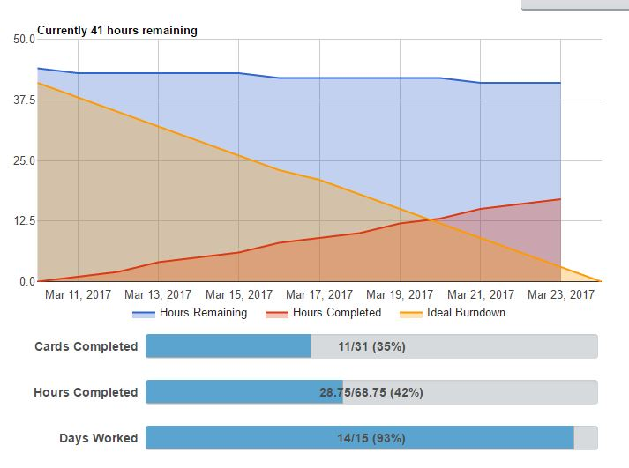

### 1.7.2. Comments on Burndown

We got off to what looks like a slow start. We wanted to spend the first week making sure everyone was familiar with the range of technologies and tools involved in the project: Amazon RDS, RESTful APIs, Flask etc. Particularly because, although we have encountered some of these technologies in other modules, piecing them all together is a challenge. This approach has proved to be valuable so far in that we have been able to help each other with issues as we all have a basic understanding of the different aspects of the project.

# 2. Sprint 2

## 2.1. Sprint 2 Planning Meeting

### 2.1.1. Meeting Details

Date: 27th March 2017

Attended by:

Customer: Devin Stacey

Team Members: Pamela, Katherine, Emma.

### 2.1.2. Plan for Sprint 2

* Discussed the redesign for the database – it needs to have 2 tables, one for static data and one for dynamic data. Possibly a table for predictive data in the future.
* Implement this new design through Amazon RDS. We were initially using workbench but based on advice given by Devin, we are going to implement the data base through python instead to avoid unnecessary dependencies for the client’s machine and to increase abstraction of the final product for the client.
* Once the database is ready, implement functionality in the scraper for writing to the database, using SQL alchemy and/or pymysql.
* Transfer data already collected in file format to the database.
* Start working on the Flask application – in particular, look at how to decompose this aspect of the project – as Devin advised that each team member should get experience with using Flask.
* Start working on additional features such as predictive analysis, real time responses etc.

See Appendix B for the full task table for sprint 2

## 2.2. Stand-up Meeting/ Scrum 1

### 2.2.1. Meeting Details

Date: 31st March 2017

Scrum master: Katherine Campbell

Attendees: Katherine Campbell, Pamela Kelly, Emma Byrne

### 2.2.2. Tasks Accomplished Since Last Meeting and Tasks to Accomplish

Katherine:

* Redesigned the Dublin Bike information database from one large table to a 2-table one-to-one relation structure.
* Set-up instance for the Dublin Bike information database in RDS and made it accessible to everyone - fixed the security issues.
* Wrote and tested code to create said tables in the database.
* Have read flask documentation and have installed flask, sqlalchemy, and other packages in preparation for next step
* Next step: create weather data scraper
* Not Blocked.

Pamela:

* Fine-tuned the scraper as far as possible whilst waiting for the Dublin Bike information database
* Helped debug the create tables in database script via code editing/review.
* Next step: address and fix issue with the time for the scraper and other bugs
* Not Blocked.

Emma:

* Refactored code – tidied it up
* Changed the layout of the project
* Researched flask and its implementation
* Next step: Work on the front end set up in HTML and CSS and create weather database and code to create table within said database
* Blocked: Need the Dublin Bike information database populated and Flask to be set up before it is possible to access the data.

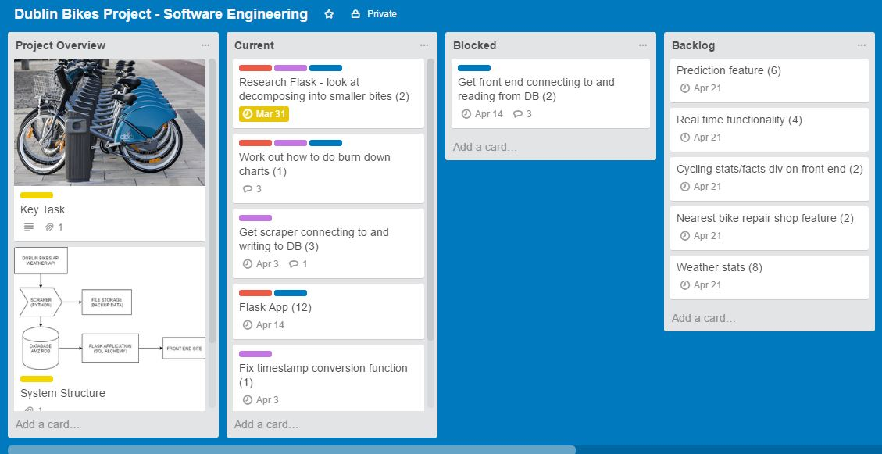

Figure 1: A screen shot of the group trello board showing a few key sections at the time of Sprint 2 Scrum 1

## 2.3. Stand-up Meeting/Scrum 2

### 2.3.1. Meeting Details

Date: 5th April 2017

Scrum Master: Katherine

Attendees: Pamela Kelly, Katherine Campbell, Emma Byrne

### 2.3.2. Tasks Accomplished Since Last Meeting and Tasks to Accomplish

Katherine:

* Signed up and read documentation for open weather map API
* Created weather data scraper
* Wrote code to populate weather DB
* Formatted API responses to feed into write to db function (pair program with Pamela)
* Next step: create skeleton of flask app to process dynamic data and formulate SQL queries that users would use pertaining to said dynamic data
* Not Blocked.

Pamela:

* Used object mapping in SQL alchemy to optimise scraper
* Identified and fixed a problem with Mercian prime concerning the main scraper and the Dublin bikes Database (see sprint 2 challenges for more details)
* Helped debug the database and weather scraper script via code editing
* Next step: Host the site on EC2
* Not Blocked.

Emma:

* Created a database to contain the weather data
* Helped debug scraper code via code editing
* Next step: Create a flask app to process the static data from the Dublin bikes DB
* Not Blocked

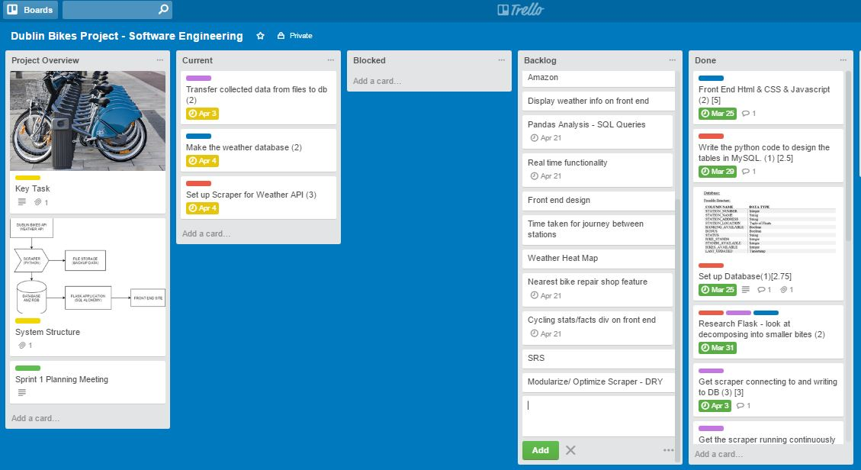

Figure 2: A screen shot of the group trello board showing a few key sections on the 3rd of April

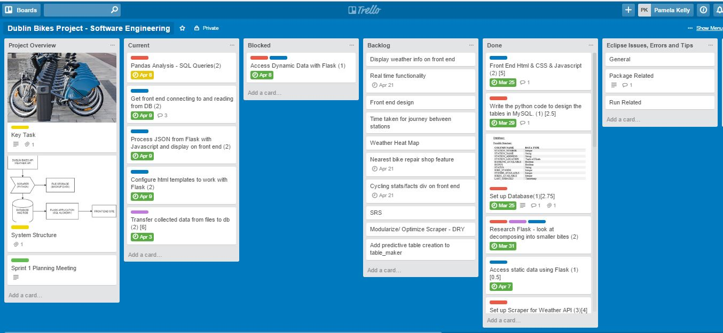

Figure 3: A screen shot of the group trello board showing a few key sections on the 4th of April

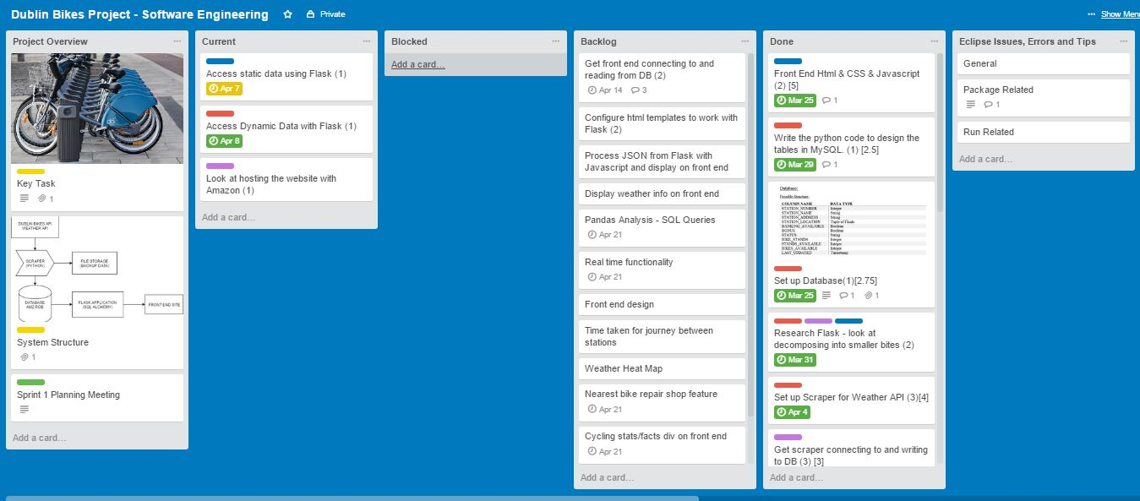

Figure 4: A screen shot of the group trello board showing a few key sections on the 6th of April

## 2.4. Sprint 2 Retrospective

### 2.4.1. Meeting Details

Date: 7th April 2017

Attended By:

Team Members: Pamela, Katherine, Emma.

### 2.4.2. Current State of the Project

All items listed below are complete and additive items to what has been mentioned in the previous sprints.

* The main scraper is running and transferring data from the Dublin Bikes API, storing it to text files and then sending those files to and populating an appropriate database that has been set up with two tables – one for static and another for dynamic data. This improved database is set up on Amazon RDS. Security groups are set to open so that it can be accessed remotely.
* The weather scraper is running and transferring data from the current open weather API to the weather data base.
* The weather data base, set up on Amazon RDS, is complete with appropriate tables. Security groups are set to open so that it can be accessed remotely.
* The website is now being hosted through EC2
* A Flask app has been designed to process the static data from the databases, turning it into a JSON file, and then pushing that to the front end. This was done via paired programming.

### 2.4.3. Issues to be addressed

* A better grasp of the function of flask is necessary – although the project is moving along well, flask seems to be a bit of a road block wherein we require more information than has been given by the slides and some tutorials. This is particularly important in terms of dynamic data.

### 2.4.4. Sprint 2 Challenges

* There were some issues getting the main scraper configured, specifically in that SQL columns were too narrow. The prime example of this was the last updated column which continuously noted that there were duplicate values, which should not have been the case (it was a composite key with station_number. Setting up the table in such a way should have, theoretically, made duplicate values impossible). After several hours of research, rewriting code, and checking the database, it was discovered that the data type given for last_updated, date time, was too small to contain the number it was receiving. The database attempted to execute the code despite this issue by plugging in the largest possible integer it could handle, in this case an integer known as the Mercian Prime. Because each entry was the Mercian Prime, there were obviously several duplicates. This problem which caused a lot of grief had a straightforward and quick fix and was solved by simply changing the data type for that column to BigInt.
* There was a problem concerning the flask app for static data in that the static data didn’t work with the syntax .items. After much research, it was discovered that this is because JSON is a dictionary stored as a list. This resulted in code changes.
* Along similar lines, initially there was a problem with the weather scraper in that the code threw errors concerning the way the JSON file was accessed. The method we had first learned to access the open weather API JSON file was through java script with JSON. This is different than how it is done in python.
* There is apparently an issue with windows 7 pip installing the correct version of pymysql. The first thought was that pip3 could resolve the issue, however, this was not recognized by the command line. This means that one of the team mates, Katherine, cannot run any code requiring pymysql. Work arounds were developed so that if such a code written by her needed to be tested, it would be pushed to git, run, and any errors would be reported back to her.

## 2.5. Sprint 2 Overview

### 2.5.1. Emma

Name: Emma Byrne Group: 7 Sprint:2

**Percentage of Group Submission:** 33%

**Skills Practised:** Flask, JavaScript, creating a database in Amazon RDS using Python

**Learning Done:** Incorporating Flask on the front end. Setting up a weather database on RDS

**Goals:** Front end design, pass values from JavaScript into Flask to query the database

### 2.5.2. Katherine

Name: Katherine Campbell Group: 7 Sprint:2

**Percentage of Group Submission:** 33%

**Skills Practised:** deleting, creating, and populating databases on rds via python code. creating tables and adding and deleting rows via code. Accessing APIs, working with APIs, reading JSON, interpreting and taking specific data from a JSON file and putting that in a table. Building a scraper with python, attaching code to databases and APIs, securely accessing APIs via code. Debugging.

**Learning Done:** Security on Amazon RDS and workarounds - learning to set everything to open access. how to work and manipulate tables with python and python packages. Learned how to make code accessing DBs secure. Regarding python packages learning how to work with pip and working around libraries not installing properly (ie. pymysql) Learning how to access and scrape APIs via python and use that data to populate a db.vLearning how sql alchemy reasons JSON files.

**Goals:** Join the weather and bikes databases via code, create a live weather display on the website, create sql queries for dynamic data/predictive analysis and connect that with flask.

### 2.5.3. Pamela

Name: Pamela Kelly Group: 7 Sprint:2

**Percentage of Group Submission:** 33%

**Skills Practised:** Use of SQLAlchemy and object relational mapping. Python programming –writing to remote databases (from API requests and files), helper functions. Pair programming. Hosting web applications on remote compute instances.

**Learning Done:** Learned how to use SQLAlchemy and ORM. Learned about constraints with data types for databases – Mercian Prime Issue. Learned about hosting on EC2 using Apache.

**Goals:** Get some experience working with flask. Look at google charts and displaying results of predictive queries.

## 2.6. Sprint 2 Burndown

### 2.6.1. Burndown Chart

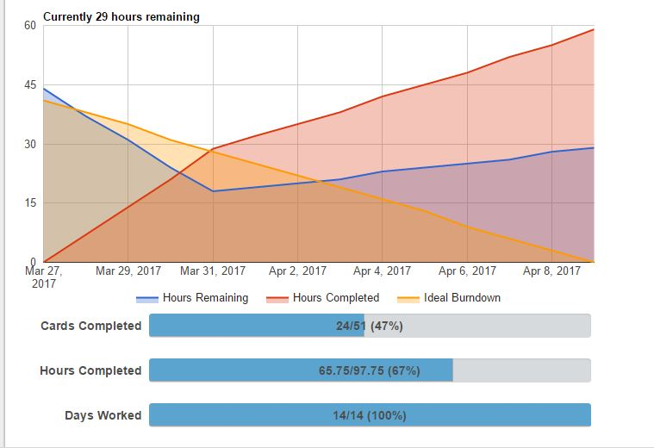

### 2.6.2. Comments on Burndown

Some tasks have grown to take much more time than we initially anticipated. This has been a learning curve in terms of allowing time for refactoring and testing.

# 3. Sprint 3

## 3.1. Sprint 3 Planning Meeting

### 3.1.1. Meeting Details

Date: 7th April 2017

Scrum Master: Emma Byrne

Attended by:

Customer: Devin Stacey

Team Members: Pamela, Katherine, Emma.

### 3.1.2. Plan for Sprint 3

* Discussed the completion of the dynamic flask app and have decided that this would best be done via paired programming.
* Decided to create and implement user stories.
* Planned other predictive analytic SQL queries concerning both bike and weather data which might be helpful to the user.
* Once these additional SQL queries are created, add them to the dynamic flask app and connect that to the front end.
* Discussed the front end, user view design in terms of said queries
* Discussed the creation of user stories
* Discussed the method and possibility of real-time functionality
* Discussed the addition of extra features – distance between each station etc.
* Discussed the challenges facing us in designing our queries as to maximise performance and not have queries that take a long time to load.
* Discussed incorporating Google Charts to the front end

## 3.2. Stand-up Meeting/ Scrum 1

### 3.2.1. Meeting Details

Date: 11th April 2017

Scrum Master: Emma Byrne

Attended By:

Team Members: Pamela, Katherine, Emma.

### 3.2.2. Tasks Accomplished Since Last Meeting and Tasks to Accomplish

Pamela:

* Getting hourly/daily queries set up
* Fixed the scraper – the connection issues
* Looked at connection pooling and disposing of connection pools before creating new ones
* Nearly finished hosting the app on ec2 with the flask app
* Did some pair programming with Emma and Katherine with regards to flask
* Next step: Work on queries to get data for daily/hourly dynamic information for stations and visualise this with Google charts
* Not blocked

Katherine:

* Created sql queries for querying dynamic/predictive data
* Tested connecting flask with the SQL queries
* Did some pair programming with Pamela and Emma with regards to flask
* Next step: Joining databases together
* Creating a div for where the weather data will be displayed
* Pair programming with Emma to get predictive analysis for weather data

Emma:

* Set up the flask app
* Linked the flask app to the front end via pair programming with Pamela
* Got the map with markers up and running via the flask app and javaScript
* Accessed static station information via the flask app
* Accessed weather and occupancy information via flask app but not very efficiently – Katherine will be working on queries for the weather app
* Next step: Linking everything to the front end – linking the weather information, google charts and other necessary information to the javaScript and HTML
* Pair programming with Katherine to get the predictive analysis for the weather
* Not blocked

## 3.3. Stand-up Meeting/ Scrum 2

### 3.3.1. Meeting Details

Date: 14th April 2017

Scrum Leader: Emma Byrne

Attended By:

Team Members: Pamela, Katherine, Emma.

### 3.3.2. Tasks Accomplished Since Last Meeting and Tasks to Accomplish

Pamela:

* Modularised and refactored the code – scraper.py
* Transferred all of the files stored on EC2 to the database
* Scraper now collecting data directly from the Dublin Bikes API
* Started working on the sql queries for hourly/daily dynamic data
* Looked at Google graphs
* Not blocked

Katherine:

* Looked up how to merge databases: three ways to do this
* Tried to determine the best way to do this
* Also looked at/practiced how to do this by writing a python function
* Pair programmed with Emma on writing dynamic flask apps with queries
* Testing merging databases
* Not blocked

Emma:

* Researched how to connect flask to javaScript and back again – get and post methods
* Further research into connecting Flask to HTML
* Looked into new design ideas for the front end
* Started working on ideas for querying the weather database
* Pair programmed with Katherine on writing dynamic flask app with queries
* Blocked: Can’t quite figure out how to send a variable to the database via flask and get the results of the query displaying on the front end

## 3.3. Stand-up Meeting/ Scrum 3

### 3.3.1. Meeting Details

Date: 18th April 2017

Scrum Leader: Emma Byrne

Attended By:

Team Members: Pamela, Katherine, Emma.

### 3.3.2. Tasks Accomplished Since Last Meeting and Tasks to Accomplish

Pamela:

* Worked on (and still working on) fixing hosting issues
* Set up port forwarding with Apache
* Pair programmed with Emma on flask on getting dynamic data for each station to display on the home page
* Next step: Keep working on hosting
* Get daily/hourly stats and create Google charts from the resulting stats.

Katherine

* Researched and wrote python/MySQL alchemy code to copy a table and its data from one database to another
* Checked and updated predictive queries (average bikes/stands currently available)
* Next step: Create a div in the HTML page and create a javaScript function to display live weather stats in that div
* Incorporate weather icons

Emma

* Worked on passing the station number for a specific station into a sql query – pair programming with Pam – for now this value is only passed into a javaScript function
* Added banking available to the info window popup
* Made small changes to the CSS, HTML and javaScript files
* Next step: Get the station number for a station to pass into a sql query to get the occupancy information for a specific station

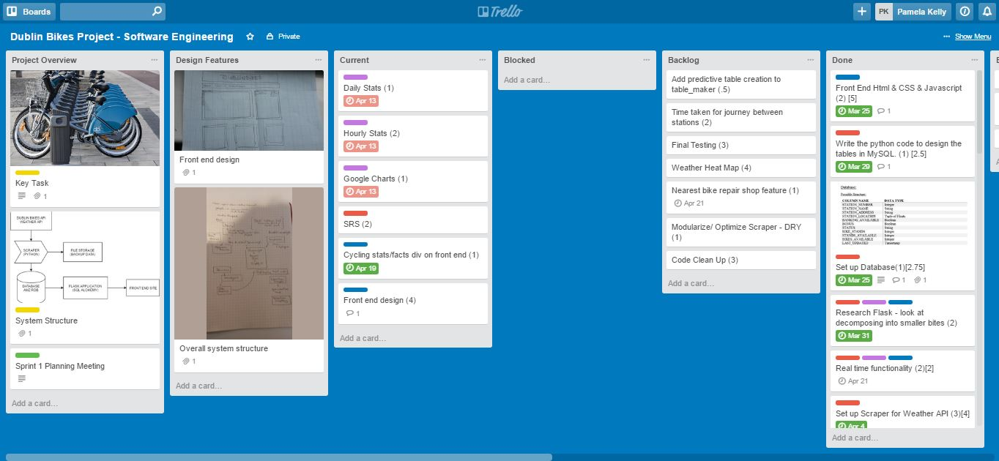

Figure 5: A screen shot of the group trello board showing a few key sections on the 19th of April

## 3.4. Stand-up Meeting/ Scrum 4

### 3.4.1. Meeting Details

Date: 21st April 2017

Scrum Leader: Emma Byrne

Attended By:

Team Members: Pamela, Katherine, Emma.

### 3.4.2. Tasks Accomplished Since Last Meeting and Tasks to Accomplish

Pamela:

* Got the Google Charts working and incorporated them into the and displayed them on the front end
* Worked on getting the final app running on EC2 and the website is now hosted on ec2
* Next step: Tidy up code and annotate code. Get documentation written up.

Katherine:

* Worked on getting the live weather data displaying on the front end
* Incorporated Open Weather Map API via JavaScript and JQuery with HTML to display live weather data on the front end
* Incorporated weather icons in the weather information
* Next step: Tidy up code. Get documentation written up including the SRS

Emma:

* Worked on front end design, displaying everything together on the webpage in an attractive way
* Added a header and a footer along with various images and facts to the front-end design
* Next step: Tidy up and annotate code. Write up necessary documentation.

## 3.5. Sprint 3 Retrospective

### 3.5.1. Meeting Details

Date: 22nd April 2017

Scrum Leader: Emma Byrne

Attended By:

Customer: Devin Stacey

Team Members: Pamela, Katherine, Emma.

### 3.5.2. Current State of Project

* All primary goals of the project have been achieved
* The app/website is complete with all of the necessary features
* The website is up and running on an Amazon ec2 instance
* The website contains a map with markers indicating the location of all of the Dublin Bikes stands across the city
* The website displays live weather information
* The website supports interactivity by being able to select station markers for a specific station
* The website displays occupancy information for a specific station when it is selected
* Hourly and daily statistics are also displayed for a specific bike station

### 3.5.3. Sprint 3 Challenges

* There were many issues when hosting the app on ec2. There were numerous import issues with python 3 modules which meant that we couldn’t use the wsgi system. The solution to this was setting up port forwarding so that the site running on the local host was redirected to the public IP for the ec2.
* There were several JavaScript issues when trying to send parameters to the url and then passing that information into a sql query in the flask app. Solution: Emma and Pamela utilised pair programming to create an on-click function which is called within the loop when creating the markers so that the on-click was dynamic and specific for that station. This enabled the correct occupancy information to be displayed for whichever station was selected.
* Several issues occurred when trying to merge databases – the weather and bike databases via sql alchemy. Other issues encountered included copying the data from one database to another. The solution to this would have been to use the Amazon migration functionality but because this is a paid service, it was decided that the tables would not be merged.
* Other challenges included getting the live weather data to display on the front end using jquery but this ended up being because of the order in which it was being called on the front end.

## 3.6. Features in Backlog

* There were a few features in the backlog that were not added to the project due to time constraints. These included a heat map, calculating the time it would take to get from one stop to another and showing the nearest bike repair shop.
* The historical weather data was to be used so as to make predictions about the availability of bikes depending on the different weather conditions. For example, what would be the chance of getting a bike from a particular station at a certain time if it is raining.

## 3.7. Overall Feedback from Customer

* The project fulfils the necessary requirements as outlined in the documentation
* Ensure everything is working perfectly including hosting and statistical charts
* Ensure that the code can be run on different environments including different laptops and on ec2
* Ensure that no part of the application takes too long to load – map, weather, statistics etc.
* Ensure code is concise and not reused

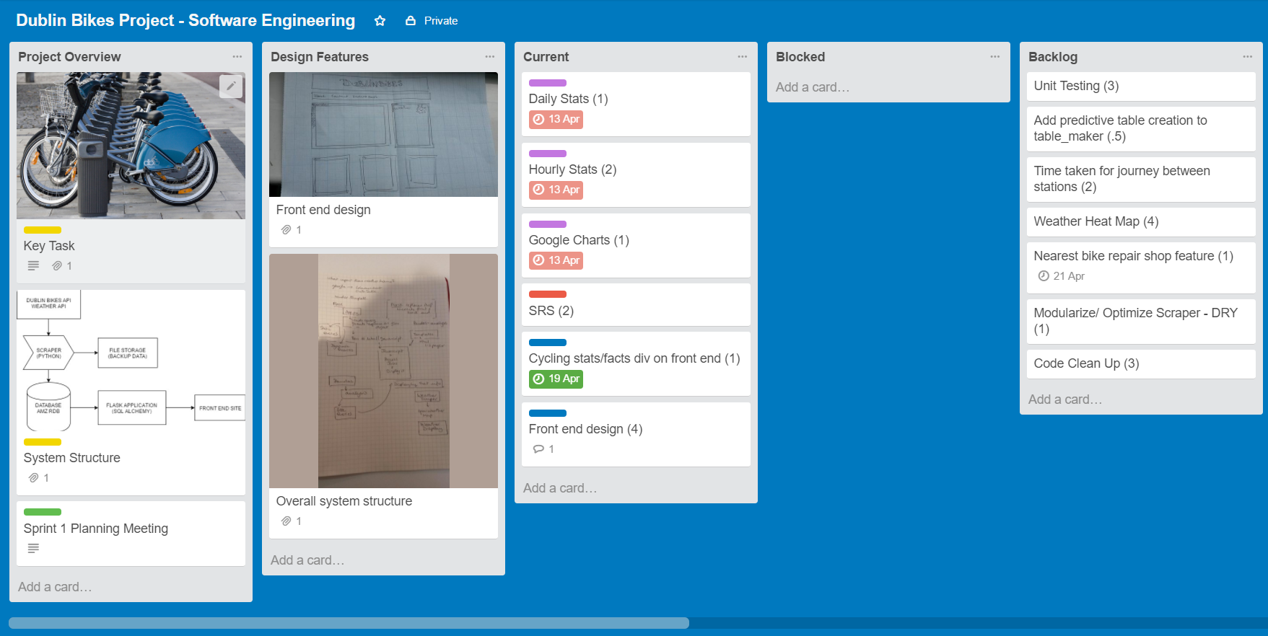

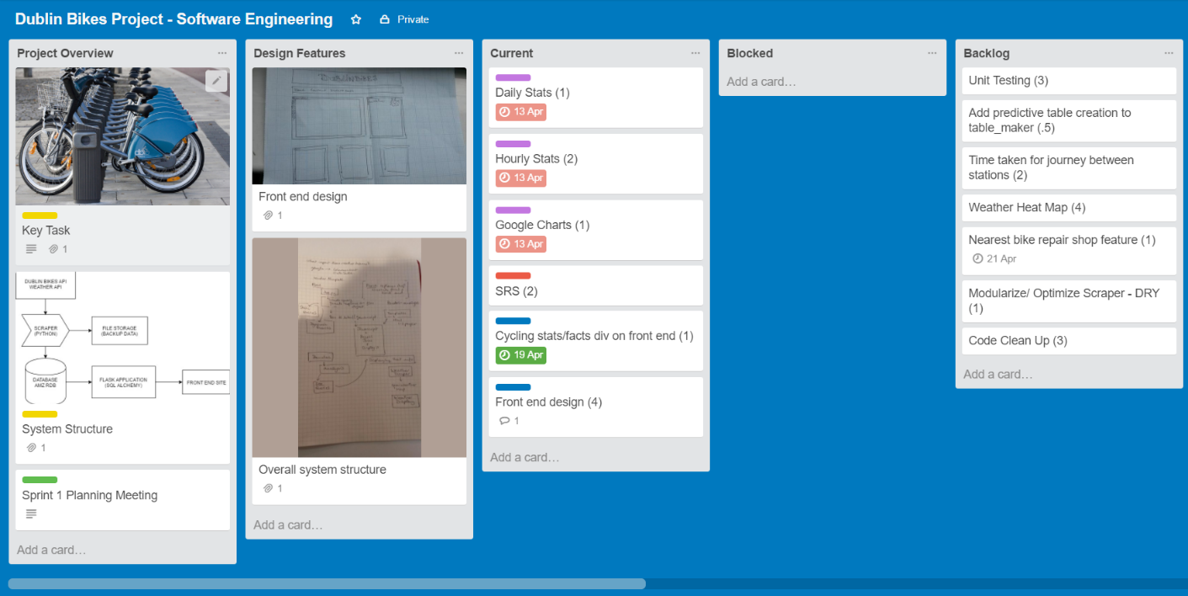

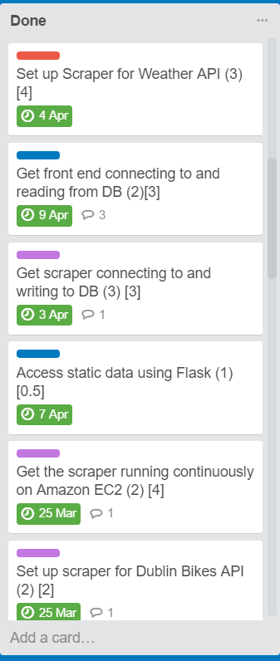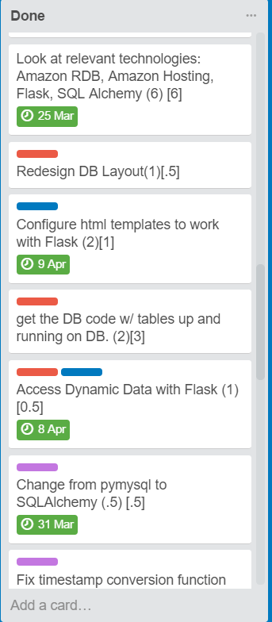

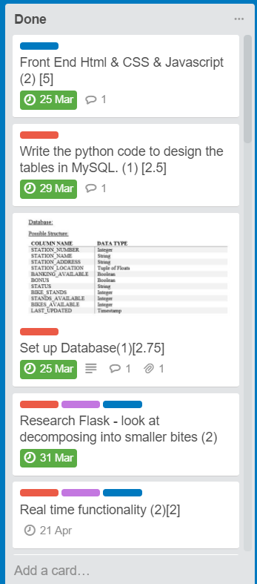

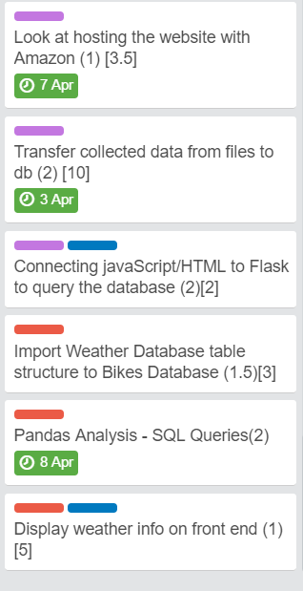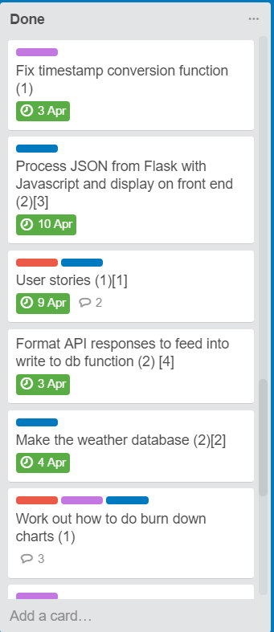

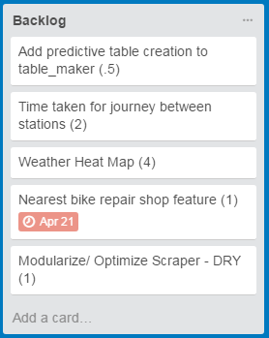

Fig. X: The remaining backlog on the final day

## 3.8. Sprint 3 Overview

### 3.8.1. Emma

Name: Emma Byrne Group: 7 Sprint# 3 Date:

**Percentage of Group Submission:** 33%

**Skills Practised:** HTML, JavaScript, CSS, Flask, Python

**Learning Done:** Passed JavaScript variable to Flask to query the database about occupancy information for a specific station – peer programming with Pamela

**Final Thoughts:** Successful project, set out what we wanted to achieve. Given more time some of the features in the backlog could have been incorporated.

### 3.8.2. Katherine

Name: Katherine Campbell Group: 7 Sprint# 3 Date:

**Percentage of Group Submission:** 33%

**Skills Practised:** Writing python code copying a table from one db into another using sql alchemy. Dumping data import/export with mysql, working with dynamic flask applications, Queries in sql alchemy. JavaScript, HTML, JQuery, JQuery uses connecting with HTML, connecting and reading JSON from Openweathermap API, writing SRS.

**Learning Done:** Learned three ways to copy a table from one data base to another - using dumps, CREATE TABLE..LIKE db1.table; INSERT INTO db2 SELECT * FROM db1.table, and via python using alchemy, 2 engines and metadata. Copying said table and data with python code. Learned that rds allows tables to be copied but not data. Must use charged migration service. Learned JQuery. Learned how to use JQuery with APIs and html. Learned how to write sql queries, select only the most updating entries. Learned how to work around the previous pymysql issue with mysqldb. Learned how to work with predictive data, and tie said data into a dynamic flask app to get it to the front end.

**Final Thoughts:** Overall a successful project – ensured a very steep learning curve to gain a lot of valuable experience. Now much more comfortable with sql, and have learned something about Flask and JQuery. We were so close to incorporating predictive weather data and had we stored in the same data base that wouldn’t have been an issue. Would have liked more time to focus only on this project – many cool items in the backlog would have been nice to incorporate (e.g. heatmap, search bar, predictive weather data, etc.). Otherwise, very pleased.

### 3.8.3. Pamela

Name: Pamela Kelly Group: 7 Sprint# 3 Date:

**Percentage of Group Submission:** 33%

**Skills Practised:** Hosting on EC2 with Apache via wsgi module, and then subsequently via port forwarding. Writing mysql queries to calculate statistical data. Javascript – Google Charts and connecting results of statistical queries to front end. Flask – connecting queries to javascript. Refactoring code.

**Learning Done:** Learned how to use Apache to host web applications on remote instances. Learned that it is difficult to write efficient sql queries – would have preferred if the Google Charts appeared more quickly – currently taking 20-30 seconds. Learned how to use Flask in further detail.

**Goals:** With more time, I would like to have gotten the performance of the statistical data to be much faster. Ideally, I would like to have created a predictive stats table, ran the analytical queries and stored the results here. Then the query for the database would pull less data and there would relieve the computational load from the front end.

Burndown:

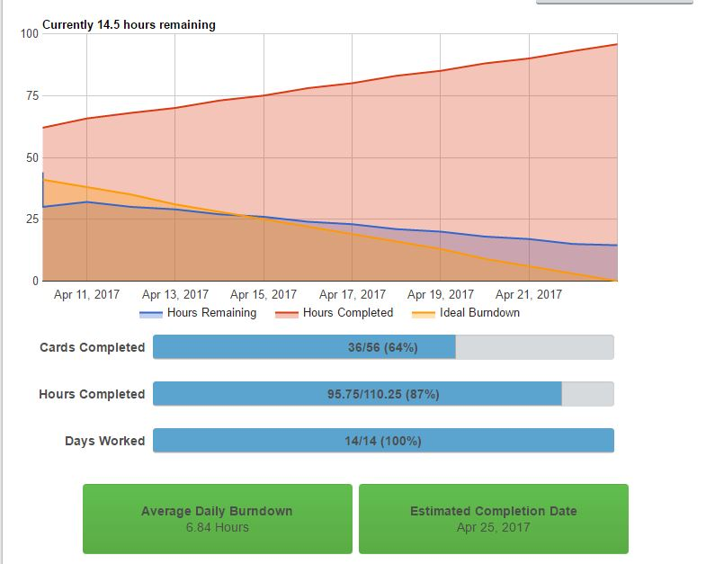

Comments on Burndown:

We didn’t quite get to finish all of the work planned. We had a few tasks left on the backlog, however ideally with another sprint we would improve speed performance of the statistical information. We would also like to have completed some of the additional features listed in the backlog, such as the heatmap.

Appendices

**Appendix A: Sprint 1 Task Table**

|  |  |  |  |  |  |
| --- | --- | --- | --- | --- | --- |
| Tasks | Owner | Est | Due | Done | Notes |
| Research Dublin Bikes API | All team members | 1hr | 17th March | 17th March | - |
| Research Weather API | All team members | 1hr | 17th March | 17th March | - |
| Formalise structure & design for database | All team members – discussion | 1hr | 17th March | 17th March | - |
| Research Amazon RDS  Research Amazon Hosting | All team members | 1hr | 17th March | 17th March | - |
| Research Flask | All team members | 2hrs | 17th March | 17th March | - |
| Organise Trello & burndowns | Pamela | 1hr |  |  |  |
| Update Trello | All team members | - |  |  | - |
| Plan Stand-ups | Pamela | - |  |  | - |
| Write Scraper | Pamela | 2hrs | 25th March | Bugs – ran into Sprint 2 | - |
| Set up Database | Katherine | 2hrs | 25th March | Issues – ran into Sprint 2 | - |
| Write initial front end HTML/CSS/JavaScript | Emma | 2hrs | 25th March |  | - |
| Set up skeleton Flask App | TBD | - | - | - | - |

**Appendix B: Sprint 2 Task Table**

|  |  |  |  |  |  |
| --- | --- | --- | --- | --- | --- |
| Tasks | Owner | Est | Due | Done | Notes |
| Redesign Database | Katherine | 30 min | 27th March | 27rd March | - |
| Implement new Database via RDS | Katherine | 1hr | 27th March | 27th March | - |
| Write Python code to design tables in the MySQL DB | Katherine | 1hr | 29th March | 29th March | - |
| Get the database code w/ tables up and functional on the Dublin Bikes Database | Katherine | 2hr | 29th March | 29th March | - |
| Research to understand Flask | All | -- | - | - | - |
| Change from pymysql to SQLAlchemy | Pamela | 30 min | 31st March | 31st March |  |
| Get Scraper connecting to and Writing to the Dublin Bikes database | Pamela | 2hr | 3rd April | 3rd April | Mercian Prime issues – see scrum notes |
| Fix timestamp conversion function | Pamela | 1hr | 3rd April | 3rd April |  |
| Transfer collected data from files to DB | Pamela | 2hr | 3rd April | 3rd April |  |
| Create Scraper for OpenWeather API | Katherine | 3hr | 4th April | 4th April | - |
| Format API responses to feed into the write to database function | Katherine and Pamela | 2hr | 3rd April | 3rd April | Each for respective scraper – pair programmed |
| Create DB for weather data | Emma | 2hrs | 17th March | 4th April | - |
| Host the site on EC2 | Pamela | 1hr | 7th April | 7th April |  |
| Write Flask Apps for static data | Emma | 30 min | 9th April | 7th April |  |