The Eighth Annual Midwinter Coffeehouse in West Newton Square
Saturday February 9th

The eighth annual Midwinter Coffeehouse will be held at 7:00 pm, Saturday, February 9th, at the First Unitarian Society Parish Hall, 1326 Washington St, West Newton. This event, presented as a benefit for The Parent Teacher Organization (PTO) of the Franklin Public Elementary School in West Newton, is one of Newton’s only regular coffeehouses, and features singer/songwriters active in the Boston folk music community who have donated their time to benefit the PTO. The tradition of excellence continues in this, the eighth year of this unique fundraising event, with award-winning songwriter, Newton resident, and Franklin parent Catie Curtis.

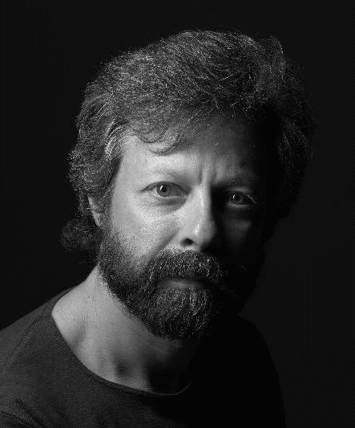
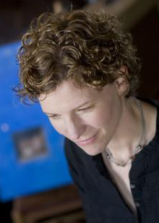
Curtis has headlined clubs and theaters throughout the US since the mid-nineties. She has shared the bill with artists such as Dar Williams and Richard Thompson and toured in Europe with Mary Chapin Carpenter. Catie's grassroots fan base has grown by word of mouth over the years based on the strength of her recordings and live shows. A supporter of social causes, Curtis has played concerts benefiting organizations including Paul Newman's Hole In the Wall Gang Camp, Women of Means (medical care for homeless women), and many others. Her songs have appeared in television shows as diverse as Grey's Anatomy, Dawson's Creek, Felicity, and Alias. Her new CD “Long Night Moon” features the Katrina-themed track “People Look Around” for which Curtis (along with co-writer Mark Erelli) was honored with the Grand Prize in this year's International Songwriting Competition (out of 15,000 entries from 82 countries).

Newton’s Rob Siegel is well known in Boston folk music circles as an innovative songwriter who mines his middle-class suburban existence and produces memorable, intelligent, well-crafted songs. Sing Out magazine says “Siegel’s talents run far wider than great writing; he is uniquely entertaining and thoughtful.” Rob has opened for Bill Staines, Vance Gilbert, Jack Hardy and others. His recent CD “Voices from the Right Brain: Rob Siegel Live at Club Passim” reached #52 on the Folk DJ charts.

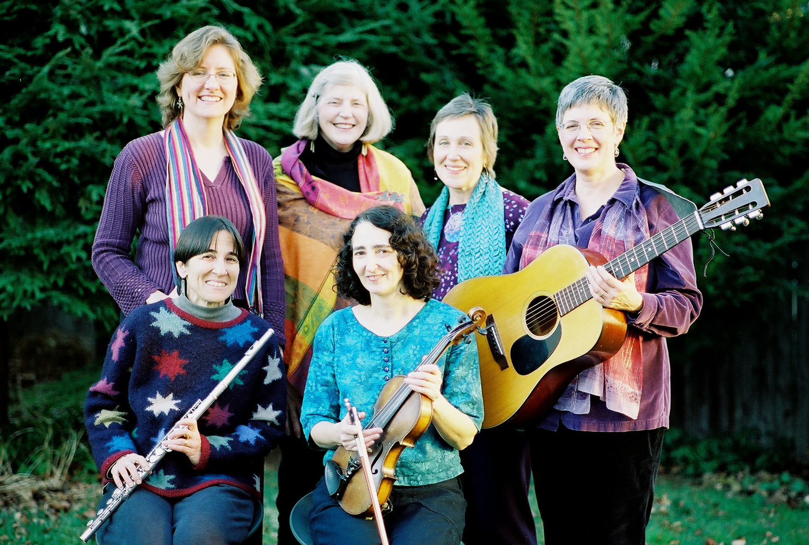
Newton’s Cindy Mapes is a member of “Constellations,” a group of women who perform original compositions and traditional and contemporary folk music from around the world. Performing both a cappella and accompanied by guitar, flute, violin, and percussion,“Constellations” includes Jackie Damsky, Brett Frechette, Sue Kranz, Liz Lewis, and Jan Maier. Dedicated to the promotion of peace and social justice, they are known for their delightful harmonies and for involving their audiences in music-making.

This year’s roster of other performers includes Franklin parents and friends Galina Brusilovsky, Carroll Eastman, Pamela McA’Nulty and Don Levey, Jennifer O’Brien, and Michael Rizzo. Eric Moore will emcee.

The event is from 7:00 to 10:30 pm. Doors open at 6:30. Tickets are $15, available in advance or at the door to adults 21 or over. Refreshments include coffee, wine and beer, juice and soda, and snacks. For more information, including advanced ticket sales, contact Cindy Mapes at 617-527-4858 or at midwintercoffeehouse@yahoo.com. The event is wheelchair-accessible.

