ConEd Manhattan Steam Attrition Dashboard
Technical Manual & Deck Reference

Version 1.0 · June 2026 · Prepared for Blackstone Preview

Portfolio: 1,210 Manhattan Steam Buildings · $81.9M LL97 2024 Exposure

Section 0 — Deck Quick-Reference (Simplified)
Use this section for presentation talking points. Each bullet maps to a dashboard feature with a plain-English explanation.

▶ What is this?: A live dashboard tracking 1,210 Manhattan buildings that use ConEd district steam heat. It identifies which buildings are most likely to disconnect from the steam grid — a risk called 'attrition' — using permit data, energy benchmarks, and NYC Local Law 97 compliance status.
▶ Why does this matter?: Each large steam customer that disconnects costs ConEd millions in lost recurring revenue. The dashboard lets account managers identify at-risk accounts before they act, not after. Think of it as a churn model for a utility.
▶ What drives attrition risk?: Three main factors: (1) high LL97 fines that incentivize switching to electric heat pumps, (2) recent permit activity suggesting capital investment in alternatives, (3) low Energy Star scores and high steam intensity compared to peer buildings.
▶ What is LL97?: NYC Local Law 97 of 2019 caps carbon emissions per square foot for buildings over 25,000 ft². Buildings that exceed the cap pay $268 per metric ton of excess CO₂e per year. The limits tighten in 2030, tripling the average fine exposure across the portfolio.
▶ The 5 building archetypes: The ML model groups all 1,210 buildings into 5 clusters using energy, permit, and age data. Two clusters are flagged High-risk: 'Pre-War Active' (older buildings with lots of permit activity — landlords renovating toward electrification) and 'Low-Compliance Commercial' (large offices that are over the LL97 cap but haven't acted yet — acute financial incentive to switch by 2030).
▶ $81.9M — what's that number?: The total annual fine exposure across all 1,210 buildings if none of them make changes. In reality, ConEd's risk is: buildings with high fines switch to electric and disconnect. Top 5 most-exposed: 31 W 34th St ($17M), Columbia University complex ($12.5M), 111 8th Ave ($6.8M), 415 E 68th St ($4.3M), The Met ($3.1M).
▶ Risk score — what does it mean?: Each building gets a score from 0.0 to 1.0 from a Gradient Boosting classifier. Score ≥ 0.70 = High risk (58 buildings). Score 0.30–0.70 = Medium (11 buildings). Score < 0.30 = Low (1,141 buildings). The distribution is strongly bimodal — the model is a binary classifier by design, not a nuanced scorer. It flags likely churners.
▶ How current is the data?: Steam and GHG data: 2021–2024 NYC LL Benchmarking. DOB permits: updated through June 2026 via the NYC Open Data DOB NOW API. The dashboard runs a live Express backend — no cloud dependencies, no API keys exposed to the browser.

Section 1 — System Architecture
The dashboard is a two-process Node.js application. The Express backend (port 3001) serves pre-computed JSON files and proxies the Groq AI chat endpoint. The Vite/React frontend (port 5173) renders all charts client-side using recharts 2.x.

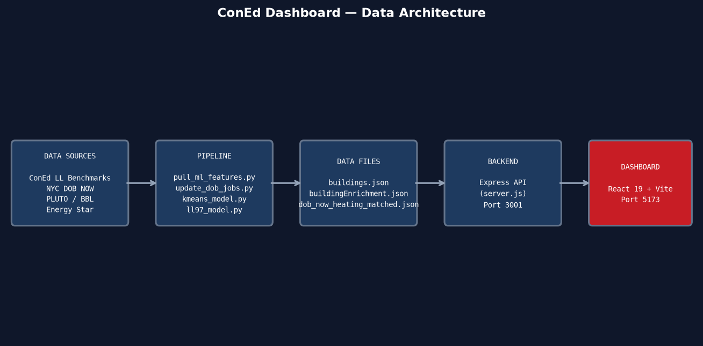

1.1 Stack
Component | Role | Notes
React 19 + Vite 8 | Frontend SPA | recharts 2.15.0, TailwindCSS v4
Express 5 | Backend API server | Port 3001; serves JSON files, proxies Groq
Python 3.13 | Data pipeline | sklearn, numpy; runs offline to rebuild enrichment
Groq API (Llama 3.3 70B) | AI filter | Natural language → JSON filter spec
NYC Open Data (Socrata) | DOB permits | Dataset w9ak-ipjd; incremental fetch via BBL
PLUTO (NYC) | Geocoding | BBL → lat/lon → building owner verification

Section 2 — Data Sources & Pipeline

2.1 Source Files
File | Source | Key Fields
steam-buildings.csv | NYC LL Benchmarking (ConEd export) | Floor area (ft²), use type, Energy Star score, GHG
steam-consumption.csv | NYC LL Benchmarking | Annual steam kBtu 2021–2024 per building
steam-buildings-geocoded.csv | Above + PLUTO join | BBL per building; used as join key for DOB
dob_now_heating_matched.json | NYC Open Data (DOB NOW w9ak-ipjd) | 19,879 permit records 2019–2026-06-13
peer_scores.json | Derived | Z-score of EUI vs. same use-type buildings
steam_trend_signals.json | Derived | YoY steam trend label: big_drop / moderate_drop / stable / growth

2.2 BBL Join Logic
NYC buildings are identified by BBL (Borough-Block-Lot). The dashboard joins ConEd steam accounts to DOB permits via BBL rather than address string (addresses are inconsistent across datasets).

BBL decode: borough = bbl // 1_000_000_000
block = (bbl % 1_000_000_000) // 10_000
lot = bbl % 10_000
→ Borough 1 = Manhattan. API returns unpadded block/lot (e.g. '1172' not '01172').

2.3 DOB Permit Update Procedure
Incremental updates run via update_dob_jobs.py. The script fetches records since CUTOFF_DATE in chunks of 20 block+lot pairs per API call to avoid URL length limits.

Step | Action
1 | Parse all BBLs from steam-buildings-geocoded.csv → set of (block, lot) pairs
2 | Load existing dob_now_heating_matched.json → build deduplication key set
3 | Fetch from DOB NOW API (w9ak-ipjd) where filing_date > CUTOFF and borough='MANHATTAN'
4 | Deduplicate on (block, lot, filing_date[:10], job_type)
5 | Merge and rewrite dob_now_heating_matched.json
6 | Recount dob_jobs per building using 24-month rolling window
7 | Update buildingEnrichment.json → recompute log_dob_jobs
8 | Re-run kmeans_model.py then ll97_model.py to rebuild all ML scores

Section 3 — Machine Learning Pipeline

3.1 K-Means Clustering (Archetype Assignment)
All 1,210 buildings are clustered into K=5 archetypes using sklearn KMeans on standardized features. The K was selected by balancing Silhouette score and Calinski-Harabasz index (K=5 offered the best interpretability vs. statistical separation tradeoff).

Features used for clustering:
Feature | Source | Role
log_steam | log1p(steam kBtu/yr) | Primary consumption signal; log-compressed for scale
year_built | Construction year | Pre-war vs. post-war capital stock proxy
log_dob_jobs | log1p(DOB permits, 24mo) | Active investment signal; high = renovating
energy_star | Energy Star score 0–100 | Efficiency peer benchmark; imputed by use-type median
peer_score | Z-score vs. peers | EUI compared to same-use-type buildings
use_type_ord | Ordinal 1–4 | Electrification sensitivity by use type

Silhouette score: s(i) = (b(i) − a(i)) / max(a(i), b(i))
→ a(i) = avg intra-cluster distance; b(i) = avg nearest-cluster distance. Range: −1 to 1. Achieved: 0.191 at K=5.

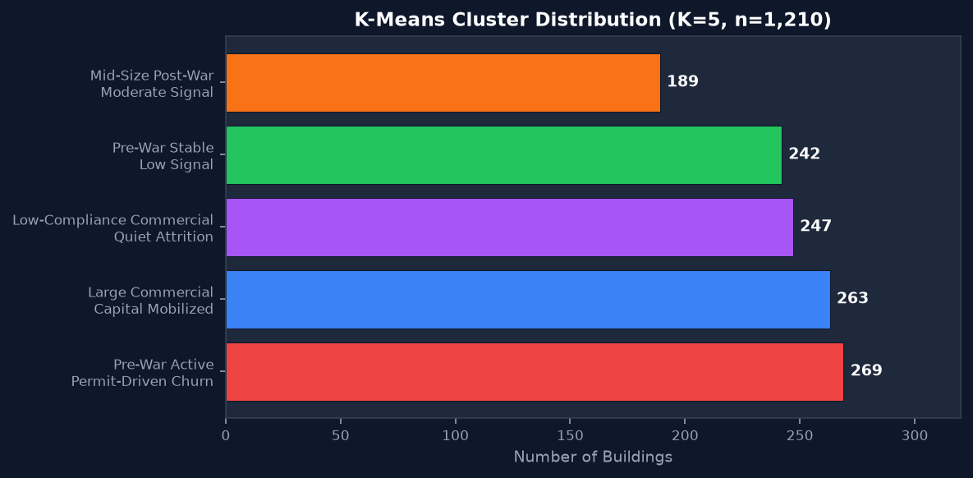

3.2 Five Archetypes
ID | Archetype Name | Risk | Count | Avg Steam | Avg Yr | Key Signal
0 | Pre-War Active — Permit-Driven Churn | High | 269 | 30.7M kBtu avg | 1963 | Low DOB → high churn signal from capital activity
1 | Mid-Size Post-War — Moderate Signal | Medium | 189 | 13.2M kBtu avg | 1969 | Low Energy Star (21) — underperforming, moderate pressure
2 | Pre-War Stable — Low Signal | Low | 242 | 3.5M kBtu avg | 1934 | Good ES (72), older buildings, no strong churn signal
3 | Large Commercial — Capital Mobilized | Medium | 263 | 4.6M kBtu avg | 1937 | Pre-war commercial, low permits, stable base
4 | Low-Compliance Commercial — Quiet Attrition | High | 247 | 29.1M kBtu avg | 1963 | High DOB (12.3 avg), 97% office — acute LL97 fine exposure

3.3 Gradient Boosting Risk Classifier
After clustering, a supervised GradientBoostingClassifier produces a continuous 0–1 attrition probability per building. Training labels are derived from historical steam trend signals: buildings with a confirmed 'big_drop' in steam consumption are labeled positive (likely churner).

Important design decision:
Buildings labeled 'moderate_drop' were explicitly excluded from training. This produces the observed bimodal distribution — the model is a near-binary classifier, not a nuanced scorer. This is intentional: it maximizes precision on the high-risk tail at the cost of coverage in the middle band.

GBM Features (12 total):
Feature | Approx. Importance | Interpretation
ll97_penalty_2024_log | ~22% | Dominant signal — acute financial pressure to switch
log_steam | ~17% | Raw consumption volume
ll97_over_2024 | ~13% | Binary: is building currently non-compliant?
log_ghg | ~12% | GHG intensity
peer_score | ~9% | Relative efficiency vs. same-use peers
ll97_penalty_2030_log | ~7% | Forward-looking pressure signal
cluster_id | ~6% | Archetype membership from K-means
steam_ghg_share | ~5% | Fraction of building GHG attributable to steam
energy_star | ~4% | Efficiency benchmark
year_built | ~2% | Building age proxy
log_dob_jobs | ~2% | 24-month permit activity
use_type_ord | ~1% | Electrification sensitivity ordinal

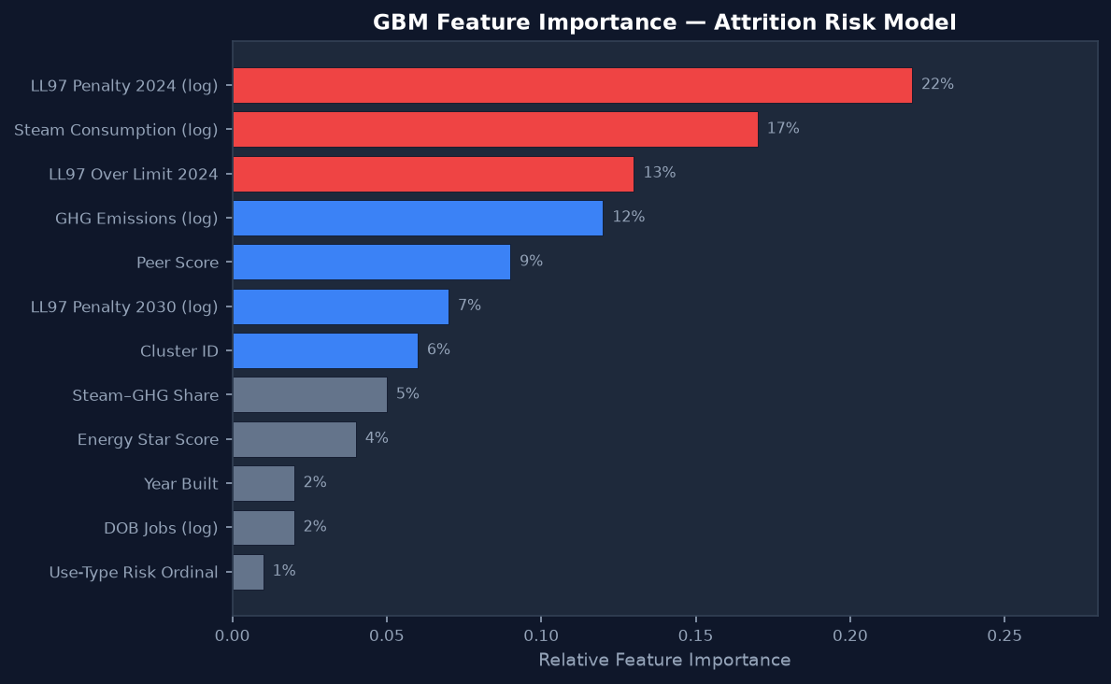

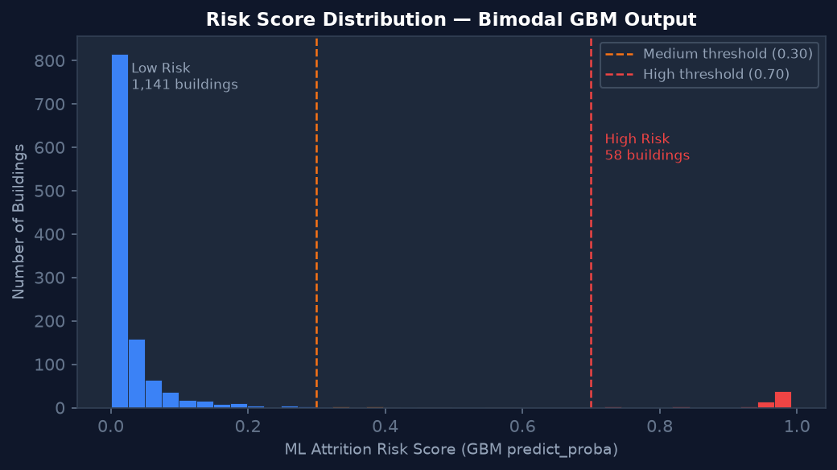

Risk Tier Thresholds:
Tier | Score Range | Buildings | Description
High | ≥ 0.70 | 58 (4.8%) | Strong churn signal; immediate account management attention
Medium | 0.30–0.70 | 11 (0.9%) | Moderate signal; monitor quarterly
Low | < 0.30 | 1,141 (94.3%) | No strong signal; routine stewardship

Section 4 — LL97 Equations & Penalty Model
NYC Local Law 97 (2019) mandates annual carbon intensity limits for buildings over 25,000 sq ft. The dashboard computes compliance status and projected fines for both the 2024 (Phase 1) and 2030 (Phase 2) thresholds.

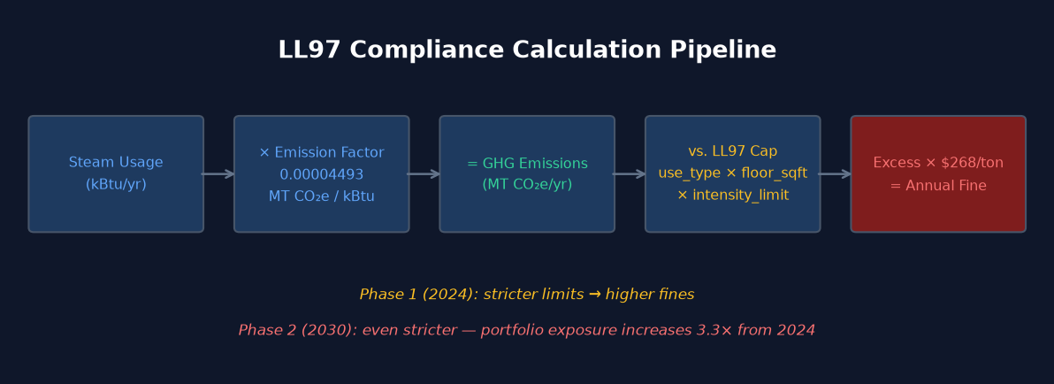

4.1 Steam → GHG Conversion
GHG (MT CO₂e/yr): GHG = steam_kBtu × 0.00004493
→ 0.00004493 MT CO₂e/kBtu is the LL97-specific binding coefficient (NYC DOB Chapter 103 Rules). Note: EPA eGRID cites ~6.68×10⁻⁵ — LL97 uses the lower value as the official regulatory standard.

4.2 Annual Cap Calculation
Emission cap (MT CO₂e/yr): cap = floor_sqft × intensity_limit[use_type][phase]
→ intensity_limit varies by building use type and compliance phase (see table below).

4.3 Excess & Fine
Annual fine (USD): excess = max(0, GHG − cap)
fine = excess × $268
→ $268/MT CO₂e is the statutory penalty rate. There is no cap on total fines.

4.4 LL97 Intensity Limits by Use Type
Use Type | Phase 1 Limit (2024)  MT CO₂e / ft² / yr | Phase 2 Limit (2030)  MT CO₂e / ft² / yr
Office / Financial Office | 0.00846 | 0.00453
Multifamily Housing / Dorm | 0.00675 | 0.00400
Hotel | 0.01450 | 0.00700
Retail Store | 0.00846 | 0.00403
K-12 School / College | 0.00846 | 0.00453
Hospital / Clinic | 0.02381 | 0.00840
Performing Arts / Museum | 0.01074 | 0.00420
Worship Facility | 0.01074 | 0.00420
Default (Other) | 0.00846 | 0.00453

4.5 Portfolio LL97 Exposure
Metric | 2024 (Phase 1) | 2030 (Phase 2)
Total portfolio fines (all buildings) | $81,875,711 | $270,916,416
Buildings over limit | ~516 | ~760 (est.)
Multiplier vs. 2024 | 1.0× | ~3.3×
Top fine: 31 W 34th St | $16,987,675 | ~$56M (est.)
2nd: Columbia Univ (116 St complex) | $12,504,928 | ~$41M (est.)

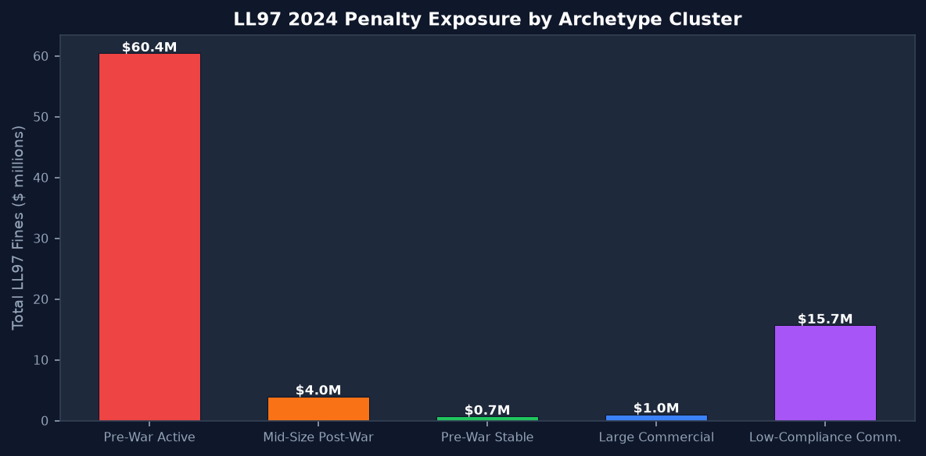

Section 5 — Dashboard Components
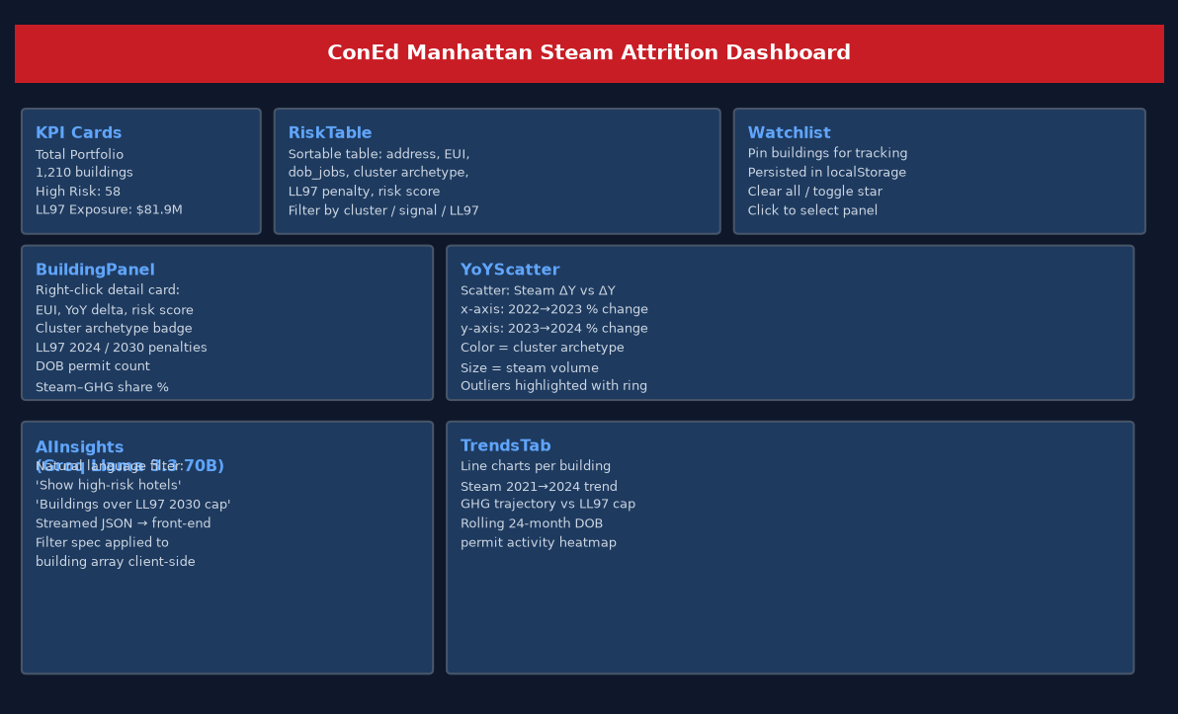

5.x KPI Cards (top bar)
Four summary statistics: Total Portfolio (1,210), High-Risk count (58), LL97 2024 Exposure ($81.9M), and filtered/watchlist count. Values update reactively when filters or watchlist change.

5.x RiskTable
Sortable, filterable table of all buildings. Columns: Address, EUI (kBtu/ft²), Steam (kBtu/yr), DOB Permits (24mo), Cluster Archetype, LL97 2024 fine, Risk Score. Filters: archetype dropdown, steam signal (big_drop/stable/growth), LL97 compliance status. Click a row to open BuildingPanel. Star button to add to Watchlist.

5.x BuildingPanel
Right-side detail panel for the selected building. Shows: EUI, YoY steam delta (22→23 and 23→24), GBM risk score with color badge, cluster archetype name, LL97 2024 and 2030 fine, DOB permit count, steam-GHG share percentage, and building year. Appears on row click or watchlist click.

5.x YoYScatter
Scatter plot comparing two YoY steam change periods. X-axis: 2022→2023 % change. Y-axis: 2023→2024 % change. Each dot = one building. Color = cluster archetype. Size encodes steam volume. Buildings with extreme outlier values in either year receive a highlight ring. The scatter reveals whether declines are accelerating (down-right quadrant = declining again) or one-time shocks (up-right = recovered).

5.x Watchlist
Persistent sidebar (localStorage) for pinned buildings. Supports: add/remove individual buildings (star toggle), clear all button, click-to-select. Useful for account managers monitoring a specific set of customers across sessions.

5.x AI Insights (Groq)
Natural language filter powered by Llama 3.3 70B via Groq API (streamed). User types a query ('show me hotels over the LL97 2030 cap') — the backend sends a system prompt + building schema to Groq, receives a JSON filter spec, and the frontend applies it client-side via groqFilter.js. No building data leaves the local network — only the query and field schema go to Groq.

5.x Trends Tab
Per-building line charts showing annual steam consumption 2021–2024, GHG trajectory vs. LL97 cap line, and rolling DOB permit activity. Allows visual inspection of trend shape (accelerating decline vs. one-time dip).

Section 6 — Data Field Definitions
Field | Unit | Description
steam | kBtu/yr | Annual district steam consumption (most recent year)
ghg | MT CO₂e/yr | GHG from steam: steam × 0.00004493
eui | kBtu/ft²/yr | Energy Use Intensity: steam / floor_sqft
floor_sqft | ft² | Gross floor area (self-reported, NYC LL Benchmarking)
energy_star | 0–100 | Energy Star score; imputed by use-type median when absent
peer_score | Z-score | EUI vs. same-use-type peers; negative = more efficient
dob_jobs | integer | DOB NOW permit filings in trailing 24 months
log_dob_jobs | float | log1p(dob_jobs); used as ML feature
cluster_id | 0–4 | K-means archetype assignment
cluster_name | string | Human-readable archetype name
cluster_risk | High/Medium/Low | Risk tier assigned to this archetype
ml_risk | 0.0–1.0 | GBM predict_proba — attrition probability score
ll97_penalty_2024 | USD/yr | Projected annual fine under Phase 1 limits
ll97_penalty_2030 | USD/yr | Projected annual fine under Phase 2 limits
ll97_over_2024 | 0/1 | Binary: building exceeds Phase 1 cap
ll97_over_2030 | 0/1 | Binary: building exceeds Phase 2 cap
ll97_cap_2024 | MT CO₂e/yr | Building's Phase 1 emission allowance
steam_ghg_share | 0.0–1.0 | Fraction of building GHG attributable to steam
yr | year | Year built (from LL Benchmarking / PLUTO)
bbl | string | Borough-Block-Lot; may be semicolon-delimited for multi-tax-lot buildings

Section 7 — Update Runbook

7.1 Incremental DOB Update
Run from coned-dashboard/ directory:
cd coned-dashboard
/opt/homebrew/bin/python3.13 update_dob_jobs.py
/opt/homebrew/bin/python3.13 kmeans_model.py
/opt/homebrew/bin/python3.13 ll97_model.py

7.2 Full ML Rebuild
Same three scripts as above. Takes ~2 minutes. After running, commit public/buildingEnrichment.json and cluster_profiles.json.

7.3 Start the Dashboard (local)
# Terminal 1 — backend
cd coned-dashboard && node server.js
# Terminal 2 — frontend
cd coned-dashboard && npm run dev
# Access: http://localhost:5173
# Password: coned-steam-2026

7.4 Remote Access via Tailscale
Start Vite with --host to expose on all interfaces:
npm run dev -- --host
Other devices on Tailscale can access at: http://100.107.92.16:5173

Section 8 — Known Limitations & Data Notes
⚠ Risk model is binary by design: The GBM was trained on big_drop vs. no_signal labels. Buildings with 'moderate_drop' were excluded from training. The result: very few buildings score in the 0.30–0.70 medium band (11 buildings total). This is a modeling choice, not a bug.
⚠ YoY data coverage gap: 2022→2023 YoY delta covers 743 buildings. 2023→2024 covers only 422 buildings because 2024 benchmarking data was not yet available for all accounts at data collection time. Buildings missing 2024 data show their most recent available year.
⚠ LL97 2030 estimates are projections: The 2030 fine calculations assume current steam consumption levels hold constant. Actual fines will depend on: LL97 regulatory changes, building renovations, and whether building owners comply via offsets, retrofits, or switching.
⚠ Floor area is self-reported: GFA comes from NYC LL Benchmarking self-reporting. Errors in floor area directly affect EUI and LL97 penalty calculations. Some buildings show EUI outliers due to misreported floor area.
⚠ DOB permits proxy only: dob_jobs counts permit filings, not completed work. High permit counts may indicate renovation toward electrification OR general building maintenance. The model uses this as a directional signal, not a definitive indicator.
⚠ LL97 fine cross-check: The $81.9M total cannot yet be independently verified against NYC DEP compliance reports because official 2024 enforcement data has not been released. The calculation uses the statutory formula as written in LL97 and NYC DOB Chapter 103 Rules.

Appendix A — Quick Numbers Reference
Metric | Value
Portfolio size | 1,210 buildings
Borough | Manhattan only
Steam emission factor | 0.00004493 MT CO₂e / kBtu
LL97 fine rate | $268 per MT CO₂e over cap
Total LL97 2024 fine | $81,875,711
Total LL97 2030 fine | $270,916,416
High-risk buildings | 58 (score ≥ 0.70)
Medium-risk buildings | 11 (score 0.30–0.70)
Low-risk buildings | 1,141 (score < 0.30)
K-means K | 5 clusters
Silhouette score @ K=5 | 0.191
DOB records total | 19,879 (through 2026-06-13)
DOB rolling window | 24 months
GBM features | 12
Dashboard password | coned-steam-2026

