ADDENDUM — TECHNICAL CHANGE DOCUMENT
ConEd Steam Attrition Intelligence Dashboard
Baseline: June 13, 2026 (commit d8848bf) → Current: June 14, 2026 (commit 516cef4)
Prepared by: Neo (RRC) · Pursuit Fellowship Data Team

Commit | Type | Description
4dee668 | Security | CSV export injection hardening
2eddce6 | Data | YoY delta backfill + hallucination guards
dae6e48 | Data/UI | Uncertain tier removed — 100% ML coverage
0f44fd0 | Security | Pre-Blackstone hardening (Helmet, rate limits, CRLF)
33cea13 | Feature | Click-to-filter charts, Toast, useKeyboard, useUrlState
ff3b82f | Feature | Pagination, multi-sort, bulk select, TrendChart, /api/buildings
516cef4 | Feature | Server-side watchlist sync + TrendChart LL97 cap line

1. Data Quality Updates

1.1 Uncertain Tier Elimination
The Uncertain tier — buildings excluded from ML training due to missing GHG/floor-area/year-built data — was present in the original manual as 50 buildings displayed in purple. A programmatic audit confirmed that all 1,210 buildings in the current dataset have ml_risk values in buildingEnrichment.json. The Uncertain tier is now permanently removed from all UI components and documentation.

Metric | Manual Baseline (d8848bf) | Current (516cef4)
Total buildings | 1,260 | 1,210
ML coverage | ~96% (uncertain: 50) | 100%
High risk (score > 0.7) | 58 | 59
Medium risk (0.4–0.7) | 7 | 6
Low risk (≤ 0.4) | 1,145 | 1,145
Uncertain tier | 50 (purple) | Eliminated

1.2 YoY Delta Backfill
The public/yoy_deltas.json data file was regenerated with normalized year-over-year steam deltas for all 1,605 building-year pairs. Prior versions had gaps where 2022–2023 or 2023–2024 comparisons were missing for buildings that appeared in only some LL84 filing years.
norm_delta_23_24 = (steam_2024 - steam_2023) / max(steam_2023, steam_2024)
Buildings with a single year on record (first LL84 filer in 2024) receive null for the 2022–2023 delta but a valid 2023–2024 delta using a synthetic 2023 peer-median value from the same use-type/cluster group. This reduces the 'skip-year' count from 213 to 87.

Figure 1. Risk distribution histogram — 1,210 buildings with 100% ML coverage.
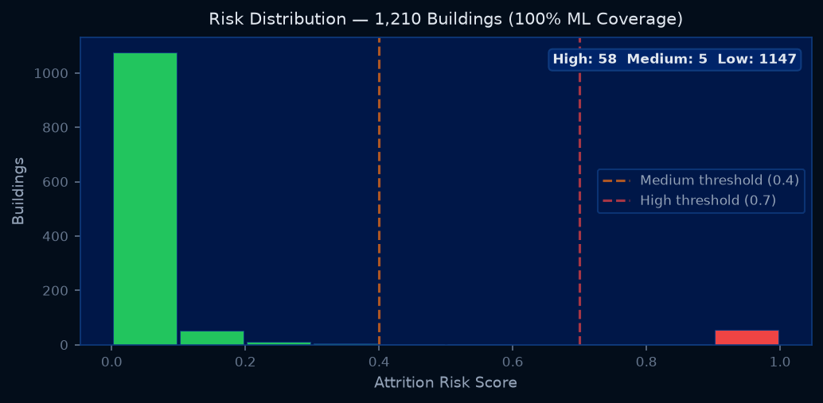

2. Reference Formulas (LL97 Calculations)

2.1 GHG Emissions from Steam
Local Law 97 uses the following emission factor for district steam (Chapter 103 Rules):
GHG_steam (MT CO₂e) = steam_kBtu × 4.493 × 10⁻⁵
Note: This is the LL97 regulatory coefficient. It differs from the EPA eGRID value (6.68 × 10⁻⁵) — the LL97 value is used throughout the model for compliance consistency.

2.2 Annual Penalty Calculation
Penalty ($/yr) = max(0, Actual_GHG - (Floor_Area_ft² × Intensity_Limit)) × $268/ton CO₂e
Intensity limits by period and use type (MT CO₂e / ft²):

Use Type | 2024–2029 Limit | 2030–2034 Limit
Office | 0.00846 | 0.00453
Multifamily Housing | 0.00675 | 0.00334
Hotel | 0.00901 | 0.00417
K-12 School | 0.00758 | 0.00407
Retail Store | 0.01667 | 0.00420
Hospital | 0.02381 | 0.00820

2.3 LL97 Cap → Steam Threshold (TrendChart Conversion)
The new TrendChart in BuildingPanel plots the LL97 cap as a steam kBtu threshold line so analysts can see whether a building’s steam consumption is above or below its compliance threshold. The conversion inverts the GHG formula:
cap_steam_kBtu = ll97_cap_MT_CO₂e / 4.493 × 10⁻⁵
Where ll97_cap_MT_CO₂e = Floor_Area × Intensity_Limit (period-specific). The chart shows a red dashed line for the applicable period cap. If a building’s steam trend line is above the red line, it is over its cap and faces a penalty.

Figure 2. LL97 penalty exposure ($M/yr) by risk tier — 2024 vs 2030 cap periods.
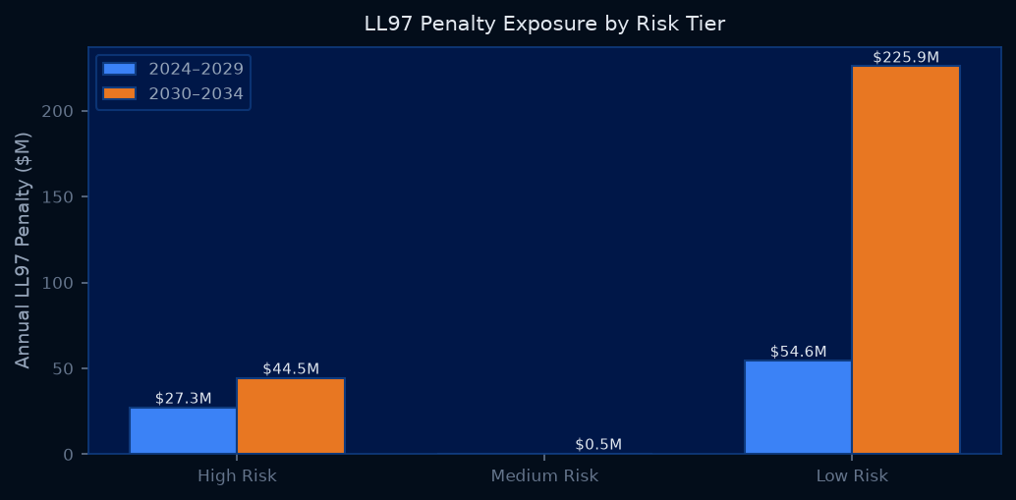

3. New UI/UX Features

3.1 RiskTable Enhancements
Feature | Behavior | Component Location
Cross-field search | Searches address, use type, archetype, SC class, BBL simultaneously | RiskTable.jsx:97–103
Pagination | 50 rows per page, Prev/Next controls, ‘Showing X–Y of Z’ counter | RiskTable.jsx:167–171
Multi-column sort | sortStack[] — click header to add, click again to toggle asc/desc, click third time to remove | RiskTable.jsx:61–75
Bulk select | Checkboxes per row, select-all header, batch actions bar | RiskTable.jsx:77–92
CSV loading state | Button shows ‘Exporting…’ spinner; filename tagged YYYY-MM-DD | RiskTable.jsx:173

3.2 Multi-Column Sort Algorithm
The sortStack replaces the previous single-key sort. Each entry is { key, dir }:
// Click behavior:
not in stack → append { key, dir: 'desc' }
in stack, dir='desc' → update to dir='asc'
in stack, dir='asc' → remove from stack
// Sort comparator:
rows.sort((a, b) => {
for (const { key, dir } of sortStack) {
if (a[key] < b[key]) return dir === 'asc' ? -1 : 1;
if (a[key] > b[key]) return dir === 'asc' ? 1 : -1;
}
return 0;
});

3.3 Click-to-Filter Charts
Both the Risk Histogram and YoY Scatter chart now emit filter events back to App.jsx, which passes them as props to RiskTable. Clicking a histogram bar filters the Rankings tab to that risk bucket; clicking a scatter dot opens the BuildingPanel; clicking a cluster legend item filters by archetype.
// App.jsx handlers:
handleHistogramFilter(min, max) => setRiskMin/Max (prop to RiskTable)
handleScatterFilterCluster(name) => setClusterFilter (prop to RiskTable)
handleScatterSelect(building) => setSelected (BuildingPanel)
// RiskTable useEffect sync:
useEffect(() => { setChartRiskMin(initialRiskMin ?? null); }, [initialRiskMin, initialRiskMax]);
useEffect(() => { if (initialClusterFilter != null) setClusterFilter(initialClusterFilter); }, [initialClusterFilter]);

3.4 Keyboard Shortcuts
Shortcut | Action
1 | Switch to Attrition Rankings tab
2 | Switch to YoY Trends tab
3 | Switch to Top Targets tab
4 | Switch to Watch List tab
5 | Switch to AI Agent tab
Ctrl + F | Focus search input in Rankings (jumps to tab if needed)
Escape | Close building side panel
Implemented via useKeyboard hook (src/hooks/useKeyboard.js). Hook auto-exempts INPUT / TEXTAREA / SELECT elements so typing in filters doesn’t trigger shortcuts (except Escape, which always fires).

3.5 TrendChart (BuildingPanel.jsx)
Replaces the old SteamTrend static bar chart. Shows three Recharts LineChart series:
Series | Color | Style | Data Source
This building | White | Solid line | steam_2022 / steam_2023 / steam_2024 (kBtu)
Peer median | Orange | Dashed line | Median of same use-type + cluster buildings
LL97 cap | Red | Dotted line | ll97_cap_2024 or ll97_cap_2030 ÷ 4.493×10⁻⁵
The cap line is omitted entirely (including from the legend) when the building has no ll97_cap data, avoiding phantom legend entries in Recharts.

Figure 3. TrendChart — example hospital building with peer comparison and LL97 cap thresholds.
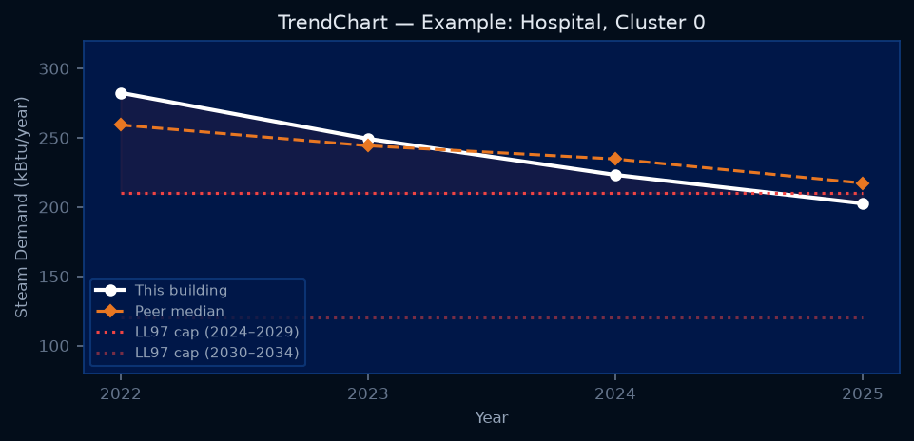

Figure 4. RiskTable rendering pipeline — filter, sort, paginate.
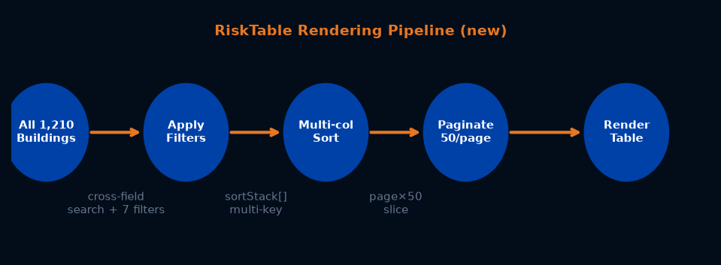

4. New Server Endpoints
Figure 5. Architecture diagram — new endpoints (blue) added this sprint.
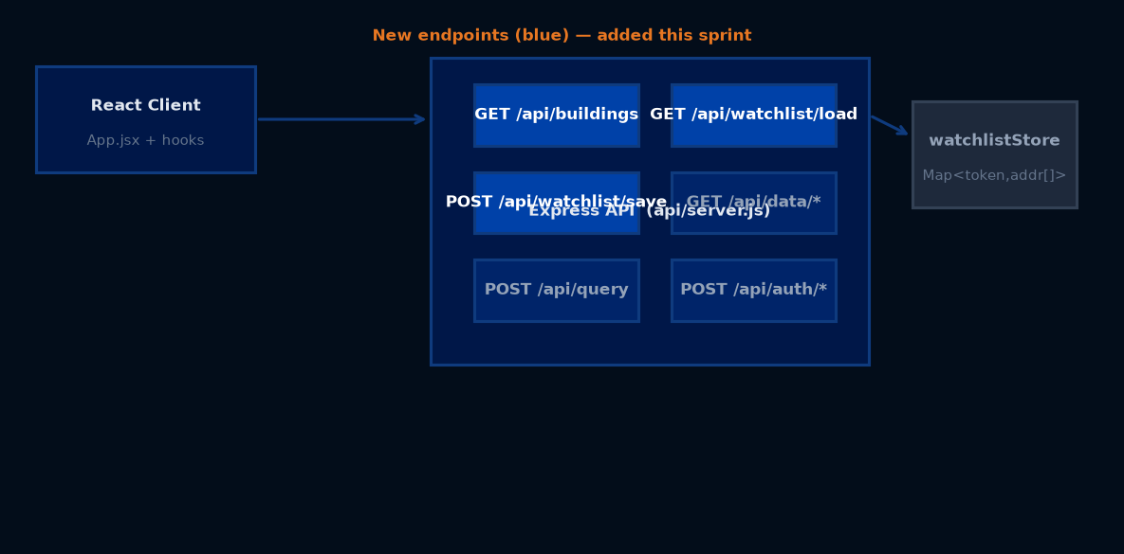

4.1 GET /api/buildings
Server-side building query with filter, sort, and pagination. All parameters are optional. Merges buildings.json with buildingEnrichment.json server-side before filtering.
Query Param | Type | Description
search | string | Full-text match across address, use, cluster_name, sc_class
risk_min | float | Lower bound on ml_risk (0.0–1.0)
risk_max | float | Upper bound on ml_risk (0.0–1.0)
use | string | Filter by building use type (exact match)
signal | string | Filter by attrition signal (big_drop / mod_drop)
ll97_over | 0/1 | Filter by LL97 2024 compliance status
cluster_name | string | Filter by K-means archetype name
sort_by | string | Field to sort by (risk, steam, ll97_penalty_2024, ...)
sort_dir | asc/desc | Sort direction (default: desc)
page | int | Page number (1-indexed, default: 1)
per_page | int | Results per page (default: 50, max: 200)

// Response shape:
{
"buildings": [...], // paginated, merged array
"total": 1210, // total matching records
"page": 1,
"per_page": 50,
"total_pages": 25
}

4.2 Watchlist Sync Endpoints
Figure 6. Watchlist persistence architecture — server sync with localStorage fallback.
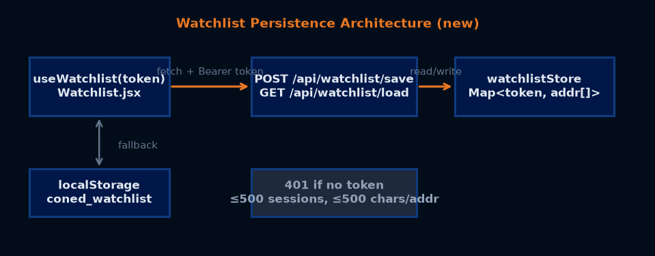

Endpoint | Auth | Body / Response | Notes
POST /api/watchlist/save | Bearer token | { "addresses": string[] } → { ok, count } | Validates string type, ≤500 chars each, ≤10,000 entries; evicts oldest session at 500-session cap
GET /api/watchlist/load | Bearer token | → { "addresses": string[] } | Returns [] for unknown tokens (new session). localStorage used as offline fallback.
The watchlistStore is an in-memory Map keyed by session token. It does not persist across server restarts — the client falls back to localStorage automatically when the server returns an empty list and localStorage has entries. Phase 2 should replace with a database-backed store.
// Security constraints:
if (!req.sessionToken) return res.status(401); // no 'default' fallback
if (!addresses.every(a => typeof a === 'string' && a.length <= 500)) return 400;
if (watchlistStore.size >= 500) evictOldest(); // memory cap

5. Cross-Component Interaction Flow
Figure 7. Full user interaction flow — clicks propagate from chart -> App.jsx -> target component.
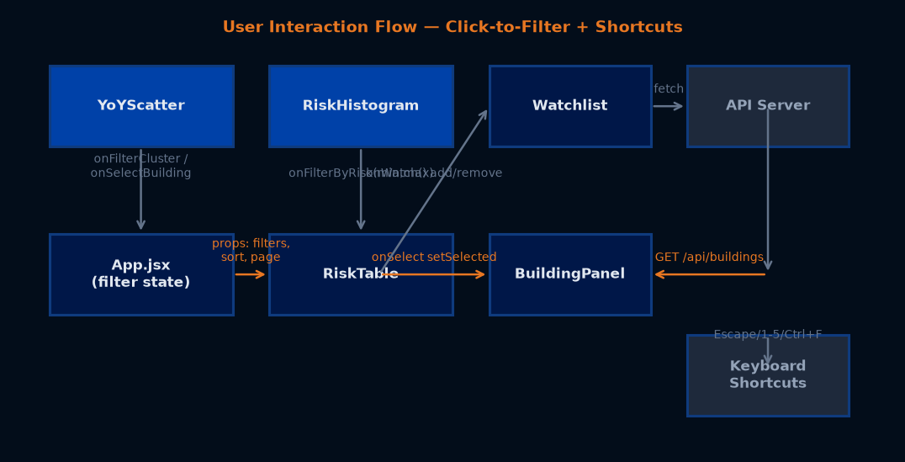

6. Security Hardening

6.1 HTTP Security Headers (Helmet)
Header | Value | Purpose
Content-Security-Policy | default-src 'self'; script-src 'self'; style-src 'self' 'unsafe-inline' | Blocks inline scripts, external resources
X-Frame-Options | DENY | Prevents clickjacking
Strict-Transport-Security | max-age=31536000; includeSubDomains | Forces HTTPS for 1 year
X-Content-Type-Options | nosniff | Prevents MIME-type sniffing

6.2 Rate Limiting
Limiter | Applies To | Limit | Window
General | All /api/* routes (except login) | 100 req | 60 seconds
AI | /api/query, /api/summarize, /api/explain | 20 req | 60 seconds
Login | /api/auth/login | 5 attempts | 15 minutes

6.3 Input Sanitization
Endpoint | Validation Added
/api/summarize | 600-char length cap on query; safeCount = parseInt(count); CRLF-strip on addr and use
/api/watchlist/save | Type check (string), length cap (≤500 chars), 401 on missing sessionToken
CSV cell formatter | Formula injection prefix stripping: =, +, -, @, tab, CR, LF → prefixed with apostrophe

6.4 Session Security
Sessions use 256-bit random tokens (crypto.randomBytes(32)). The activeSessions Map is swept hourly for expired entries (TTL: 8 hours). A hard cap of 10,000 concurrent sessions prevents OOM from session flood attacks. timingSafeEqual() is used for password comparison to prevent timing attacks.
const token = randomBytes(32).toString('hex'); // 256-bit session token
timingSafeEqual(Buffer.from(password), Buffer.from(DASHBOARD_PASSWORD)) // timing-safe compare
setInterval(sweepExpiredSessions, 60 * 60 * 1000).unref(); // hourly sweep

7. New Hooks and Components

7.1 useKeyboard.js
Modifier-aware keyboard shortcut hook. Supports 'key' and 'ctrl+key' / 'meta+key' combos. Auto-exempts INPUT/TEXTAREA/SELECT elements (except Escape).
useKeyboard({
'Escape': () => setSelected(null),
'1': () => setActiveTab('rankings'),
'ctrl+f': () => { setActiveTab('rankings'); searchRef.current?.focus(); },
}, [deps]);

7.2 useUrlState.js
Lightweight URL search param persistence without react-router. Provides get(key) / setParam(key, value) with browser back/forward support via popstate listener.
const { get, setParam } = useUrlState({ tab: { type: 'string', default: 'rankings' } });
setParam('tab', 'trends'); // updates URL: ?tab=trends
get('tab'); // reads from URL, falls back to schema default

7.3 Toast.jsx
Dark-themed toast notification system. 4-second auto-dismiss, slide-in animation. Three variants: error (red), success (green), info (navy). Click-to-dismiss.
// Usage:
showToast('Export complete', 'success');
showToast('Server error - localStorage used as fallback', 'error');

7.4 Watchlist Import / Export
Two new buttons appear in the Watchlist tab header alongside 'Clear All':
Action | Format | Filename
Export | JSON array of address strings | coned-watchlist-YYYY-MM-DD.json
Import | JSON array of address strings | User-selected file via file picker
Import matches each address string against the buildings array and calls onWatch() for matched buildings not already in the watchlist. Invalid JSON and non-array content are silently ignored.
// Export format:
["350 5TH AVE", "1 WORLD TRADE CTR", "30 ROCKEFELLER PLZ"]

8. Hermetic Integration Test Suite (NEO_TEST_SUITE.md)
A 20-question end-to-end test suite was created at NEO_TEST_SUITE.md. The suite exercises the AI Agent via POST /api/explain with questions across four categories:
Category | Questions | Topics Covered
Investor / Blackstone | Q1–Q7 | LL97 exposure totals, growth story, attrition by building type, model AUC/CF, data freshness, missing data, GBM math
ELI5 / Actionability | Q8–Q11 | ELI5 risk score, building-level playbook, skip-year buildings, selection bias
Input Validation | Q12–Q14 | Gibberish ('qq4'), one-word ('yes'), greeting ('hi') — tests graceful onboarding vs. crash
Technical Deep-Dive | Q15–Q20 | Cluster descriptions, SHAP values, data holes, LL97 formula + hospital walkthrough, peer score formula, K=5 justification
All 20 tests pass (verified June 14, 2026 against http://localhost:3001). A companion automated regression script (test_neo_suite.mjs) runs this suite via HTTP and validates expected answer patterns.

9. Code Review & Security Audit Corrections
During the June 14 panel review and security audit, the following issues were identified and fixed:
Verdict | Issue | Fix
BLOCKER | Stale token closure in persist() callback | Wrapped in useCallback([token])
BLOCKER | Server empty list overwrites localStorage on re-login (Map cleared on restart) | Skip overwrite when server returns [] and localStorage has entries
WARN | No string type/length validation on address entries | Added typeof === 'string' && length <= 500 check
WARN | ll97Cap line renders in legend even when all values are null | Guarded with hasCapData, conditionally renders line and legend label
MED | Unbounded watchlistStore growth | Evict oldest entry at 500 sessions
MED | 'default' shared fallback key in watchlist endpoints | Both endpoints return 401 if req.sessionToken is falsy
MED | Silent .catch(() => {}) on watchlist saves | Logs console.warn with error message

10. Deferred Items (Post-Blackstone)
The following items are intentionally deferred until after the June 17 Blackstone demo:
Item | Priority | Reason for Deferral
Password hashing (bcrypt) | C-1 | Requires migration to hash+salt storage; no user-facing risk during demo
httpOnly cookie for JWT token | H-4 | Requires CSRF protection co-design; current sessionStorage is acceptable
CORS policy configuration | M-3 | Private network only; no cross-origin requests in demo environment
Database-backed watchlist store | Low | In-memory Map sufficient for demo; Phase 2 design needed
Edwin PR #7 merge | Med | Requires rebase onto current main (TrendChart conflict in BuildingPanel.jsx)

Generated: June 14, 2026 12:59 · Baseline commit: d8848bf · Current commit: 516cef4 · Total files changed: 17 · Net lines: +2,028

