EdgeAnalytics

Network Observability PRD

Author: Pamela Cassan
Last Edit Date: May 24, 2026
Status: Draft
Table of Contents
2 Executive Summary 5
2.1 Key Value Propositions 5
3 Product Overview & Goals 5
3.1 Product Positioning 5
3.2 Navigation 5
3.3 Upgrade Path 6
4 User Roles & Access Control 6
4.1 Eligible Roles 6
4.2 MSSP roles – Tenant Roles 6
4.3 Per-User Service Permissions 6
4.4 Admin UI Changes 7
5 Technical Requirements 7
5.1 Time Range Selector 7
6 System Administration 8
6.1 Snapshots & Restore 8
6.2 Backups 9
6.3 Software Upgrades 9
7 ASN Path Analysis 9
7.1 Page Layout 9
7.2 Stage Filters 10
7.2.1 Stage Visibility 10
7.3 Sankey Diagram 10
7.3.1 Tooltips 11
7.3.2 Click Interactions 11
7.3.3 PNG Download 11
7.4 ASN Path Analysis Table 11
7.5 My ASN Popup 12
7.5.1 Left Panel: Tree Topology 12
7.5.2 Other elements 12
7.5.3 Tab 1: Routers & Interfaces (Sunburst) 12
7.5.4 Tab 2: Traffic 14
7.6 Flow Popup 15
7.6.1 General KPIs 15
7.6.2 Traffic per Protocol 16
7.6.3 Top 10 Applications 16
8 Queries & Dashboards 16
8.1 Widget Model 16
8.2 My Dashboards 16
8.2.1 Dashboard Header 17
8.2.2 Widget Selector pop-up or Dashboard Edit 17
8.2.3 Widget Cards on the Dashboard 19
8.2.4 New Dashboard/Edit dashboard/Clone Dashboard 19
8.2.5 Open in New Tab 20
8.2.6 Dashboard Delete 20
8.2.7 Dashboard Persistence 20
8.3 Queries & Widgets 20
8.3.1 Top Header 20
8.3.2 List Panel (Left) 21
8.3.3 Preview Panel 21
8.3.4 Queries & Widgets Pop-ups 22
8.3.5 Popup Close Behavior 24
8.4 SQL Query Language 24
8.4.1 SQL Syntax Highlighting 25
8.4.2 SQL Auto-Complete 25
8.4.3 SQL Column Names 25
8.4.4 AI SQL Query Assistant 28
8.4.5 Chart Recommendation Engine 28
8.4.6 Widget Configuration 29
9 Export & Reporting 38
9.1 Per-Chart Export 38
9.2 Page-Level Export 38
10 Appendix 38
10.1 Out of Scope 38

Executive Summary
EdgeAnalytics is an add-on platform for EdgeProtect customers that provides deep visibility into network traffic distribution and health. It enables network operators to monitor traffic flows between origins and destinations, analyze ASN-level path data, and build custom dashboards using SQL queries with AI-assisted natural language generation.
To start, the platform has two main functional areas: Network Observability that does ASN Path Analysis (interactive Sankey-based flow visualization), Queries and Dashboards (SQL-based analytics with multi-widget visualizations, intelligent chart type recommendations, an AI query assistant, and a drag-and-drop dashboard builder).
A defining feature of the Queries & Dashboards module is the multi-widget model: a single SQL query can produce any number of named, independently configured visualizations called widgets. Each widget specifies its own chart type and configuration. Dashboards are assembled by selecting widgets (not queries) allowing multiple representations of the same underlying data to coexist on a single dashboard.

Key Value Propositions
- Bridge the observability gap with competitors (e.g., Arbor)
- Allow operators to monitor traffic distribution and health in real time
- Enable one query to drive multiple chart types e.g., the same traffic data rendered as a time series, a bar chart, or a heatmap simultaneously on the same dashboard
- Provide SQL-based queries with AI-assisted natural language generation and intelligent chart type recommendations
- Enable multi-screen control room setups via shareable dashboard tabs

Product Overview & Goals

Product Positioning
EdgeAnalytics is a separate product that can be sold independently or bundled with EdgeProtect. Both products share the same UI shell (navigation, clock area, account profile) but can be purchased in any order. Users see both tool tabs when subscribed to both.

Navigation
EdgeAnalytics appears as a top level tab alongside EdgeProtect. Users with both licenses switch between them via the top navigation bar. The left sidebar within EdgeAnalytics contains section icons. Network Observability are the primary available sections composed by: ASN Path Analysis, My Dashboards, My Queries. Future releases will add sections such as Network Assurance, Capacity planning or Alerts.
Tooltips with the following text should be shown on each respective icon: ASN Path Analysis, My Dashboards, My Queries.

Upgrade Path
EdgeProtect users who have not purchased EdgeAnalytics will see the EdgeAnalytics tab with a lock icon, greyed out. Clicking it opens a popup prompting the user to contact customer support for a license upgrade, consistent with the existing license-upgrade flow.

User Roles & Access Control

Eligible Roles
The following EdgeProtect roles can be granted access to EdgeAnalytics:
Role | Access Level | Notes
Admin | Full access | Can enable EdgeAnalytics per user and assign service permissions
Super Operator | Full access | Can manage all EdgeAnalytics settings and users
Operator | Configurable | Access granted per service (see Section 3.2)
Analyst | Read-only | Can view dashboards and query results; cannot create or edit

MSSP roles – Tenant Roles
EdgeAnalytics supports MSSP with its liscence.
MSSP roles would behave as MSSP in EdgeProtect. Allowing only the Operator’s network data to be feed into the system and not all of the ISP network data.
Same tenant roles as EdgeProtect:
- Tenant Admin: edit + add or remove users
- Tenant SuperOperator: edit
- Tenant analyst: view
- Tenant user: no rights

Per-User Service Permissions
When an Admin enables EdgeAnalytics for a user, they select which services the user can access via checkboxes:
- ASN Path Analysis
- My Queries & Widgets
- My Dashboards

Admin UI Changes
In Settings > Authentication Management > Internal Keycloak, the user creation/edit form includes an "EdgeAnalytics" toggle. When enabled, a checkbox list of services appears. Non-admins without EdgeAnalytics access see EdgeProtect as if it were the only tool, without the EdgeAnalytics top navigation icon.
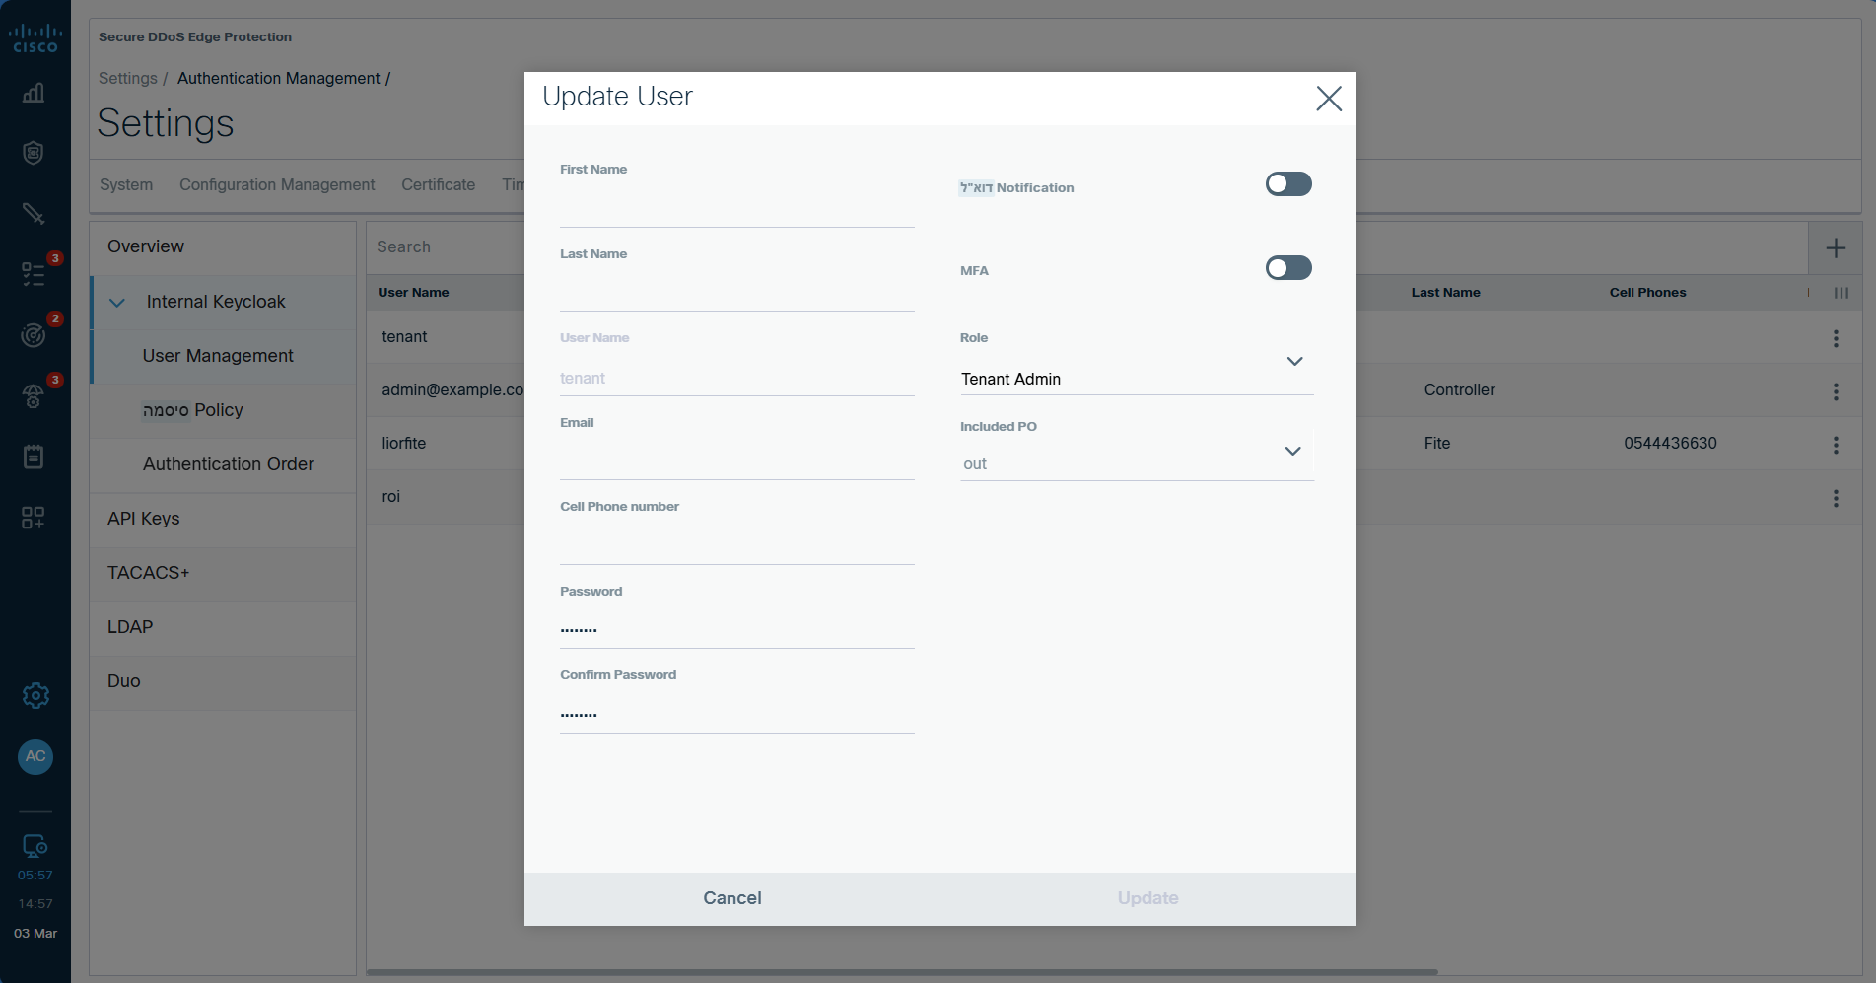Figure 1: Current Update user pop-up. Need to add EdgeAnalytics toggle with the sub-sections toggles

Technical Requirements

Time Range Selector
A time range selector is present on every screen that displays data (ASN Path Analysis, Query Dashboard, My Queries widget preview, Query Editor). Available presets:
- Last 1 hour (default)
- Last day
- Last 3 days
- Last 7 days
- Last 30 days
- Custom range (date/time pickers)

System Administration

Snapshots & Restore
Users must be able to restore EdgeAnalytics configuration without re-creating queries, dashboards, or widgets. Snapshots include:
- All dashboards and their widget layouts
- ASN Path Analysis configuration
- All saved queries and drafts, including all named widgets associated with each query
UI: Inside Configuration Management, two tabs are available: EdgeProtect and EdgeAnalytics. The EdgeAnalytics tab follows the same snapshot and restore flow as EdgeProtect.
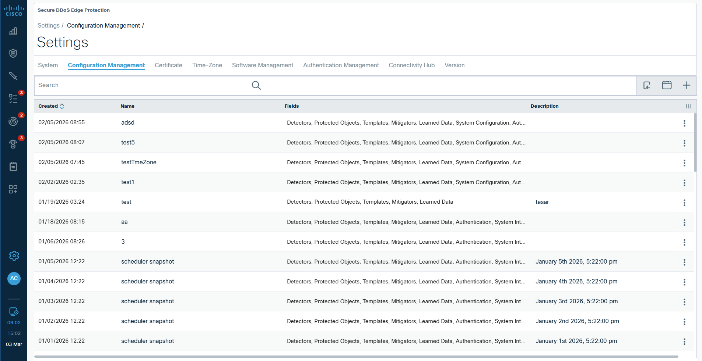
Figure 2: Current Configuration Management Update user pop-up. Need to add EdgeAnalytics tab
Columns and look and field of the table are the same as for EdgeProtect
Snapshot fields:
- Observability
- ASN Path Analysis
- My Queries
- My Dashboards
- System Configuration
- Authorization
- System Integrations
- Users
Each snapshot field supports Replace or Append restore actions.
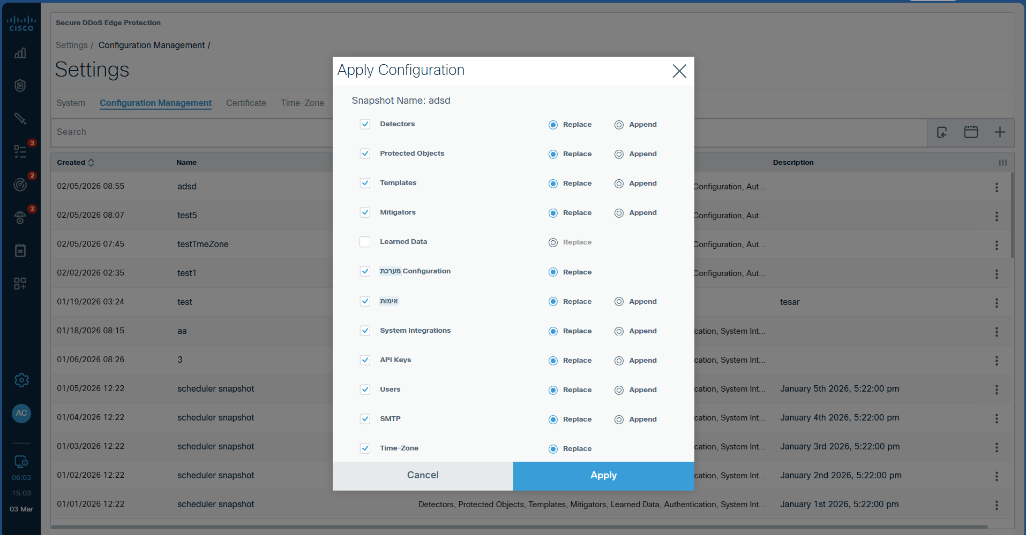
Figure 3: Current Configuration Management Snapshots fields. Need to do one like this for EdgeAnalytics fields

Backups
Clients are recommended to maintain their own redundant, high-availability storage for backups. Both system-initiated and user-initiated backups should be supported. Retention follows a FIFO (first-in, first-out) policy.

Software Upgrades
In Settings > Software Management > Configuration Management. Upgrades follow the same flow as Controller upgrades (paste a package link from Cisco). EdgeAnalytics packages can be issued and applied independently from EdgeProtect upgrades. Revert and rollback procedures are identical to the EdgeProtect upgrade flow.
Links from Cisco can be for EdgeProtect and EdgeAnalytics together or separate.

ASN Path Analysis
ASN Path Analysis allows network operators to visualize traffic flows across ASNs using an interactive Sankey diagram. Users can drill into individual ASNs and flows via click-through popups.

Page Layout
The ASN Path Analysis page contains:
- Stage Filters (top): filter which ASN stages are displayed
- Time Range Selector (top right)
- Page-level Export button (top right, dropdown): PDF / HTML / CSV / JSON
- Sankey Diagram (main area)
- ASN Path Analysis Table (below the Sankey)

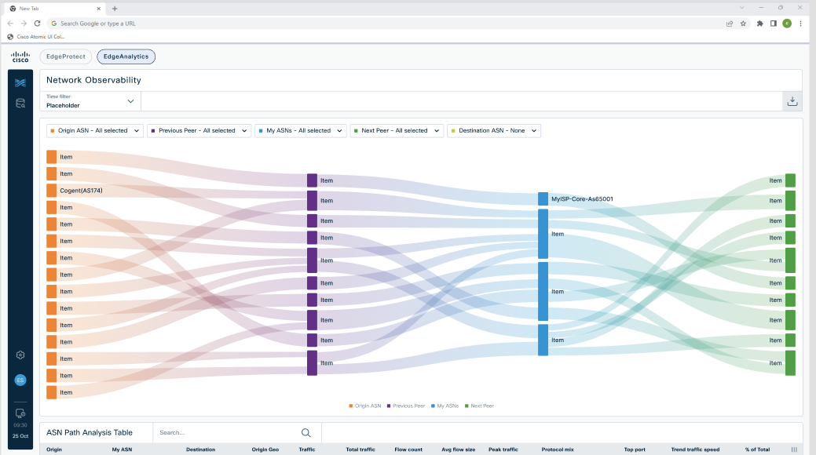
Figure 4: ASN path Analysis tab – UI still needs some changes

Stage Filters
The user selects which stages to display in the Sankey. Stages appear in a fixed left-to-right order: Origin, Previous Peer, My ASN, Next Peer, Destination.
- Minimum selection: 2 stages. Maximum: all 5 stages.
- Each stage has a dropdown with search by ASN Name or ASN ID.
  - User can select ALL, or choose specific ASNs within each stage.

Stage Visibility
Unchecking a stage from the legend removes its column from the Sankey diagram; the remaining stages expand to fill the available width. Re-checking a stage restores it. A minimum of 2 stages must remain checked at all times.

Sankey Diagram
The Sankey has two visual elements:
- ASN Nodes: rectangles representing individual ASNs, color-coded by stage
- Flows: thick lines between ASN nodes, width proportional to traffic volume, rendered with a source-to-destination color gradient

Tooltips
Hovering over an ASN node shows:
- Header: ASN Name (ASN Number)
- Traffic: Total Gbps (note: Total In= Total Out)
- Country, State, City: Country of the ASN, State of the ASN, City of the ASN
- In Flows: Number of flows going in (hidden for the first stage)
- Out Flows: Number of flows going out (hidden for the last stage)
Hovering over a flow shows:
- Header: Origin ASN Name (Number) → Destination ASN Name (Number)
- Traffic: Total Gbps of the flow
- Top Protocol: e.g., TCP
- Top Application: Port number and name (e.g., HTTPS: 443)

Click Interactions
The cursor changes to a pointer over clickable elements:
- "My ASN" nodes à open the My ASN Popup
- “Flows” à open the Flow Popup

PNG Download
A small download icon (only showing when the mouse is over the diagram) on the Sankey chart allows the user to download the current diagram as a PNG image. It appears only when the mouse is on top of the ASN Path Analysis diagram (this same logic will be used to download as PNG all of the widgets)

ASN Path Analysis Table
ASN Path Analysis Table consist of the following columns. All of them follow the same logic as EdgeProtect.
ASN Path analysis Table has a general search bar in which the user can search any ASN ID, ASN Name, Geo ( Country, State or City), protocol or Port (either by name or number) and the relevant rows will show up filtered.
The table values depend on the time filter selected at the top of the screen, and they will be calculated for that particular period.
- Columns that allow Filtering:
- Origin: Origin ASN Name and ASN ID (in small greyed out)
- My ASN: Name of my ASN and ASN ID (in small greyed out)
- Destination: Destination ASN Name and ASN ID (in small greyed out)
- Origin Geo: Origin Country, City Name (in small greyed out
- Destination Geo: Destination Country, City Name (in small greyed out)
- Protocol Mix: Protocol breakdown (e.g. 68% TCP, 28% UDP, 4% Other)
- Top Port: Most used port on that path (e.g. 72% 443:HTTPS)

- Columns that allow sorting:
- Traffic: In Gbps
- Traffic Variation: in % with + or – The trend value is calculated comparing the average traffic value of the current time filter vs the previous traffic value for the same amount of time.
- Total Traffic: in TB
- Peak Traffic: in Gbps
- % of Total Traffic: this particular path share of the total traffic of the time period chosen
- Flow Count: (number)
- Average Flow Size: in MB

My ASN Popup
Opens when clicking any "My ASN" node. The screen behind is shaded semi-transparent. Closes via the X button or clicking outside the popup.

Left Panel: Tree Topology
A hierarchical tree showing: My ASN > Routers > Interfaces. Clicking any level updates all tabs on the right side.
- Columns of the hierarchical tree: Name — Code/ID — Traffic (Gbps/PPS (depending on selection) — % of total traffic of the ASN
- Search bar to find routers/interfaces by name
- Tree selection is persistent across tabs

Other elements
- Download icon as Json, CSV, Html or PDF: only of the graphs and data the user is seeing (current tab)
- Toggle: Inbound / Outbound (default: Inbound)
- BPS/PPS toggle
- Time Range Selector in the header (affects the tree and all tabs)

Tab 1: Routers & Interfaces (Sunburst)
A sunburst chart with sub-tabs for Inbound and Outbound.
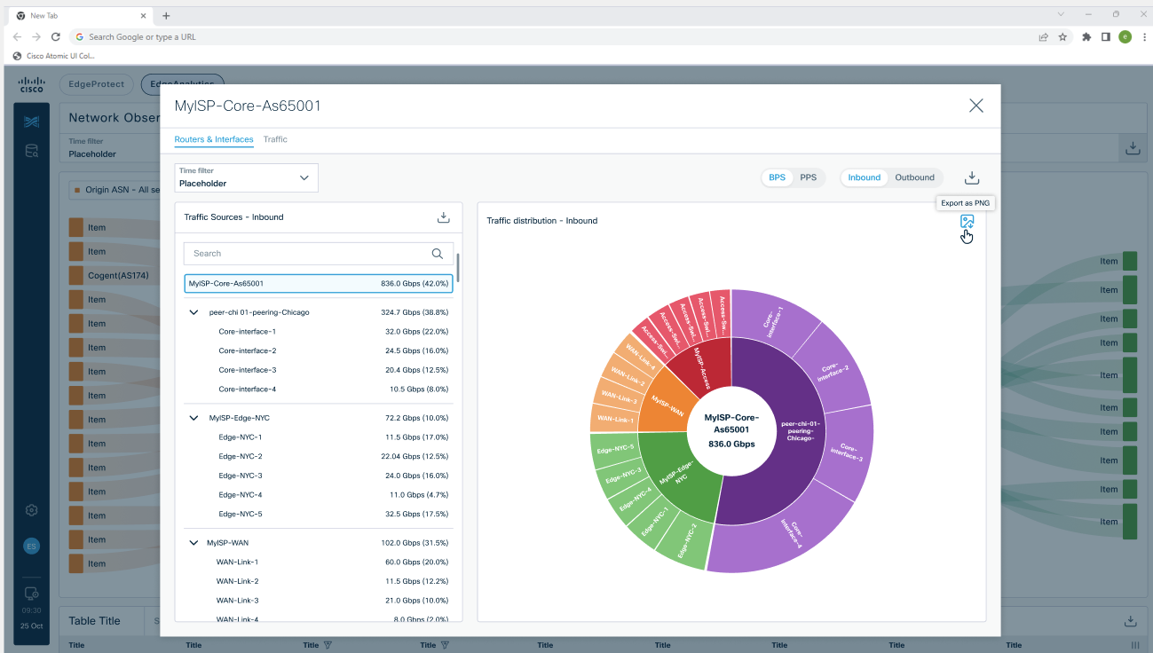
Figure 5: My ASN pop-up: first view the user sees when clicking on an ASN within My ASNs is Routers and Interfaces tab
When viewing from the ASN level (3 concentric rings):
- Center: My ASN name + total Gbps
- 1st ring: Routers (name)
- 2nd ring: Interfaces (name)
Clicking a router zooms in to 2 rings (center: router name + Gbps; ring: interfaces). Clicking the center zooms back out. Clicking an interface shows a single full circle for that interface.
Hovering over a segment will highlight and give the following information:
- Name
- Traffic: %Gbps
- BPS: in Gbps
- PPS: in pps
IMPORTANT NOTE: data when hovering will be always based on the ring the value is at and its previous level. For example:
- Interface values when the main circle is my ASN will be the % based on the whole ASN traffic
- But Interface values when the main circle is its router will be the % based on the Router’s traffic

PNG download icon on the chart hovering as in all EdgeAnalytics

Tab 2: Traffic
This area shows 3 graphs with a scroll at the “level” selected on the tree topology.
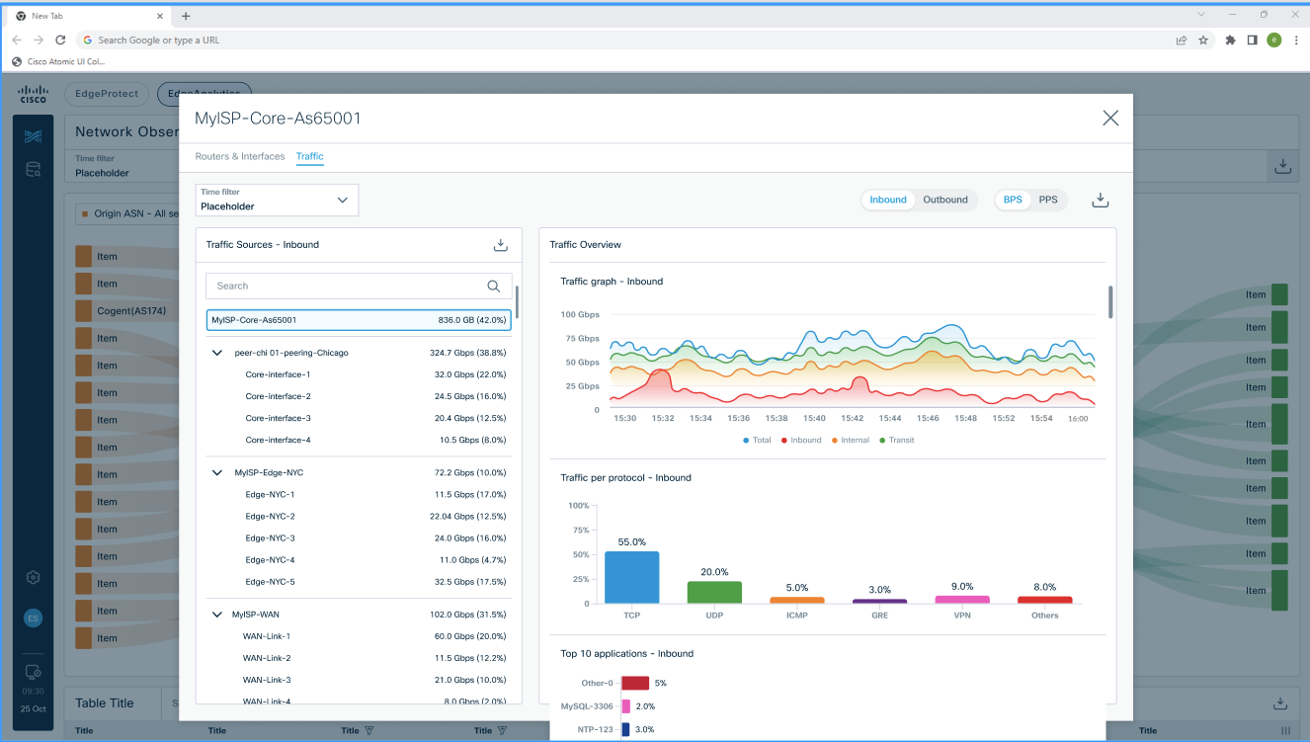
Figure 6: My ASN pop-up: Traffic tab displays 3 graphs. Need proper UI mok-up with the proper scroll

Top graph: Traffic (Time Series)
A stacked area time series chart. Toggle: Gbps / pps and Inbound/Outbound. Series depend on the tree selection:
- ASN selected: total ASN traffic à ASN-level series
- Router selected: total router traffic à Router-level series
- Interface selected: total interface traffic à Interface-level series
- PNG download icon on the charts as defined

Middle graph: Traffic per Protocol (Bar Chart)
A vertical bar chart showing traffic distribution by protocol.
- Legend: TCP, UDP, ICMP, GRE, VPN, Others
- Vertical axis: selection from the togle (bps or pps)
- On top of each bar %
- Tooltip on hover: traffic value (bps/pps) + percentage
- PNG download icon on the chart.

Bottom graph: Top 10 Applications (Bar Chart)
A horizontal bar chart of the top 10 applications by TCP/UDP port (IANA).
- Legend by application name (e.g., HTTPS/443, HTTP/80, DNS/53, SSH/22, BitTorrent/6881)
- Horizontal axis: selection from the togle (bps or pps)
- On the side of each bar %
- Tooltip on hover: name, traffic (bps/pps)+ percentage
- PNG download icon on the chart.

Flow Popup
Opens when clicking any flow on the Sankey diagram. Closes via X or clicking outside. Header: ASN Name (ID) → ASN Name (ID).
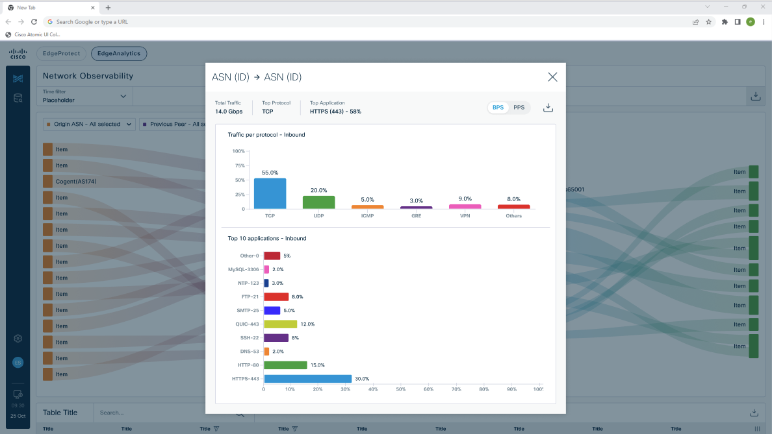
Figure 7: Flow Pop-up shown when clicking on a Sankey diagram
General buttons:
- BPS/PPS
- Download icon: Json, CSV, Html, PDF

General KPIs
On the top of the screen the pop-up shows a general section displaying:
- Total Traffic: total traffic of the flow for the period of time selected in the Sankey diagram in Gbps
- Top protocol: TCP, UDP, etc.
- Top application: e.g: HTTP(443)

Traffic per Protocol
Bar chart identical to the Section Traffic Per Protocol of My ASN Pop-up but scoped to this specific flow. Toggles: Inbound / Outbound and bps / pps. PNG download icon.

Top 10 Applications
Bar chart identical to Section Top 10 Applications of My ASN Pop-upbut scoped to this specific flow. PNG download icon.

Queries & Dashboards
The Queries section allows users to create custom visualizations (widgets) using SQL queries (ClickHouse-compatible) and organize them into dashboards in the Dashboard section. The module has two views: Query Dashboard and My Queries. An AI-powered natural language assistant helps users generate SQL from plain English descriptions.

Widget Model
The Queries & Dashboards modules are built around three layers:
- Queries: SQL scripts that retrieve and aggregate network flow data. Each query is a first-class saved object in the query library, independent of any dashboard.
- Widgets: Named visualizations attached to a query. Each widget specifies a chart type (e.g., time series, bar, pie) and its chart configuration (axis mappings, groupings, thresholds). A single query can have any number of widgets, each presenting the same underlying data (programmed in the query) in a different visual format.
- Dashboards: Collections of widget panels arranged on a resizable, drag-and-drop grid. A dashboard may contain widgets from multiple queries, and multiple widgets from the same query.
This model decouples data retrieval from visualization. Editing a query's SQL automatically propagates to all widgets derived from it and to all dashboard panels that reference those widgets. The same query can simultaneously power a time series panel and a bar chart panel on the same dashboard.
Edgecase: if while updating a query the user for example removes a column that it’s being used in a widget and/or in a widget inside the dashboard then the widget will show everywhere it exists a message such as: No data – update query. This also will happen if the widget comes from a query that is set as “private”

My Dashboards
A drag-and-drop, resizable grid where users compose dashboards from saved widgets. Users can arrange panels freely and resize them to build custom monitoring layouts.
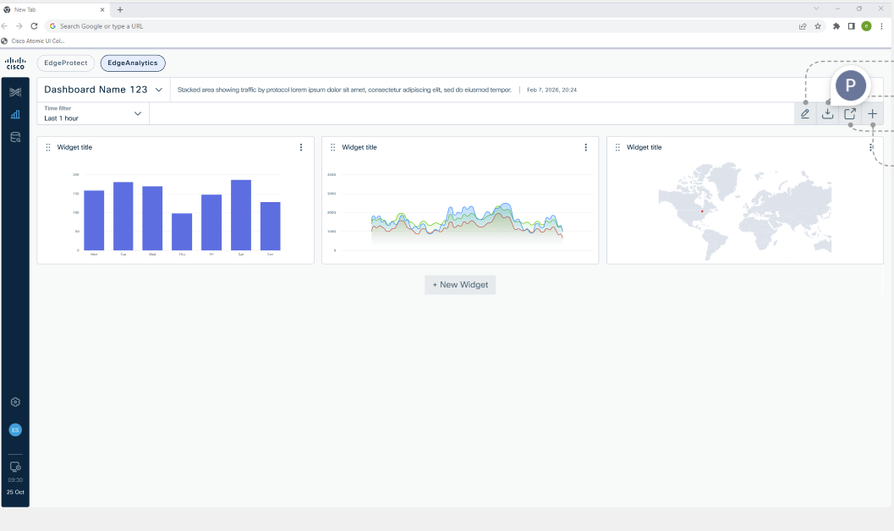
Figure 8: My Dashboards – WIP screen

Dashboard Header
- Dashboard name
- Actions possible in the dashboard:
- Edit
- Download (PDF, HTML, CSV, Json, PNG)
- Open in a new tab
- Delete
- New dashboard
- Delete button opens a pop up: Are you sure you want to delete this dashboard? Yes/No
- Dashboard selector dropdown: switch between saved dashboards (search feature included)
- Time Range Selector: applies to all widgets in the dashboard

Widget Selector pop-up or Dashboard Edit
Creating a new dashboard or editing an existing one will open the Widget selector pop-up.
Clicking "+ " opens the Widget Selector popup. This popup displays all named widgets available across all saved (non-draft) queries and allows the user to select one or more widgets to add to the dashboard.
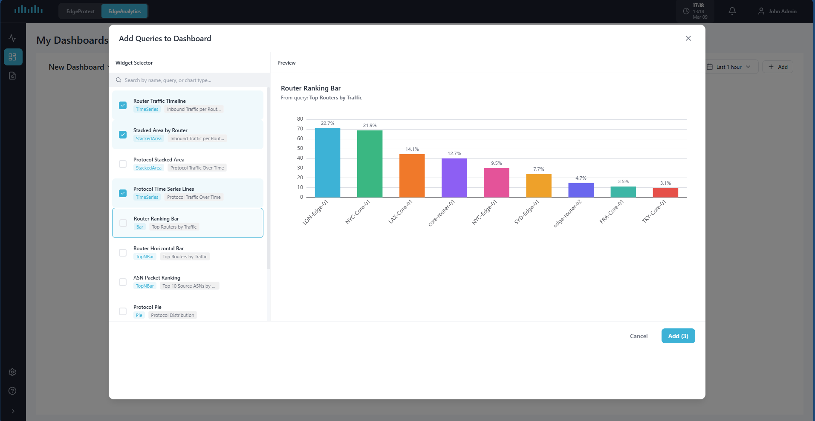
Figure 9: My Dashboards – Widget Selector – Screenshot from prototype, need UI
Left panel à Widget list:
- Header: "Widget Selector"
- Search bar: filters the widget list in real time by widget name, parent query name, or chart type
- Result count indicator (e.g., "3 of 12") visible when a search term is active
- Scrollable list of widgets: each row shows a checkbox, the widget name, a chart type badge (e.g., "timeSeries", "bar"), and a parent query name tag (North America Query) identifying which query the widget belongs to
- When moving the mouse over each widget in the list there will be a preview available
- Multi-select: multiple widgets can be checked simultaneously
- Empty state when no widgets exist: "No widgets available. Open a query in My Queries and save widgets to it first."
- Empty state when search yields no results: "No widgets match your search."
Right panel à Widget selector
- All the widgets selected will be displayed here in a scrollable way
Footer:
- Cancel button
- Add (N) button: adds all checked widgets to the dashboard; disabled when no widgets are checked
- Clicking outside the popup acts as Cancel

Toggle to make Private/Public the dashboard

Widget Cards on the Dashboard
Each widget on the dashboard is displayed as a card:
- Header: widget name
- Body: the chart rendered at the widget's current grid size
Widget card controls:
- Drag handle: repositions the widget on the grid
- Resize handle (bottom-right corner): the widget resizes automatically until the minimum possible by the chart type to allow minimum visibility
- PNG download icon downloads the chart as a PNG image as in the rest of observability. Icon only shows when hovering over the widget
- Three-dot menu: Edit Query (opens the query editor; saving updates the query and all its widgets), Remove (removes the widget from the dashboard without deleting the underlying query or widget definition)

New Dashboard/Edit dashboard/Clone Dashboard
They will essentially show the same pop-up with small modifications between them

New Dashboard:
- Top side:
  - Name: mandatory
  - Description: optional
- Left side: widget selector:
  - Search bar on top
  - Sort by:
    - Graph type
    - Query name
  - Widgets show widget name and tags: query name and graph type
- Right side:
  - List of widgets selected
- Cancel/Add(with the number of widgets in parenthesis).

Edit dashboard:
- Will be the same as above just with the possibility of change name and description and of de-select widgets or add more

Clone dashboard:
- Same as Edit but name and description will be empty for the user to add new ones.

Open in New Tab
Each saved dashboard has an "Open in New Tab" button. This enables control room setups where operators display multiple dashboards across separate browser tabs and screens. The new tab shows a full-screen view of the dashboard without editing controls.

Dashboard Delete
Users can delete a saved dashboard via the trash icon next to the dashboard name. A confirmation dialog appears: "Are you sure you want to delete [Dashboard Name]? This action cannot be undone. All widgets and layout configuration for this dashboard will be permanently removed." The dialog offers Cancel and Delete buttons. Deleting a dashboard does not delete the underlying queries or widget definitions.

Dashboard Persistence
All dashboards, their widget layouts, and the active dashboard selection are persisted to the browser's local Storage. Dashboards survive tab switches, page refreshes, and browser restarts. In production, this will be replaced with server-side storage (PostgreSQL).

Queries & Widgets
This is management interface for all user-created queries and widgets. The screen is split into three sections a list panel (left), the query panel ( top center) and a widget creation and preview panel (button center).
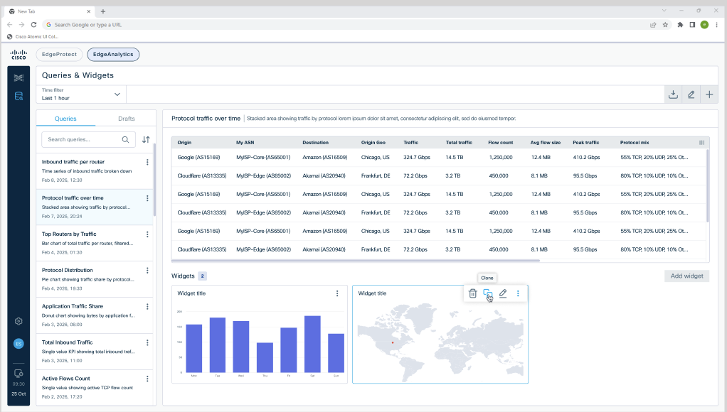
Figure 10: Queries & Widgets

Top Header
- "+ " button: opens the query editor popup for creating a new query
- Download icon: PNG, CSV, HTML, PDF
- Time selection on the left side

List Panel (Left)
Two tabs: Queries and Drafts. Both behave identically except:
- Draft queries are not available in the Widget Selector popup on the dashboard, UNLESS they are save as queries and appear in the query list
- Draft queries are only visible to the user who is creating them, even if the query toggle is set to public.
- Draft queries display a "Draft" badge.
Each query is shown as a card with: a name (with Draft badge if applicable), description (truncated when too long but visible in a tooltip when hovering), and last edited date/time.
List controls:
- Search bar: filters by name, description, chart type
- Sort: sort by Name
- Each query card has a three-dot action menu:
- Edit: opens the editor pop-up. The edit flow is the FULL one, first screen query editor with “save & next” and after clicking that it goes to the widget screen.
- Clone: opens the same flow as edit with the difference that the title and description are empty (title is a requirement for the user to fill) and we write “Clone Query”
- Delete: opens a confirmation dialog: "Are you sure you want to delete this query? This will delete also all of its widgets" with Cancel and Yes buttons.

Preview Panel
When a query is selected (single click), the preview panel shows:
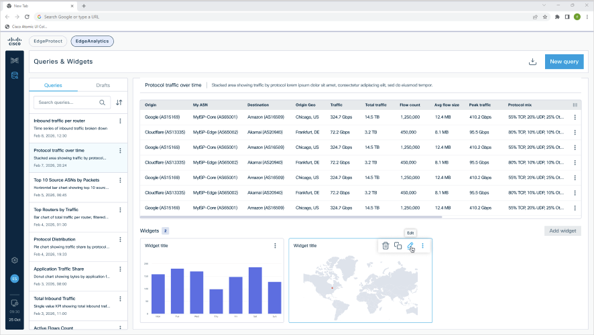
Figure 11: My Queries New Query or Edit Query Pop-up
- Query name (large heading) with Draft badge if applicable
- Description
- Last edited date and time
- Time Range Selector (top right): changing it updates all widget previews in this panel
The panel body is split into two sections, one top and one bottom:
- Top: Query table output
- Bottom: Widget grid: a card grid showing all named widgets for this query. Each card contains a header with the widget name and a mini chart preview. If the query has no widgets, the grid shows a placeholder: 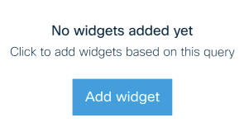
- Close to the widget name there will be a counter with the number of widgets available

Queries & Widgets Pop-ups

There are several distinct flows that will show in a pop-up:
- Creating a new query from scratch
- Widget creatin screen
- Editing a new query from the left panel
- Cloning a new query from the left panel
- Editing the query output
- Creating widgets (if there is no widget yet created)
- Editing a specific widget
- Cloning a specific widget

Creating a new query from scratch
This is the first flow the user will encounter. When there is no query and the user will see first the “query Pop up”.
- Top left: New Query
- Insert title box:
  - Query name: this one is mandatory to “Save & Next” or to “Save as draft”
  - Description: non mandatory
- Toggle: private/public:
  - Public as default in which case whatever query the user does will follow the “roles” specifications
  - Private: if the user chooses private then only he will see the query
- AI assistant
- Query input fields
- Run Query
- Query table
- Actions:
  - Cancel
  - Save as draft: saves the query as draft and closes
  - Save & Next: saves the query and passes to widget creation screen

Widget creation screen:
  - Will show the parameters section that depends on the widget, some elements are always the same:
    - Widget Name
    - Widget selector
    - Widget input parameters
    - Graph
    - New widget button: this is because you can create several widgets at the same time one after another
  - Action buttons:
    - Cancel
    - Save as draft: saves
    - Save: saves it and shows it in the query list

Editing a new query from the left panel
All the same as the previous point with just one difference:
- Titles would be Edit Query in the query screen and Edit Widgets in the widgets screens

Cloning a new query from the left panel
All the same as the previous point with just a few differences:
- Titles would be Clone Query in the query screen and Clone Widgets in the widgets screens
- In the query pop-up the Name and description will appear empty and with a red * so the user knows he need to add a new title. Description will also appear empty
- After the user clicks save and next same widgets will appear: BUT if some widgets cannot be generated anymore because the user has changed the query then “widget not available” should appear on it

Editing the query output
User can click on the top right of the query table and edit it, by doing this only the query pop up will show. This means that there will be no “save & next” only cance/save as draft / save

Creating widgets (if there is no widget created)
The user will click in add widgets and in this case he would be able to add as many widgets as he wants in one go

Editing a specific widget
For this the user needs to click on the 3 dots of the widget and then edit. Here the user can edit only that specific widget and save.

Cloning a specific widget
For this the user needs to click on the 3 dots of the widget and then ONLY that widget will show with empty name with * as required

Popup Close Behavior
Clicking outside the New Query or Edit Query popup does not close it. Instead, the query is automatically saved as a draft. Only the Cancel button discards the query. There is no X button on the popup. This prevents accidental data loss; unwanted drafts can be deleted from the Drafts tab.

SQL Query Language
The platform uses standard SQL (ClickHouse-compatible). The SQL editor supports SELECT queries with aggregations (SUM, AVG, COUNT, MIN, MAX, MEDIAN, P95, P99), GROUP BY, ORDER BY, LIMIT, and WHERE clauses. Column names use underscores (e.g., SRC.COUNTRY), mapping to the internal dot-notation (SRC.COUNTRY). The AI SQL Assistant can generate queries from natural language descriptions. The SQL editor provides syntax highlighting, intelligent auto-complete for table names, column names, SQL keywords, and aggregation functions.

SQL Syntax Highlighting
The Monaco editor provides built-in SQL syntax highlighting: keywords (blue), strings (red), numbers (green), comments (gray), identifiers (default text color).

SQL Auto-Complete
The editor provides context-aware auto-complete:
- SQL keywords: SELECT, FROM, WHERE, GROUP BY, ORDER BY, LIMIT, AS, AND, OR, IN, NOT, BETWEEN, LIKE, ASC, DESC, HAVING, DISTINCT
- Aggregation functions: SUM, AVG, COUNT, MIN, MAX, MEDIAN, P95, P99 (with snippet insertion)
- Table names (after FROM): flows, traffic, routers, interfaces, BGP or anything else
- Column names: all Dimensions and Metrics columns from the data model (e.g., SRC.COUNTRY, DST.ASN, BYTES, PROTOCOL)
- Trigger characters: space, dot, and comma
Each suggestion in the dropdown is accompanied by a small icon indicating the token category: Keyword, Function, Module (table), or Field (column).

SQL Column Names
Column names can be all metrics and dimensions from the data model.

Metrics
There are no hard limits on metric values. Real data can be of any magnitude and the display will adapt accordingly.
Metric | Base Unit | Source | Description | Display Behavior
Traffic | bits | NetFlow (bytes × 8) | Volume of network traffic measured in bits. | Auto-scales: Gbits, Mbits, Kbits.
Packets | packets (pps) | NetFlow field | Number of packets per second in the flow. | Auto-scales: Mpps, Kpps, pps.
Flows | flows | NetFlow records | Count of individual network flows. | Auto-scales: M, K, or raw count.
Bytes | bytes | NetFlow field | Volume of data in bytes (memory/storage context). | Auto-scales: TB, GB, MB, KB.
TTL | seconds | NetFlow field | Time-To-Live value from IP header. | Displayed as-is (seconds).
TCPFlags | count | NetFlow field | Count of SYN, RST, FIN, etc. For anomaly detection. | Auto-scales: M, K, or raw count.
FlowDuration | seconds | NetFlow field | Average duration of individual flows. | Auto-scales: h, min, s, ms.
PacketSize | bytes | Bytes / Packets | Average packet size. Detects amplification attacks. | Auto-scales: KB, bytes.
BitsPerPacket | bits | Bytes × 8 / Packets | Ratio metric. Small values may indicate DDoS. | Auto-scales: Kbits, bits.
FragmentedPackets | packets | IP flags | Count of fragmented IP packets. Anomaly indicator. | Auto-scales: M, K, or raw count.

Dimensions
Dimensions are the categorical fields used to group data (with GROUP BY) or filter data (with WHERE). They represent attributes of network flows derived from NetFlow records and enrichment. Dimension names are never quoted in the query.
Network Source/Destination:
Dimension | Example Values
Src.Country | United States, China, Germany, Brazil, Japan, India, United Kingdom, France, South Korea, Russia, Netherlands, Australia, Canada, Indonesia, Turkey
Dst.Country | United States, Germany, Japan, Brazil, France, United Kingdom, South Korea, India, Australia, Netherlands, Canada, Russia, Spain, Italy, Mexico
Src.City | New York, Los Angeles, Chicago, Frankfurt, London, Tokyo, Sao Paulo, Mumbai, Seoul, Paris, Sydney, Toronto
Dst.City | Frankfurt, London, Tokyo, New York, Paris, Sydney, Toronto, Mumbai, Seoul, Los Angeles
Src.STATE | Montana, California, Nebraska, New York, Ohio, Arizona, etc.
DST.STATE | Montana, California, Nebraska, New York, Ohio, Arizona, etc.
Src.ASN | AS15169 Google, AS13335 Cloudflare, AS16509 Amazon, AS8075 Microsoft, AS32934 Meta, AS174 Cogent, AS3356 Lumen, AS1299 Telia, AS6939 Hurricane Electric, AS2914 NTT, AS7018 AT&T, AS3257 GTT
Dst.ASN | AS64512 MyNet-Core, AS64513 MyNet-West, AS65001 Enterprise-A, AS15169 Google, AS13335 Cloudflare, AS16509 Amazon, AS8075 Microsoft, AS32934 Meta, AS174 Cogent, AS3356 Lumen
Prev.ASN | AS174 Cogent, AS3356 Lumen, AS1299 Telia, AS6939 Hurricane Electric, AS2914 NTT, AS7018 AT&T, AS3257 GTT, AS6762 Telecom Italia
Nxt.ASN | AS7018 AT&T, AS3257 GTT, AS6762 Telecom Italia, AS174 Cogent, AS3356 Lumen, AS1299 Telia, AS6939 Hurricane Electric, AS2914 NTT
Src.PO | Madrid, Barcelona, Lisbon, Paris, Rome, Berlin, Amsterdam
Dst.PO | Madrid, Barcelona, Lisbon, Paris, Rome, Berlin, Amsterdam
Src.Port | 443, 80, 53, 22, 25, 3306, 8080, 123, 8443, 5432
Dst.Port | 443, 80, 53, 22, 25, 3306, 8080, 123, 8443, 5432
Src.IP | 10.0.1.0/24, 172.16.0.0/16, 192.168.1.0/24, 203.0.113.0/24, 198.51.100.0/24
Dst.IP | 10.0.2.0/24, 172.16.1.0/16, 192.168.2.0/24, 203.0.113.128/25, 198.51.100.128/25

Protocol/Application:
Dimension | Example Values
Protocol | TCP, UDP, ICMP, GRE, ESP, SCTP
Application | HTTPS/443, HTTP/80, DNS/53, SSH/22, SMTP/25, BitTorrent/6881, NTP/123, QUIC/443, MySQL/3306, PostgreSQL/5432

Infrastructure:
Dimension | Example Values
Router.name | NYC-Core-01, NYC-Edge-01, LAX-Core-01, FRA-Core-01, LON-Edge-01, TKY-Core-01, SYD-Edge-01
Router.ID | rtr-nyc-01, rtr-nyc-02, rtr-lax-01, rtr-fra-01, rtr-lon-01, rtr-tky-01
Interface.name | Ethernet0/0, Ethernet0/1, TenGigE0/0, HundredGigE0/0, GigE0/0, GigE0/1
Interface.ID | eth0, eth1, te0, hun0, ge0, ge1

Time:
Dimension | Example Values
Hour | 00:00, 03:00, 06:00, 09:00, 12:00, 15:00, 18:00, 21:00
Day.week | Monday, Tuesday, Wednesday, Thursday, Friday, Saturday, Sunday
Month | Jan, Feb, Mar, Apr, May, Jun, Jul, Aug, Sep, Oct, Nov, Dec

Direction:
Dimension | Values | Description
Direction | Inbound, Outbound | Flow direction relative to the network. Determined from NetFlow ingress/egress interface.

Interconnection type:
Dimension | Values | Description
Interconnection.type | Customer | Traffic from/to a downstream customer network.

AI SQL Query Assistant
A natural language input bar above the SQL editor (sparkle icon) generates SQL from plain English descriptions (LLM-powered text-to-SQL pipeline). The user types a description and presses Enter or clicks the send button; the generated SQL replaces the editor content and auto-run triggers immediately.
Example prompts and generated queries:
- "Top 10 countries by traffic" → SELECT Src_Country, SUM(Bytes) AS Total_Bytes FROM flows GROUP BY Src_Country ORDER BY Total_Bytes DESC LIMIT 10
- "Traffic over time by protocol" → SELECT time, Protocol, SUM(Bytes) AS Bytes FROM flows GROUP BY time, Protocol ORDER BY time
- "Total flows by router" → SELECT Router, SUM(Flows) AS Total_Flows FROM flows GROUP BY Router ORDER BY Total_Flows DESC LIMIT 10
The assistant detects metrics (traffic, bytes, packets…), dimensions (country, ASN, protocol, port, router, interface, IP…), intent patterns ("top N", "over time", "total/average"…), and aggregation overrides. A rotating placeholder displays example prompts to guide new users.

Chart Recommendation Engine
After executing a SQL query, the system analyzes the result set structure and recommends the most appropriate chart types. Recommendations are made in the chart type selectors within the widget panel.
Recommendation logic:
SQL Data condition | Graph Prio 1 | Graph Prio 2 | Graph Prio 3 | Graph Prio 4
time+metric | Time Series: single line over time | Area time series: aesthetic variant of time series
Time + metric +DIMENSION | Stacked Area time series: when the sum across dimension values is meaningful (e.g., traffic by protocol). | Time Series: when the series are independent and the total is not relevant | Area time series: aesthetic variant of time series
Dimension + single metric | Bar chart | Donut: when values represent proportional breakdown of a whole | Pie: aesthetic variant of Donut | Top-N bar chart: to allow the user to limit bar chart
Metric + primary dimension and secondary dimension | Stacked bar: when the sum across secondary dimension is a meaningful total | Group bar: when secondary dimensions are independent and comparison between them matters
Single aggregated value | Single Value card | Gauge: recommended when the value has a known min/max range and threshold context is meaningful (CPU%, link utilization for example)
Geolocation dimension + metric | Geo Map (Dimension must be a geo-applicable column (Src_Country, Dst_Country, Src_City, etc.)
Two-dimensions+ one metric | Heatmap
Flow/path dimensions (= or > 2 of the type of Origin, destination) + metric | Sankey

- Table is always available as an additional option for any data structure, regardless of the recommendations above. It should always appear as a selectable chart type in the widget configuration UI.
- If more than one SQL Data Condition is met the system will propose first Graph Prio 1 of each SQL Data Condition, then Graph Prio 2, and so on. Last one will always be the Table
- The Recommendation will be based on a star system shown in each graph type. Being 5 starts the maximum.

Widget Configuration
Every Widget selected will have a set of parameters that are configurable by the user once he selected the widget

Field definitions:
- Title: Custom label displayed as the widget heading. Required.
- Metric: A dropdown populated with all numeric columns returned by the query's SELECT statement. The selected column is used as the primary measured value (e.g., Gbps, flow count, %). Only one metric can be selected unless the chart type explicitly supports multiple (we won’t support this in the first version).
- Dimension: A dropdown populated with all non-numeric (categorical or string) columns returned by the query (e.g., Src_Country, Protocol, Router_Name). Used for grouping, coloring, or mapping. Not all chart types require a Dimension.
- Filter multi select: A multi-select control populated with the unique values of the widget's selected Dimension column from the query result set. Selected values restrict the chart to show only those dimension values. Applied client-side after the query executes. If no Dimension is selected, This field is innactive.
- Unit label:
  - For axis-based charts: toggle to show the text displayed on the Y-axis. Examples: Gbps, Mbps, packets/s, flows/s, %. Optional.
  - For non-axis displays — Gauge, Single Value Card: Short unit string shown next to the value. Examples: Gbps, %, flows. Optional.
  - For spatial/topological charts — Geo Map, Heatmap, Sankey: Label shown in tooltips and legends describing the numeric measure. Examples: Gbps, %, flows. Optional.
Field | UI Element | Required
Title | Text input | Yes
Metric | Single-select dropdown: populated with numeric columns from the query SELECT | Yes
Dimension | Single-select dropdown – populated with categorical/string columns from the query SELECT | No
Filter (multi-select) | Multi-select dropdown – populated with unique values of the selected Dimension. Not available for selection if a dimension is not selected first | No
Unit label | Checkbox- to show label of the metric – this label is the one we use to display. For example, if the metric is bps but we are displaying in Gbps we will show Gbps. Unit: e.g.: Gbps, Mbps, packets/s, flows/s, % | No – but by default the toggle is on

Time Series

Field | UI Element | Required
Title | Text input | Yes
Metric | Single-select dropdown: populated with numeric columns from the query SELECT | Yes
Dimension | Single-select dropdown – populated with categorical/string columns from the query SELECT | No
Filter (multi-select) | Multi-select dropdown – populated with unique values of the selected Dimension. Not available for selection if a dimension is not selected first | No
Unit label | Checkbox- to show label of the metric – this label is the one we use to display. For example if the metric is bps but we are displaying in Gbps we will show Gbps | No – but by default the toggle is on
Show total line | Checkbox- overlays aggregate total as a separate line across all series. | No – default off
Trendline | Checkbox- overlays a linear regression line per series (dashed, same color as series) | No – default off
Threshold-line | Optional Input. (units always match unit label). Default is empty | No

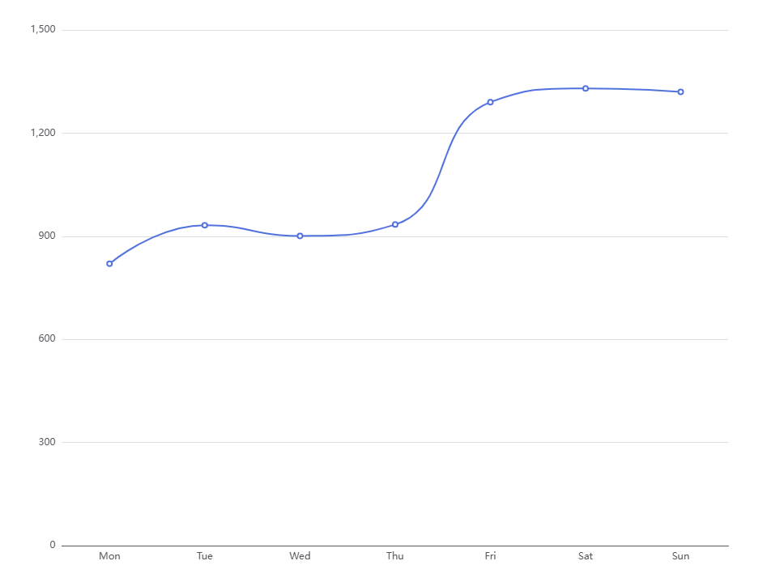

Area time series

Field | UI Element | Required
Title | Text input | Yes
Metric | Single-select dropdown: populated with numeric columns from the query SELECT | Yes
Dimension | Single-select dropdown – populated with categorical/string columns from the query SELECT | No
Filter (multi-select) | Multi-select dropdown – populated with unique values of the selected Dimension. Not available for selection if a dimension is not selected first | No
Unit label | Checkbox- to show label of the metric – this label is the one we use to display. For example if the metric is bps but we are displaying in Gbps we will show Gbps | No – but by default the toggle is on
Show total line | Checkbox- overlays aggregate total as a separate line on top of all area series . Default off | No – default off
Trendline | Checkbox overlays a linear regression line per series (dashed, same color as series) | No – default off
Threshold-line | Optional Input. (units always match unit label). Default is empty | No

- 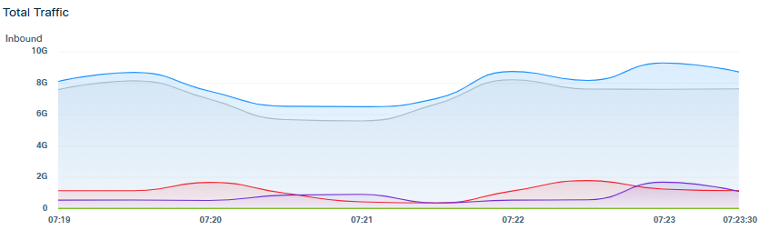

Stacked Area time series

Field | UI Element | Required
Title | Text input | Yes
Metric | Single-select dropdown: populated with numeric columns from the query SELECT | Yes
Dimension | Single-select dropdown – populated with categorical/string columns from the query SELECT | Yes
Filter (multi-select) | Multi-select dropdown – populated with unique values of the selected Dimension. Not available for selection if a dimension is not selected first | No
Unit label | Checkbox to show label of the metric – this label is the one we use to display. For example if the metric is bps but we are displaying in Gbps we will show Gbps | No – but by default the toggle is on
Show total line | Checkbox- overlays aggregate total as a separate line on top of all stacked areas. | No – default off
Trendline | Checkbox -overlays a linear regression line per series (dashed, same color as series) | No – default off
Threshold-line | Optional Input. (units always match unit label). Default is empty | No

- 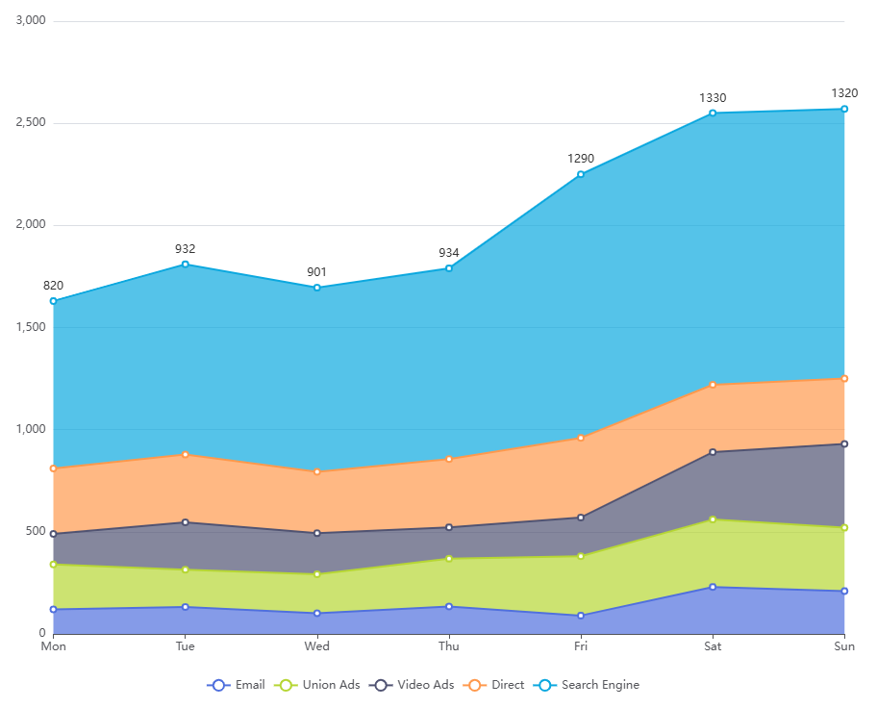

Bar chart

Field | UI Element | Required
Title | Text input | Yes
Metric | Single-select dropdown: populated with numeric columns from the query SELECT | Yes
Dimension | Single-select dropdown – populated with categorical/string columns from the query SELECT | No
Filter (multi-select) | Multi-select dropdown – populated with unique values of the selected Dimension. Not available for selection if a dimension is not selected first | No
Unit label | Checkbox- to show label of the metric – this label is the one we use to display. For example if the metric is bps but we are displaying in Gbps we will show Gbps | No – but by default the toggle is on
Show value label on bars | Checkbox - displays the value on top of each bar. | No- default off
Sort order | Single-select dropdown: By value descending / By value ascending / Alphabetical. Default: by value descending | No
Max Bars | Number input (min 1). When empty all bars are shown.  Items beyond the limit are grouped into a single "Other" bar. Limit applies to the top N items by the selected sort order. | No
Threshold-line | Optional Input. (units always match unit label). Default is empty | No
Orientation | Toggle: Vertical/horizontal | No: default vertical

- Example:
- 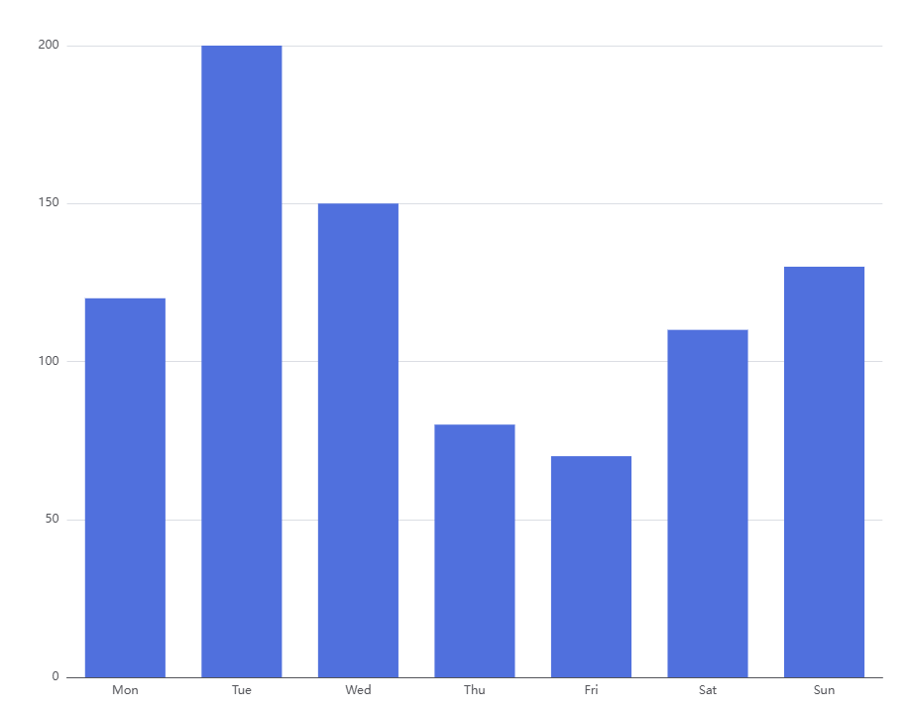

Top N chart
- Note: Difference with bar chart is that there will not be an “other” sections for items beyond the “max value”

Field | UI Element | Required
Title | Text input | Yes
Metric | Single-select dropdown: populated with numeric columns from the query SELECT | Yes
Dimension | Single-select dropdown – populated with categorical/string columns from the query SELECT | Yes
Filter (multi-select) | Multi-select dropdown – populated with unique values of the selected Dimension. Not available for selection if a dimension is not selected first | No
Unit label | Checkbox- to show label of the metric – this label is the one we use to display. For example if the metric is bps but we are displaying in Gbps we will show Gbps | No – but by default the toggle is on
Show value label on bars | Checkbox- displays the value on top of each bar. | No- default off
Sort order | Single-select dropdown: By value descending / By value ascending / Alphabetical. Default: by value descending | No
Max Bars | Number input (min 1). When empty all bars are shown.  Limit applies to the top N items by the selected sort order. | No
Threshold-line | Optional Input. (units always match unit label). Default is empty | No
Orientation | Toggle: Vertical/horizontal | No: default vertical

Donut

Field | UI Element | Required
Title | Text input | Yes
Metric | Single-select dropdown: populated with numeric columns from the query SELECT | Yes
Dimension | Single-select dropdown – populated with categorical/string columns from the query SELECT | Yes
Filter (multi-select) | Multi-select dropdown – populated with unique values of the selected Dimension. Not available for selection if a dimension is not selected first | No
Unit label | Checkbox - to show label of the metric – this label is the one we use to display. For example if the metric is bps but we are displaying in Gbps we will show Gbps | No – but by default the toggle is on
Show value label on slices | Single-select dropdown: choose between: Don’t show value, the value or % on top of each slice. Tooltip always show both as: Value (%) | No- default %
Max slices | Number input (min 1). When empty all slices are shown.  Items beyond the limit are grouped into a single "Other" slice. | No
Center label | Text input – static text displayed in the center of the donut ring (e.g., "Total"). Default empty | No – empty by default

- 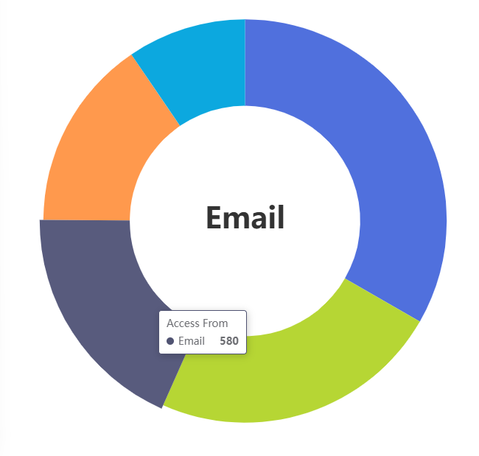

Pie

Field | UI Element | Required
Title | Text input | Yes
Metric | Single-select dropdown: populated with numeric columns from the query SELECT | Yes
Dimension | Single-select dropdown – populated with categorical/string columns from the query SELECT | Yes
Filter (multi-select) | Multi-select dropdown – populated with unique values of the selected Dimension. Not available for selection if a dimension is not selected first | No
Unit label | Checkbox- to show label of the metric – this label is the one we use to display. For example if the metric is bps but we are displaying in Gbps we will show Gbps | No – but by default the toggle is on
Show value label on slices | Single-select dropdown: choose between: Don’t show value, the value or % on top of each slice. Tooltip always show both as: Value (%) | No- default %
Max slices | Number input (min 1). When empty all slices are shown.  Items beyond the limit are grouped into a single "Other" slice. | No

- 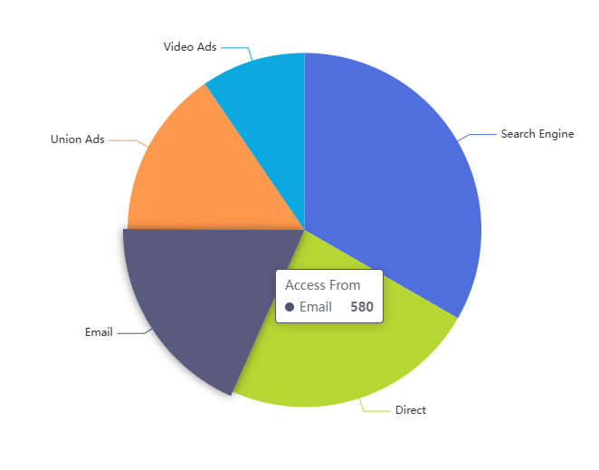

Stacked Bar

Field | UI Element | Required
Title | Text input | Yes
Metric | Single-select dropdown: populated with numeric columns from the query SELECT | Yes
Primary dimension (X-axis) | Single-select dropdown – populated with categorical/string columns from the query SELECT. Is the X-axis category (like Country) | Yes
Filter (multi-select) | Multi-select dropdown – populated with unique values of the selected Dimension. Not available for selection if a dimension is not selected first | No
SECONDARY DIMENSION (STACKED SEGMENTS) | Single-select dropdown – populated with categorical/string columns from the query SELECT. Is the dimensions showed in the stacked segments (like Protocol) | Yes
Filter (multi-select) | Multi-select dropdown – populated with unique values of the selected Dimension. Not available for selection if a dimension is not selected first | No
Unit label | Checkbox- to show label of the metric – this label is the one we use to display. For example if the metric is bps but we are displaying in Gbps we will show Gbps | No – but by default the toggle is on
SHOW TOTAL ON BAR | Checkbox – displays total above each bar | No- Default off
Show segment labels | Single-select dropdown: choose between: Don’t show value, the value or % inside of each segment. Tooltip always show both as: Value (%) | No- default %
Sort order | Single-select dropdown: By value descending / By value ascending / Alphabetical. Default: by value descending | No
Threshold-line | Optional Input. (units always match unit label). Default is empty | No
orientation | Toggle: Vertical / Horizontal. Default: Vertical | No

- 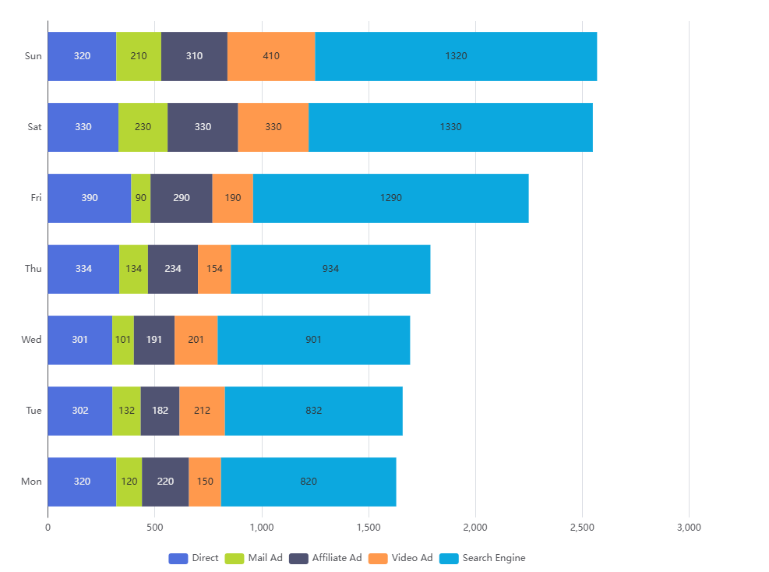

Grouped Bar

Field | UI Element | Required
Title | Text input | Yes
Metric | Single-select dropdown: populated with numeric columns from the query SELECT | Yes
Primary dimension (X-axis) | Single-select dropdown – populated with categorical/string columns from the query SELECT. Is the X-axis category (like Country) | Yes
Filter (multi-select) | Multi-select dropdown – populated with unique values of the selected Dimension. Not available for selection if a dimension is not selected first | No
SECONDARY DIMENSION (grouped bars) | Single-select dropdown – populated with categorical/string columns from the query SELECT. Is the dimensions showed in the grouped bars (like Protocol) | Yes
Filter (multi-select) | Multi-select dropdown – populated with unique values of the selected Dimension. Not available for selection if a dimension is not selected first | No
Unit label | Checkbox- to show label of the metric – this label is the one we use to display. For example if the metric is bps but we are displaying in Gbps we will show Gbps | No – but by default the toggle is on
Show value labels | Checkbox: displays the value on top of each bar segment. Default off | No-
Sort order | Single-select dropdown: By value descending / By value ascending / Alphabetical. Applies within each group: groups are ordered by their aggregate total. Default: by value descending | No
Threshold-line | Optional Input. (units always match unit label). Default is empty | No
orientation | Toggle: Vertical / Horizontal. Default: Vertical | No

- 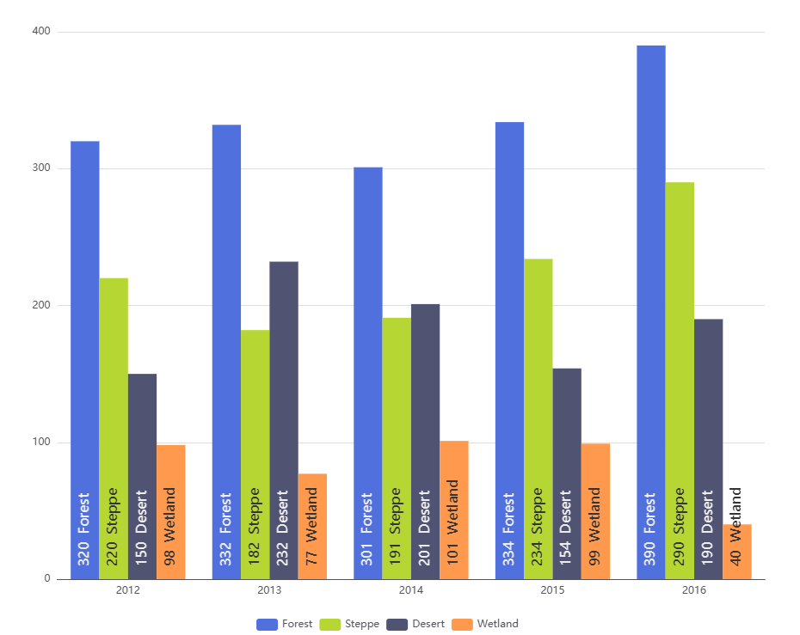

Gauge

Field | UI Element | Required
Title | Text input | Yes
Metric | Single-select dropdown: populated with numeric columns from the query SELECT | Yes
min value | Number input field. Default 0 | no
max value | Number input field. maximum value returned by the query | no
Unit label | Checkbox- to show label of the metric – this label is the one we use to display. For example if the metric is bps but we are displaying in Gbps we will show Gbps | No – but by default the toggle is on
Thresholds | Two number inputs: Warning threshold (default = 60% of max value) and Critical threshold (default = 80% of max value). Color zones: below Warning = green, Warning–Critical = yellow, above Critical = red. | Yes - defaults provided

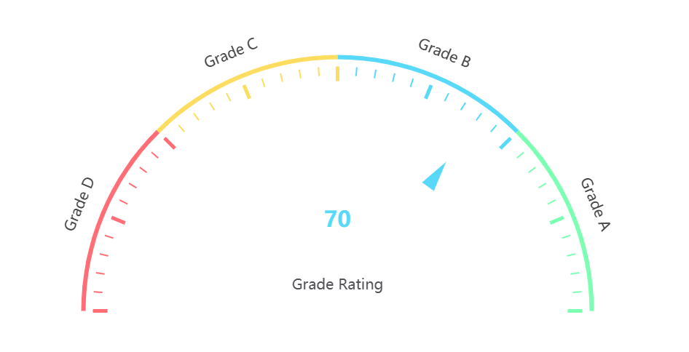

Single Value Card

Field | UI Element | Required
Title | Text input | Yes
Metric | Single-select dropdown: populated with numeric columns from the query SELECT | Yes
Unit label | Checkbox- to show label of the metric – this label is the one we use to display. For example if the metric is bps but we are displaying in Gbps we will show Gbps | No – but by default the toggle is on
Comparison | Checkbox. Show delta% compared to the previous period. Period is defined as the time filter selected in the dashboard. i.e. if the user chooses 1h, then the delta will be + or - % compared to the hour before. | No

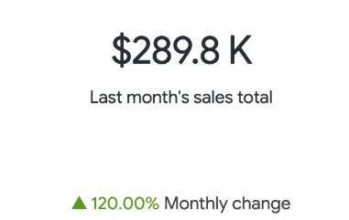

Geo Map

Field | UI Element | Required
Title | Text input | Yes
Metric | Single-select dropdown: populated with numeric columns from the query SELECT | Yes
Dimension | Single-select dropdown – geo-applicable columns only: Src_Country, Dst_Country, Src_City, Dst_City, Src_Region, Dst_Region | Yes
Filter (multi-select) | Multi-select dropdown – populated with unique values of the selected Dimension. Not available for selection if a dimension is not selected first | No
Unit label | Checkbox- to show label of the metric – this label is the one we use to display. For example if the metric is bps but we are displaying in Gbps we will show Gbps | No – but by default the toggle is on
Geo Level | Radio buttons – single selection: Country / Region / City. Default: Country | No

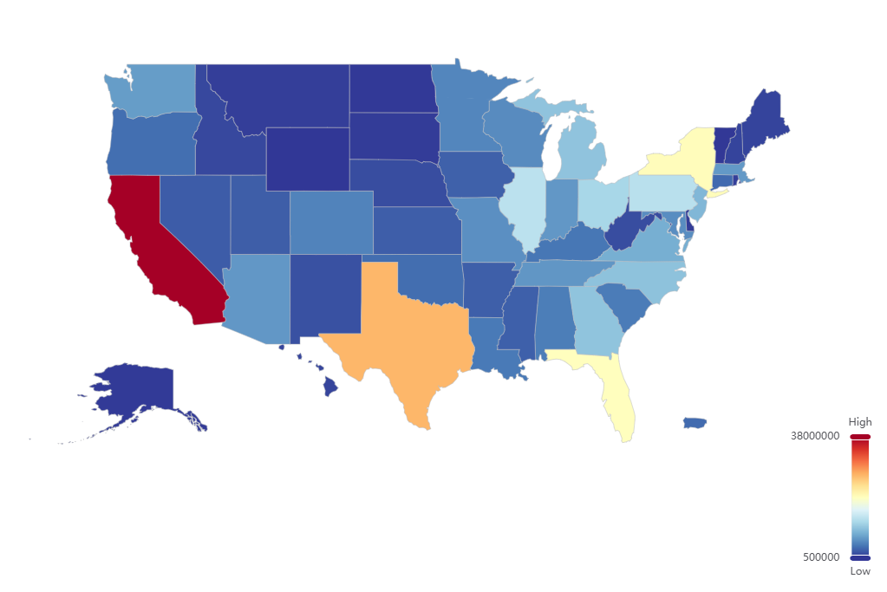

Heatmap

Field | UI Element | Required
Title | Text input | Yes
Metric | Single-select dropdown: populated with numeric columns from the query SELECT | Yes
X- Dimension | Single-select dropdown populated with  categorical/string columns from the query SELECT | Yes
Y- Dimension | Single-select dropdown populated with  categorical/string columns from the query SELECT | Yes
Filter (multi-select) | Multi-select dropdown – populated with unique values of the X an Y selected Dimensions. Not available for selection if a dimension is not selected first | No
Unit label | Checkbox- to show label of the metric – this label is the one we use to display. For example if the metric is bps but we are displaying in Gbps we will show Gbps | No – but by default the toggle is on
x-axis sort order | Single-select dropdown: By value descending / By value ascending /Alphabetical. Default: by value descending | No
Y-axis sort order | Single-select dropdown: By value descending / By value ascending /Alphabetical. Default: by value descending | No

- 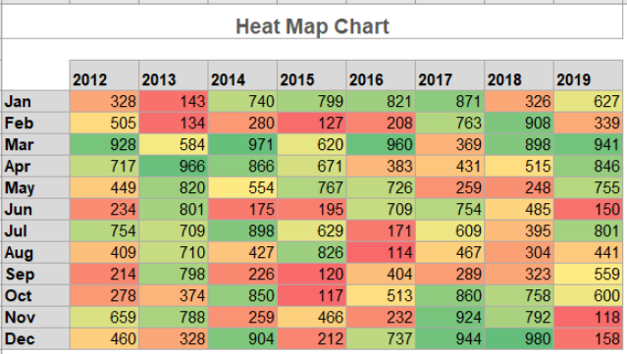

Sankey

Field | UI Element | Required
Title | Text input | Yes
Metric | Single-select dropdown: populated with numeric columns from the query SELECT | Yes
Number of nodes | Number input (min 2, max 10). Adjusting this value adds or removes node rows below. | Yes
Node 1 dimension … Node N dimension | Single-select dropdown – populated with categorical/string columns from the query SELECT. All visible node rows must be filled. | Yes
Unit label | Checkbox- to show label of the metric – this label is the one we use to display. For example if the metric is bps but we are displaying in Gbps we will show Gbps | No – but by default the toggle is on

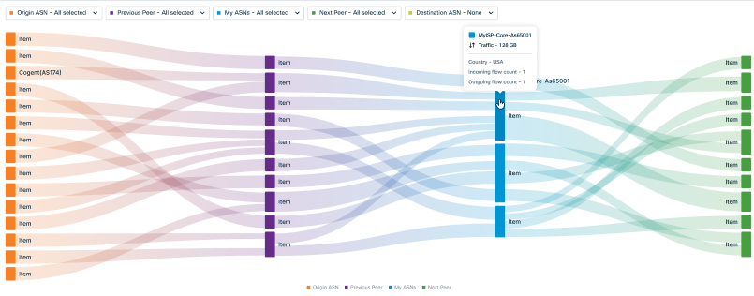

Table
- Dropdown that allows the user to select which columns to show
- Sorted: selection of the columns that will allow sorting (descending / ascending)
- Filter: selection of the columns that will allow filtering
- Note: the user should be able to one the selection is done to re-arrange columns with a drag and drop gesture and sort/filter columns. This would be the “default” state of the widget in “My Dashboards” when the user selects the widget. The user can of course re-sort/filter/rearrange columns later.
Field | UI Element | Required
Title | Text input | Yes
visible columns | Multi-select dropdown: populated with all columns returned by the query SELECT | No – default is all columns from the query
column order | Drag-and-drop reorderable list of the selected columns. Order is saved in the widget config. | No – default as query order
Sortable columns | Checkboxes within the column list – marks which columns show sort-enabled headers in the rendered table. Default: all columns | No
filterable columns | Checkboxes within the column list – marks which columns show an inline text filter input in the rendered table header row. Default: none | no
Rows per page | Single-select dropdown: 10 / 25 / 50 / 100 / All. Default: 25. When "All" is selected the table is virtualized for performance. | No

Export & Reporting
Export functionality is available at two levels: per-chart and per-page.

Per-Chart Export
Every chart in the application displays a small download icon (only showing when the mouse is over the diagram). Clicking it downloads the chart as a PNG image.
- Applies to: Sankey diagram, all charts in ASN popups, all dashboard widget charts, query editor previews, and the widget grid in the My Queries preview panel

Page-Level Export
Each main page or popup view has a general export button in the header area. Clicking it opens a dropdown with:
- PDF: full page rendered as a PDF document (graphs should fit the page)
- HTML: full page saved as an HTML file
- CSV: data exported as CSV (where applicable)
- JSON: data exported as JSON (where applicable)
Applies to:
- ASN Path Analysis page
- My ASN Popup
- Flow Popup
- Query Dashboard (full dashboard)

Appendix

Out of Scope
The following features are explicitly excluded from this release and are planned for future versions:
- Collaborative or concurrent editing of dashboards or queries
- Network Assurance section within EdgeAnalytics
- Alerting or threshold-based notifications derived from query results
- BGP Communities
- Allowing the mapping of BGP communities to the interconnection type (Customer, Peer, Transit, Provider, Internal).
- Additional metrics such as Jitter or Packet loss

