EN2532 – Robot Design and Competition: Team BASC concern regarding robot evaluation

Dear Sir,

I, Pamuditha(180616T), am writing this email as the leader of **Team BASC (Team no. 3**) for EN2532 module and the person in-charge of SLRC 2021 University Category task design. I, along with Yasod from team BASC were heavily involved in organizing SLRC 2021 University Category competition. As you are aware, the competition included a physical round and we had to build a robot for that. During the pandemic, it was risky and difficult to buy new parts from shops for the robot. Therefore, with the permission of team BASC members, I disassembled the robot we were building for the mid evaluation of EN2532 and used those parts to make a new robot for SLRC. As the travel restrictions have been in place continuously, I am unable to pickup those parts and reassemble the BASC robot.

This will affect the members of the team BASC who were not involved directly in SLRC as we cannot present our robot for the bonus marks. I would like to kindly request you to consider this situation and give our team a fair opportunity.

I have attached a comprehensive document which highlights our progress in EN2532 module task and the condition of the SLRC robot. This is a link to some photos and videos we took while building the two robots.

Thank you.

Kind Regards,

Pamuditha Somarathne

Leader, Team BASC,

18 batch, ENTC.

**EN2532 Module Robot**

We were building the initial robot for mid-evaluation with separate subsystems: motion subsystem, box picking subsystem and I2C device test-bench. What we had done during two weeks at university from 21st September 2020 to curfew enforcement on 5th October 2020 are,

* Finished line following with PID.
* Designed the PCBs and got them manufactured from JLCPCB (arrived on 13th October 2020).
* Finished straight wall following and just moved-on to curved wall.
* Completed box picking subsystem and color detection testing.
* Completed individual tests of gyro and OLED display modules.
* Finalized power system and bought the regulator modules.

Some snaps of our design and photos we took during making the robot are as follows.

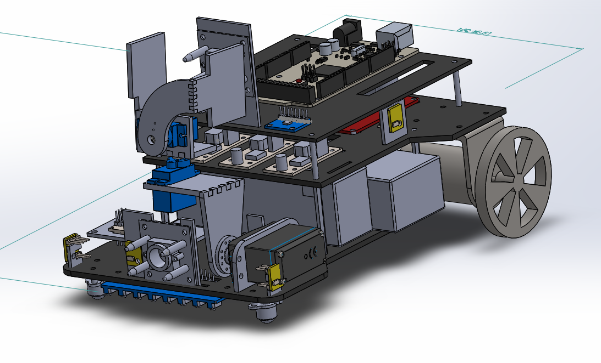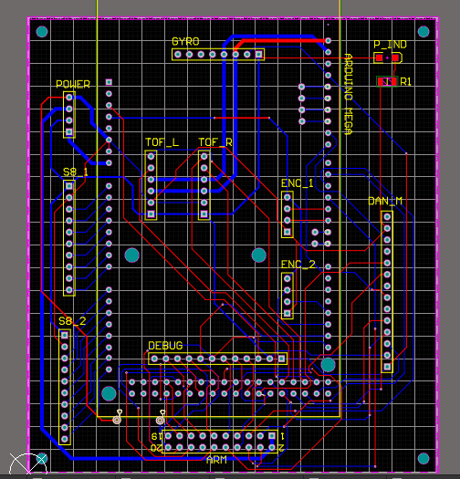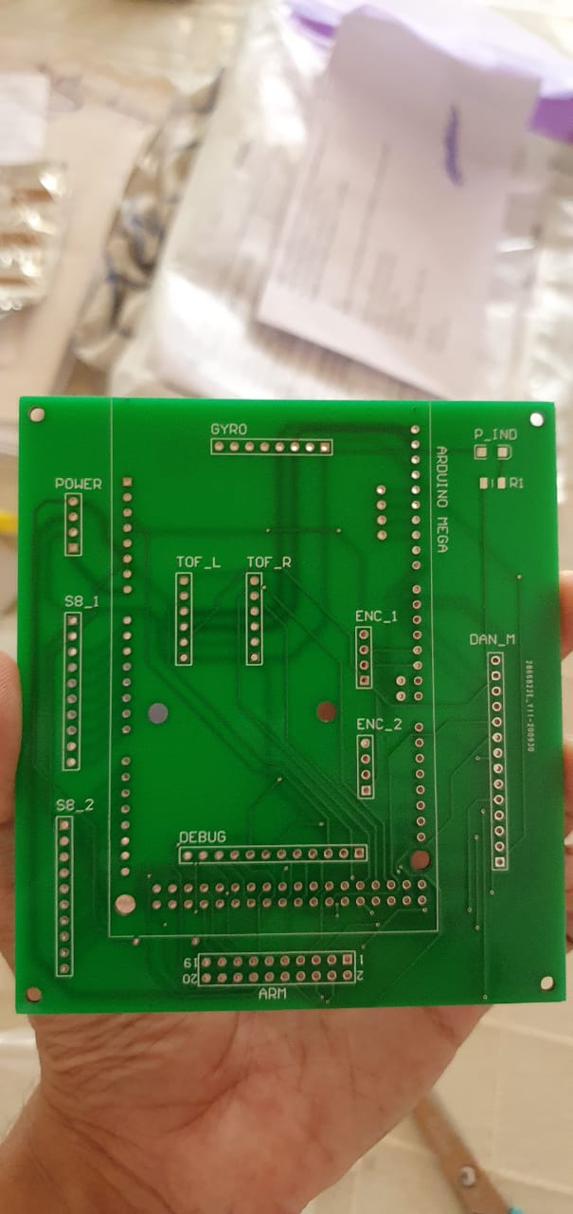

*Solidworks design PCB design Manufactured PCB*

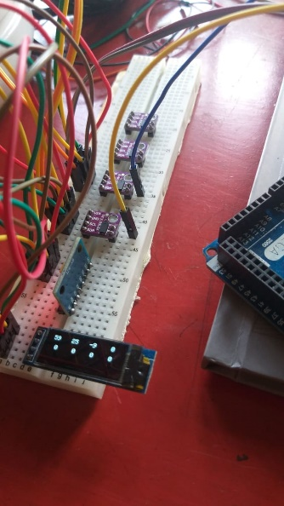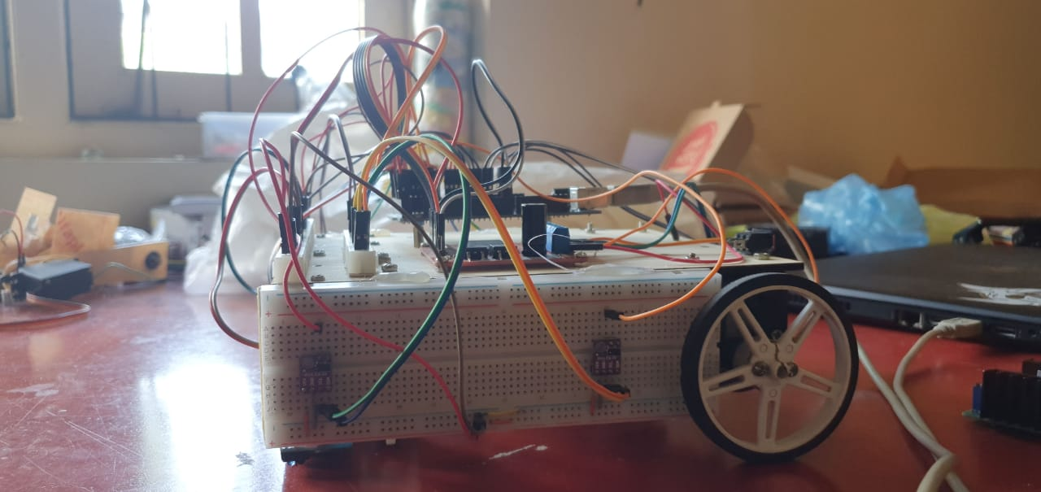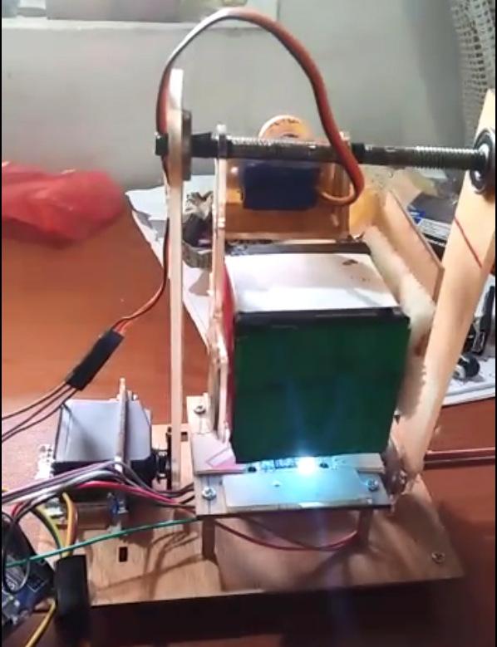

*I2C test bench Motion subsystem Box picking subsystem*

Our team members

* Yasod Ginige (180195A)
* Yomali Lokugama (180359G)
* Vidura Ravihansa (180544U)
* Pamuditha Somarathne (180616T)
* Thieshanthan Arulmolivarman (180641N)
* Tharindu Wickremasinghe (180701B)

**SLRC 2021 Robot**

This robot was designed by **Yasod** and **Pamuditha**(me). After validation of the design from Chamath (180441C) and Asiri (180609B); **Pamuditha**(me) and Pahan (180398A – Not doing EN2532) built the robot at Pahan’s house, where the testing and evaluation was also carried out.

The parts we took from BASC robot are in following places.

* In the main robot
  + Main PCB
  + A Raykha sensor
  + High-current power regulator
  + Both motors
  + Dagaya motor driver
  + 11.1V battery
  + Two IR sensor modules
  + Two omni-wheels
* In IR panel task
  + A Raykha sensor
  + Arduino MEGA board

We are unable to collect these parts and reassemble our robot until the travel restrictions are lifted.

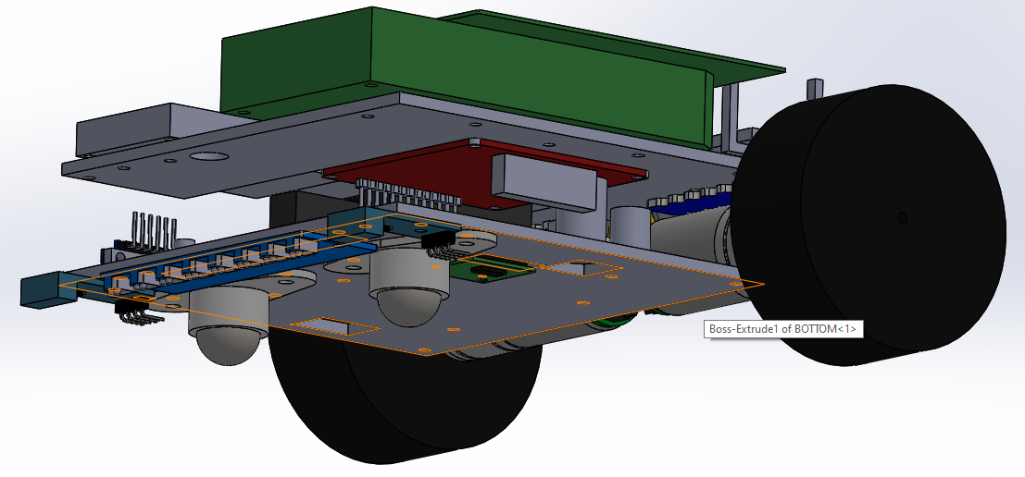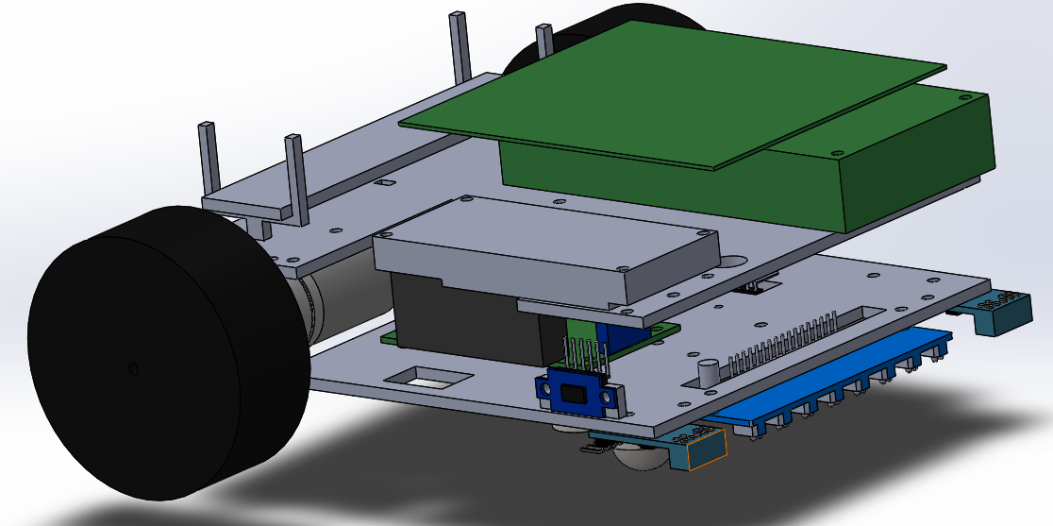

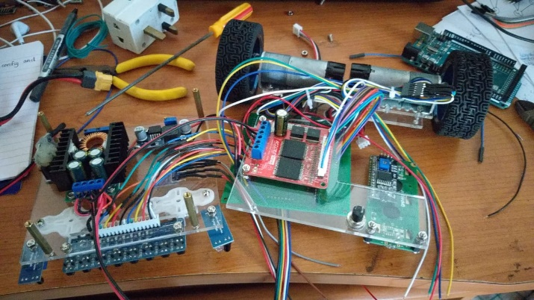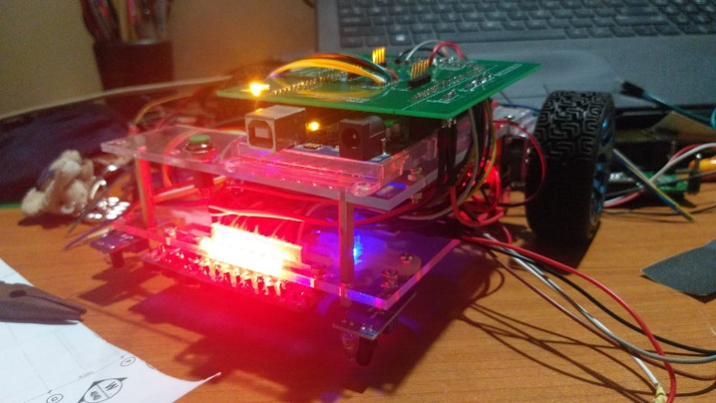

*The motors used here are Pololu 25D (47:1) motors with encoders and are not the ones given by the university. We used my personal motors because the continuous running during physical round might damage the motors of the university.*

It is worth noting that the robot we built for SLRC physical round worked without any errors or failures, during the 8-hour testing round and the 3-hour evaluation round; with codes from 11 teams.