**EN2532 Module Robot**

We were building the initial robot for mid-evaluation with separate subsystems: motion subsystem, box picking subsystem and I2C device test-bench. What we had done during two weeks at university from 21st September 2020 to curfew enforcement on 5th October 2020 are,

* Finished line following with PID.
* Designed the PCBs and got them manufactured from JLCPCB (arrived on 13th October 2020).
* Finished straight wall following and just moved-on to curved wall.
* Completed box picking subsystem and color detection testing.
* Completed individual tests of gyro and OLED display modules.
* Finalized power system and bought the regulator modules.

Some snaps of our design and photos we took during making the robot are as follows.

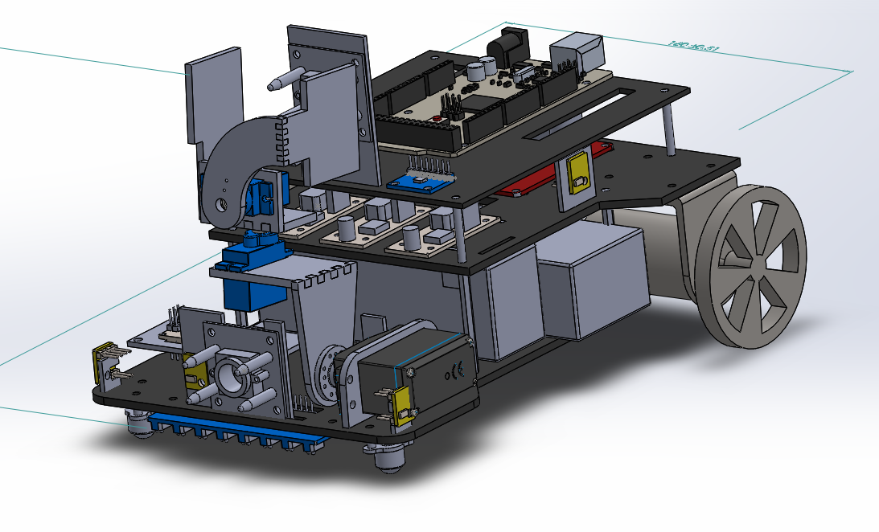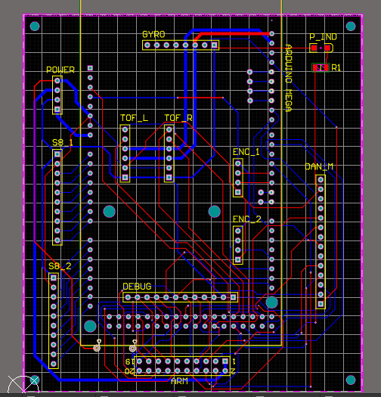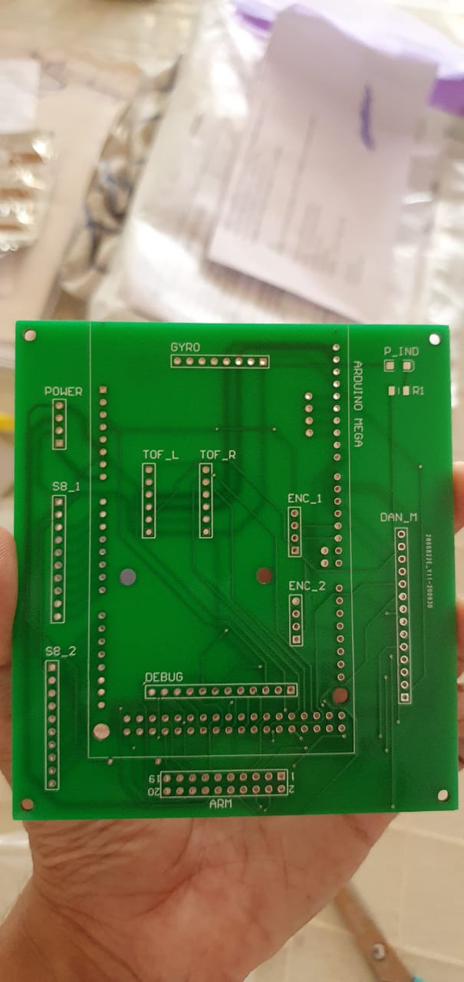

*Solidworks design PCB design Manufactured PCB*

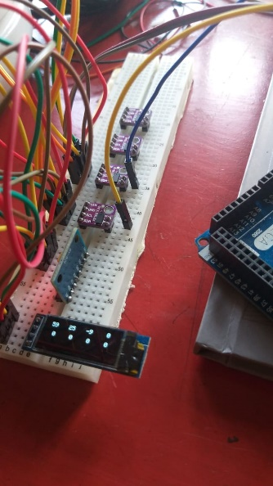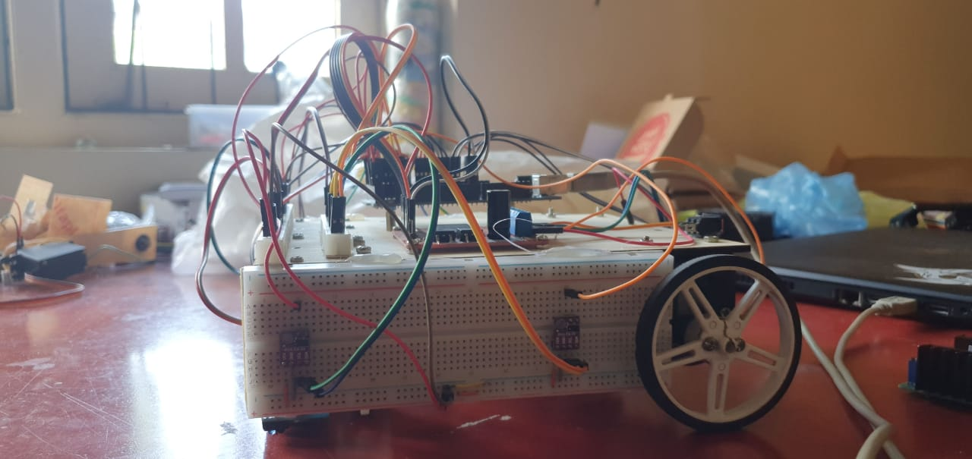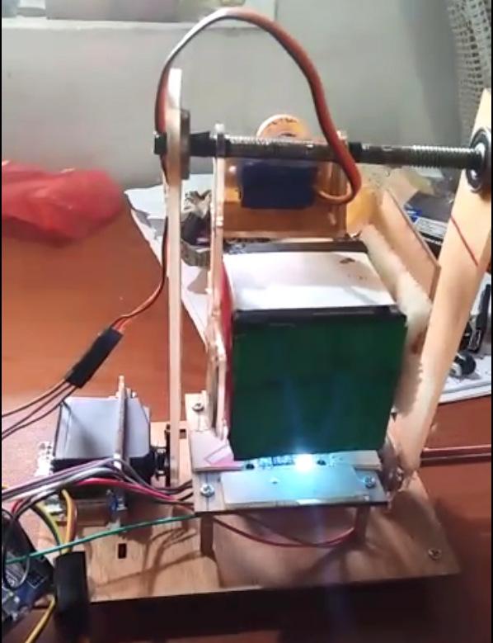

*I2C test bench Motion subsystem Box picking subsystem*

Our team members

* Yasod Ginige (180195A)
* Yomali Lokugama (180359G)
* Vidura Ravihansa (180544U)
* Pamuditha Somarathne (180616T)
* Thieshanthan Arulmolivarman (180641N)
* Tharindu Wickremasinghe (180701B)

**SLRC 2021 Robot**

This robot was designed by **Yasod** and **Pamuditha**(me). After validation of the design from Chamath (180441C) and Asiri (180609B); **Pamuditha**(me) and Pahan (180398A – Not doing EN2532) built the robot at Pahan’s house, where the testing and evaluation was also carried out.

The parts we took from BASC robot are in following places.

* In the main robot
  + Main PCB
  + A Raykha sensor
  + High-current power regulator
  + Both motors
  + Dagaya motor driver
  + 11.1V battery
  + Two IR sensor modules
  + Two omni-wheels
* In IR panel task
  + A Raykha sensor
  + Arduino MEGA board

We are unable to collect these parts and reassemble our robot until the travel restrictions are lifted.

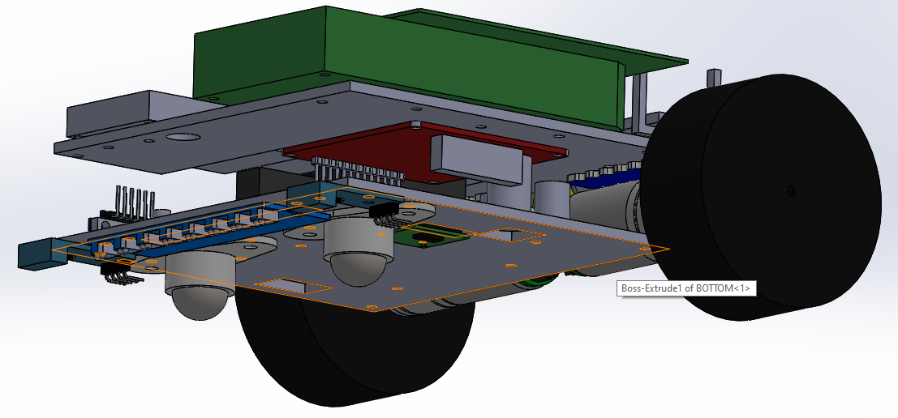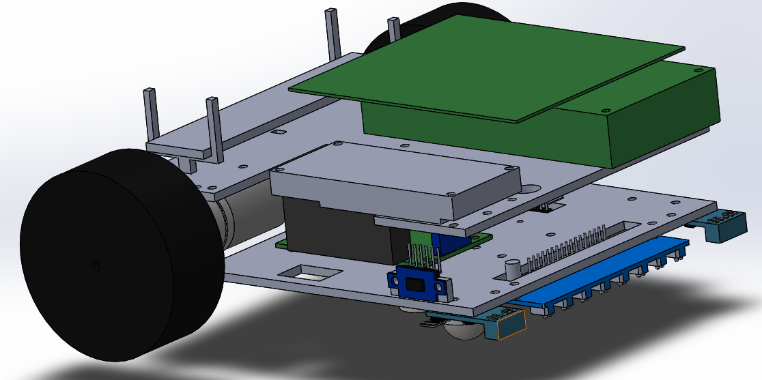

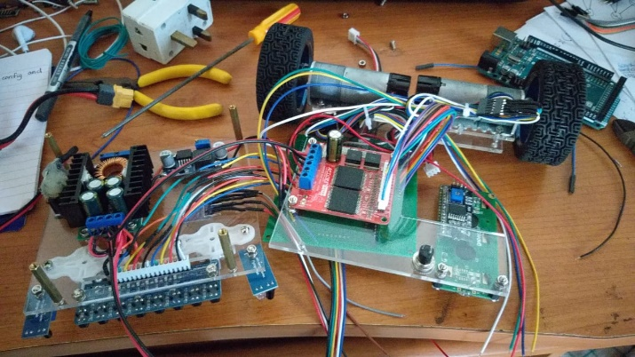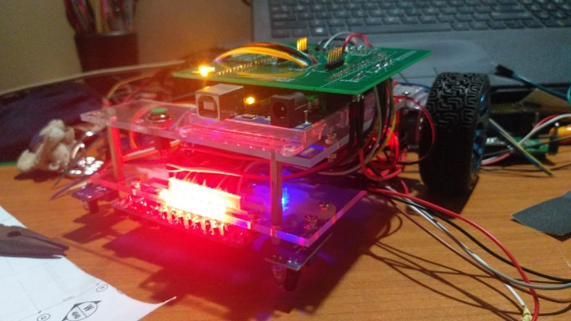

*The motors used here are Pololu 25D (47:1) motors with encoders and are not the ones given by the university. We used my personal motors because the continuous running during physical round might damage the motors of the university.*

It is worth noting that the robot we built for SLRC physical round worked without any errors or failures, during the 8-hour testing round and the 3-hour evaluation round; with codes from 11 teams.