**Total Weight Calculation**

Lipo Batteries – 200g x 2 400g

Arduino mega - 40g

12V motors – 200g x 2 400g

Arduino nano – 7g

Display – 15 g

Dangaya Motor Controller – 75g

Servo motors – 20g x 3 60g

Color Sensors – 15g x 2 30g

ToF and Gyro meter - 20g

Wheels, Spaces, Nuts – 80g

Raykha Sensor – 25g

Perspex floors – 100g

Wires and other – 50g

Body Cover – 100g

**Total Weight (Worst case) = 1500g**

According to the path that robot is going to follow, the highest current and the torque will be needed at the enter point of the Ramp. Worst case scenario will be, robot stops at the ramp and try to climb it. This case will be required the highest torque and the stall current.

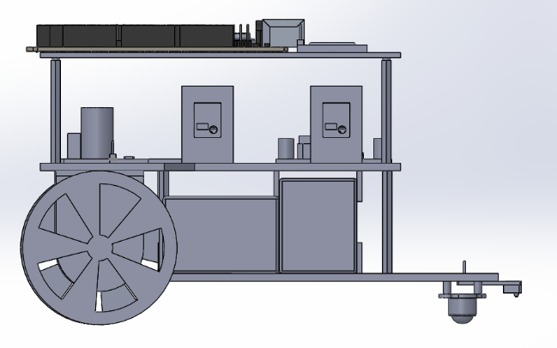

**44cm**

**20®**

**F**

**1.5 kg**

We do the calculations for starting the ramp at zero speed and accelerate to 6cms-1 in 2s. Then climb the ramp with that constant speed.

Accelerated distance = (V+U)*2 / 2

= 6 cm

Then We can do the ramp climb in 2 + 38/6 = 8.3 s.

Acceleration = 6/2 = 3cms-2

By applying F=MA to the robot along the inclined plane..

Total force needed by wheels = mg sin(20) + mA

= 1.5x9.8xsin(20) + 1.5x3/100

= 5.077 N

Force required by one wheel = 5.077/2 = 2.54 N

Torque required from a wheel = Fd

= 2.54x3 Nm

**= 7.62 Ncm**

**= 0.777 kgcm**

To leave a 25% space for any error (friction),

**# We should use a motor with 1.036 kgcm stall torque at least.**

Angular Velocity at the maximum speed in the ramp = 6 cms-1/ 3 cm

= 2 rads-1

In this moment, maximum power output of the motor (P) = τω

= 7.6 x 2 / 100 Nm

= 0.144 W

Regulated Voltage supplied to the motor = 9V

Back emf of the motor = X

**# Maximum current need at the ramp = P/V**

**= 0.144 / 9**

**= 0.016 A**

We are planning to complete first the line following part(approximately 250 cm) in 30 seconds and it will be the fastest run.

**# Maximum RPM needed = 250 x 60 / (30 x 2π x 3)**

**=26.52 rpm**

**Climb down the Ramp**

To maintain a constant speed, again motors should take the torque occurs due to weight.

Torque = 1.5x9.8xsin(20) x 3/2 Ncm

= 7.54 Ncm

= 0.76 kgcm

**# Current in climb down of the ramp = 0.144 x 7.54/ ((9-X) x 7.56)**

**=**