ANALYSTLAB AFRICA
Week 5: HealthConnect Initial Analytics Report
Data Analytics Track | Experience Lab Internship Programme
Prepared by: Pamela, Data Analytics Intern

Part 1: Review of Week 4 Foundation
- Problem defined: Nearly half of scheduled appointments end in a no-show, wasting appointment slots and disrupting continuity of care.
- Week 4 approach: Assess data quality, then define five business questions and candidate KPIs before calculating anything.
- Resources used: HealthConnect_Appointment_Data.csv (5,000 rows, 18 columns) and HealthConnect_Data_Dictionary.xlsx.
- Key assumptions/limitations carried forward: dataset is fictional and synthetic; missingness in distance_to_clinic_km and waiting_time_minutes assumed missing at random; treatment of Cancelled appointments (5.3% of records) was an open decision.
- Proposed Week 5 focus: Calculate the five KPIs identified in Week 4 and visualise the clearest early patterns, particularly prior no-show history and booking lead time.

Part 2: Data Preparation Summary
The full dataset (5,000 rows) was re-checked and confirms the Week 4 quality assessment. No duplicate appointment IDs and no fully duplicate rows were found. previous_no_shows never exceeds previous_appointments, and no booking_lead_days values are negative, confirming the dataset's internal consistency.

Missing Values
Column | Treatment Applied
reminder_channel (27.3% missing) | Filled with 'No Reminder' — structural, matches reminder_sent = No exactly
distance_to_clinic_km (1.8% missing) | Median imputation; flag column retained
waiting_time_minutes (1.2% missing) | Median imputation; flag column retained

Decision: Treatment of Cancelled Appointments
This was an open item from Week 4. Decision: Cancelled appointments (5.3% of records) are kept as their own category throughout this analysis, since a proactive cancellation is behaviourally different from a silent no-show. The headline No-Show Rate is reported both as a share of all appointments (48.5%, operational view) and as a share of decided appointments only — Attended + No-Show, excluding Cancelled (51.2%, behavioural view). All KPI breakdowns below use the decided-appointments base so Cancelled records don't dilute the comparison.

Part 3: Exploratory Data Analysis
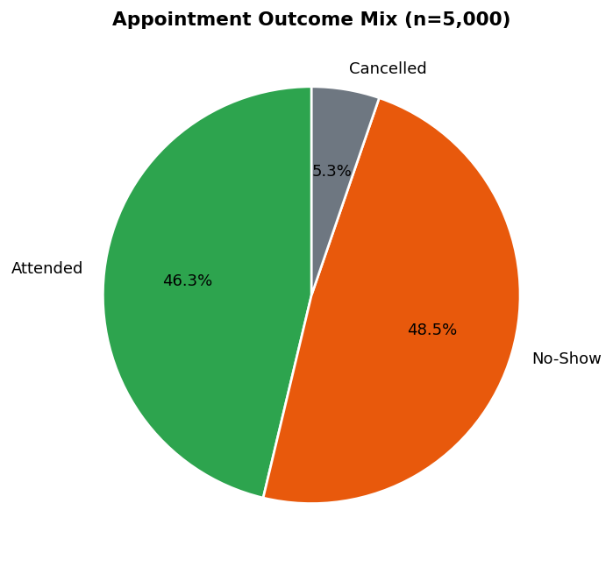
Figure 1: Appointment outcome mix across all 5,000 records.
No-shows and attended appointments are nearly evenly split, with a small share of proactive cancellations. This confirms the scale of the no-show problem described in the business scenario.

Part 3b: Cross-Check Against a Second Notebook
As a validation step, the same dataset was independently re-analysed in a second notebook using pd.crosstab() with normalize='index', which reports each group's full split across Attended, Cancelled, and No-Show simultaneously (rather than a No-Show Rate calculated over decided appointments only, as used elsewhere in this report). Recalculating the decided-only rate from those crosstabs (No-Show ÷ [Attended + No-Show]) reproduces the KPI 1, 2, and 3 figures in this report exactly — for example, the reminder-sent no-show rate resolves to 49.9% and 54.6% either way. This cross-check confirms the underlying analysis is consistent, and surfaced two additional findings folded in below: a finer view of booking lead time, and a check on patient age.

Additional Finding: No-Show Rate by Lead-Time Band
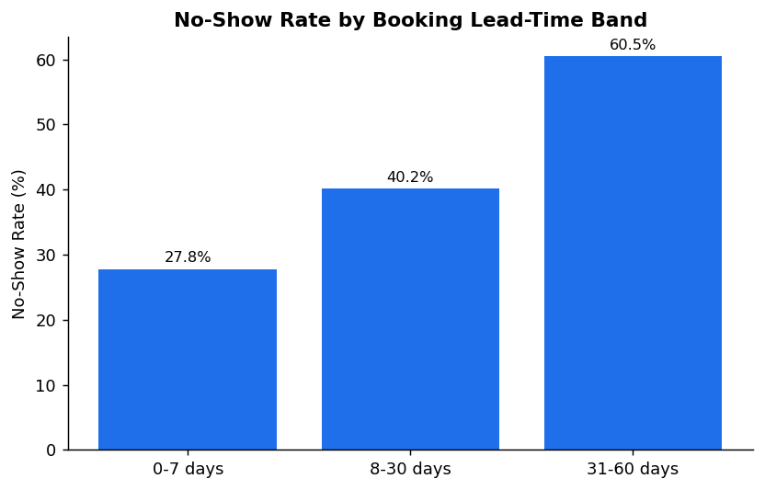
Figure 7: No-show rate rises sharply as booking lead time increases.
Interpretation: Grouping booking lead time into bands sharpens KPI 4's finding considerably. No-show rate is 27.8% for appointments booked 0–7 days ahead, rising to 40.2% for 8–30 days, and 60.5% for 31–60 days — a 32.7-point spread. This is the single largest effect found across the whole analysis and strengthens the case for reconfirmation outreach on far-ahead bookings.

Additional Finding: No-Show Rate by Age Group
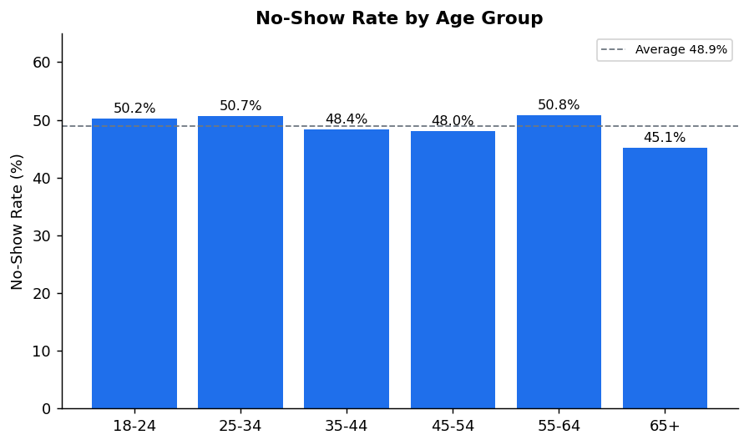
Figure 8: No-show rate is roughly flat across age groups.
Interpretation: No-show rate stays within a narrow 45–51% band across every age group from 18–24 through 65+, with no clear upward or downward trend. Age does not appear to be a useful predictor of attendance in this dataset.

Part 4: KPI Development

KPI 1: Overall No-Show Rate, by Appointment Type / Day / Time
Definition: Share of appointments ending in No-Show. Why it matters: this is the foundational metric for the whole project. Business question: What proportion of appointments result in a no-show, and does this vary by type, day, or time of day?
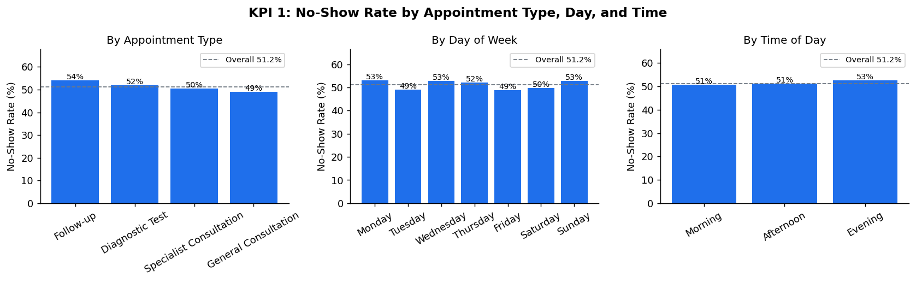
Figure 2: No-show rate broken down by appointment type, day of week, and time of day.
Interpretation: The no-show rate sits at 48.5% overall (51.2% excluding cancellations). Follow-up appointments (54.2%) and Monday/Wednesday/Sunday slots run a few points above average, but the overall spread across type, day, and time is modest (roughly 49–54%). Scheduling timing alone is a secondary factor compared to the patient-level drivers in KPI 3.

KPI 2: No-Show Rate by Reminder Status and Channel
Definition: No-show rate segmented by whether a reminder was sent, and by channel. Why it matters: reminders are a low-cost intervention the clinic already runs. Business question: Does sending a reminder — and the channel used — reduce no-shows?
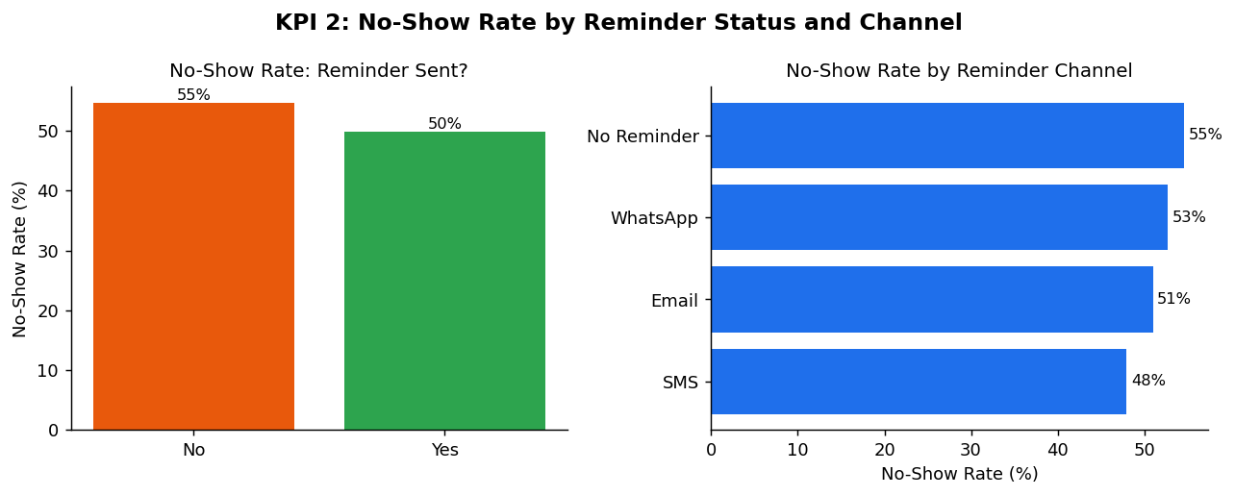
Figure 3: No-show rate with vs. without a reminder, and by reminder channel.
Interpretation: Sending any reminder is associated with a roughly 5-point lower no-show rate (49.9% vs. 54.6% with none). SMS performs best (48.0%), Email sits in the middle (51.0%), and WhatsApp (52.7%) is closer to the no-reminder baseline. The effect is real but modest — reminders help, but won't solve a problem this large on their own.

KPI 3: No-Show Rate by Prior No-Show History
Definition: No-show rate segmented by number of previous no-shows (0, 1, 2, 3+). Why it matters: most patients in this dataset have multiple appointments, so patient-level history is usable and is the clearest lens on risk. Business question: Does a patient's prior no-show history predict their next outcome?
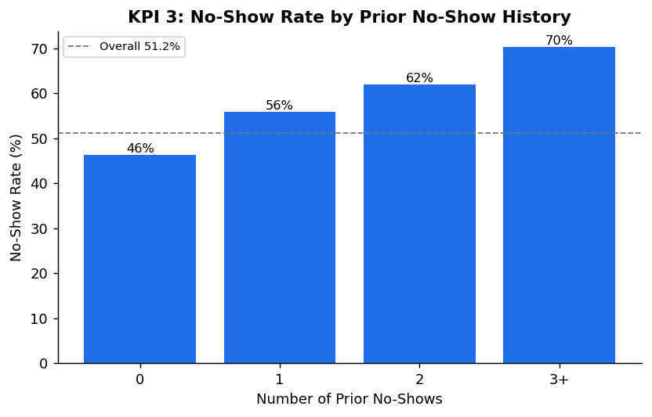
Figure 4: No-show rate climbs steadily with each additional prior no-show.
Interpretation: This is the strongest and cleanest signal in the dataset. No-show rate rises from 46.3% (no prior no-shows) to 70.3% (3+ prior no-shows) — a 24-point gradient. Prior behaviour is a far stronger predictor than any scheduling variable tested in KPI 1, making it the clearest candidate for a targeted outreach or risk-flagging intervention.

KPI 4: Average Booking Lead Time by Outcome
Definition: Mean and median days between booking and appointment date, split by outcome. Why it matters: booking policy is fully within the clinic's control, unlike patient demographics. Business question: Does how far in advance an appointment is booked affect attendance?
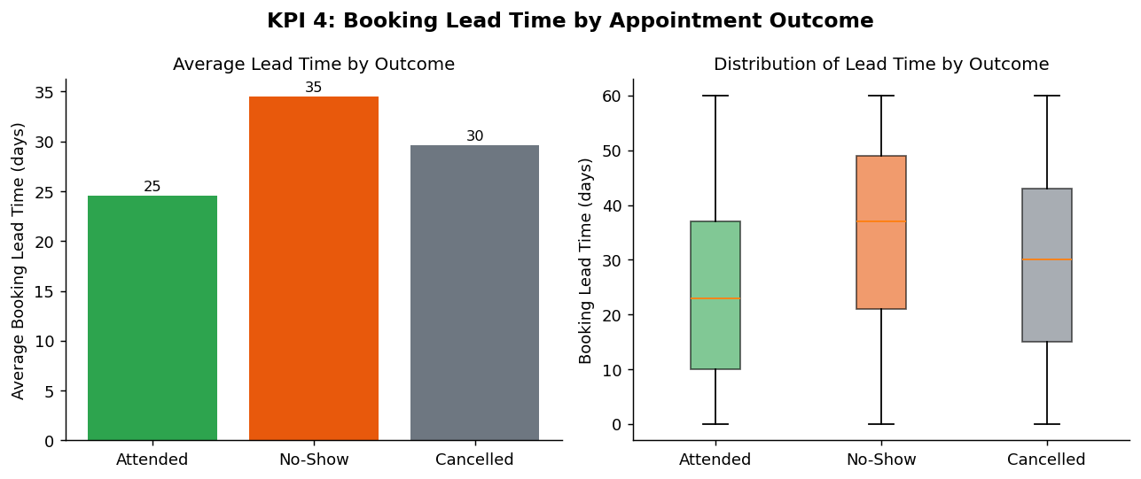
Figure 5: Booking lead time is notably longer for missed appointments than attended ones.
Interpretation: No-shows are booked roughly 10 days further in advance on average than attended appointments (34.5 vs. 24.5 days; medians 37 vs. 23 days). This is the largest absolute gap of any KPI measured and points to a concrete, controllable lever: reconfirmation workflows for appointments booked well ahead of time.

KPI 5: No-Show Rate by Distance to Clinic
Definition: No-show rate segmented into distance bands (under 5km, 5–15km, 15km+). Why it matters: distance is a structural barrier rather than a behavioural one, pointing to a different type of solution. Business question: Does distance to the clinic affect attendance?
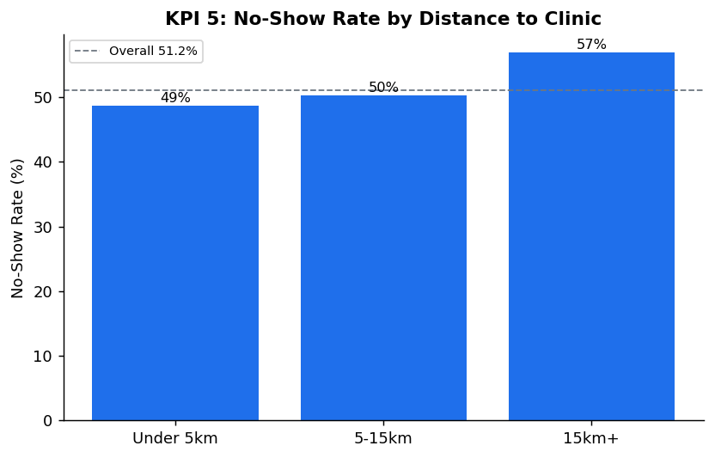
Figure 6: No-show rate increases with distance from the clinic.
Interpretation: No-show rate rises from 48.7% (under 5km) to 56.9% (15km+), an 8-point gap. Distance is a real but secondary factor compared to prior history and lead time, and supports considering telehealth or transport-assistance options for patients living further away.

Part 5: Business Insights
- Prior no-show history is the strongest single predictor available — the rate climbs from 46% to 70% as prior no-shows go from 0 to 3+. A simple risk flag (e.g. 2+ prior no-shows = high-risk) could target outreach where it matters most.
- Booking far in advance is strongly associated with no-shows — a ~10-day average gap between attended and missed appointments suggests reconfirmation messages closer to the appointment date for long-lead bookings would help.
- Reminders help, but only modestly, and channel matters — SMS shows the lowest no-show rate (48%) versus no reminder (54.6%); WhatsApp underperforms SMS and Email here, worth validating before scaling WhatsApp reminders.
- Distance is a real but secondary barrier — patients 15km+ away no-show almost 9 points more than those under 5km, pointing toward telehealth or transport support as a longer-term lever.
- Scheduling slot (type/day/time) has the least explanatory power of the five KPIs — only a ~5-point spread across all appointment types, days, and times — so operational rescheduling alone is unlikely to move the needle much.
- Follow-up appointments have the highest no-show rate by type (54.2%), worth a closer look at whether patients deprioritise these versus new-issue consultations.
- Booking lead time, viewed in bands, is the single strongest effect in the whole analysis — no-show rate rises from 27.8% (booked 0–7 days ahead) to 60.5% (booked 31–60 days ahead), a 32.7-point spread.
- Patient age has almost no relationship with attendance — no-show rate stays within a narrow 45–51% band across all age groups from 18–24 to 65+, so age-based targeting is not a useful lever.

Part 6: Cross-Track Collaboration
Track interacted with: Data Science.
Information exchanged: The five KPI definitions, the prior-no-show risk segmentation (0 / 1 / 2 / 3+), and the booking-lead-time finding were shared as candidate engineered features for the Data Science track's baseline no-show prediction model.
Why relevant: Data Science's Week 5 task requires proposing features and a target variable for a baseline classifier; the Data Analytics KPIs identify which raw variables actually carry signal (prior history and lead time) versus which don't (scheduling slot), helping focus feature engineering effort.
What changed as a result: The Data Science track can prioritise previous_no_shows and booking_lead_days as high-value features and treat appointment_type/day/time as lower priority, rather than testing all variables with equal weight.

Part 7: Limitations
- Dataset is fictional and synthetic — findings demonstrate analytical process, not real clinical evidence.
- All relationships shown are correlational, not causal (e.g. reminders vs. attendance); this is an observational dataset, not a controlled experiment.
- Median imputation for distance and waiting time assumes missing-at-random; this has not yet been re-verified against appointment type or outcome.
- The Cancelled-appointment treatment (kept separate, excluded from KPI denominators) is a reasoned choice, not the only valid one — a future pass could test sensitivity by merging Cancelled into No-Show.
- KPIs are univariate/bivariate; interacting effects (e.g. whether the lead-time effect is really a proxy for appointment type) have not been tested and would benefit from the Data Science track's modelling work.
- Patients with 4 or 5 prior no-shows show very high rates (66.7% and 100% respectively) in the cross-check notebook, but these groups almost certainly contain very few patients — these specific figures should be treated as low-confidence and not quoted as strong findings without checking the underlying sample size.

Part 8: Business Recommendations
- Build a simple patient-level risk flag from prior no-show count and prioritise outreach to patients with 2+ prior no-shows.
- Add an SMS reconfirmation step for appointments booked more than roughly 3–4 weeks in advance — this is the highest-impact single lever identified, given the 32.7-point gap between the shortest and longest lead-time bands.
- Standardise on SMS as the default reminder channel where feasible, pending further validation.
- Evaluate telehealth or transport-support options for patients 15km+ from the clinic, especially for Follow-up appointments.
- Hand these KPI definitions and risk segments to the Data Science track as candidate features for a predictive no-show model.

Part 9: Assumptions, Limitations, Risks & Dependencies — Week 4 to Week 5
Item | Status in Week 5
Dataset is fictional/synthetic | Still relevant — unchanged
Missingness assumed missing-at-random | Still relevant — not yet re-tested against outcome
Cancelled-appointment treatment undecided | Resolved — kept as separate category, documented in Part 2
Relationships are correlational, not causal | Still relevant — unchanged
New: WhatsApp underperforms other channels | New finding — needs validation before scaling WhatsApp reminders

Week 5 Project Summary
1. What I planned to accomplish: Calculate the five KPIs identified in Week 4 and visualise the clearest early patterns, particularly prior no-show history and booking lead time.
2. What I actually completed: Re-validated data quality on the full dataset, resolved the open Cancelled-appointments decision, calculated all five KPIs with supporting visualisations, and produced at least five business insights and recommendations, delivered as both a Jupyter notebook and this Word report.
3. Key findings: Prior no-show history (46%→70%) and booking lead time (~10-day gap) are the strongest drivers of no-shows; reminders and distance have real but smaller effects; scheduling slot (type/day/time) has the weakest effect of the five.
4. Major challenges encountered: Deciding how to treat Cancelled appointments required a documented judgement call rather than a purely data-driven answer, since the assignment brief flagged it as an open item rather than specifying a rule.
5. Important decisions made and why: Cancelled appointments were kept as their own category rather than merged into No-Show or excluded, because a proactive cancellation is a materially different patient action from a silent no-show; KPI denominators use decided appointments only so this doesn't distort comparisons.
6. Changes to Week 4 approach: None to the KPI list itself; the only change was resolving the previously undecided Cancelled-appointments treatment.
7. Cross-track collaboration completed: Shared KPI definitions and the risk segmentation with the Data Science track as candidate features for their baseline model (see Part 6).
8. Remaining work: Build an interactive Power BI/Tableau dashboard; test KPI interactions (e.g. lead time within appointment type) rather than only univariate views.
9. Proposed focus for Week 6: Convert these static KPIs into an interactive dashboard for non-technical stakeholders, and support the Data Science track in validating which engineered features actually improve their baseline model.

