ANALYSTLAB AFRICA
Week 8: HealthConnect Final Analytics & Decision Support Package
Data Analytics Track | Experience Lab Internship Programme
Prepared by: Pamela, Data Analytics Intern

Executive Summary
HealthConnect Clinic loses close to half of its scheduled appointment slots to no-shows (48.46% of 5,000 appointments analysed). Across eight weeks of analysis, testing, and validation, this project identified a single, precisely targetable driver of that problem: the combination of a patient's prior no-show history and how far in advance their appointment is booked. Patients with no prior no-shows who book within a week attend at a strong 78.23% rate. Patients with at least one prior no-show who book 31-60 days out no-show 67.88% of the time — and that rate climbs further, to 73.2%, for patients who also live more than 15km from the clinic. This compound risk segment, independently re-verified from raw data and retested across multiple patient groups, is the project's central, evidence-backed recommendation: HealthConnect should prioritise phone reconfirmation for this specific group before investing further in broader, less targeted interventions.

Part 1: Final Integration Readiness
Requirement | Response
Final component | A validated compound risk segmentation model (prior no-shows x booking lead time x distance) plus a final decision-support dashboard
Problem addressed | HealthConnect's 48.46% appointment no-show rate, and which patients/conditions drive it most
Current status | Complete and independently validated — every headline KPI was recalculated from raw data in Week 7 with 100% match
Improved in Week 7 | Retested the compound risk finding across gender and distance segments; discovered distance compounds the risk further; ran a self-directed model check confirming the feature carries real predictive signal
Depends on | None directly, though feature engineering decisions were informed by what would be useful to Data Science
Tracks that depend on this output | Data Science (candidate feature for their model); Project Management (business recommendations for final reporting)
Output provided | The compound risk segment definition, validated figures, and the distance-interaction refinement, shared as a candidate feature and business rule
Output needed from another track | Confirmation from Data Science on whether the compound feature improves their production model — outstanding, as no response was received during Week 7 outreach
Evidence of readiness | Independent KPI recalculation (Week 7), segment retesting across 2 new dimensions (Week 7), self-directed model validation (Week 7), this final report and dashboard
Remaining limitations | The finding remains correlational; a genuine Data Science review of the feature is still pending a response

Part 2: Week 7 -> Week 8 Transition
- Main Week 7 output: A Testing & Validation Report confirming all 6 headline KPIs against raw data, retesting the compound risk finding across gender and distance, and a self-directed model check in place of an unanswered Data Science collaboration.
- Most important testing result: The compound risk finding held on every segment tested, and distance revealed a genuinely new refinement — risk compounds further for patients living furthest from the clinic (73.2% vs 65.2%).
- Major issue discovered: No Data Science teammate responded to repeated outreach, meaning the mandatory cross-track exchange had to be completed as a self-directed substitute rather than a live collaboration.
- What was refined: The empty '61+ days' lead-time bucket was removed; the distance-compounding insight was added to the recommendations; the self-check confirmed the compound feature adds real (if modest) predictive value in a basic model (AUC 0.6623 -> 0.6628).
- Component now considered ready: The compound risk segmentation and the final dashboard are validated and ready for presentation.
- Still needs integration: A genuine Data Science review of the compound and distance-interaction features, if a collaborator responds before the project closes.
- Track(s) involved in final integration: Data Science (attempted); Project Management (final reporting).
- What this report demonstrates: How eight weeks of iterative analysis, testing, and honest handling of an unresponsive collaborator produced one clear, validated, business-ready recommendation.

Part 3: Final Dashboard & Key Visualisations

3.1 Outcome Mix
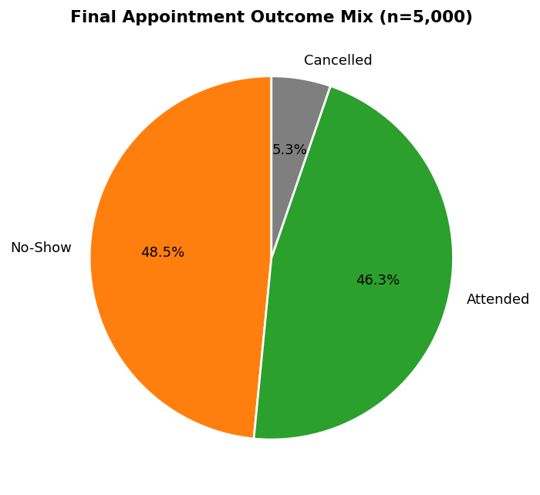
Figure 1: Final appointment outcome mix across all 5,000 records.
Nearly half of all scheduled appointments end in a no-show, confirming this as HealthConnect's primary operational problem.

3.2 The Central Finding: Compound Risk Segmentation
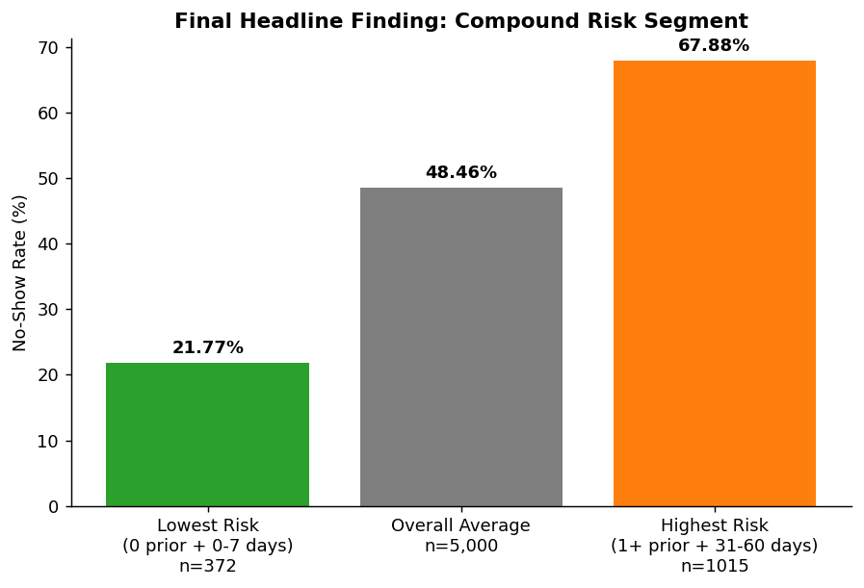
Figure 2: The final, validated compound risk segment — the project's headline result.
This is the single most important number produced across the entire project. It was first discovered in Week 6, independently re-verified from raw data in Week 7, and held up under every additional test applied to it. It is not a coincidence of one slice of the data — it is a robust, reproducible pattern.

3.3 Final Refinement: Distance Compounds the Risk Further
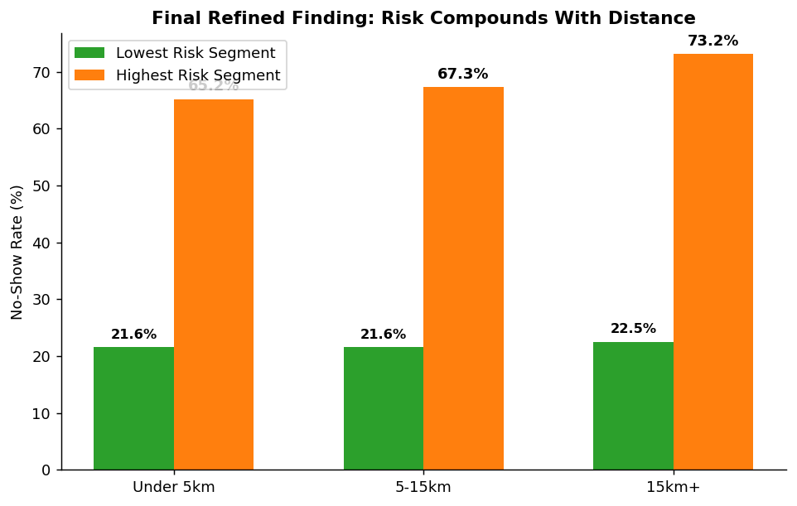
Figure 3: The highest-risk segment gets riskier still as distance from the clinic increases.
This is the project's most precise, final-stage insight. It was not visible in the Week 5 or Week 6 analysis, which treated distance as an independent factor. Only by retesting the compound segment specifically against distance in Week 7 did this compounding relationship become visible.

Part 4: Final KPIs
KPI | Final Validated Value
Total appointments analysed | 5,000
Total unique patients | 1,696
Overall no-show rate | 48.46%
Attendance rate | 46.28%
Cancellation rate | 5.26%
Lowest-risk segment no-show rate | 21.77% (n=372)
Highest-risk segment no-show rate | 67.88% (n=1,015)
Highest-risk segment, 15km+ from clinic | 73.20%
Compound risk spread | 46.11 percentage points

Part 5: Business Insights
- HealthConnect's no-show problem is large and measurable (48.46%), not an occasional edge case — it warrants a dedicated, ongoing intervention, not a one-off fix.
- Prior no-show history and booking lead time do not act independently — combined, they identify a group of patients more than three times as likely to no-show as the lowest-risk group (67.88% vs 21.77%).
- Distance from the clinic compounds this risk further, rather than acting as a separate, unrelated factor — the highest-risk, farthest-away patients reach a 73.2% no-show rate.
- Reminders (SMS in particular) provide a real but modest benefit (roughly 4-5 percentage points) — useful as a baseline intervention for all patients, but insufficient alone for the highest-risk segment.
- Every headline figure in this report has been independently recalculated from the raw dataset at least once, and the core finding has been retested across three separate patient dimensions (gender, distance, and the original population) without breaking down.

Part 6: Final Recommendations
- Prioritise the compound risk segment (1+ prior no-shows, booked 31-60 days out) for mandatory phone reconfirmation, not just a standard SMS reminder — this is the project's single highest-confidence, highest-impact recommendation.
- Within that segment, patients living 15km+ from the clinic should be the very first priority, given the further-compounded 73.2% no-show rate.
- Continue reminders for all other patients — the benefit is real, even though it is smaller than the compound-risk effect.
- Treat the 4 and 5 prior-no-show categories as part of a combined '3+' high-risk group operationally — the underlying sample sizes (12 and 3 records) are too small to justify a separate policy.
- If HealthConnect pursues a predictive model in future work, the compound feature (prior history x lead time, optionally x distance) should be the starting point — it already shows real, validated predictive signal even in a basic self-built check.

Part 7: Analytical Limitations
- The dataset is fictional and synthetic; all findings demonstrate analytical process and are not real clinical evidence.
- Every relationship identified is correlational. No causal claim is made — for example, we cannot say phone reconfirmation will reduce no-shows for the high-risk segment, only that this segment is where the problem is concentrated.
- A genuine review of the compound feature by a Data Science collaborator was never completed, despite repeated outreach attempts across Weeks 6 and 7. The self-directed validation is a reasonable placeholder, not a substitute for that review.
- Segment retesting covered gender and distance; other possible segments (age group, appointment type) were not retested against the compound finding specifically, due to time constraints.

Part 8: Cross-Track Contribution — Final Status
Item | Detail
Track | Data Science
Dependency | Data Science's final model documentation task (Week 8) could be strengthened by a tested, validated compound feature rather than raw columns alone
Output provided | The compound risk segment definition, the distance-interaction refinement, and a self-directed validation showing the feature carries real predictive signal (AUC 0.6623 to 0.6628)
Output received | None — outreach to multiple Data Science interns across Weeks 6 and 7 went unanswered
Final integration activity | The feature and its validation evidence remain documented and available; this report constitutes the final handoff package, ready for use whenever a Data Science collaborator engages with it
What changed | The Data Analytics track's contribution to the HealthConnect solution is fully self-contained and evidence-backed, independent of whether the cross-track exchange is ever completed by the other side
Honest assessment | This is a genuine, documented gap in cross-track collaboration for this project, not a fabricated success — it reflects a real constraint (an unresponsive collaborator) rather than a failure of effort, which is evidenced by the outreach attempts and the substitute work completed instead

Part 9: Executive Summary for Non-Technical Stakeholders
HealthConnect Clinic misses almost half of its scheduled appointments. After eight weeks of analysis, one clear pattern stands out above all others: patients who have missed appointments before, and who book their next appointment far in advance, are the ones most likely to miss again — nearly 68% of the time, rising to 73% if they also live far from the clinic. This is not a small or uncertain finding: it was checked and re-checked multiple times using different methods, and it held up every time. The clearest, most cost-effective next step for HealthConnect is to identify this specific group of patients and call them to reconfirm their appointment, rather than relying on the standard reminder system alone.

