|  |  |
| --- | --- |
| **Title：** | Software Design Document |

|  |  |  |  |
| --- | --- | --- | --- |
| **Project:** | NBrush | **Model:** | DM-08NBrush-20A |
| **Stage:** | M2 | **Doc ID:** | NA |
| **Doc Version:** | A02 | **Doc Status:** | Ready |

|  |  |  |  |
| --- | --- | --- | --- |
| **Prepared by** | | | |
| **Role** | **Name** | **Department** | **Date** |
| SW Dev | Su Zhifei | CT_IND_UIT | 2020/10/10 |
| **Reviewed by** | | | |
| **Role** | **Name** | **Department** | **Date** |
| SW PL | Pan Rongtao | CT_IND_UIT | 2020/10/10 |
| SYS RM |  |  |  |
| SW Arch |  |  |  |
| SW Test |  |  |  |
| SW Dev |  |  |  |
| SW Dev |  |  |  |
| **Approved by** | | | |
| **Role** | **Name** | **Department** | **Date** |
| SW PL | Pan Rongtao | CT_IND_UIT | 2020/10/10 |

|  |  |  |  |
| --- | --- | --- | --- |
| **Distribution List** | | | |
| **Role** | **Name** | **Department** | **Date** |
| PM | Xiao Guansong | ITTI_AD_HZ | 2020/10/10 |

|  |  |  |  |  |  |
| --- | --- | --- | --- | --- | --- |
| **Document History** | | | | | |
| **Version** | **Status** | **Date** | **Document Owner** | **Department** | **Changes** |
| A.01 | New | 2020/10/15 | Su Zhifei | CT_IND_UIT | New |
| A.02 | New | 2020/12/11 | Su Zhifei | CT_IND_UIT | New |
|  |  |  |  |  |  |
|  |  |  |  |  |  |

|  |
| --- |
| **Purpose:** |
| This is the SW Design Document of the SW Package NewBrush of *modelLoad* |

|  |
| --- |
| **Scope (validity area & date, replaced documents):** |
| This document applies to Desay SV, <...>-discipline by the above mentioned project. It describes the SW Design of *G6S* valid for all prototypes *(i.e. B1, B2 and C Prototype)*. |

|  |
| --- |
| **Audience:** |
| The intended readers of this document are the SW Developers that have interfaces to the SW Package described, the SW (Sub-)Project Leader and the SW Architect responsible for the SW Component *G6S*.  *Note: A design description of low-level SW such as device drivers may be reviewed by HW developers, too*. |

|  |
| --- |
| **Maintenance:** |
| The first version of this document shall be released before milestone SW3.1. It will be updated on major changes or (if necessary) at the end of each project process phase. |

Table of contents

1 Acronyms, Abbreviations, Terminology 3

2 SW Package Overview 4

2.1 SW Package Context 5

2.2 SW Package Interface 5

2.3 SW Package Non-Functional Requirements 5

3 Design and Implementation Constraints 5

4 Development Steps 5

5 Variants 5

6 SW Design 6

6.1 Use case diagrams, scenarios 6

6.2 Structure overview of the SW Package 6

6.3 Dynamic Structure and Dynamic Model 7

6.3.1 Interaction Diagrams 7

6.3.2 State/events diagrams 7

6.3.3 Runtime Behavior 7

6.3.4 OS Description / Usage 7

6.3.5 Performance Assessment 7

6.3.6 Diagnostics 8

6.4 Initialization and System Events 8

6.5 Test Concept 8

7 Interfaces 8

7.1 External Interfaces 10

7.2 Internal Interfaces 10

8 Further Implementation Details 11

9 Related Documents 相关文档 11

10 Appendix 附录 11

# Acronyms, Abbreviations, Terminology

|  |  |
| --- | --- |
| **Term / Abbreviation** | **Definition (local)** |
| USB | Universal Serial BUS |
| SD | Secure Digital Memory Card |
|  |  |
|  |  |
|  |  |
|  |  |
|  |  |
|  |  |
|  |  |
|  |  |
|  |  |
|  |  |
|  |  |
|  |  |
|  |  |
|  |  |
|  |  |
|  |  |
|  |  |
|  |  |

# SW Package Overview

ModelLoad用于显示和设置3D模型的相关属性，比如设置动画，特效等。

## SW Package Context

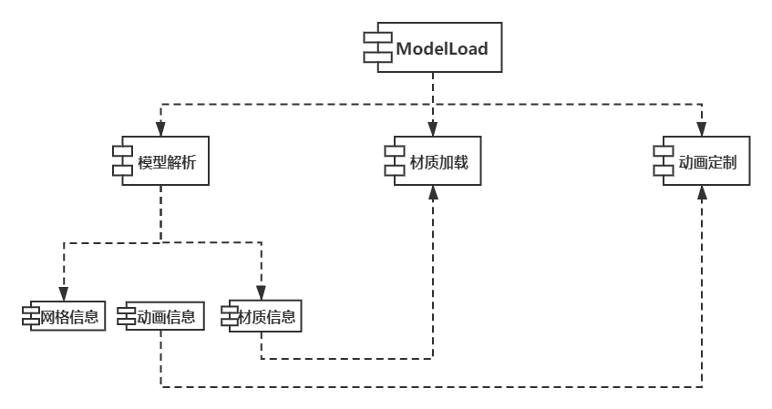

1. StatusBar App组件图

## SW Package Interface

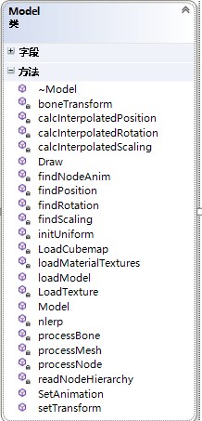

1. Figure 2 SW Package Interface

## SW Package Non-Functional Requirements

NA

# Design and Implementation Constraints

NA

# Development Steps

模型加载程序主要是从3D模型文件（.FBX等）获取资源，经过数据解析，处理材质和动画后，通过OpenGL最终绘制出来。

1. 确定3D模型的功能。
2. 加载外部资源（.FBX等）。
3. 解析模型数据，包括材质、动画等。
4. 处理模型数据，和功能逻辑
5. 集成，优化。

# Variants

NA

# SW Design

模型加载程序用于显示3D模型，所关联到的是3D模型文件。

## Use case diagrams, scenarios

参考RD

## Structure overview of the SW Package

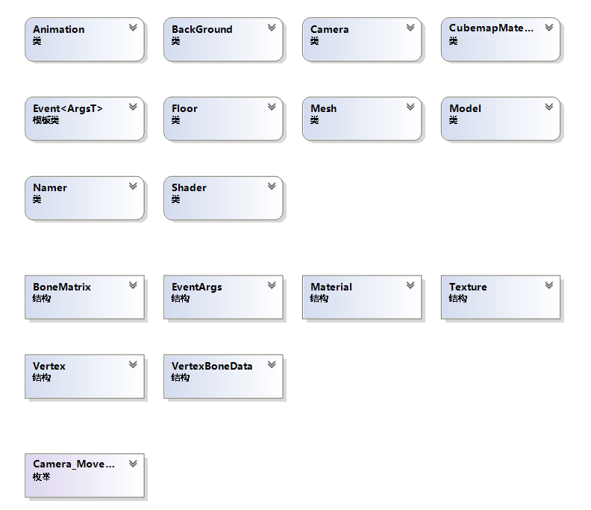

Figure 3: Logical View

## Dynamic Structure and Dynamic Model

### Interaction Diagrams

#### 模型解析结构图

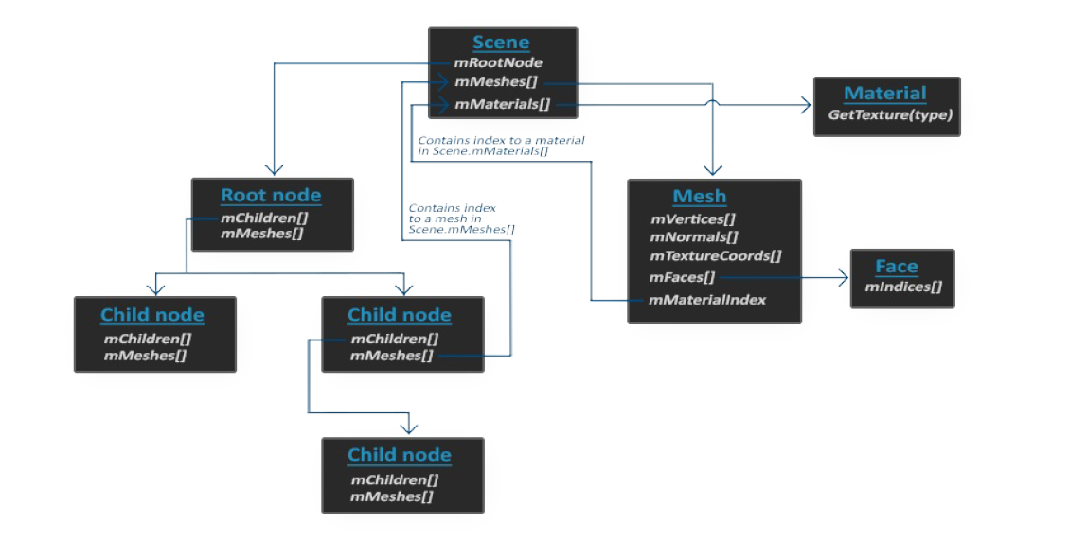

Figure 4: 模型解析结构图

#### 材质加载时序图

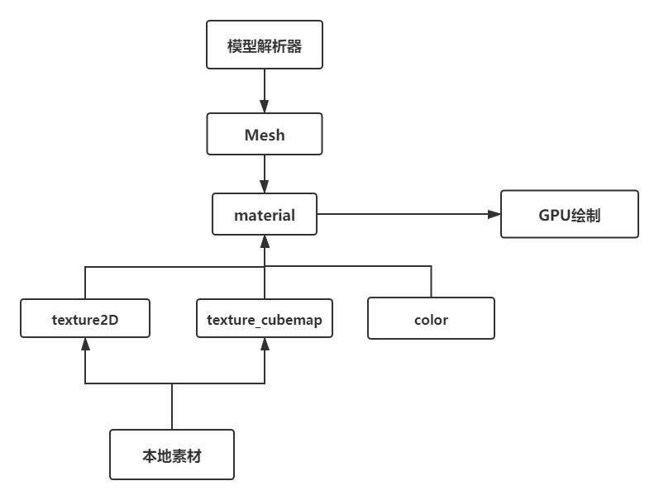

Figure 5: 材质加载时序图

#### 动画定制时序图

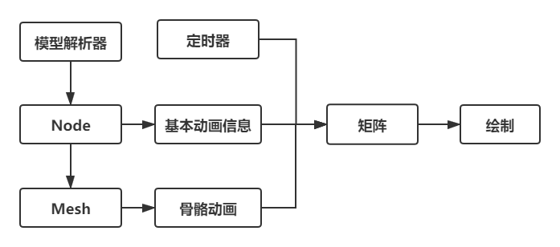

Figure 6: 动画定制时序图

### State/events diagrams

NA

### Runtime Behavior

#### Processes, Threads and Interrupts (optional)

NA

#### Timers (optional)

NA

#### Synchronization Primitives (if used)

NA

### OS Description / Usage

NA

### Performance Assessment

NA

### Diagnostics

NA

## Initialization and System Events

NA

## Test Concept

NA

# Interfaces

## External Interfaces

参考OpenGL ES 2.0

## Internal Interfaces

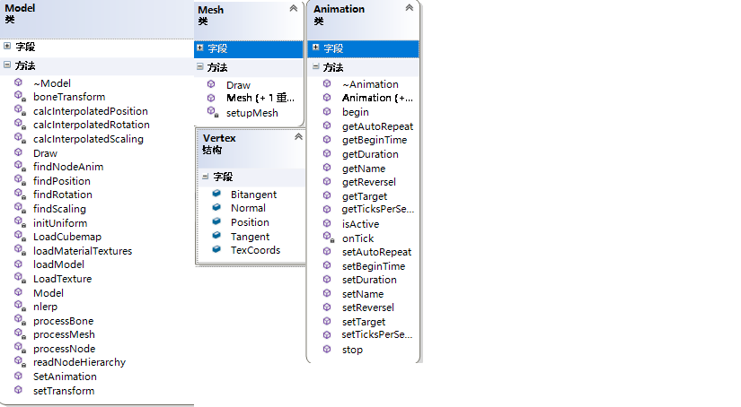

# Further Implementation Details

NA

# Related Documents 相关文档

# Appendix 附录