How to use
- Login
Double-click the icon ”Callsys” in the desk of computer：
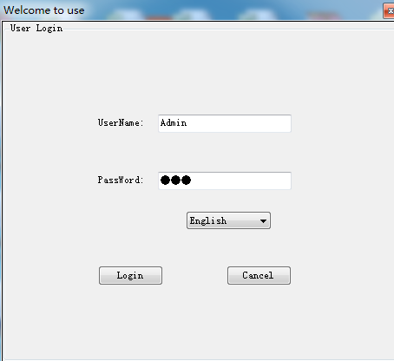
Enter UserName and PassWord to login，Default UserName: Admin, Default PassWord: 123.
- Main interface window
After login, the main interface as follows:
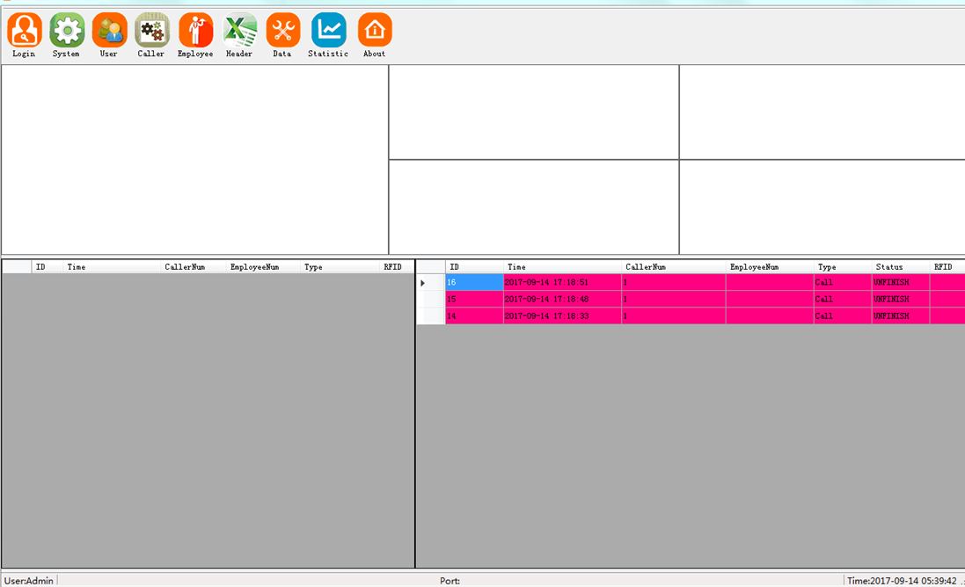
3. Setup
3.1 Login
Click Login icon to re-enter the system
3.2 System
Setup Company Name, Serial Setting, Button Function, Calling Record Display and Respond Time.

3.2.1 Company Name
3.2.2 Serial Setting
Serial Port: Depends on real situation (Usually it is COM3)
Data Bit: 8
Baud Rate: 9600
Stop Bit: 1
3.2.3 Button Function
Setup button name or function.
3.2.4 Calling Record Display
Setup calling record display sequence and color
- Ascending or Descending
- Different color to identify calling record
3.2.5 Respond Time
- Respond Time Setting:
- Unfinished Time Setting:
3.3 User
Add and delete the user and their authorities.
3.4 Calling Button
Setup Caller Zone and ID
3.4.1 Caller Zone
3.4.2 Caller ID
Caller ID from 001 to 999 (for receiver WL-CR22) or 00001 to 99999 (including English letter for receiver WL-CR28)
3.5 Employee
Add and delete the employee.
3.6 Header
Setup the header information for form.
3.7 Data maintenance
Delete the data. Please use it carefully!
3.8 Statistic
Check and review all calling information of different type and relevant statistic information.

