**Supporting Information**

**Analyzing Microalgal Biofilm Structures Formed Under Different Light Conditions by Evaluating Cell–Cell Interactions**

*Hao Yuan, a Yi Wang, a Zhijian Lai, b Xinru Zhang,**a,* *c* * *Zeyi Jiang, a,* *d Xinxin Zhang a, d*

a School of Energy and Environmental Engineering, University of Science and Technology Beijing, Beijing, 100083, China

b School of Chemistry and Biological Engineering, University of Science and Technology Beijing, Beijing, 100083, China

c Beijing Engineering Research Center of Energy Saving and Environmental Protection, Beijing, 100083, China

d Beijing Key Laboratory for Energy Saving and Emission Reduction of Metallurgical Industry, Beijing, 100083, China

**Corresponding Author**

*Xinru Zhang Ph. D

Mailing Address: School of Energy and Environmental Engineering, University of Science and Technology Beijing, Beijing, 100083, China

Phone: 86–10–62334971; E-mail: [xinruzhang@ustb.edu.cn](mailto:xinruzhang@ustb.edu.cn)

**S1. The culture medium for microalgae**

The inoculum cells for biofilm cultivation were pre-cultured in 500 mL flasks containing 100 mL media. The microalgae cells were evenly vacuum filtered onto the cellulose acetate–nitrate membrane to form a microalgae biofilm. The porous membranes were then attached to the solidified BG–11 to maintain microalgae growth. Then the microalgal biofilm microstructure and biomass were determined after 7 days of cultivation.

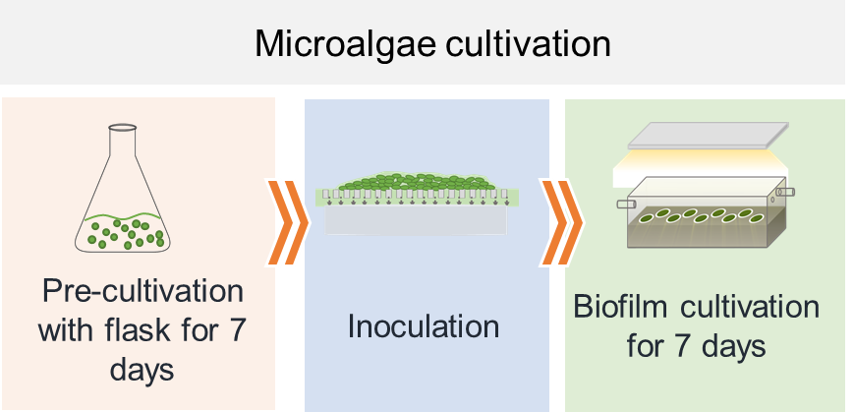

**Figure S1. Implementation of the experiment.**

The composition of BG–11 medium can be found in Table S1, and S2. It should be noted that, during biofilm cultivation, the solidified BG–11 culture medium with 1% agar was used.

**Table S1. The composition of BG**–**11 medium**

|  |  |  |
| --- | --- | --- |
| Medium Components | Mother Solution（g/100 mL） | Dosage |
| NaNO3 | 15 g | 10 mL/L |
| K2HPO4 | 4 g | 1 mL/L |
| MgSO4 · 7H2O | 7.5 g | 1 mL/L |
| CaCl2 · 2H2O | 3.6 g | 1 mL/L |
| Citric acid | 0.6 g | 1 mL/L |
| Ferric ammonium citrate | 0.6 g | 1 mL/L |
| EDTANa2 | 0.1 g | 1 mL/L |
| Na2CO3 | 2.0 g | 1 mL/L |
| A5 (Trace metal solution) | - | 1 mL/L |

**Table S2. The composition of A5 solution for BG**–**11 medium**

|  |  |
| --- | --- |
| Components | Concentration（mg·L-1） |
| H3BO3 | 2.86 g/L |
| MnCl2 · 4H2O | 2.86 g/L |
| ZnSO4 · 7H2O | 0.22 g/L |
| Na2MoO4 · 2H2O | 0.02 g/L |
| CuSO4 · 5H2O | 0.08 g/L |
| Co(NO3)2 · 6H2O | 0.05 g/L |

**S2. The absorption spectrum for microalgae cells and the irradiation spectra of LEDs**

The absorption spectra of *S.obliquus* were characterized by an ultraviolet-visible spectrophotometer (Epoch, BioTek, Winooski, VT, USA), as shown in Figure S2(a). The result indicated that the *S.obliquus* had an absorption peak at the light spectra of 420–480 nm (blue) and 620–680 nm (red). Meanwhile, the light spectra of these four LEDs were characterized by a fiber spectrometer (USB4000, Ocean Optics Inc., USA) between 350 and 750 nm, as shown in Figure S2(b). The white LED was not the sum of the constituent colors, but fabricated by associating an InGaN-based blue LED chip with a yellow luminescent phosphor, *i.e.*, Y3Al5O12 : Ce (Ce-doped yttrium alumina garnet) [1].



**Figure S2.** The absorption spectra of *S.obliquus* (a), and the irradiation spectra of light-emitting diodes (LEDs) (b).

**S3. The details on the experiment measurements**

As shown in Figure S3, the experiments were repeated three times on separate days (*i.e.*, Run 1, Run 2, Run 3). In each run, three microalgal biofilm samples were used in the observation of biofilm structure. Three samples were used in the profilometric measurement to determine their roughness. Nine samples were used to prepare the cell lawns for the contact angle measurements. Six samples were used to determine the biomass yield.

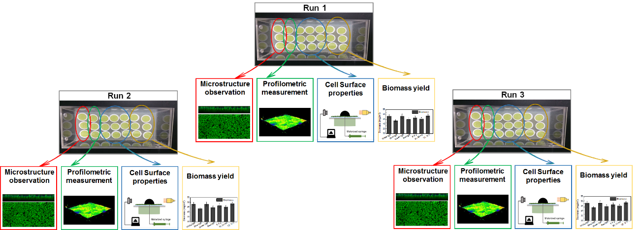

**Figure S3.** Implementation of the experiment measurement.

**S4.** **Determining biofilm porosity**

For each image gained from confocal laser scanning microscopes, a fixed threshold value was given to threshold the image. Then a binaryzation image formed, where a value of one obtained if the original pixel value was above or equal to the threshold value and a value of zero obtained if the original pixel value was below the threshold value**.**

## S5. Determining the surface free energy (SFE) of microalgae cells.

The SFEs of microalgae cells cultured under different light conditions were determined by a low-rate dynamic contact angle measurement (LDCAM) [2, 3], in conjunction with the Lifshitz–van der Waals/acid–based approach (LW–AB). Pure water, formamide, and methylene iodide were used as the probe liquids[4, 5].

### **S5.1.** LDCAM **on the microalgae cell lawns.**

In this study, the LDCAM was performed on microalgae cell lawns. Before the measurements, microalgae cells, cultured under different conditions, were collected by resuspension of microalgae biofilms in phosphate buffer solution, followed by centrifugation at 1770 *g* for 4 min to remove cell debris. During the measurement, the microalgal cell lawns were prepared by filtering 200 mL washed microalgae suspensions at a concentration of 106 cells/mL onto a filter paper with a pore size of 2 μm. Subsequently, this cell lawn was mounted onto a glass slide using a double-side adhesive tape, and then air dried for 30 min. After that, the LDCAs were measured on these cell lawns by the contact angle meter (DSA100, Krüss GmbH, Germany), with the pure water, formamide, and methylene iodide as the probe liquids.

In the contact angle (CA) measurement, because the Young’s CA should be approximated by the advancing CA [2, 4], we determined the low-rate advancing CA. During the experiment, first, the sessile drop of the probe liquid with a diameter of 3−4 mm was carefully deposited on the cell lawn. Then, the probe liquid was continuously injected into the initial sessile drop from above using a motorized syringe until the three-phase contact line of the sessile drop was steadily advanced. Images of the sessile drop were continuously acquired with a high-speed camera. The advancing CAs can be determined by drop shape analysis.

### S5.2. Determining the SFEs of cells from the LDCAM.

The SFEs of microalgae cells were determined with the LW–AB approach [3], as expressed by the Eqs. S1-S4,

 （Eq. S1）

 （Eq. S2）

 （Eq. S3）

 （Eq. S4）

where, ,  and  are the CAs of pure water, formamide, and methylene iodide on cell lawns, respectively. , ,  and  are the SFEs of the microalgae cells, pure water, formamide, and methylene iodide, respectively. , ,  and  are the van der Waals components of SFEs for the cells, pure water, formamide, and methylene iodide, respectively. , ,  and  are the electron acceptor components of SFEs for the cells, pure water, formamide, and methylene iodide, respectively. , ,  and  are the electron donor components of SFEs for the cells, pure water, formamide, and methylene iodide, respectively. is the acid–base components of SFEs for the cells. ,  and  can be measured from LDCAM. , , , , , , , , , ,  and  can be obtained from the liquid properties tables. , ,  and  can be calculated by combining the Eqs. S1~S4.

**S5.3. The SFE errors determination.**

Based on the propagation of errors, the SFE errors for microalgae cells were estimated according to the equations S5-S7,

 (Eq. S5)

 (Eq. S6)

 (Eq. S7)

where  and  represent the standard errors of SFE and contact angles, respectively. All calculations in this study were completed using MATLAB (9.6 MathWorks, USA).

**Table S3.** The surface properties for microalgae cells cultured under different light conditions.

|  |  |  |  |  |  |  |  |
| --- | --- | --- | --- | --- | --- | --- | --- |
| Light conditions | θW | θF | θM | γtot | γLW | γ+ | γ— |
| (°) | | | (mJ/m2) | | | |
| White | 43.6±3.1 | 33.7±2.3 | 56.1±1.7 | 48.5±1.1 | 30.9±1.0 | 2.3±0.6 | 33.2±4.4 |
| Blue | 26.5±2.9 | 32.0±1.8 | 56.8±1.9 | 49.4±1.3 | 30.4±1.1 | 1.7±0.4 | 52.2±3.5 |
| Green | 35.2±2.8 | 33.4±3.6 | 55.3±2.0 | 47.2±2.2 | 31.3±1.1 | 1.4±0.6 | 46.0±4.4 |
| Red | 33.4±3.1 | 36.6±3.2 | 55.0±1.3 | 47.1±2.4 | 31.5±0.7 | 1.3±0.5 | 48.1±4.9 |
| 5:5 s | 33.7±2.4 | 30.4±2.0 | 54.8±2.3 | 50.3±1.1 | 31.6±1.3 | 2.0±0.5 | 43.5±3.2 |
| 30:30 min | 29.3±3.5 | 27.1±2.4 | 55.1±2.7 | 51.9±1.3 | 31.4±1.6 | 2.3±0.6 | 46.7±4.2 |
| 12:12 h | 33.9±2.3 | 32.0±2.1 | 59.4±2.1 | 49.9±1.2 | 28.9±1.2 | 2.5±0.5 | 44.3±3.3 |

**S6. Statistical analysis for biofilm porosity and roughness.**

The one-way ANOVA analysis was performed to study the significance of cell surface properties and biofilm structures formed under different light conditions using MATLAB (9.6 MathWorks, USA) software. The determined *F* and *P*-values suggested that the cell surface properties and biofilm structures formed under different light conditions were significantly different.

**Table S4**. The ANOVA table for the biofilm porosity.

|  |  |  |  |  |  |
| --- | --- | --- | --- | --- | --- |
| Source | SS | df | MS | *F* | Prob>*F* |
| Groups | 1405.91 | 6 | 234.32 | 63.59 | 2.22E-12 |
| Error | 77.38 | 21 | 3.69 |  |  |
| Total | 1483.29 | 27 |  |  |  |

**Table S5**. The *P*-values for the porosity of biofilms formed under different light conditions (with a significance level of 0.05).

|  |  |  |  |  |  |  |  |
| --- | --- | --- | --- | --- | --- | --- | --- |
| Light  conditions | White | Blue | Green | Red | 5:5s | 30:30min | 12:12h |
| White | —— | 1.38E-05 | 2.17E-04 | 3.75E-06 | 1.25E-05 | 1.62E-05 | 1.72E-04 |
| Blue |  | —— | 9.96E-03 | 4.79E-01 | 1.81E-01 | 9.45E-01 | 3.41E-04 |
| Green |  |  | —— | 2.45E-03 | 2.69E-02 | 1.07E-02 | 1.36E-01 |
| Red |  |  |  | —— | 1.49E-02 | 5.66E-01 | 1.93E-05 |
| 5:5s |  |  |  |  | —— | 1.83E-01 | 3.64E-04 |
| 30:30min |  |  |  |  |  | —— | 4.43E-04 |
| 12:12h |  |  |  |  |  |  | —— |

**Table S6.** The ANOVA table for the biofilm roughness

|  |  |  |  |  |  |
| --- | --- | --- | --- | --- | --- |
| Source | SS | df | MS | *F* | Prob>*F* |
| Groups | 49.24 | 6 | 8.21 | 12.57 | 7.61E-07 |
| Error | 18.28 | 28 | 0.65 |  |  |
| Total | 67.52 | 34 |  |  |  |

**Table S7.** The *P*-values for the roughness of biofilms formed under different light conditions (with a significance level of 0.05).

|  |  |  |  |  |  |  |  |
| --- | --- | --- | --- | --- | --- | --- | --- |
| Light  conditions | White | Blue | Green | Red | 5:5s | 30:30min | 12:12h |
| White | —— | 1.50E-04 | 3.57E-03 | 6.88E-04 | 1.82E-02 | 9.64E-04 | 1.18E-01 |
| Blue |  | —— | 1.01E-01 | 4.25E-01 | 1.87E-03 | 9.74E-02 | 2.24E-04 |
| Green |  |  | —— | 3.56E-01 | 1.19E-01 | 7.40E-01 | 1.61E-02 |
| Red |  |  |  | —— | 1.51E-02 | 4.53E-01 | 1.90E-03 |
| 5:5s |  |  |  |  | —— | 3.30E-02 | 1.57E-01 |
| 30:30min |  |  |  |  |  | —— | 2.92E-03 |
| 12:12h |  |  |  |  |  |  | —— |

**S7. The errors determination and statistical analysis for co-adhesion energies (*ΔGco-adh*)**

Based on the CA results (see Table S3) and the propagation of errors, the errors of *ΔGco-adh* for microalgae cells under different light conditions were estimated according to equation S8,

 (Eq. S8)

where and represent the standard errors of co-adhesion energy and contact angles, respectively. The calculations were completed using MATLAB software (9.6 MathWorks, USA). Table S8 shows the determined errors of *ΔGco-adh* for microalgae cells under different light conditions.

**Table S8.** The *ΔGco-adh* of microalgae cells cultured under different light conditions.

|  |  |
| --- | --- |
| Conditions | *ΔGco-adh* |
| White | 8.1±5.7 |
| Blue | 31.9±4.5 |
| Green | 21.7±6.2 |
| Red | 29.0±7.0 |
| 5:5 s | 20.6±4.2 |
| 30:30 min | 23.0±5.2 |
| 12:12 h | 20.9±4.1 |

**Table S9.** The ANOVA table for the *ΔGco-adh*.

|  |  |  |  |  |  |
| --- | --- | --- | --- | --- | --- |
| Source | SS | df | MS | *F* | Prob>*F* |
| Groups | 5148.72 | 6 | 858.12 | 25.99 | 2.70E-18 |
| Error | 3235.81 | 98 | 33.02 |  |  |
| Total | 8384.53 | 104 |  |  |  |

**Table S10.** The*P*-values of *ΔGco-adh* for microalgae cells under different light conditions (with a significance level of 0.05).

|  |  |  |  |  |  |  |  |
| --- | --- | --- | --- | --- | --- | --- | --- |
| Lights | White | Red | Blue | Green | 5:5s | 30:30min | 12:12h |
| White | —— | 2.22E-08 | 9.01E-13 | 3.36E-07 | 1.31E-06 | 2.23E-07 | 1.31E-06 |
| Red |  | —— | 3.25E-01 | 6.68E-03 | 1.34E-03 | 3.40E-03 | 3.40E-03 |
| Blue |  |  | —— | 1.83E-06 | 3.51E-08 | 5.18E-05 | 8.33E-07 |
| Green |  |  |  | —— | 4.57E-01 | 5.27E-01 | 6.70E-01 |
| 5:5s |  |  |  |  | —— | 1.80E-01 | 7.95E-01 |
| 30:30min |  |  |  |  |  | —— | 3.14E-01 |
| 12:12 h |  |  |  |  |  |  | —— |

**S8. Biomass accumulation**



**Figure S4.** The biomass accumulation for biofilms cultured under different light conditions.

**Reference**

[1] C. Lin, Y. Zheng, H. Chen, C. Ruan, G. Xiao, R. Liu, Improving optical properties of white LED fabricated by a blue LED chip with yellow/red phosphors, Journal of The Electrochemical Society 157(9) (2010) H900-H903.

[2] D.Y. Kwok, A.W. Neumann, Contact Angle Measurement and Contact Angle Interpretation, Advances in Colloid and Interface Science 81(3) (1999) 167-249.

[3] P.K. Sharma, K. Hanumantha Rao, Analysis of Different Approaches for Evaluation of Surface Energy of Microbial Cells by Contact Angle Goniometry, Advances in Colloid and Interface Science 98(3) (2002) 341-463.

[4] D.Y. Kwok, R. Lin, M. Mui, A.W. Neumann, Low-rate dynamic and static contact angles and the determination of solid surface tensions, Colloids and Surfaces A: Physicochemical and Engineering Aspects 116(1–2) (1996) 63-77.

[5] X. Zhang, X. Cai, K. Jin, Z. Jiang, H. Yuan, Y. Jia, Y. Wang, L. Cao, X. Zhang, Determining the Surface Tension of Two-Dimensional Nanosheets by a Low-Rate Advancing Contact Angle Measurement, Langmuir 35(25) (2019) 8308-8315.