
ISOM4007
Graduation Project - CatFace
User Menu
Section 002

Student Name | Student Number | Short Name
YUAN JIA XUN | BC104215 | Claudia
LU QIAO XUAN | BC206700 | Lydia
PAN CHENG | BC209427 | PAN
HE CHEN XIAO | BC209795 | Yasmine
LYU XING JIA | BC210029 | Kelven
LI GUI XIN | BC208903 | Kelly
User Menu 1
1. User Menu for rescue organization 1
1.1 Rescue Organization Portal Entry 1
1.2 Organization Log In 1
1.3 Rescue Dashboard Overview 1
1.4 Cat List Management 1
1.5 Application Review 1
1.6 Notifications & Message Threads 1
2 User Menu for adopters 1
2.1 Adopter Log in & sign up 1
2.2 Community Page 1
2.3 Adoption Page 1
2.4 Notification Page 1
2.5 Account Page 1
2.6 Cat Health Records Page 1

User Menu

1. User Menu for rescue organization

1.1 Rescue Organization Portal Entry
Rescue organizations can access the backend portal from the main user login page.
Steps to find the backend entry:
- Open the CatFace Log In page.
- In the login panel, look below the Log In buttons.
- Find the highlighted link: “Are you a rescue organization? Log in here”.
- Click this link to open the Rescue Organization Login page (backend entrance).
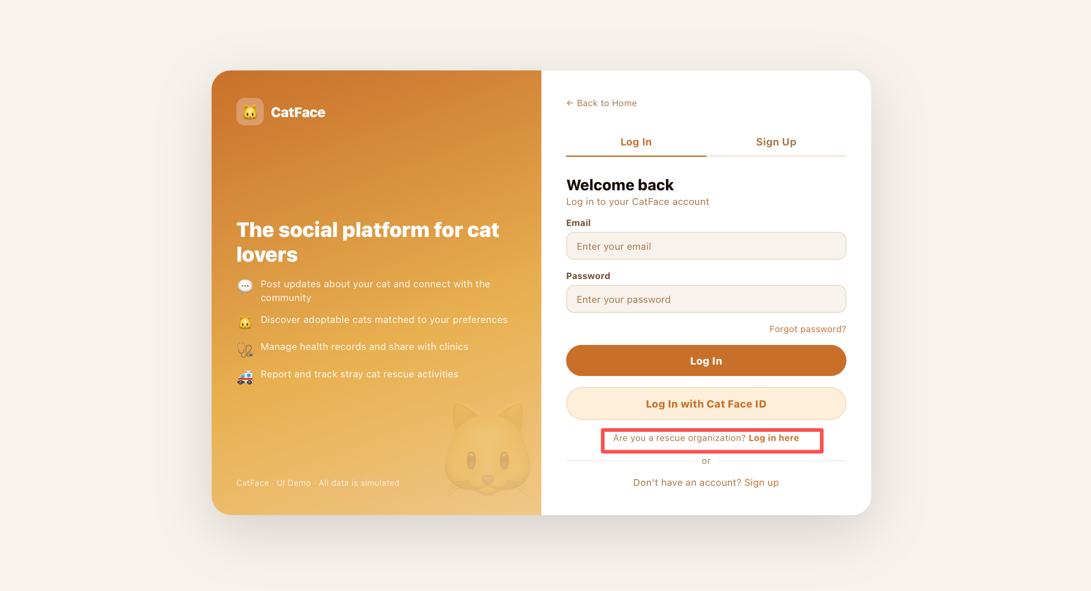

1.2 Organization Log In
This page is the dedicated login entry for rescue organizations.Authorized staff should use the organization account credentials provided by the CatFace admin team.
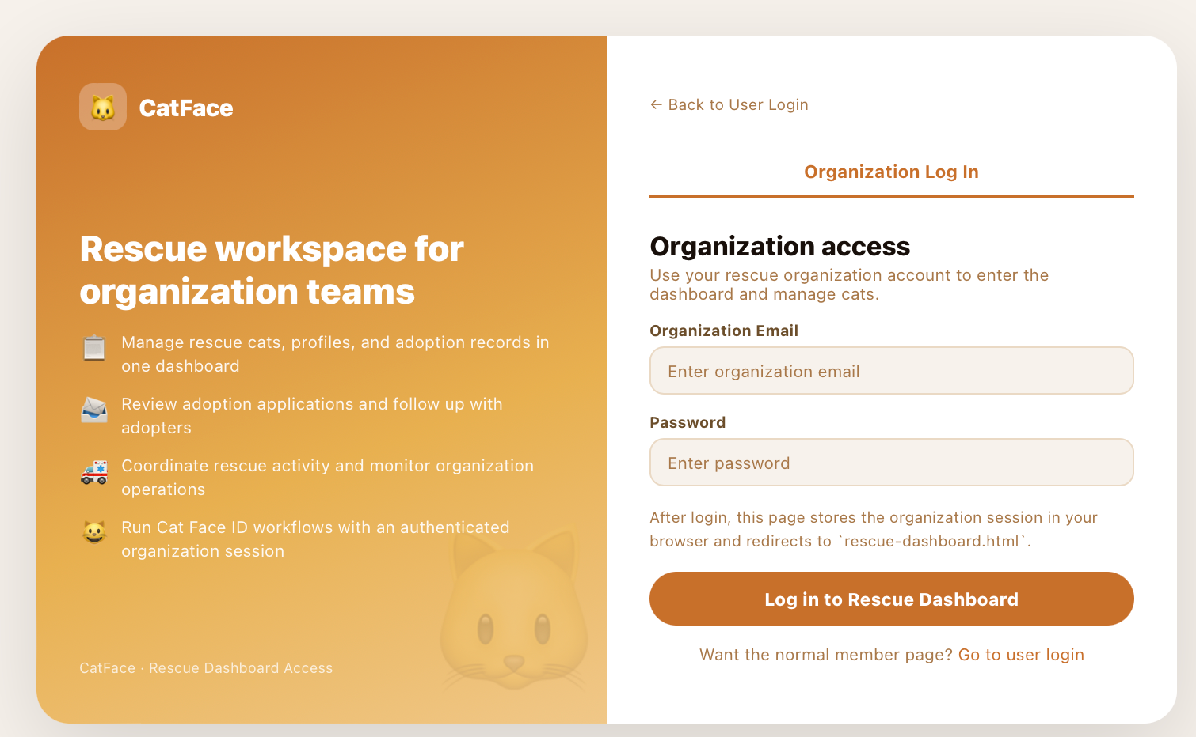

1.3 Rescue Dashboard Overview
After logging in, organizations first land on the Dashboard, which provides a data summary to support planning and decision-making. The dashboard helps rescue teams quickly understand adoption performance, review workload, and communication activity, so they can adjust operational strategy in time. Key metrics shown on the dashboard include:
- Available Cats
Number of cats currently open for adoption across the platform.
- Total Applications
Total incoming applications in the current tracking scope.
- Approval Rate
Percentage of applications that successfully move from submission to approval.
- Completed Adoptions
Number of applications that have been finalized as completed adoptions.
- Active Conversations
Number of ongoing communication threads with adopters.
- Average Review Time
Average time required to process reviewed applications. Decision-support panels:
- Application Funnel
Displays counts by stage (Submitted / Pending / Approved / Rejected) to show conversion and drop-off points.
- Monthly Trend
Compares incoming applications and approvals over time to identify growth, decline, or seasonal patterns.
- Status Breakdown
Highlights where cases are currently concentrated, helping teams prioritize workflow bottlenecks.
- Breed Preference
Shows which cat profiles attract more applications, supporting listing and rescue prioritization strategy.
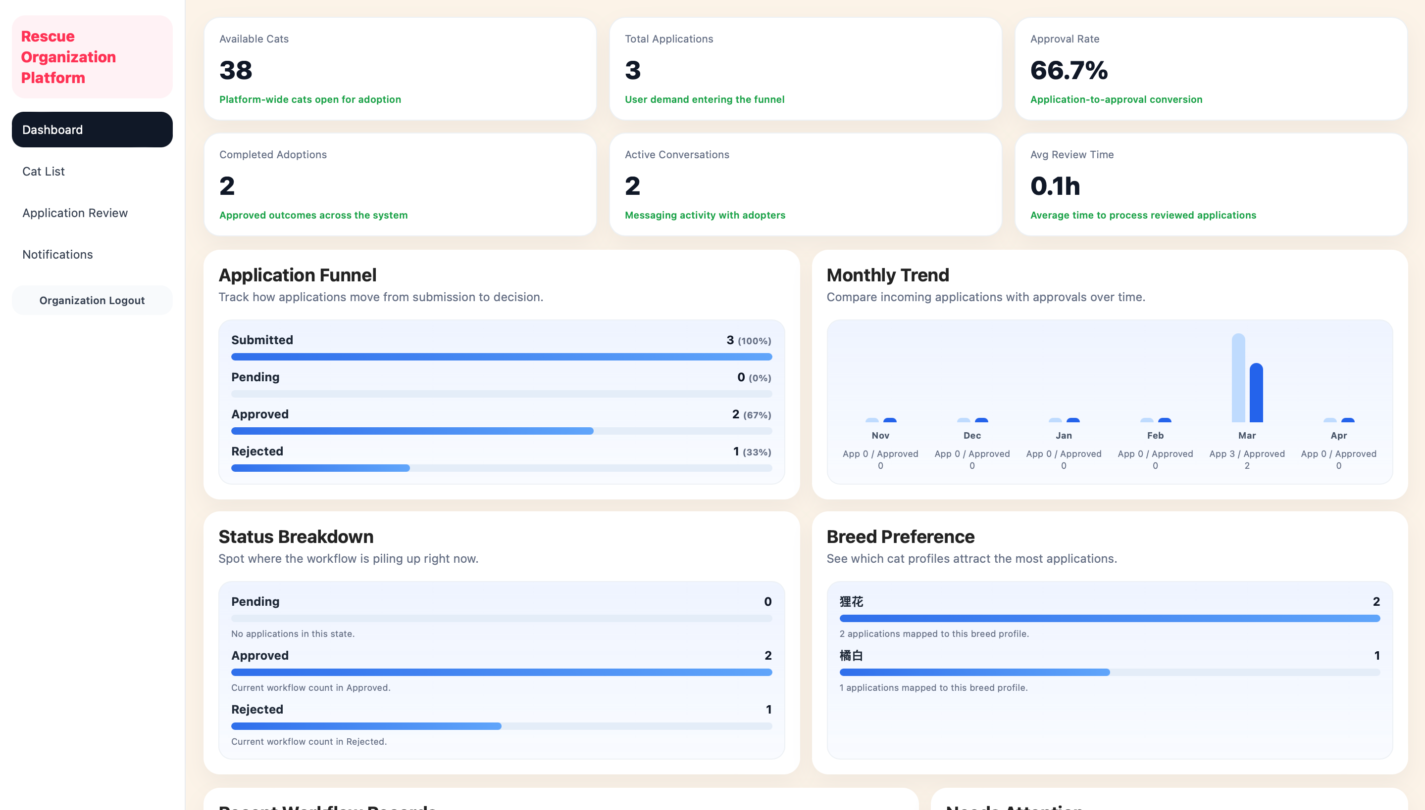

1.4 Cat List Management
The Cat List page allows rescue organizations to manage all cat profiles under their account in one place.Core actions on this page:
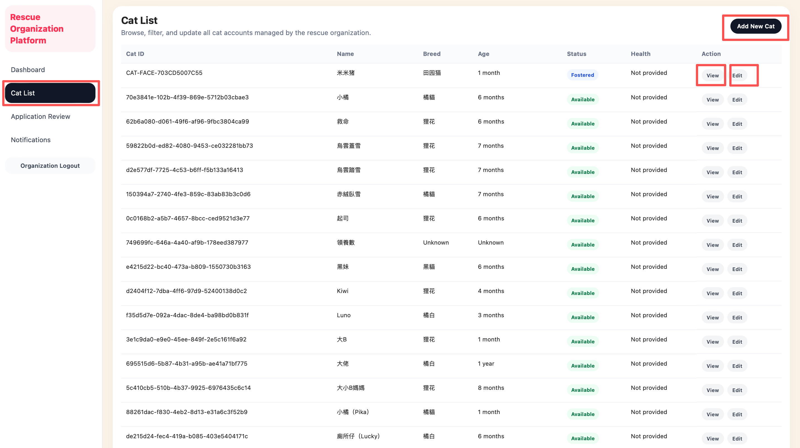
- View existing cat information
Click View in the Action column to open and review a cat’s full profile details.
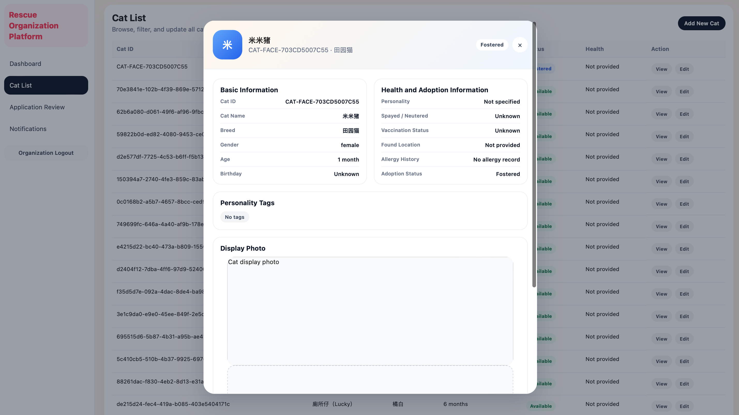
- Edit existing cat information
Click Edit in the Action column to update profile data (such as breed, age, status, and other record fields).
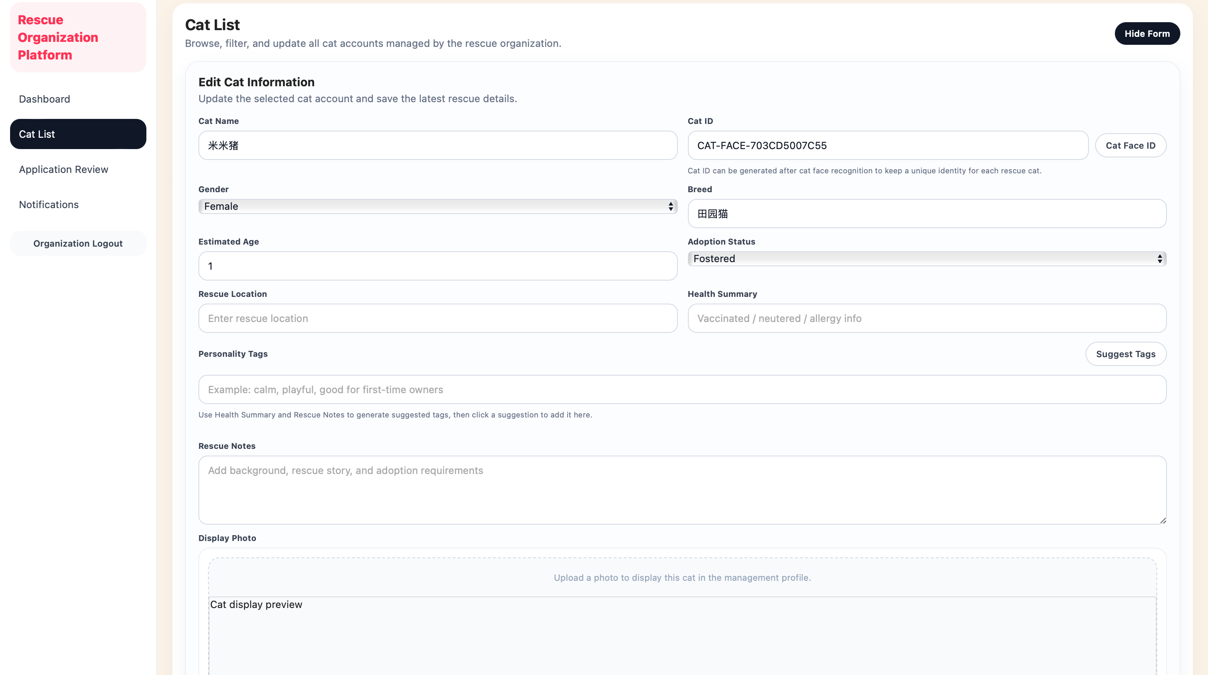

- Add a new cat profile
Click Add New Cat (top-right) to create a new cat record for the organization.
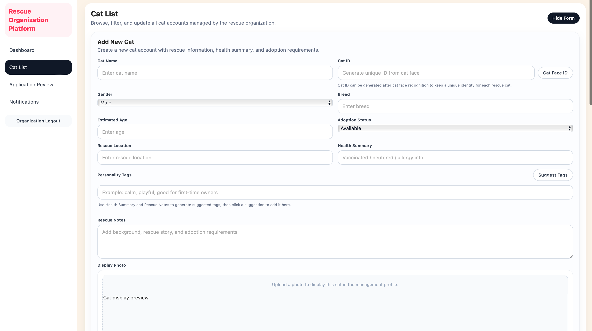
When adding a new cat profile, staff can click Cat Face ID to open the face recognition dialog and generate a unique cat identifier. If the uploaded cat already exists in the database (matched face record), the system returns an error message and does not create a duplicate Cat ID.
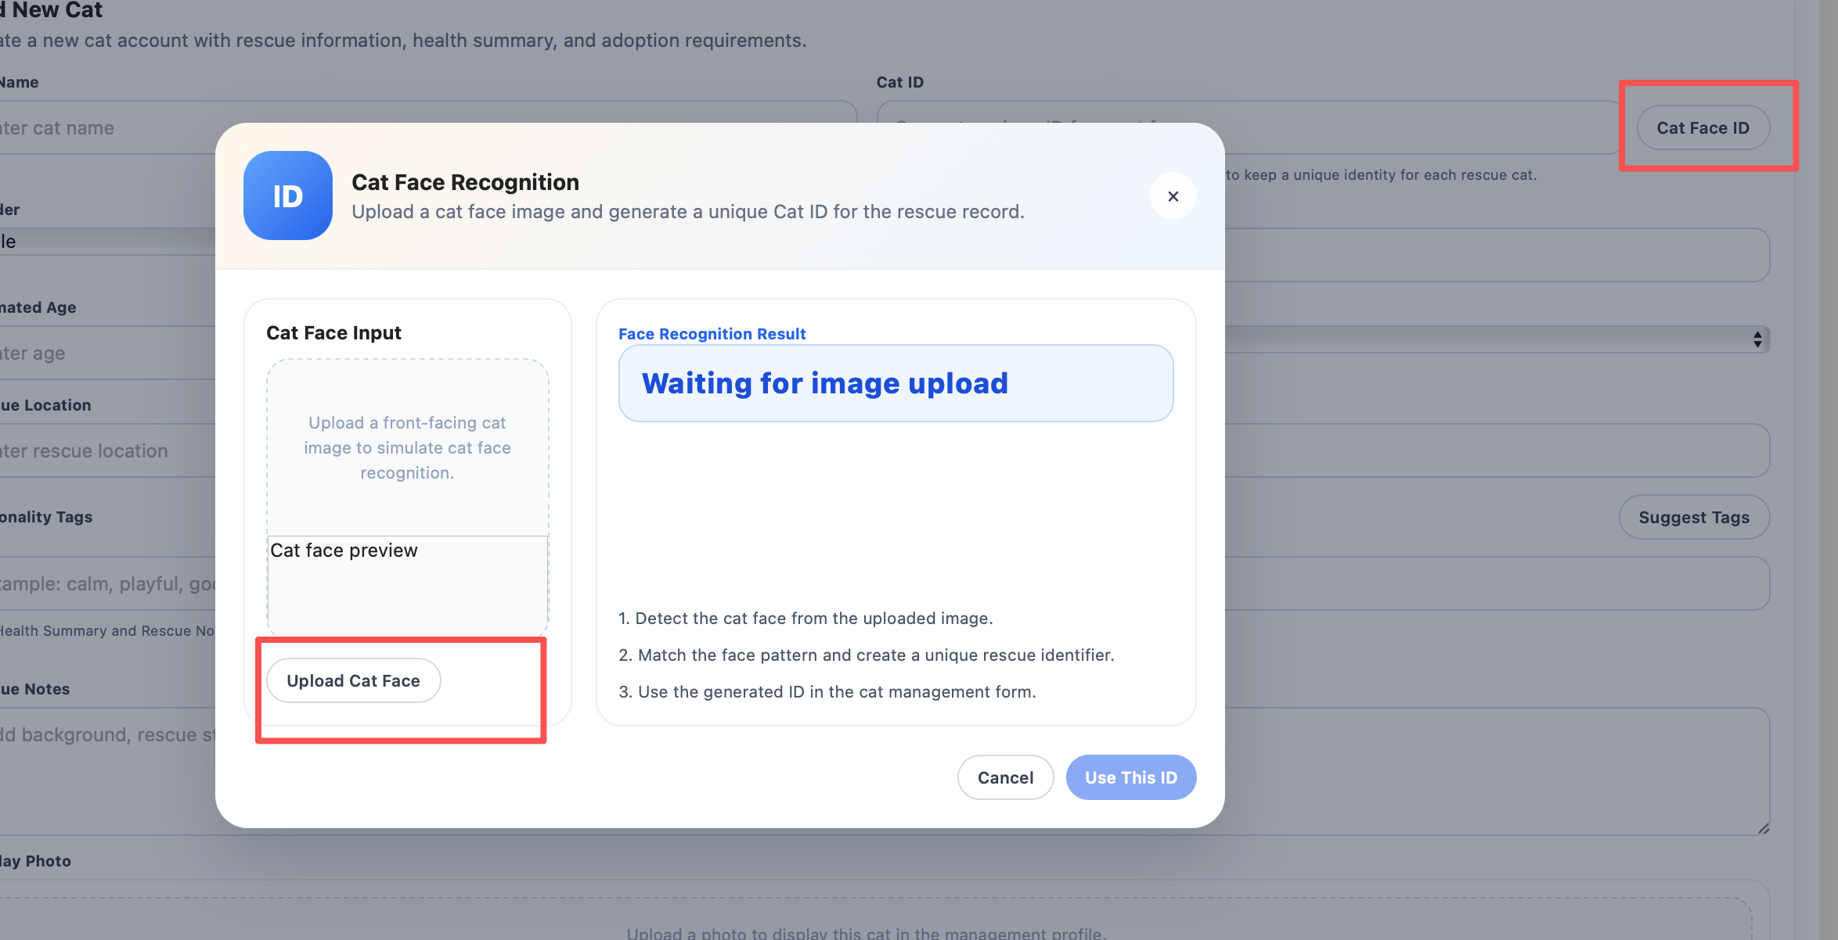
Organization staff can describe a cat in one sentence, and the system will automatically generate suggested tags for classification.
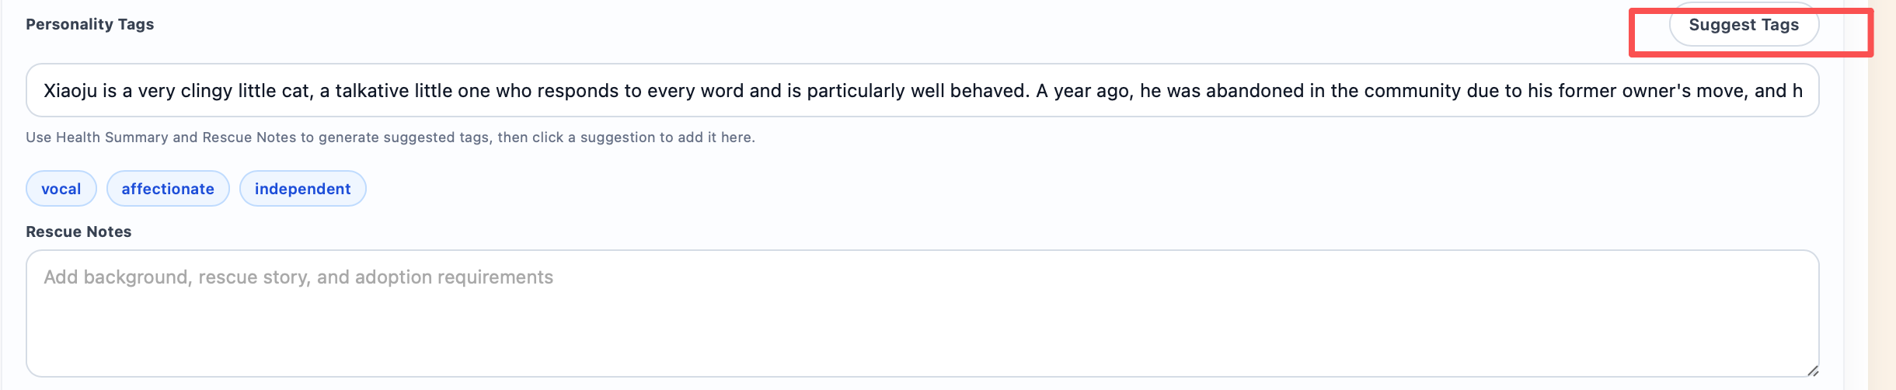
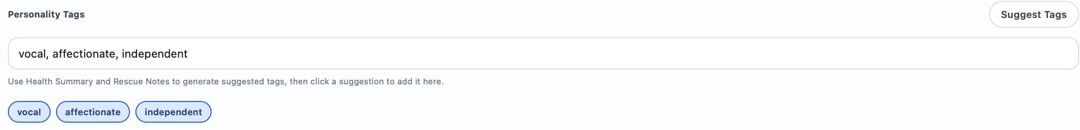

1.5 Application Review
The Application Review page allows rescue organizations to evaluate submitted adoption requests and make final decisions. Available actions:
- Review application records
Each row shows key details such as Application ID, Cat, Applicant, Status, and Submitted Date.
- View full application details
Click View to open the detailed review panel.
- Approve an application
Click Approve in the action column to mark the request as accepted.
- Reject an application
Click Reject in the action column to mark the request as declined.
- Contact the applicant
Inside the View detail panel, click Contact Applicant to start follow-up communication with the applicant.
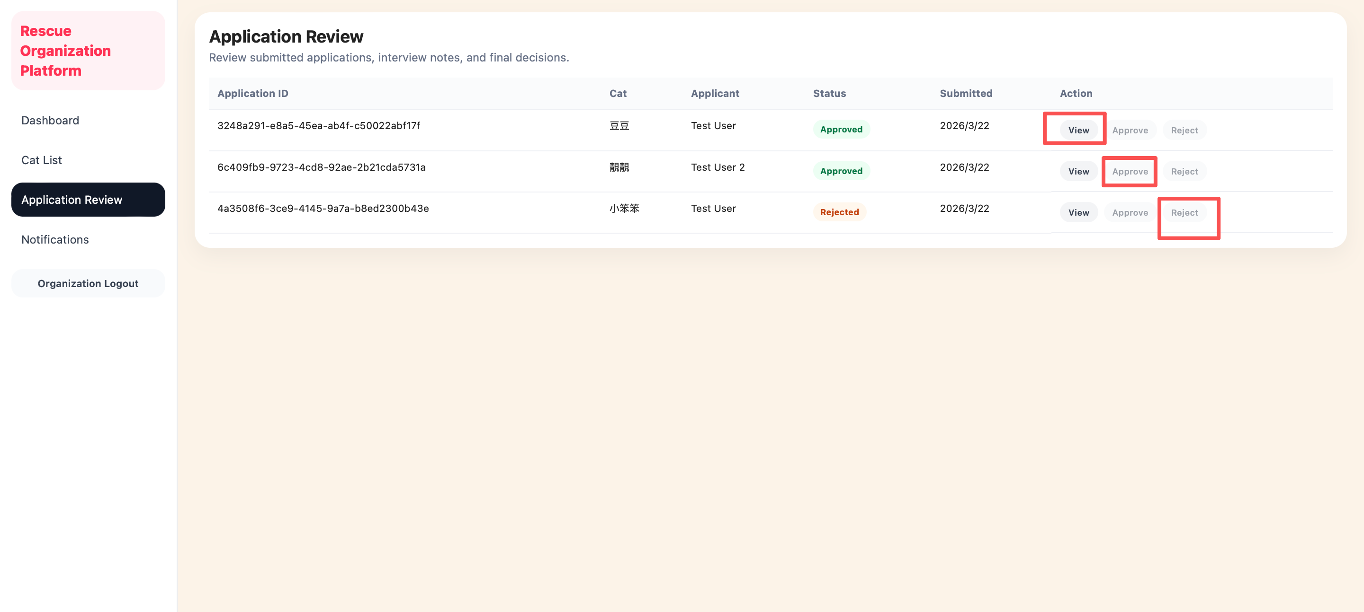
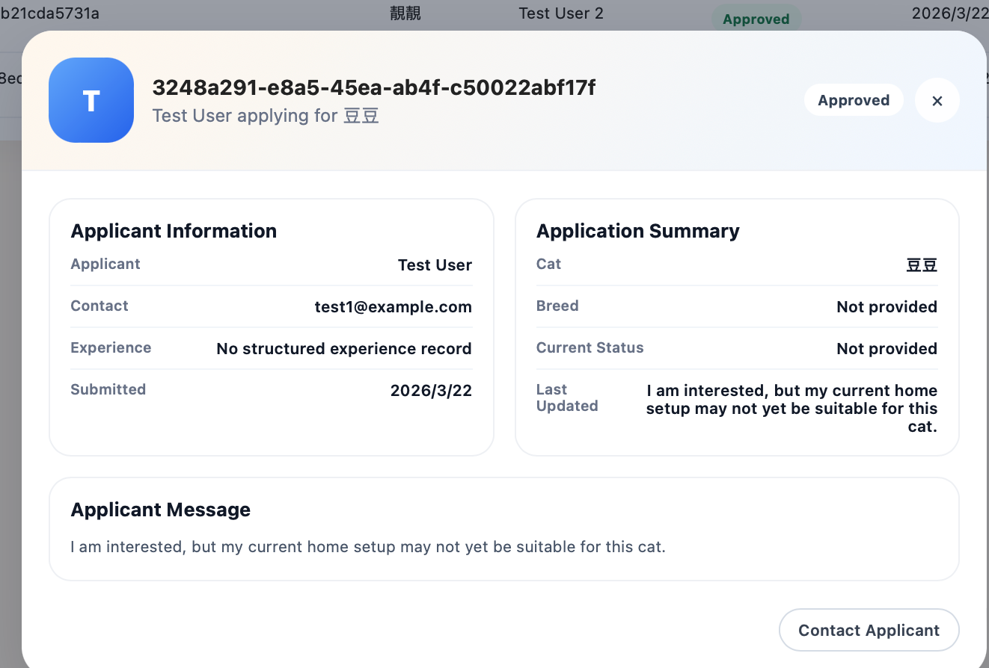

1.6 Notifications & Message Threads
The Notifications page is used to receive communication updates from applicants and manage ongoing message communication.
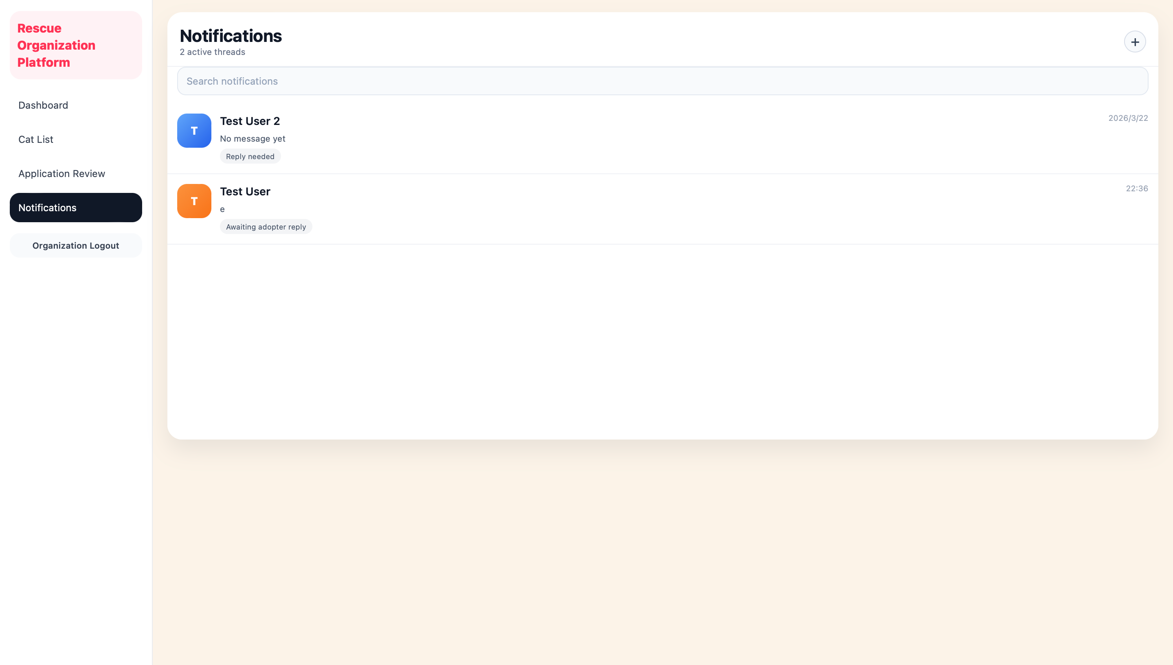

2 User Menu for adopters

2.1 Adopter Log in & sign up
Adopters can register a new account or log in through the main entry page.
New users are required to provide cats information such as email, username, and password.
During the sign-up process, users can select:
- “I have a cat” and input cat information and cat photos for cat face recognition.
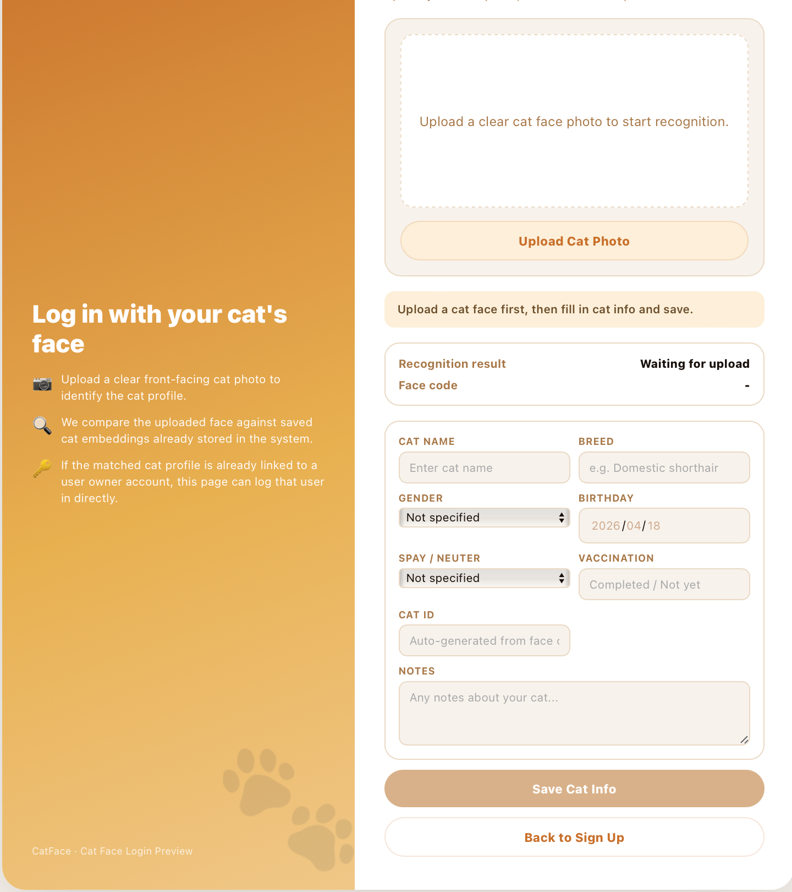

- “I want to adopt” and choose your ideal preferences. These preferences are stored in the system and are later used to support personalized adoption recommendations.
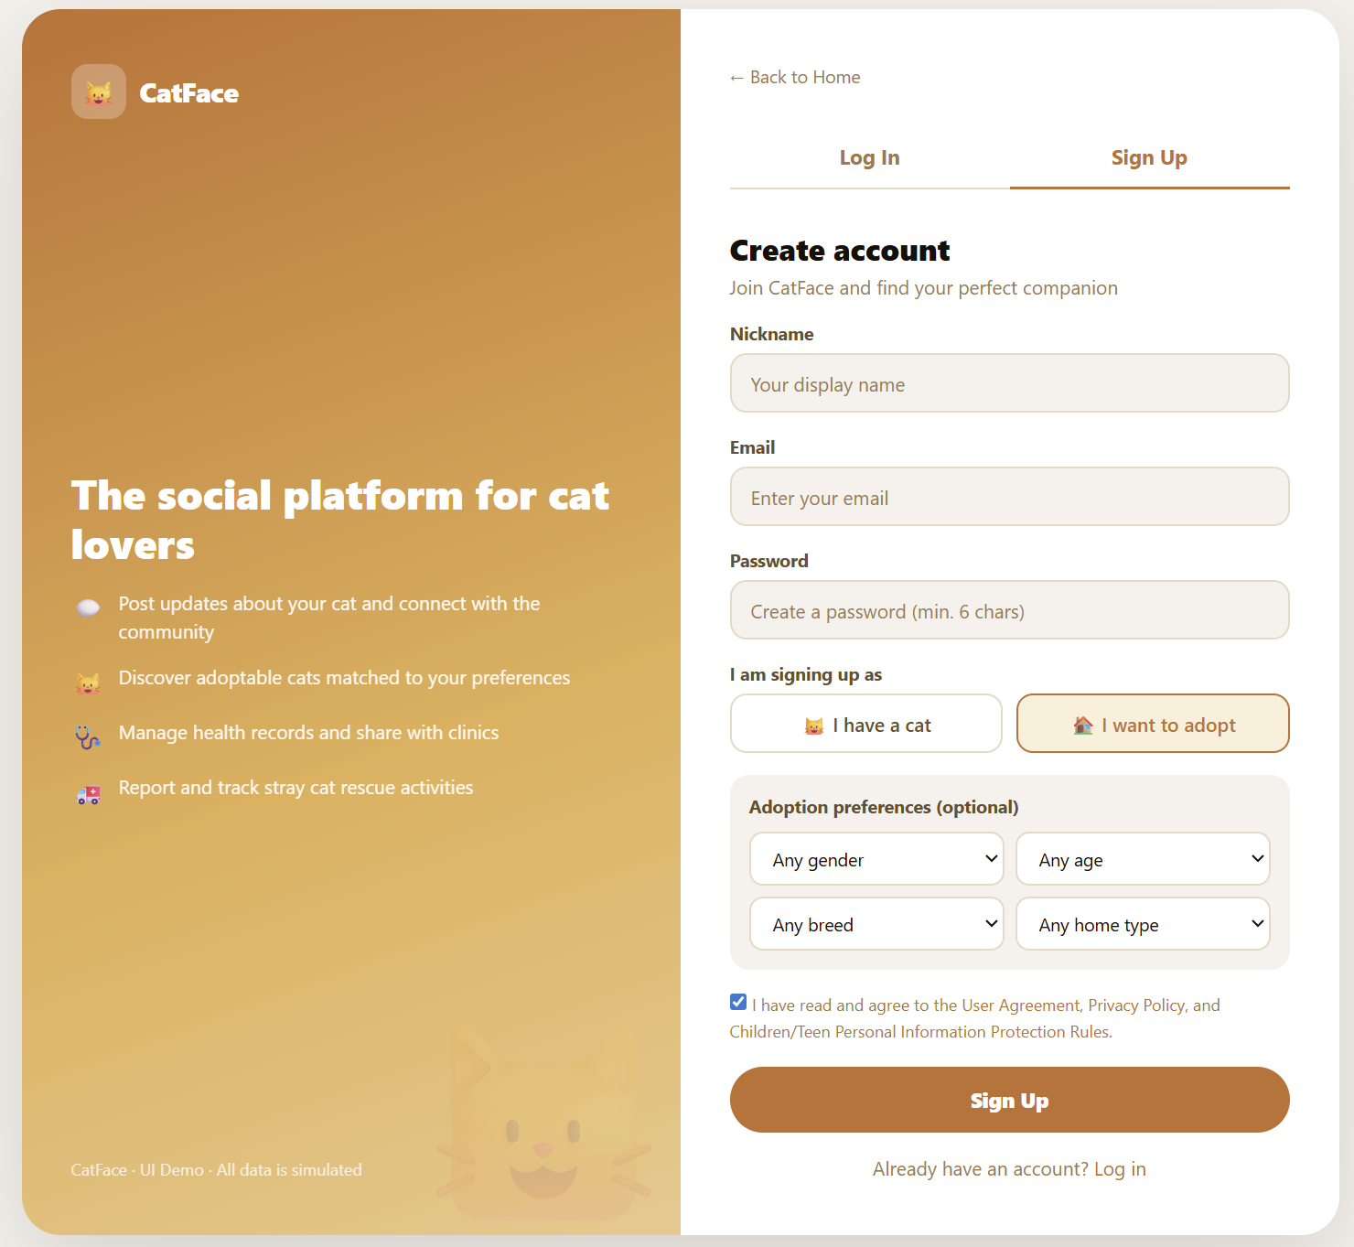

For existing users, you can log in using your registered account or upload a photo of your cat via facial recognition.
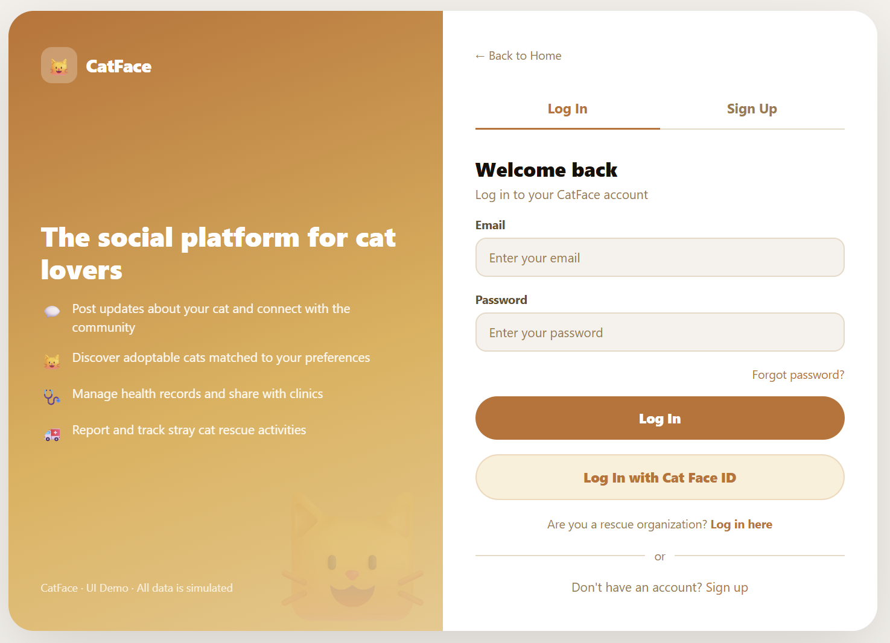

2.2 Community Page
The community page is the primary social interaction platform for adopters.
After logging in, adopters can browse cat-related posts shared by other users. The page displays a content feed where users can view posts containing text and images.
Core functions of this page include:
- Browsing regular feeds or following posts within feeds
- Creating new posts by adding text and images
- Interacting with posts by liking and commenting
- Following or unfollowing other users
- Viewing popular posts in the "This Month's Hot Topics" section
- Discovering recommended accounts in the "Cats to Follow" section

Community Page
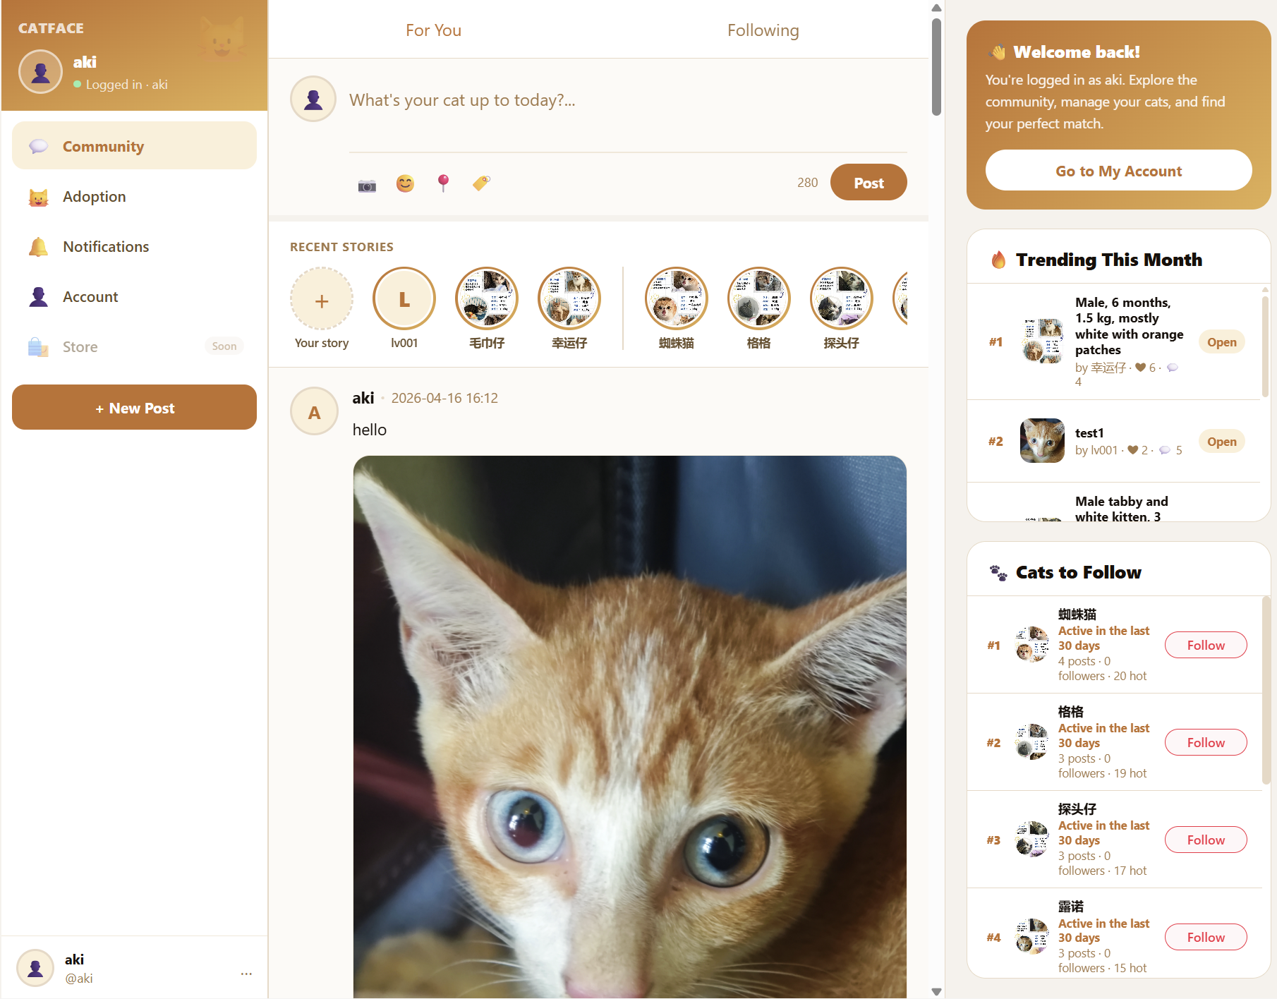

View User Posts
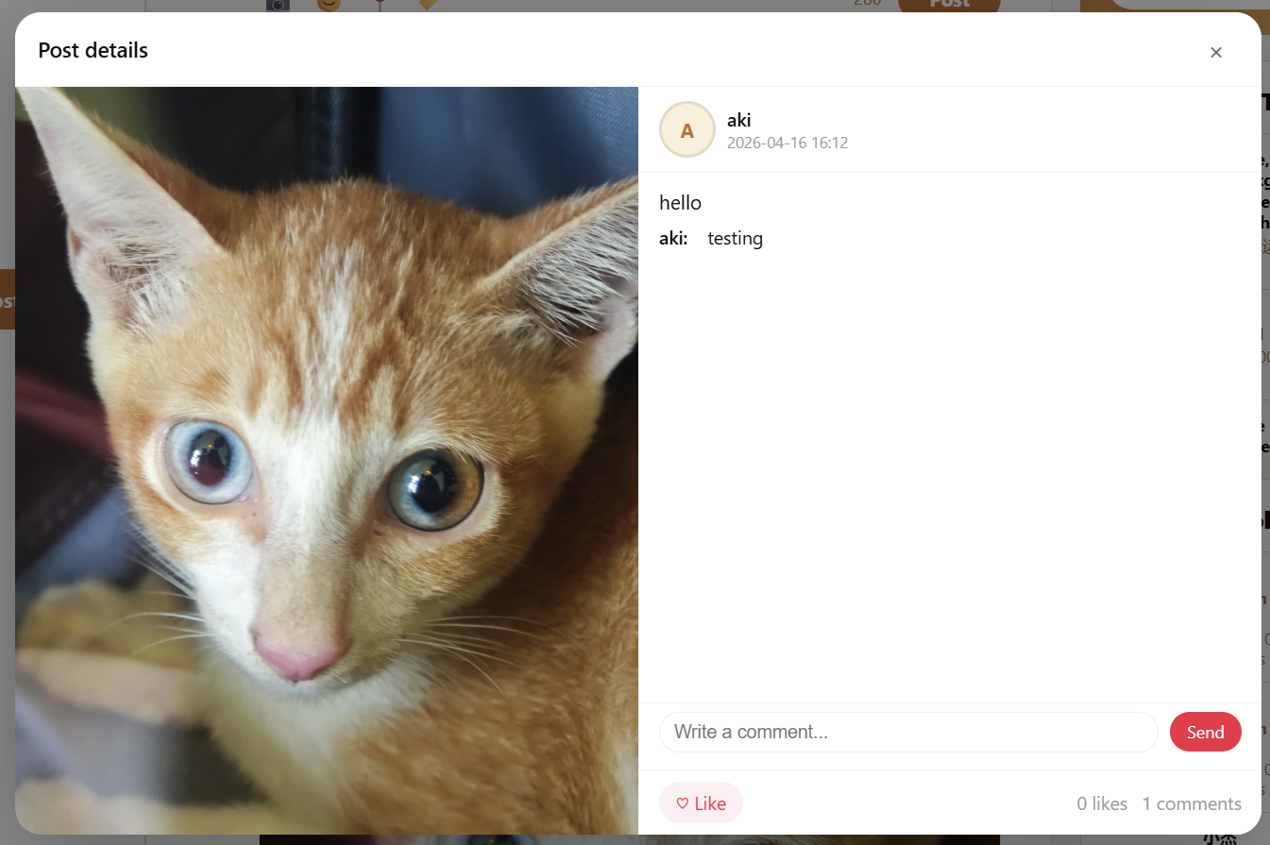
Creating new posts
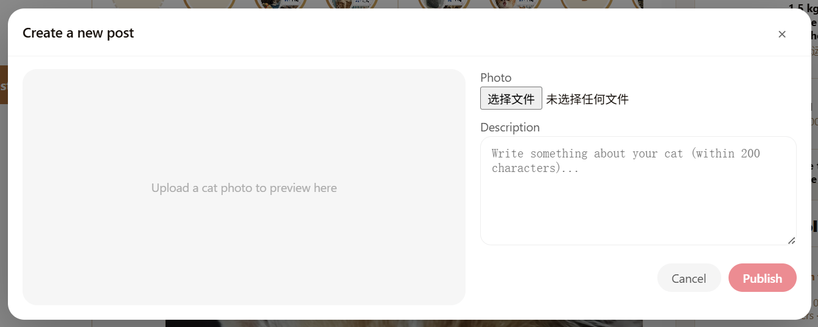

2.3 Adoption Page
Each cat's card displays key information such as a photo, age, sex, breed, and basic health status.
Key actions on this page include:
- Swipe right or tap the "Like" button to save your interest in a cat.
- Swipe left or tap the "Dislike" button to skip a cat.

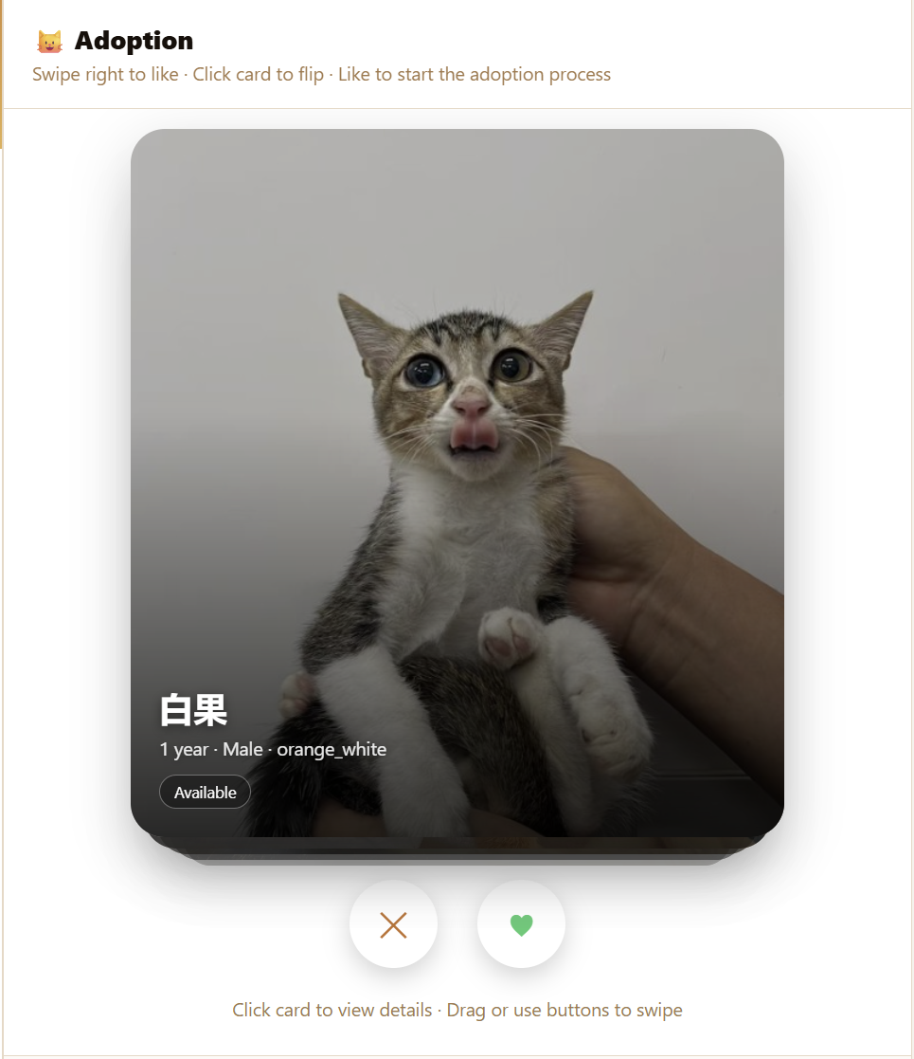

Click the "View" button to see the cat's detailed information.
Visit the "Favorite Cats" list to review the information saved.
Click "Contact Rescue Organization" to communicate directly with a rescue organization.
Click "Apply for Adoption" to submit your adoption application.
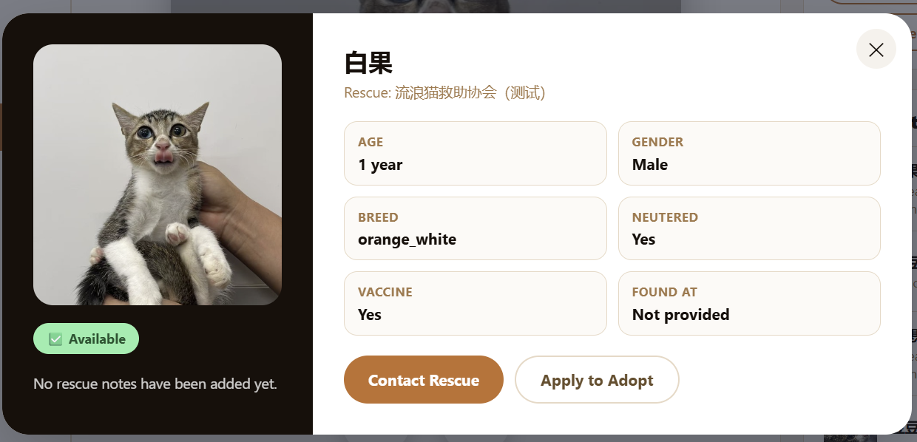
Once an application is submitted, adopters can track its status (submitted, pending, approved, or rejected) in the My Applications section.
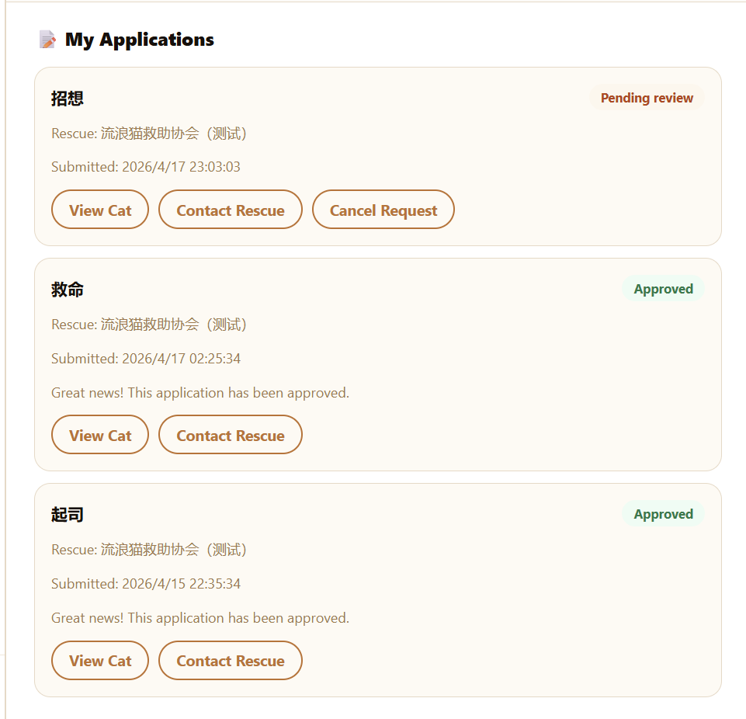
Click “Contact Rescue” to chat with Rescue Organizations
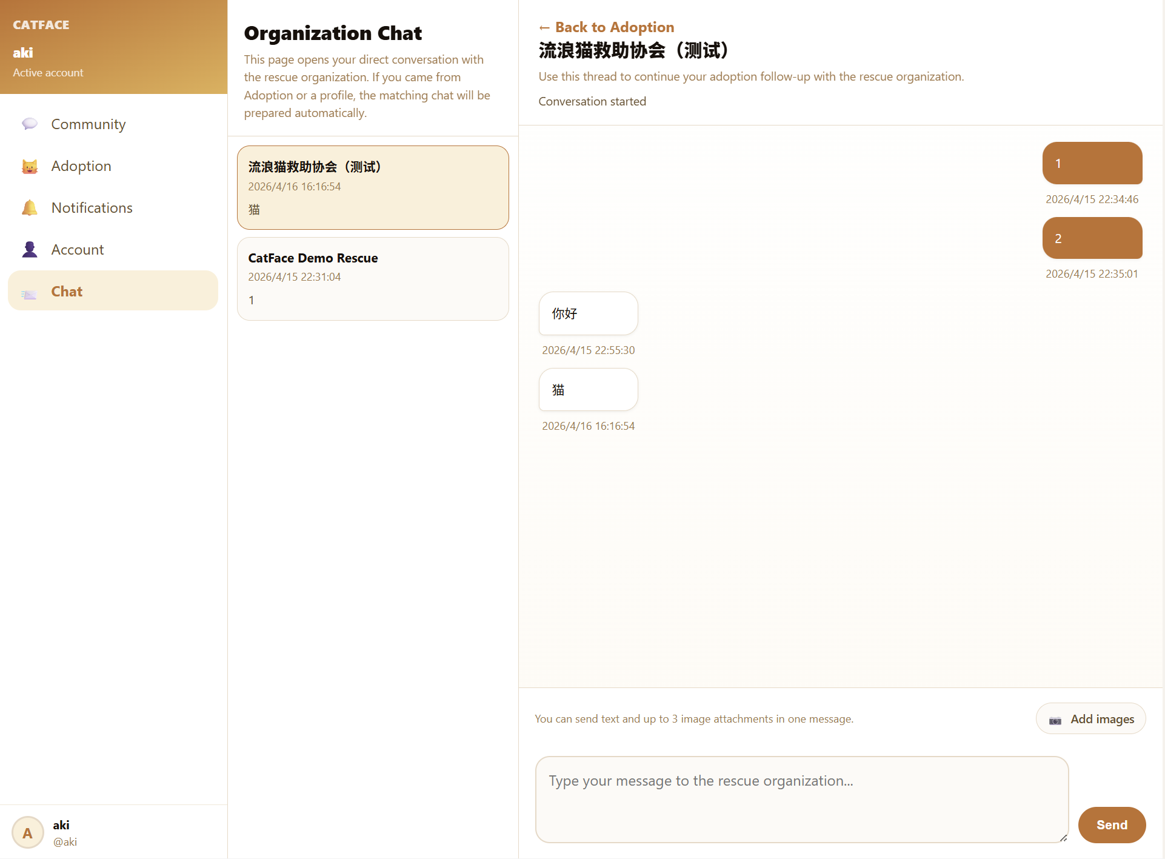

2.4 Notification Page
The notification page provides adopters with real-time updates on platform activities.
Notifications are automatically generated when users receive the following:
- A post receives likes or comments
- A new follower
- Messages from rescue organizations
- Updates related to adoption applications
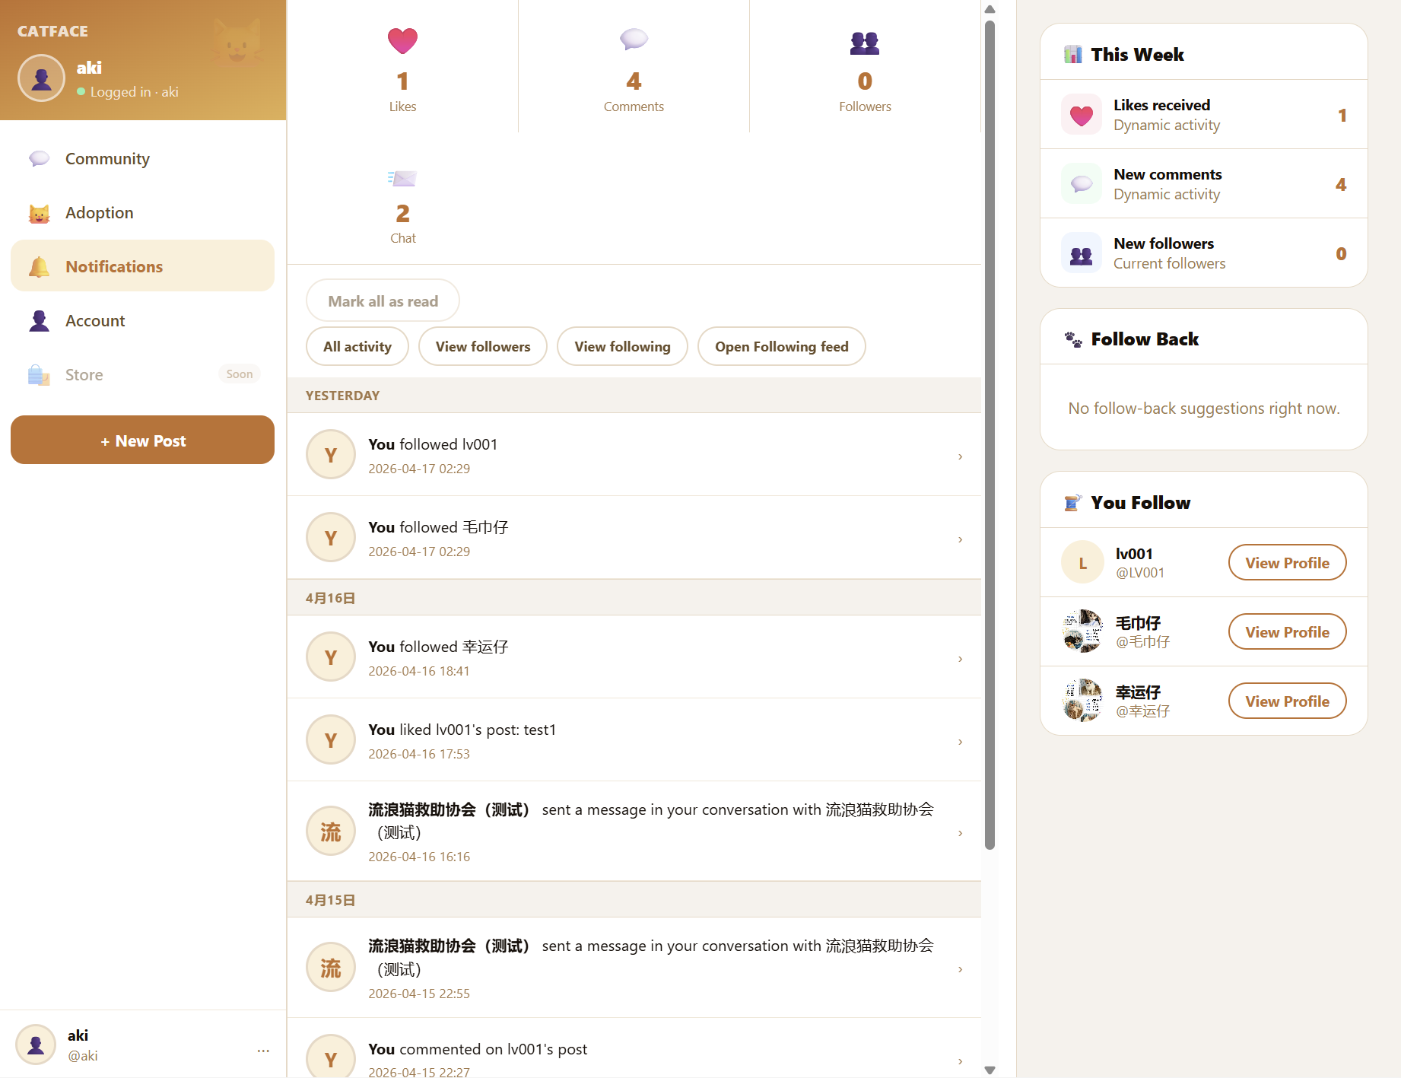

2.5 Account Page
The account page allows adopters to manage their personal information and system preferences.
On this page, users can:
- View and update basic profile information, such as username and email address
- Modify adoption preferences, including cat attributes and environmental needs
- Manage login-related information
- All updates are synchronized throughout the system to ensure consistency in personalization settings and accuracy of recommendations.
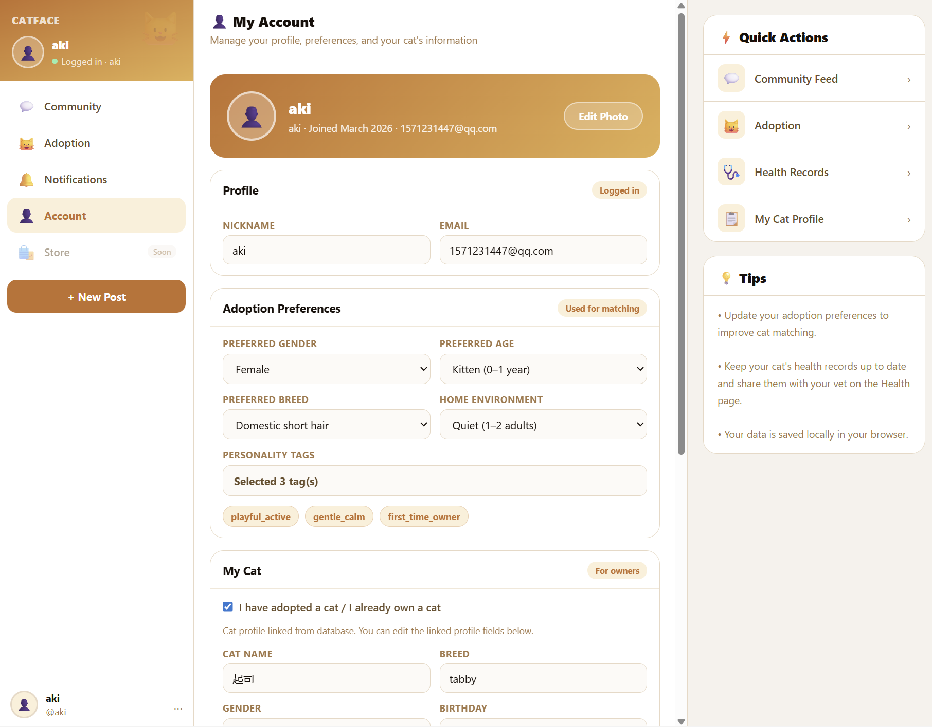

2.6 Cat Health Records Page
Dedicated module for cat health management.
Health Passport: Displays unique code and summary of key health information (vaccinations, deworming, spay/neuter status, weight)
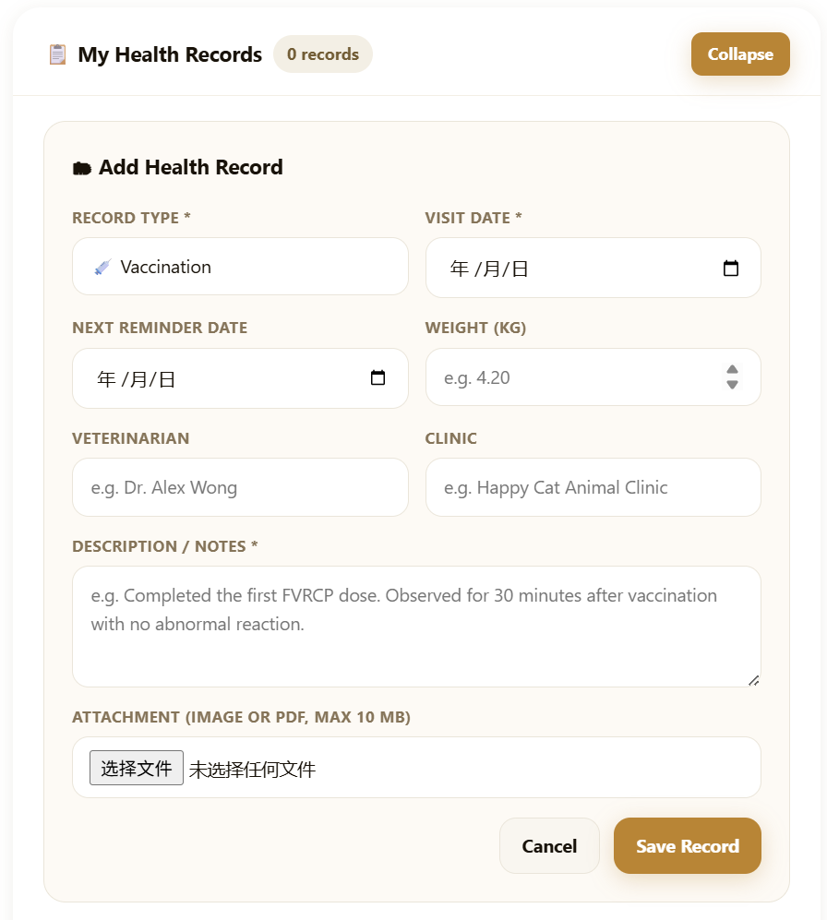

Owner Records: Add and manage health events (vaccinations, check-ups, treatments) with attachments Clinic Reports: View official read-only reports uploaded by partner clinics
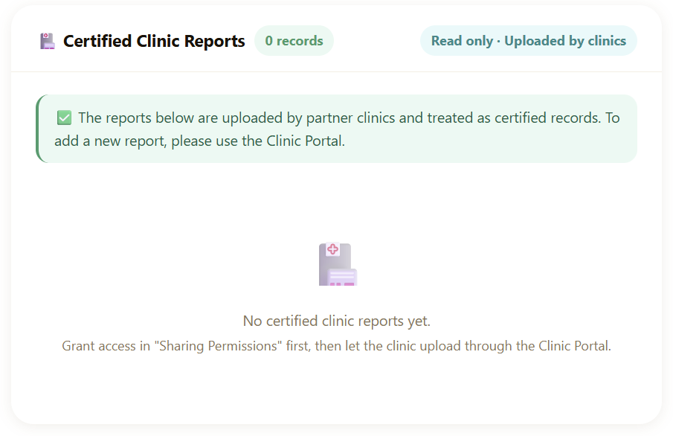
Permission Control: Grant/revoke clinic access to your cat's health data by entering the clinic's organization ID
