***4. Wind Energy Lab game play***

***Step 1: Open the lab***

The generated lab is provided through a web link. A precompiled version can be found in

*http://envisagelabs.iti.gr/games/energy/*

***Step 2: How to start playing***

When the browser has loaded the lab, the player is transferred to the main menu scene, where she/he can read information about the tasks he must complete as well as the controls used throughout the lab. After pressing the play button, the input scene is loaded asking for login information in Figure 4.14.

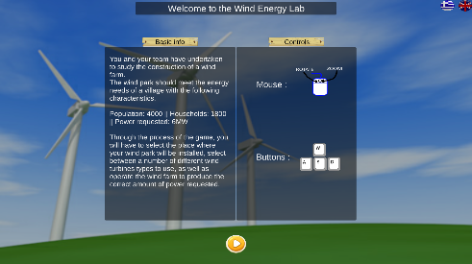 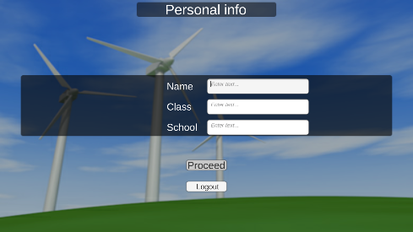

Figure 4.14: Main menu screen on the left and the login screen on the right.

**Step 3: Regional scenes selection**

After the player has filled in all the input fields, the player is transferred to the first stage of the wind farm construction, where he/she can choose from a list of three available regions to install the wind farm, as shown in Figure 4.15. Every area holds different characteristics that can have an impact in the performance of the farm. To choose a regional area the player must click on one of the green buttons in the bottom of the screen. Also, in case changes need to be made to the login information, the player can return back by clicking the exit button (top left corner).

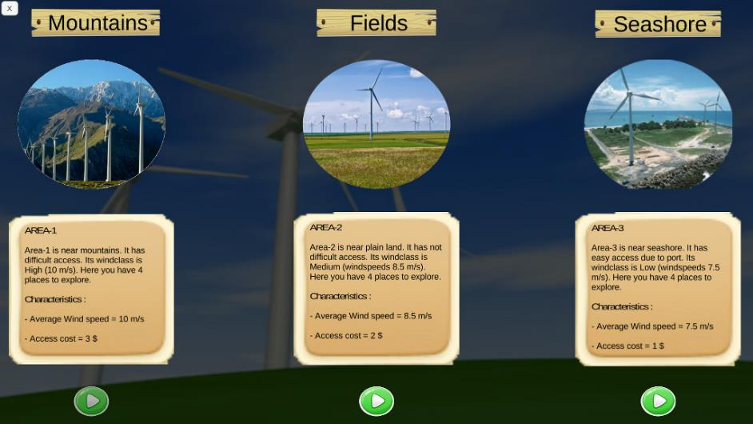

Figure 4.15: The three available main areas in the Regional selection scene.

***Step 4: Subarea selection scene***

After the player has picked a region, a new scene is loaded where the player can locate a number of markers throughout the scene terrain. This scene is the subarea selection and gives a 3D representation of the region that has been chosen by the player. Here, by using the WASD keys or by moving the mouse, the learner can fly through the scene in different directions. The purpose is to choose one of the available markers by hovering the mouse cursor above them. If the marker’s displayed characteristics satisfy the player, then the last can pick that subarea (marker) to install his farm by a left mouse click action in Figure 4.16.

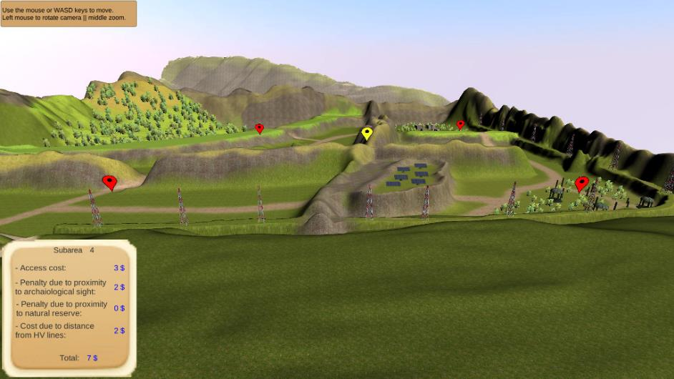

Figure 4.16: The subarea selection scene (Mountains regions).

***Step 5: Turbine Selection***

Subsequently, the player is transferred to the turbine selection process where a choice concerning the turbine for the farm is made, as shown in Figure 4.17 Again the selection is very easy to make by just clicking on the dropdown screen element. To aid the player’s choice a table with different turbine types and their characteristics is displayed.

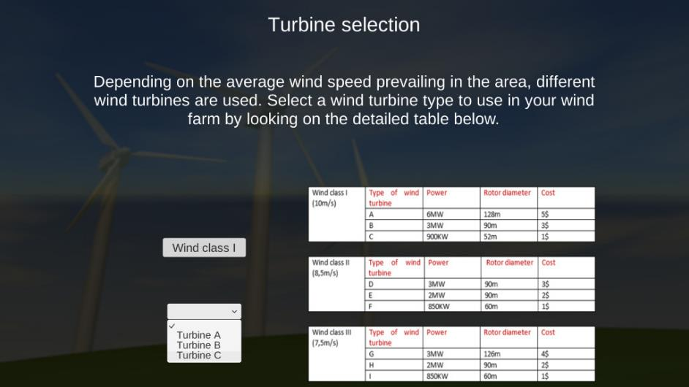

Figure 4.17: The turbine selection scene.

***Step 6: Simulation scene***

After the player has made all the required actions to install to setup the wind farm, the simulation scene follows. Here, the player can control the wind turbines for producing the appropriate amount of energy, based on the speed of the wind. Like in previous scenes the player can move using either the mouse or the WASD keys and interact with the turbines (turn on/off) by hovering the mouse cursor over them. The simulation runs for 3 minutes and the player can get real-time glimpse of the usage values (bottom left corner) such as the wind farm usage, produced electricity, wind speed and the energy requirements. In case the user wants to exit the simulation, he can do so by clicking the menu button (yellow button top left corner) and see all the available options (Figure 4.18).

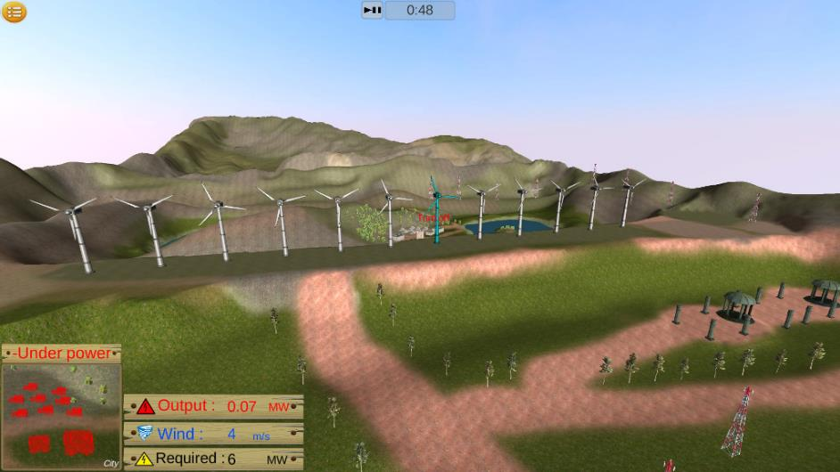

Figure 4.18: Wind Energy simulation scene.

***Step 7: Gamification elements***

Wind energy lab is an educational lab and measure of performance could not be left out of the design. After the player finishes the simulation a multiple choice quiz is presented, which asks general questions regarding future actions that could be taken for the player’s wind farm. Moreover, throughout the lab and the quiz, the options that the player chooses are validated resulting in an overall score in the end of the lab. Last but not least, an analysis of the wind farm usage, cost and general actions are presented to the player when the simulation has finished. In the end the player can exit the lab or play again to increase the total score as shown in Figure 4.19.

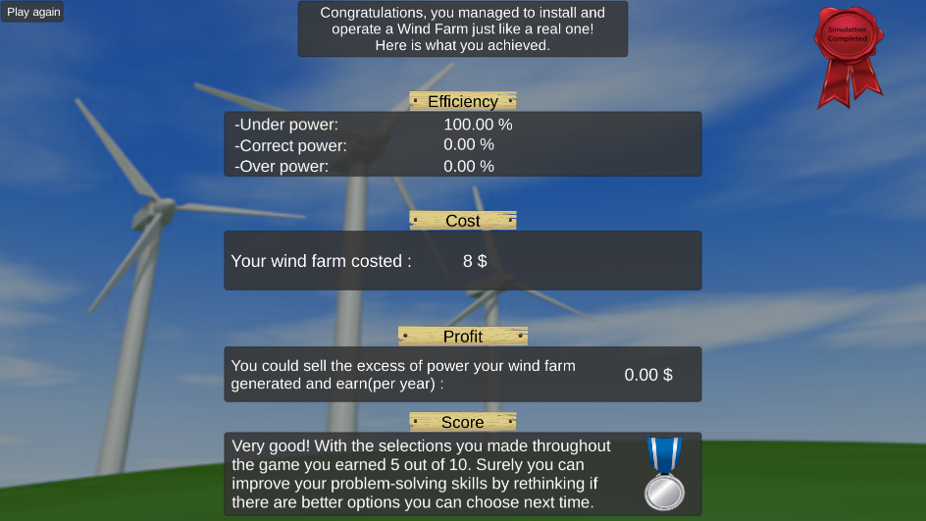

Figure 4.19: The final scene of the lab displaying the total score gathered.