Multifunctional Clock

1.Project Overview

With fast-paced life and social progress improvement of people's living style, more and more people want to live regularly in the city. People expert to have a machine that can record and monitor weather in their home. The machine can help people monitor indoor temperature and pressure and humidity.

The project is a simple clock with multifunctional monitoring temperature and pressure and humidity. When it is placed at home, it like a weather reporter in our home. When people take it as traveling assistant, it gives people messages about current circumstance. Those messages will prompt people whether it is suitable to doing some activity. On the base of sensor accurate, it has three sensors model for collect environment information on real-time.

2.System Basic Framework

The system uses Arduino Uno as the core of the system, with a weather station model and two adjust button, based on sensor and AD transformation theory, a serial of analog signal is convert to digital signal and display on LM016L.There are two little button which is use to adjust time after the multifunctional Clock powering off.

1. The block diagram below:

Arduino

Uno

**显示模块**

**电源模块**

**时钟模块**

**复位模块**

**传感器模块**

**控制模块**

1. System diagram is as follows:

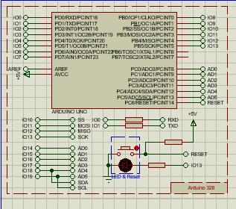

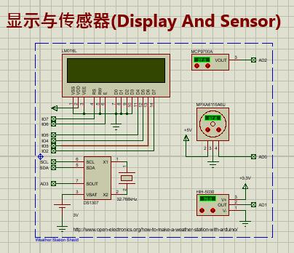

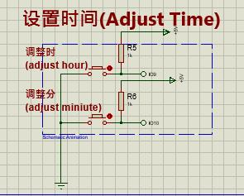

1. The program flow chart is as follows:

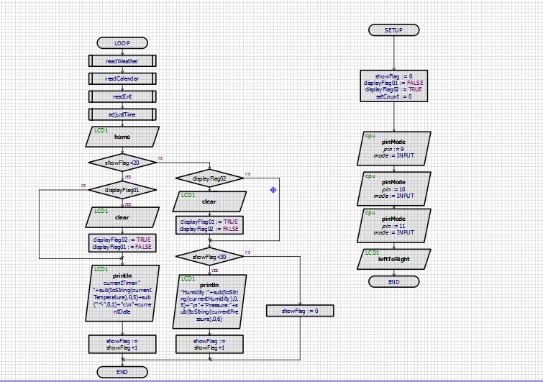

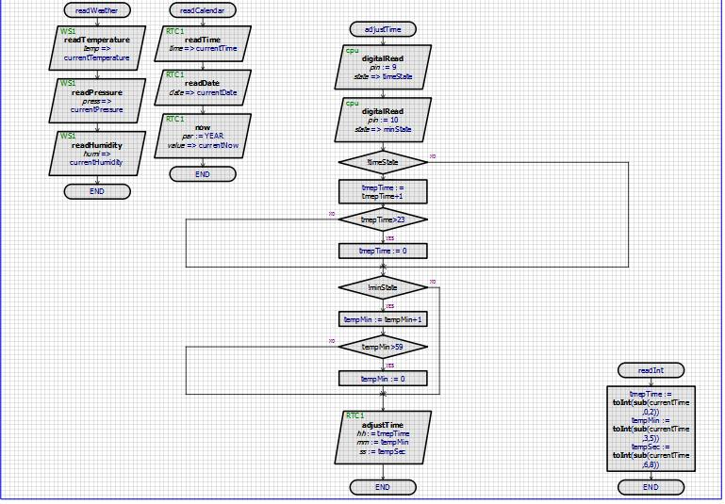

3.Working Principle

Arduion Uno as a main controller that provides three analog interfaces for coming signal for three sensors. The Weather Station Shield was constituted by flour different function par, which takes charge time and temperature and humidity and pressure. The DS1307 chip composed clock model, with a 32.768MHz crystal oscillator, produces exact clock and calculate time and send to Arduion Uno. When MCU receives the time data and other sensors signal, it put the data to LM016L model that takes charge of showing the transformed date on the LCD. Although the little LCD doesn't have enough room to display all data, time sharing multiplex solution, a loop that divide into two that one part showing time and temperature and other part showing humidity and pressure, solves this problem.

4.Significance of the Project

This project is mainly designed for giving a family or a person a multi-function clock. Placed in the home, it can not only record the time but also collect the real-time environment temperature, humidity and air pressure, hoping that people living in subtropical area can make adequate preparation timely for damp and hot weather. If we make the module integrated, and designed it as a miniature wearable watch, it is very useful for travelers, mountain climbers and adventure lovers, resulting from the fact that they can understand the change of the surrounding environment in time so that they can draw up the next step plan easily.

By PanQuanXing

2307461965@qq.com

2016-04-30